Total No. of Questions : 10] PE-5705 | SEAT No. :
Total No. of Questions : 10] PE-5705 | [Total No. of Pages : 3
[6582]-201
S.E. (Artificial Intelligence and Data Science/Computer Science
and Engineering)
PCC-201-AID : DATA STRUCTURES
(2024 Pattern) (Semester - III)
Time : 2½ Hours] [Max. Marks : 70
Instructions to the candidates :
1) Answer Q1 or Q2, Q3 or Q4, Q5 or Q6, Q7 or Q8 and Q.9 or Q.10.
2) Neat diagrams must be drawn wherever necessary.
3) Figures to the right indicate full marks.
4) Use of electronic pocket calculator is allowed.
5) Assume suitable data, if necessary.
Q1)a) What is meant by time and space complexity? Explain the asymptotic
notations used for time complexity? [5]
b) What is Sequential Search explain with Example? [5]
c) Explain Bubble sort using the following Example :
18, 13, 12, 22, 15, 24, 10, 16, 19, 14, 30. [4]
OR
Q2)a) Explain binary search with appropriate example. Comment on their data
organization, time complexity and space complexity. [5]
b) Explain quick sort algorithm with suitable example. What is advantages
of quick sort algorithm. [5]
c) What is hashing? Explain the properties of good hash function. [4]
Q3)a) Write a pseudo code to insert new node in to singly link list. [7]
b) Explain the representation of polynomial using GLL. [7]
OR
Q4)a) What is Link List? Explain its types with diagram. [7]
b) Write and explain node structure of Generalized linked list for representing
multiple variable polynomial. Represent given polynomial graphically using
Generalized Linked List: 5x7 + 7xy6 + 11xz. [7]
P.T.O.
https://t.me/SPPU_TE_BE_COMP



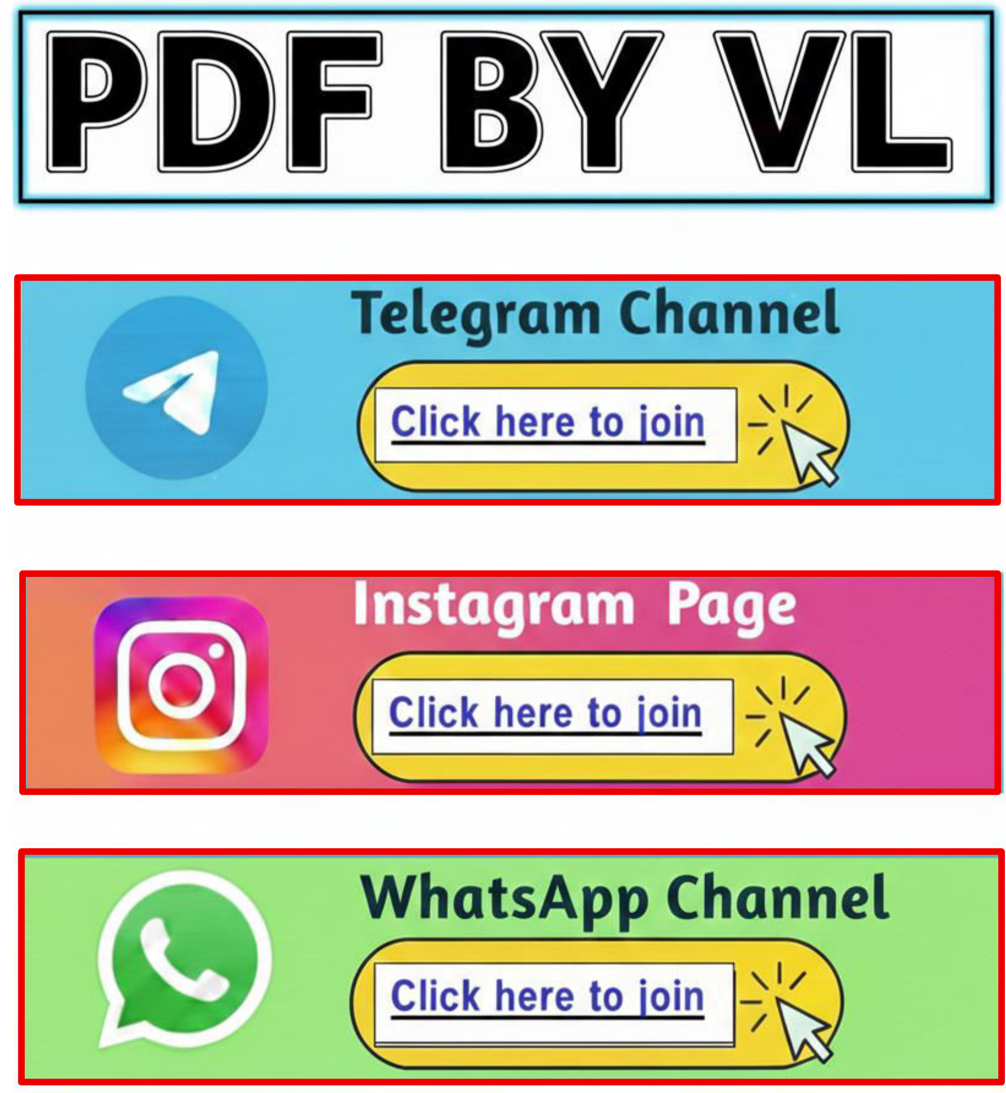

Q5)a) Write rules to convert given infix expression to postfix expression using stack. Convert expression (A*B–(C+D*E)^(F*G/H)) stepwise using above rules. [6]
b) What is queue? How they are represented in memory? [4]
c) Explain the concept circular queue. Give the advantages of circular queue over linear queue. [4]
OR
Q6)a) What is infix, prefix and postfix expression? Give example of each. Explain evaluation of postfix expression with suitable example expression? [6]
b) | Draw and explain Priority Queue? State any real-life application. | [4]
c) | Convert following expression into postfix. | [4]
(A + B) - (C/D-E) + (F + G/K)
Q7)a) | Write pseudocode for BFS traversal of binary search tree. | [7]
b) | Explain Optimal Binary Search Tree (OBST) with Example. | [7]
OR
Q8)a) | Explain in details AVL tree, Heap Tree. |  | [7]
b) | Describe binary search tree deletion with example. |  | [7]
Q9)a) | Elaborate following terminologies : |  | [5]
b) | i) | Graph | [5]
b) | ii) | Adjacency List | [5]
b) | iii) | Adjacency Matrix | [5]
b) | Explain Kruskal Algorithms with suitable example. |  | [5]
c) | Write Prim’s algorithm to find minimum spanning tree. |  | [4]
OR
[6582]-201 2
https://t.me/SPPU_TE_BE_COMP

Q10)a) Apply Kruskal’s algorithm to find the MST of the graph shown below.[5]
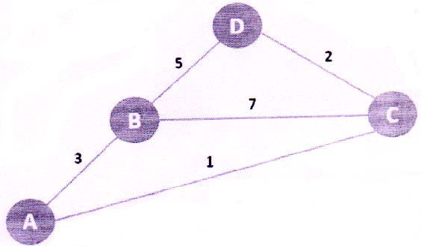
b) | Give difference between Prim’s and Kruskal’s algorithm. |  | [5]
c) | Write the applications of : |  | [4]
c) | i) | BFS | [4]
c) | ii) | DFS | [4]
♦♦♦
[6582]-201 3
https://t.me/SPPU_TE_BE_COMP

Total No. of Questions : 10] | [6582]-202 | SEAT No. :
PE-5706 | [6582]-202 | [Total No. of Pages : 2
S.E. (Artificial Intelligence & Data Science) (Computer Science & Engineering(A.I.))
PCC - 202 - AID : Artificial Intelligence
(2024 Pattern) (Semester - III)
Time : 2½ Hours] [Max. Marks : 70
Instructions to the candidates:
Q1) | 1) | Neat diagrams must be drawn wherever necessary. | [5]
Q1) | 2) | Numeric figures in square brackets [ ] indicate full marks. | [5]
Q1) | 3) | Use of electronic pocket Calculator is allowed. | [5]
Q1) | 4) | Assume suitable data, if necessary. | [5]
Q1) | a) | What is AI? Explain risk and benefits of AI. | [5]
Q1) | b) | Explain utility based agent with the help of neat diagram. | [5]
Q1) | c) | List and Explain characteristics of intelligent agent. | [4]
OR
Q2) | a) | What is Intelligent Agent? Explain structure of agent. | [5]
Q3) | b) | Explain "Simple Reflex agent" with the help of Schematic diagram.[5]
Q3) | c) | Define concept of rationality & explain rational agent with example. [4]
Q3) | a) | Define Heuristics. Explain the significance of Heuristics Function in the
Q3) | b) | Informed search with suitable example. | [7]
Q3) | b) | Explain A* algorithm with example. | [7]
OR
Q4) | a) | Describe DFS using suitable example. | [7]
Q5) | b) | Explain Hill Climbing algorithm. Explain Local maxima, Global maxima
Q5) | b) | and Plateau for an example. | [7]
Q5) | a) | and Plateau for an example. | [7]
Q5) | a) | Explain Alpha - Beta Tree Search and cutoff procedure in detail with an
Q5) | b) | example. | [6]
Q5) | b) | Define and explain constraints satisfaction problem. | [4]
Q5) | c) | Write short note on Features of AI game. | [4]
P.T.O.
https://t.me/SPPU_TE_BE_COMP

OR
Q6) | a) | Explain Minimax algorithm in detail. | [6]
Q7) | b) | Explain the concept of backtracking in CSPs. | [4]
Q7) | c) | Explain constraint propagation in detail. | [4]
Q7) | a) | Explain Wumpus World environment giving its PEAS description.[7]
Q7) | b) | Explain FOL, State and explain different inference rules in FOL with
Q7) | b) | suitable example. | [7]
OR
Q8) | a) | Write an propositional logic for the statement, |  | [7]
Q9) | b) | i) | "All birds fly" | [7]
Q9) | b) | ii) | "Every man respect his parents" | [7]
Q9) | b) | iii) | "It is raining" | [7]
Q9) | b) | iv) | "The sky is blue" | [7]
Q9) | b) | Write and explain the steps of knowledge engineering process. |  | [7]
Q9) | a) | Discuss AI and its ethical concerns. Explain limitations of AI. |  | [5]
Q9) | b) | Analyze various planning approaches in detail. |  | [5]
Q9) | c) | Write Short note on Generative AI. |  | [4]
OR
Q10) a) | Explain different component of planning system. | [5]
b) | Explain the analysis of planning approaches. | [5]
c) | What is classical planning? Explain with example. | [4]
♣♣♣
[6582]-202 2
https://t.me/SPPU_TE_BE_COMP

Total No. of Questions : 10] PE-5707 | SEAT No. :
Total No. of Questions : 10] PE-5707 | [Total No. of Pages : 3
[6582]-203
S.E. (Artificial Intelligence and Data Science Engineering/
Computer Science & Engg. (Artificial Intelligence))
PCC-203-AID/CAI : OPERATING SYSTEM
(2024 Pattern) (Semester - III)
Time : 2½ Hours] [Max. Marks : 70
Instructions to the candidates:
1) Neat diagrams must be drawn wherever necessary.
2) Figures to the right indicate full marks.
3) Use of electronic pocket calculator is allowed.
4) Assume suitable data, if necessary.
Q1)a) Define Operating System. List and explain any four major functions
of an OS. [5]
b) Discuss the role of the Operating System as a Resource Manager.[5]
c) What is a System Call? List and describe different types of system calls
in Linux. [4]
OR
Q2)a) Explain the role of data structures used in process management (e.g.,
PCB - Process Control Block). [5]
b) Explain the Process Life Cycle with a neat Process State Transition
Diagram. [5]
c) Compare process execution in Linux and Windows operating systems.
[4]
Q3)a) Describe the concept of cache affinity and its role in multiprocessor
scheduling. [7]
b) Describe Multiprocessor Scheduling and explain how cache affinity
affects performance. [7]
OR
P.T.O.
https://t.me/SPPU_TE_BE_COMP

Q4)a) | Given the following processes: - | [7]

Process | Arrivaltime | Burst time
P1 | 0 | 5
P2 | 1 | 3
P3 | 2 | 1
P4 | 3 | 2
P5 | 4 | 3
Draw the Round Robin scheduling Gantt chart with (Time Quantum
= 2 unit) and calculate :
i) Completion Time of all processes
ii) Average Turnaround Time
iii) Average Waiting Time
b) Draw Gantt chart and calculate turnaround time, wait time for following
processes using
FCFS CPU scheduling algorithm.
Process Arrival Time Burst time
Pl 0 8
P2 1 5
P3 3 3
P4 4 1
P5 6 4
Q5)a) Define Address Space. Explain how memory virtualization is achieved
in modern systems. [6]
b) Explain Paging with neat diagrams. Discuss how logical addresses are
translated into physical addresses. [4]
c) Compare segmentation and paging technique. [4]
OR
Q6)a) What is a Translation Lookaside Buffer (TLB)? Explain its working
and replacement policies. [6]
b) Explain how malloc() and free() work and what issues can arise from
improper use of these calls. [4]
c) Discuss the working of a demand paging system and explain page
fault handling. [4]
[6582]-203 2
https://t.me/SPPU_TE_BE_COMP

Q7)a) Define Thread. Explain the need for threads and thread creation using
Pthread API. [7]
b) Define Semaphore. Differentiate between Binary and Counting
Semaphores. [7]
OR
Q8)a) What is Concurrency? Explain the problems caused by uncontrolled
scheduling in concurrent systems. [7]
b) Explain the concept of shared data problems in concurrency with an
example. [7]
Q9)a) Explain the System Architecture for I/O Management in operating
systems. [5]
b) Describe File System Implementation and explain the concept of Fast
File System (FFS). [5]
c) Explain Disk Failure Modes. How are Checksums used for detecting
and recovering from disk errors? [4]
OR
Q10)a) Describe how Interrupts and DMA (Direct Memory Access) reduce
CPU overhead during I/O operations. [5]
b) Explain the working of a Device Driver with an example of an IDE
Disk Driver. [5]
c) What are Hard Disk Drives? Explain how files and directories are
managed in the OS. [4]

[6582]-203 3
https://t.me/SPPU_TE_BE_COMP

Total No. of Questions : 10] | [6582]-204 | SEAT No. :
PE5708 | [6582]-204 | SEAT No. :
PE5708 | [6582]-204 | [Total No. of Pages : 2
S.E. (Artificial Intelligence & Data Science) (CSE)
MDM-221-AID-CAI : DIGITAL ELECTRONICS AND LOGIC DESIGN
(2024 Pattern) (Semester - III)
Time : 2½ Hours] [Max. Marks : 70
Instructions to the candidates:
1) Answer Q.1 or Q.2, Q.3 or Q.4, Q.5 or Q.6, Q.7 or Q.8, Q.9 or Q.10.
2) Neat diagrams must be drawn wherever necessary.
3) Numeric figures in square brackets [] indicate full marks.
4) Use of electronic pocket calculator is allowed.
5) Assume suitable data, if necessary.
Q1)a) Simplify F(A, B, C, D) = ∑m (0, 1, 2, 4, 5, 6, 8, 9, 12, 13, 14) using
K-map and implement using logic gates. [5]
b) Convert octal (725.25) into its decimal, binary and Hexadecimal equivalent.[5]
c) Explain binary subtraction using 1’s complement and two’s complement
method with example. [4]
OR
Q2)a) b)  c) | Convert 42 and 22 in BCD and add them in BCD form. |  |  |  |  |  |  | [5]
Q2)a) b)  c) | Reduce F (A, B, C, D) = |  |  |  | ∑ | M | (0, 1, 2, 4, 5, 7, 10, 15) using K-map and
Q2)a) b)  c) | implement using logic gates. |  |  |  |  |  |  | [5]
Q2)a) b)  c) | Convert the following expressions into standard SOP and POS form.[4]
Q2)a) b)  c) | i) | AB+BC+AC
Q2)a) b)  c) | ii) | (A+B) (B |  | C)
Q3)a) b) | ii) | (A+B) (B | +
Q3)a) b) | Design and draw full adder circuit using 4:1 MUX. |  |  |  |  |  |  | [7]
Q3)a) b) | Design 3-bit binary to gray code converter circuit and implement using
Q3)a) b) | logic gates. |  |  |  |  |  |  | [7]
OR
Q4)a) | Explain and implement 2-bit magnitude comparator circuit using logic
gates. |  |  | [7]
b) |  | Design BCD to excess-3 code converter. Also implement the circuit.[7]
[6582]-204 |  |  | 1 | P.T.O.
https://t.me/SPPU_TE_BE_COMP

Q5)a) Explain working of SR Flip flop with neat block diagram and truth table.[6]
b) Differentiate between synchronous and asynchronous counters. [4]
c) Write short note on Shift registers. [4]
OR
Q6)a) | Design a 3-bit asynchronous UP counter using T flip-flops. | [6]
b) | Enlist difference between Mealy and Moore circuits. | [4]
c) | Explain in details Twisted Ring Counter. | [4]
Q7)a) | Explain architecture of 8086 microprocessor with diagram. | [7]
b) | Explain in details GPU-based AI processing with its applications. | [7]
OR
Q8)a) Draw and explain the ARM Cortex architecture in details. [7]
b) Write an Assembly Language Program (ALP)/C language code for[7]
i) addition of two integers
ii) variable assignment
iii) if-else statement
Q9)a) Explain the concepts of Edge AI & Cloud AI processing. [5]
b) Enlist the AI-focused processors types. Explain any two in brief. [5]
c) Explain how TPUs differ than GPUs. [4]
OR
Q10)a) What do you understand by the term Heterogeneous Computing? Explain.[5]
b) Explain key AI performance metrics such as FLOPS, TOPS, latency and
power efficiency and discuss how they influence processor selection. [5]
c) How do VPUs contribute to vision-based AI applications such as image
recognition and video analytics? [4]
  
[6582]-204 2
https://t.me/SPPU_TE_BE_COMP

Total No. of Questions : 10] PE-5709 | SEAT No. :
Total No. of Questions : 10] PE-5709 | [Total No. of Pages : 3
[6582]-206
S.E. (Artificial Intelligence and Machine Learning)
PCC-201-AIM : DATA STRUCTURES & ALGORITHMS
(2024 Pattern) (Semester - III)
Time : 2½ Hours] [Max. Marks : 70
Instructions to the candidates:
1) Answer Q.1 or Q.2, Q.3 or Q.4, Q.5 or Q.6, Q.7 or Q.8, Q.9 or Q.10.
2) Neat diagrams must be drawn wherever necessary.
3) Figures to the right side indicate full marks.
4) Assume suitable data if necessary.
5) Use of Scientific calculator is permitted.
Q1)a) What is an Abstract Data Type (ADT)? Write ADT operations. [5]
b) Explain Big-Oh, Big-theta and Big-Omega notation with graphs denoting
growth rate. [5]
c) Differentiate with example between: [4]
i) Static and Dynamic Data structures
ii) Persistent and Ephemeral Data Structures
OR
Q2)a) What is Analysis of programming constructs-Linear, Quadratic, Cubic,
And Logarithmic? [5]
b) Define characteristics of an Algorithm? Explain algorithm design strategy
in detail? [5]
c) What is time and space complexity? How asymptotic notations plays
important role in defining complexity class? [4]
Q3)a) What is infix, prefix and postfix expression? Give example of each.
Explain evaluation of postfix expression with suitable example expression
and assume values for variables used to solve it. [7]
b) Explain Primitive Operations on Linked List- Create, Traverse, Search,
Insert, Delete, Sort, and Concatenate. [7]
OR
P.T.O.
https://t.me/SPPU_TE_BE_COMP

Q4)a) Define Stack. Explain Implicit and Explicit stack and basic operation of
stack with example. [7]
b) What is circular queue? Explain the advantages of circular queue over
linear queue. [7]
Q5)a) Explain binary tree traversals - Inorder, Preorder, Postorder with example?
[6]
b) Explain & Write an algorithm for Breadth first traversal of a graph.[4]
c) Explain Min and Max Heap in detail? [4]
OR
Q6)a) Write Kruskal’s algorithm for minimum spanning trees and explain with
example. [6]
b) Explain & Write an algorithm for Depth first traversal of a graph. [4]
c) Explain Heap sort in detail & Write applications of heap? [4]
Q7)a) Explain hash table, hash function, basic operations, bucket, collision,
probe, overflow, open hashing, closed hashing, perfect hash function,
b) | rehashing, properties of good hash function, | [7]
b) | Explain in detail Naïve String Matching Algorithms? | [7]
OR
Q8)a) We have a hash table of size 10 to store integer keys, with hash function
h(x) = x mod 10. Construct a hash table step by step using linear probing
[5] without replacement strategy and insert elements in the order 31, 3, 4,
21, 61, 6, 71, 8, 9, 25. Calculate average number of comparisons required
to search given data from hash table using linear probing without
replacement. [7]
b) Explain in detail Social Network Graph Analysis? [7]
[6582]-206 2
https://t.me/SPPU_TE_BE_COMP

Q9)a) Explain the quick sort algorithm. Show the contents of array after every iteration of your algorithm start from following status of array.
b) | 27, 76, 17,9,57,90,45, 100, 79. | [5]
b) | Explain in detail 0/1 Knapsack with example? | [5]
c) | Explain in detail Huffman Coding Algorithms? | [4]
OR
Q10)a) Explain the Merge Sort algorithm. Show the contents of the array after every merge operation of your algorithm, starting from the following
b) | initial array: 42, 15, 67, 23, 89,4, 38, 50 | [5]
b) | Explain in detail Activity Selection with example? | [5]
c) | Explain in detail Floyd-Warshall? | [4]

[6582]-206 3
https://t.me/SPPU_TE_BE_COMP

Total No. of Questions : 10] | [6582]-207 | SEAT No. :
PE-5710 | [6582]-207 | [Total No. of Pages : 2
S.E. (Artificial Intelligence & Machine Learning)
PCC - 202 - AIM : Object Oriented Programming
(2024 Pattern) (Semester - III)
Time : 2½ Hours] [Max. Marks : 70
Instructions to the candidates:
1) Answer Q.1 or Q.2, Q3. or Q.4, Q.5 or Q.6, Q.7 or Q.8, Q.9 or Q.10.
2) Neat diagrams must be drawn wherever necessary.
3) Figures to the right indicate full marks.
Q1) | 4) | Assume suitable data, if necessary.
Q1) | a) | Why was procedural programming not sufficient for large-scale software
Q1) | b) | development? Give technical reasons. | [5]
Q1) | b) | Define data encapsulation. How does it improve software robustness?[5]
Q1) | c) | What is meant by class visibility modifiers? Why do we need them in
Q1) | c) | designing a class? | [4]
OR
Q2) | a) | Explain dynamic binding using the concept of virtual functions. | [5]
Q3) | b) | What is polymorphism? Explain How polymorphism and inheritance
Q3) | b) | are related? | [5]
Q3) | c) | are related? | [5]
Q3) | c) | Define abstraction and encapsulation. How are they implemented in class
Q3) | c) | design? | [4]
Q3) | a) | design? | [4]
Q3) | a) | What is method overloading? How is it different from method overriding?
Write a Java program that overloads a method to calculate simple and compound interest. [7]
b) Explain array of objects with an example. Write a Java program to create an array of Employee objects and display the details of employees having salary above Rs. 50,000. [7]
OR
P.T.O.
https://t.me/SPPU_TE_BE_COMP

Q4) | a) | Explain object creation and memory allocation using new operator. Write
a Java program demonstrating object creation and memory usage through multiple objects. [7]
b) Discuss constructor overloading and show how it is used for flexible object initialization. Write a program to create Book objects using
Q5) | a) | multiple constructors. | [7]
Q5) | a) | List six distinctions between method overloading and method overriding.[6]
Q5) | b) | Which inheritance is not supported in Java and Why? | [4]
Q5) | c) | Distinguish between compile time and runtime polymorphism. | [4]
OR
Q6) | a) | How does an interface differ from a class? Provide justification with
Q7) | b) | example. | [6]
Q7) | b) | Explain multilevel inheritance with example. | [4]
Q7) | c) | Elaborate hierarchical inheritance by utilizing super with an example.[4]
Q7) | a) | Explain why exception handling is important in Java and write a program
Q7) | b) | usin try, catch, and finally blocks. | [7]
Q7) | b) | What is the List interface in Java? Explain its key features and implementations.
[7]
OR
Q8) | a) | Explain the importance of Collection Interfaces in Java and their types.[7]
Q9) | b) | Differentiate between errors and exceptions in Java. Give examples of
Q9) | b) | each and explain when to handle them in a program. | [7]
Q9) | a) | each and explain when to handle them in a program. | [7]
Q9) | a) | Differentiate between sequential files and random-access files. | [6]
Q9) | b) | What is a Design Pattern? Write a short note on ‘Iterator’ design pattern.
[8]
OR
Q10) a) Write program to handle primitive data types in file handling. [6]
b) What are the advantages of design patterns? Explain ‘Adaptor’ design pattern in detail. [8]
♣♣♣
[6582]-207 2
https://t.me/SPPU_TE_BE_COMP

Total No. of Questions : 10] PE-5970 | SEAT No. :
Total No. of Questions : 10] PE-5970 | [Total No. of Pages : 2
[6582]-208
S.E. (Artificial Intelligence and Machine Learning)
PCC-203-AIM : FOUNDATION OF ARTIFICIAL
INTELLIGENCE
(2024 Pattern) (Semester - III)
Time : 2½ Hours] [Max. Marks : 70
Instructions to the candidates:
1) Answer Q.1 or Q.2, Q.3 or Q.4, Q.5 or Q.6, Q.7 or Q.8, Q.9 or Q.10.
2) Neat diagrams must be drawn wherever necessary.
3) Figures to the right side indicate full marks.
4) Use of electronic pocket calculator is allowed.
5) Assume suitable data if necessary.
Q1)a) Define Artificial Intelligence. Explain any four characteristics of AT
systems. [5]
b) Describe the differences between AI and Human Intelligence with suitable
examples. [5]
c) Explain Goal-based and Utility-based agents with appropriate illustrations.
[4]
OR
Q2)a) Explain the Turing Test. How does it help in evaluating machine
intelligence? [5]
b) Describe AI applications in healthcare. Explain any two in detail. [5]
c) Compare Simple Reflex Agents and Model-based Agents with suitable
examples. [4]
Q3)a) Compare the uninformed and informed search algorithms with suitable
example. [7]
b) How problem formulation helps agent to achieve goal? [7]
OR
Q4)a) Explain the working of Uniform Cost Algorithm with suitable example.[7]
b) What is A* search algorithm? Explain advantages and disadvantages.[7]
P.T.O.
https://t.me/SPPU_TE_BE_COMP

Q5)a) Explain the minimax algorithm with an example of a two-player game.[6]
b) Describe alpha-beta pruning and illustrate how it reduces the search space. [4]
c) Define evaluation functions and explain their role in game-playing agents. [4]
OR
Q6)a) Explain “Cutting Off Search” in game playing. Why is it needed? Explain with an example. [6]
b) What is a Logical Agent? Explain with a simple example. [4]
c) Apply CSP to the Water Jug Problem and write the steps to reach the goal state. [4]
Q7)a) Explain the process of Unification in First Order Logic. Demonstrate with suitable examples how unification is used in Resolution-based inference. [7]
b) Describe Forward Chaining and Backward Chaining inference mechanisms in First Order Logic. Compare them with suitable examples.
[7]
OR
Q8)a) Explain Bayes’ Rule in detail. How is it used for reasoning under uncertainty? Solve a numerical example using Bayes’ Rule. [7]
b) What is a Bayesian Belief Network (BBN)? Explain its structure, components, and how approximate inference is performed using sampling methods (e.g., Likelihood Weighting or MCMC). [7]
Q9)a) Describe the architecture and workflow of an Expert System. Explain how Knowledge Base, Inference Engine, and User Interface interact during decision-making. [7]
b) Describe the applications of AI in Natural Language Processing (NLP) such as machine translation, sentiment analysis, and summarization.[7]
OR
Q10)a) Define autonomous vehicles and describe how sensors and AI algorithms enable self- driving. [4]
b) Describe Explainable AI and highlight why it is essential in domains like healthcare and finance. [5]
c) Compare the working of GPT, BERT, and DALL-E, highlighting their unique contributions to Generative AI. [5] 
[6582]-208 2
https://t.me/SPPU_TE_BE_COMP

Total No. of Questions : 10] | [6582]-209 | SEAT No. :
PE5711 | [6582]-209 | SEAT No. :
PE5711 | [6582]-209 | [Total No. of Pages : 3
S.E. (Artificial Intelligence and Machine Learning)
MDM-221-AIM : DIGITAL ELECTRONICS AND LOGIC DESIGN
(2024 Pattern) (Semester - III)
Time : 2½ Hours] [Max. Marks : 70
Instructions to the candidates:
1) Attempt Q.1 or Q.2, Q.3 or Q.4, Q.5 or Q.6, Q.7 or Q.8, Q.9 or Q.10.
2) Neat diagrams must be drawn wherever necessary.
3) Figures to the right indicate full marks.
Q1)a) Express following decimal numbers in binary form: 25.5 and 10.625.[5]
b) Compare TTL and CMOS logic Families. [5]
c) Perform the following using 2’s Complement [4]
(28)10 - (42)10,
(52)10 - (18)10
OR
Q2)a) Explain with diagram Operation of TTL NAND gate. [5]
b) Represent the following decimal numbers in [5]
i) Sign magnitude form
ii) Sign 1’s complement form
iii) Sign 2’s complement form
1) +14
2) +27
3)–17
4) +45
c) Explain in short Characteristics of Digital IC. [4]
Q3)a) Draw and explain a neat circuit diagram of BCD adder using IC 7483.[5]
b) If F(A, B, C)=∑m (0, 3,5,7) with its truth table and express F is SOP
and POS form. [5]
c) Minimize using K-map, F(A, B, C, D)=∑m (0,1,2,3,5,7,8,9,11,14) . [4]
OR
[6582]-209 | 1 | P.T.O.
https://t.me/SPPU_TE_BE_COMP

Q4)a) How will you implement full adder using half adder? Explain with circuit
diagram. [5]
b) Simplify the expression F(A, B, C, D)=∑m (1,3,7,11,15)+d (0,2,5) using
the K-Map method. [5]
c) Implement the following Boolean function using 8 : 1 multiplexer
F(A, B, C, D)=∑m (2,4,5,7,10,14) . [4]
Q5)a) Explain how J-K Flip-Flop is converted into [7]
i) TFF
ii) DFF
b) What is MOD counter? Design MOD 7 counter using IC 7490. [7]
OR
Q6)a) Design the 2-bit synchronous UP counter using T - F/F. [7]
b) What do you mean by excitation table of flip flop? Write the excitation
table of [7]
i) S-R flip flop
ii) J-K flip flop
Q7)a) With neat diagrams explain the working of the following types of shift
registers: [7]
i) Serial-in, Parallel-out (SIPO)
ii) Parallel-in, Parallel-out (PIPO)
b) Prepare state table for the following state diagram and eliminate
redundancy if any. [7]
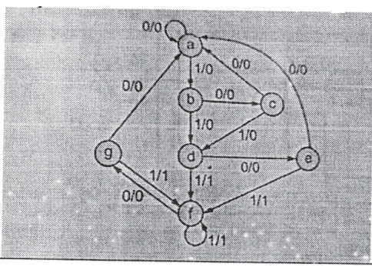
OR
[6582]-209 2
https://t.me/SPPU_TE_BE_COMP

Q8)a) Draw and explain ring counter. [7]
b) Design a sequence generator to generate sequence 10110 using D flip
flop. [7]
Q9)a) Explain different types of Memory & their uses in computer. [7]
b) Explain the components of the system bus-address, data and control
buses. [7]
OR
Q10)a) Draw and explain Von Neumann & Harvard architecture. [7]
b) Differentiate between hardwired control unit and micro programmed
control unit. [7]
  
[6582]-209 3
https://t.me/SPPU_TE_BE_COMP

Total No. of Questions : 8] PE-5956 | SEAT No. :
Total No. of Questions : 8] PE-5956 | [Total No. of Pages : 2
[6582]-210
S.E. (Artificial Intelligence & Machine Learning)
VEC-232-AIM : UNIVERSAL HUMAN VALUES
(2024 Pattern) (Semester - III)
Time : 2 Hours] [Max. Marks : 35
Instructions to the candidates :
1) Answer Q1 or Q2, Q3 or Q4, Q5 or Q6, Q7 or Q8.
2) Neat diagrams must be drawn wherever necessary.
3) Numeric figures in square brackets [] indicate full marks.
4) Use of electronic pocket calculator is allowed.
5) Assume suitable data, if necessary
Q1)a) Explain the concept of basic human aspirations with reference to
continuous happiness and prosperity. [5]
b) State and explain any two basic guidelines of Value Education. [3]
OR
Q2)a) Define the value education and explain its content. [5]
b) List the advantages of self-exploration. [3]
Q3)a) Explain Trust and Respect as the foundation of harmony in the family.[5]
b) Explain any four Universal Values in relationships. [4]
OR
Q4)a) Explain justice and responsibility in human conduct with examples. [5]
b) Explain fearlessness and co-existence in society. [4]
Q5)a) What is meant by mutual fulfillment in nature? Explain with suitable
examples. [5]
b) Explain self-regulation in nature and the human role in maintaining cyclicity
[4]
OR
Q6)a) Explain cyclicity in nature and the responsibility of human beings with
suitable examples. [5]
b) Explain the environmental and social impacts of ecological imbalance
with suitable examples. [4]
P.T.O.
https://t.me/SPPU_TE_BE_COMP

Q7)a) Explain Ethical Human Conduct and analyse its role in establishing a
Universal Human Order. Illustrate with suitable examples. [5]
b) Discuss the relationship between Human Values, Policy, and Character in
shaping ethical professional behaviour. [4]
OR
Q8)a) Evaluate how the integration of ethics with technology can contribute to a
humane and sustainable society. [5]
b) Identify and explain any three criteria for assessing whether a technology
supports harmony with nature. [4]
♦♦♦
[6582]-210 2
https://t.me/SPPU_TE_BE_COMP

Total No. of Questions : 10] | [6582]-211 | SEAT No. :
PE3774 | [6582]-211 | SEAT No. :
PE3774 | [6582]-211 | [Total No. of Pages : 4
S.E. (Automation and Robotics)
PCC201AUR : MATERIALS AND MACHINE ELEMENTS
(2024 Pattern) (Semester-III)
Time : 2½ Hours] [Max. Marks : 70
Instructions to the candidates:
1) | Answer Q1 or Q2, Q3 or Q4, Q5 or Q6, Q7 or Q8, Q9 or Q10. |  | [8]
2) | Neat diagrams must be drawn wherever necessary. |  | [8]
3) | Assume suitable data if necessary. |  | [8]
4) | Use of Non-programmable scientific calculators is allowed. |  | [8]
5) | Figures to the right indicate full mark. |  | [8]
Q1)a) | Write short note on: |  | [8]
b) | i) | Mechanical properties of metals | [6]
b) | ii) | Types of point defects | [6]
b) | Differentiate between slip and twinning. |  | [6]
OR
Q2)a) | Draw the planes in the following FCC structure. | [8]
(112), (001), (101), (110)
b) What is atomic packing factor? Determine the atomic packing factor for
body centered cubic structure. [6]
Q3)a) Compare Gray Cast Iron & White Cast Iron with respect to composition,
microstructure, application. [7]
b) Define steel? Explain classification of steel with applications. [7]
OR
Q4)a) What is the effect of different alloying elements on properties of steel?[7]
b) Differentiate between the Brasses and Bronzes along with applications.[7]
Q5) a) A steel bar of cross-sectional area 400 mm2 is surrounded by a copper
tube of area 200 mm2 as shown in Fig. The composite section carries a
load of 80 kN. The copper tube is initially shorter than the steel bar by
0.1 mm. Determine the stresses induced in the steel bar and the copper
tube. Take ESteel = 200 GPa and ECopper = 100GPa. [7]
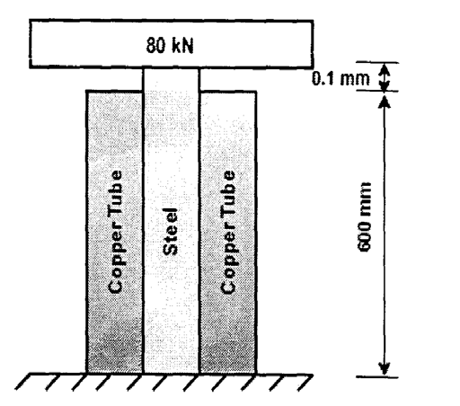
P.T.O.
https://t.me/SPPU_TE_BE_COMP

b) The composite bar shown in Fig. is 0.2 mm short of distance between the rigid supports at room temperature. What is the maximum temperature rise which will not produce stresses in the bar? Find the stresses induced when the temperature rise is 40ºC. Assume [7]
ESteel = 2 X 105 N/mm2, ECopper = 1.2 X 105 N/mm2
αSteel = 12 X 10–6 /ºC, αCopper = 17.5 X 10–6 /ºC
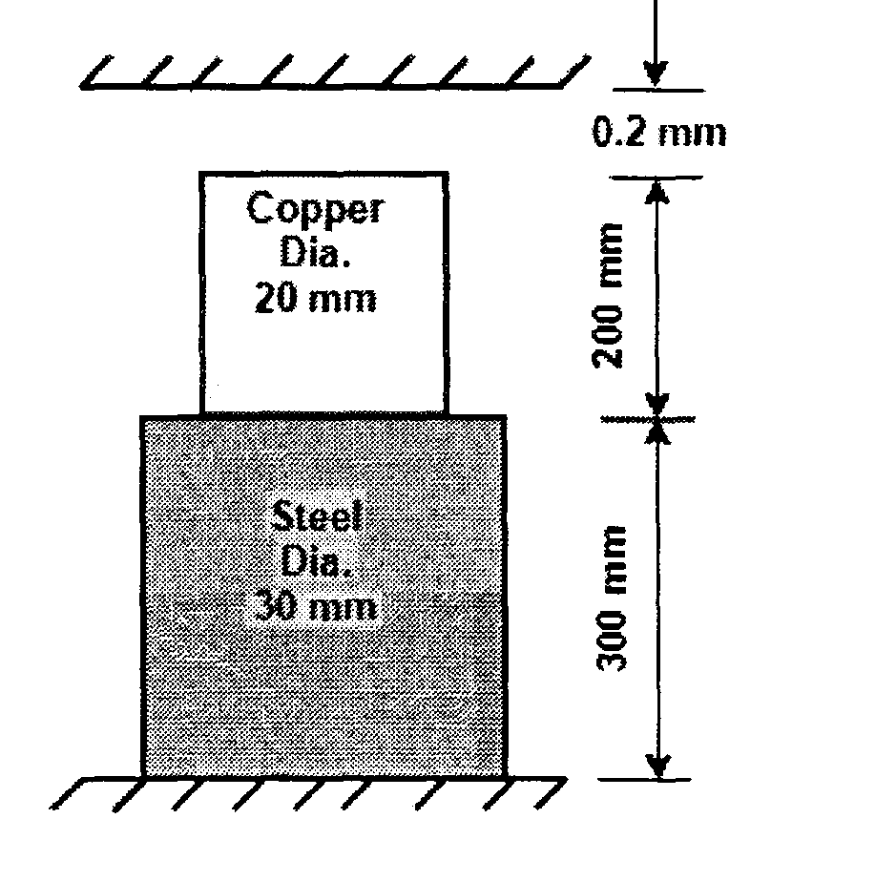
OR
Q6)a) A reinforced concrete column is 300mm × 300mm in section. The column is provided with 8 bars of 20mm diameter. The column carries a load of 360kN.
b) | Find the stresses in the concrete and steel bars. Take Es = 2.1 × 105N/mm2
b) | and Ec = 0.14 ×105 N/mm2. | [7]
b) | A composite bar is subjected to forces as shown in Fig. Small end diameter
of tapering bar and big end diameter are 12.5 mm and 40 mm respectively. Determine magnitude of force P such that net deformation in the bar does not exceed 1.5 mm. Take ESteel = 200 GPa, EA1 = 70 GPa. [7]
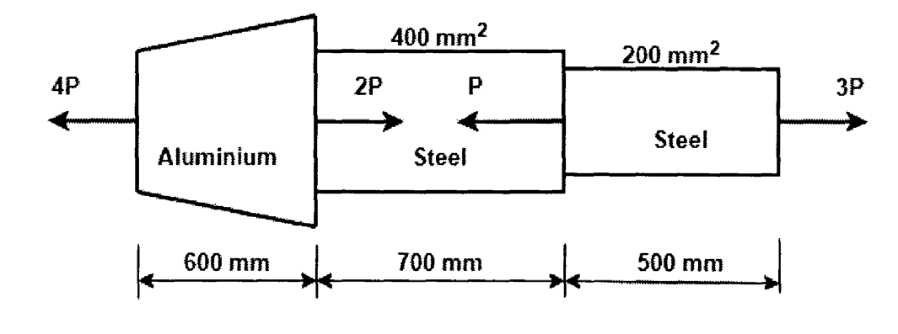
Q7)a) | Draw SFD and BMD for the beam as shown in Fig. | [7]
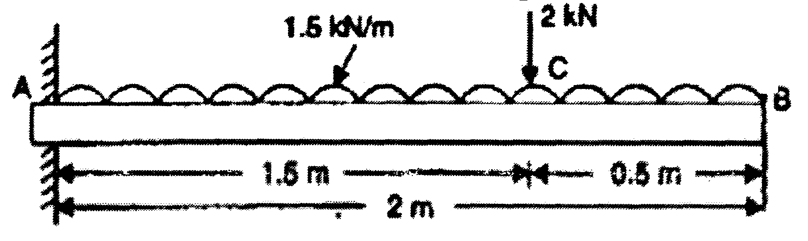
[6582]-211 2
https://t.me/SPPU_TE_BE_COMP

b) A cast iron bracket subjected to bending has cross section of I-shape with unequal flanges as shown in fig. If the compressive stress in top flange is not to exceed 17.5 N/mm2, what is bending moment the section can take? [7]
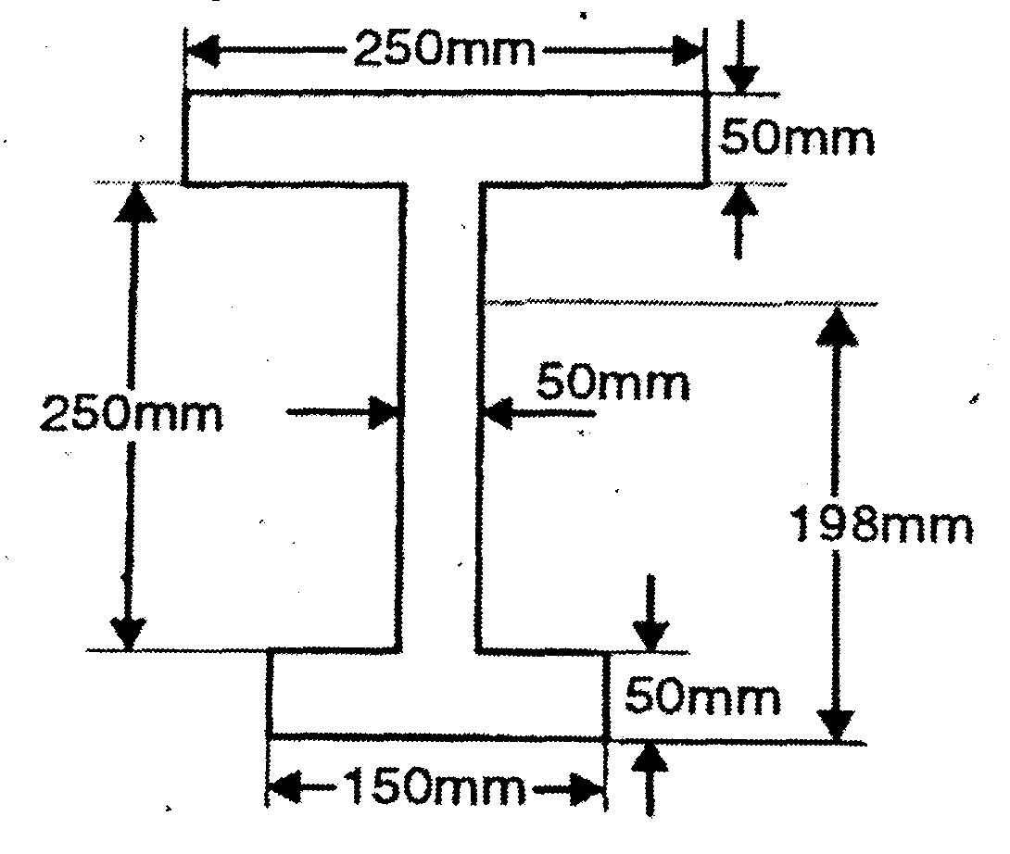
OR
Q8)a) | Draw SFD and BMD for the beam as shown in Fig. | [7]
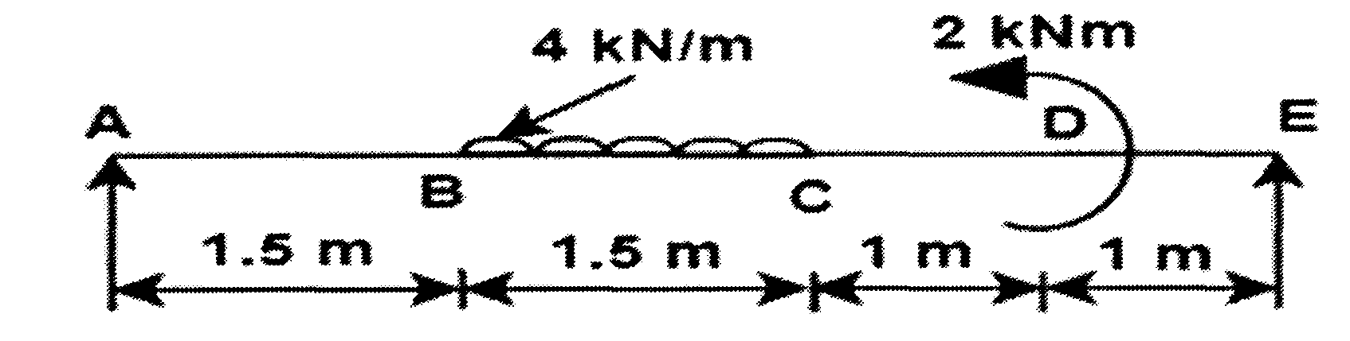
b) A cast iron beam is of T - section as shown in figure. The beam is simply supported on a span of 8m. The beam carries a udl of 1.5kN/m length on the entire span. Determine the maximum tensile and maximum compressive stresses. [7]
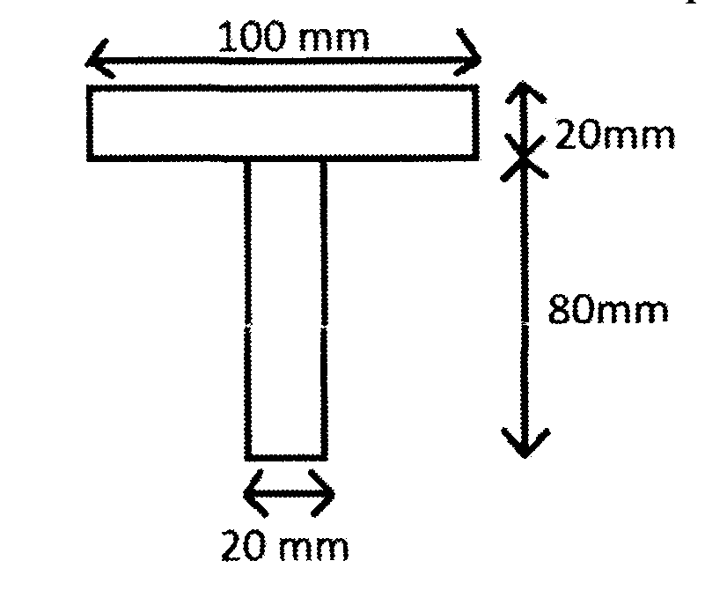
Q9)a) A hollow shaft having an internal diameter 40% of it’s external diameter, transmits 562.5kW power at 100 rpm. Determine the external diameter of the shaft if shear stress is not to exceed 60 N/mm2 and the twist in a length of 2.5m should not exceed 1.3 degrees. Assume max. torque = 1.25* mean torque. Take C = 9 × 104 N/mm2 [7]
[6582]-211 3
https://t.me/SPPU_TE_BE_COMP

b) Fig. shows the cross section of a beam which is subjected to a shear force of 20kN. Draw shear stress distribution across the depth making value at salient points. [7]
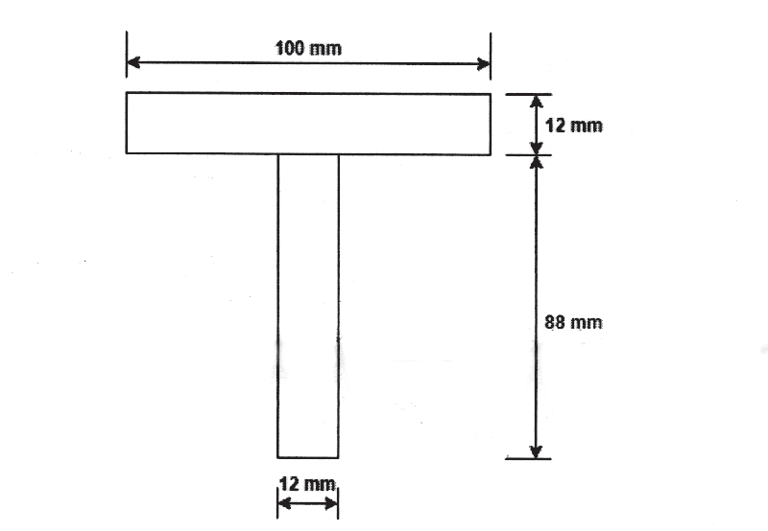
OR
Q10)a) A steel shaft ABCD having a total length of 2.4m consists of three lengths having different sections as follows:
AB is hollow having outside and inside diameters of 80mm and 50mm respectively. BC & CD are solid, BC having a diameter of 80mm & CD having a diameter of 70mm.
If the angle of twist is same for each section, determine the length of each section and the total angle of twist if the maximum shear stress in the hollow portion is 50N/mm2. Take C = 8.2 × 104 N/mm2. [7]
b) An I-section beam 340 mm X 200 mm has a web thickness 10 mm and flange thickness of 20 mm. It carries a shearing force of 100 kN. Sketch the shear stress distribution across the section. [7]
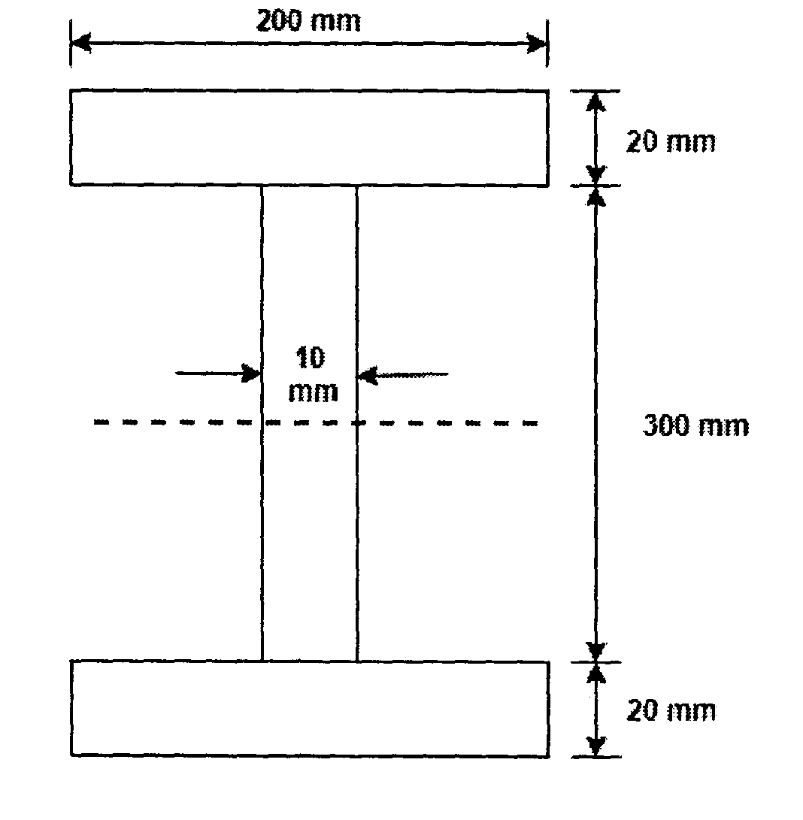
eeee
[6582]-211 4
https://t.me/SPPU_TE_BE_COMP

Total No. of Questions : 10] PE3775

[6582]-212

S.E. (Automation and Robotics)
PCC-202-AUR : INDUSTRIAL ELECTRONICS AND CONTROLS
(2024 Pattern) (Semester - III)
Time : 2½ Hours] [Max. Marks : 70
Instructions to the candidates:
1) | Answer Q.1 or Q.2, Q.3 or Q.4, Q.5 or Q.6, Q.7 or Q.8, Q.9 or Q.10. | [7]
2) | Figures to the right indicate full marks. | [7]
3) | Use of non-programmable electronic calculator is permitted. | [7]
4) | Neat diagrams must be drawn wherever necessary. | [7]
5) | Assume suitable data, if necessary. | [7]
Q1)a) | Explain the working principle of IGBT with V-I characteristics. | [7]
b) Explain the operation of electromechanical relays and limit switches used
in automation with suitable diagram. [7]
OR
Q2)a) Define Power Switches. Compare BJT, MOSFET, and IGBT based on
switching characteristics. [7]
b) Design and explain a simple circuit for power factor improvement using
capacitors. [7]
Q3)a) Explain three-phase inverter circuit with neat diagram and waveforms. [7]
b) Differentiate between inverters and converters (any two). Write short notes
on Cuk converter. (with circuit diagram and waveform) [7]
OR
Q4)a) Explain the working of three-phase controlled half wave rectifier with
resistive load controlled with waveforms. [7]
b) Explain the operation of a cycloconverter with applications. [7]
P.T.O.
https://t.me/SPPU_TE_BE_COMP

Q5)a) What are the requirement of PLC? Develop PLC ladder logic for the
following gates: (Truth table, Boolean expression, Gate symbol & PLC
ladder diagram) [7]
i) NOR
ii) XOR
b) Analyze the role of VFD in variable speed motor drives with suitable
block diagram. [7]
OR
Q6)a) Compare between P, PI, and PID controller (at least 7 parameters).[7]
b) Differentiate between SCADA and DCS. (at least 7 parameters). [7]
Q7)a) Classify different types of industrial sensors with examples (temperature,
flow, level, pressure, optical) [7]
b) What is a Wheatstone bridge? Derive its balance condition and explain its
applications. [7]
OR
Q8)a) Explain wireless sensor networks in industrial automation with proper
block diagram. [7]
b) Explain signal conditioning requirements and DAS (Data acquisition
System) for temperature sensors with proper block diagram. [7]
Q9)a) Define industrial automation and list its advantages. Also Explain the role
of robotics in smart manufacturing. [7]
b) Describe the role of IoT devices and gateways in industrial monitoring
and predictive maintenance. [7]
OR
Q10)a) Describe the architecture and working of a CNC machine using basic
block diagram. [7]
b) Compare between CAN, RS485 & Ethernet communication protocols.
(At least 7 parameters) [7]
… … …
[6582]-212 2
https://t.me/SPPU_TE_BE_COMP

Total No. of Questions : 10] | [6582]-213 | SEAT No. :
PE3776 | [6582]-213 | SEAT No. :
PE3776 | [6582]-213 | [Total No. of Pages : 2
S.E. (Automation and Robotics Engineering)
PCC203AUR : MANUFACTURING TECHNOLOGY
(2024 Pattern) (Semester - III)
Time : 2½ Hours] [Max. Marks : 70
Instructions to the candidates:
1) Solve Q.1 or Q.2, Q.3 or Q.4, Q.5 or Q.6, Q.7 or Q.8., Q.9 or Q.10.
2) Draw neat diagrams wherever necessary.
3) Figures to the right indicate full marks.
4) Use of programmable calculator is not permitted.
5) Assume suitable/standard data, if necessary.
Q1)a) Explain the function of pattern in the casting process. Draw neat sketches
of any four pattern and label their parts. [7]
b) Describe the properties of sand casting used for moulding. [7]
OR
Q2)a) What do you understand by the term gating system? Draw the neat sketch
of different gates and name them? [7]
b) Explain lost wax casting process in detail. [7]
Q3)a) Explain the Principle of resistance welding along with its types and
applications. [7]
b) Explain with neat sketch: [7]
i) Submerged Arc Welding (SAW)
ii) Gas Metal Arc Welding (GMAW)
OR
Q4)a) | Compare TIG & MIG Welding processes. |  | [6]
b) | Short notes on: |  | [8]
b) | i) | Types of Welding Joint. | [8]
b) | ii) | Defects in the welding process. | [8]
P.T.O.
https://t.me/SPPU_TE_BE_COMP

Q5)a) Explain various elements of Single point cutting tool with the help of neat
diagram. [7]
b) Discuss the various types of chips produced during metal cutting. [7]
OR
Q6)a) What is meant by subtractive manufacturing? Explain the mechanics of
metal cutting and describe the types of chips formed during machining
operations. [7]
b) A 300 mm diameter bar is turned at 45 rev/min with depth of cut of 2 mm
and feed of 0.3mm/rev. [7]
The forces measured at the cutting point are: cutting force = 1850N feed
force = 450N.
Calculate:
i) Power consumption
ii) Specific cutting energy
iii) Energy consumed if the total metal removed during the turning
operation is 2.5 × 106 mm3
Q7)a) | Differentiate between hot working and cold working? | [4]
b) | What is forging? Explain the process and give classification? | [4]
c) | Explain blanking operation with neat sketch. | [6]
OR
Q8)a) Describe extrusion operation and its types. [6]
b) Sketch and explain the working of Universal rolling mill and Planetary
rolling mill. [8]
Q9)a) Describe injection moulding process with neat sketch. [7]
b) Explain blow moulding with neat sketch along with its advantages and
limitations. [7]
OR
Q10)a) Compare between Thermosetting and Thermoplastic. [7]
b) What is additive manufactruring? Explain Various 3D Printing techniques
(FDM, SLA, SLS, DMLS)? [7]

[6582]-213 2
https://t.me/SPPU_TE_BE_COMP

Total No. of Questions : 10] | [6582]-216 | SEAT No. :
PE3777 | [6582]-216 | SEAT No. :
PE3777 | [6582]-216 | [Total No. of Pages : 3
S.E. (Automobile)
PCC-201-ABE : MECHANICS OF STRUCTURES
(2024 Pattern) (Semester - III)
Time : 2½ Hours] [Max. Marks : 70
Instructions to the candidates:
1) Attempt Q.1 or Q.2, Q.3 or Q.4, Q.5 or Q.6, Q.7 or Q.8., Q.9 or Q.10.
2) Neat diagrams must be drawn wherever necessary.
3) Figures to the right indicate full marks.
4) Assume suitable data if necessary.
Q1)a) Explain the terms: Elasticity, Hook’s law, elastic limit, Young’s Modulus
and modulus of rigidity, proof stress. [6]
b) A specimen of steel 20 mm diameter with a gauge length of 200 mm is
tested to destruction. It has an extension of 0.25 mm under a load of
80 kN and the load at elastic limit is 102 kN. The maximum load is
130 kN. The total extension at fracture is 56 mm and diameter at neck is
15 mm. Evaluate [8]
i) The stress at elastic limit.
ii) Young’s modulus.
iii) Percentage elongation.
iv) Percentage reduction in area.
v) Ultimate tensile stress.
OR
Q2)a) Explain static, dynamic and impact loading with diagrams. [6]
b) A compound bar of length 600 mm consists of a strip of aluminum
40 mm wide and 20 mm thick and a strip of steel 60 mm wide and 15 mm
thick rigidly joined at the ends. If elastic modulus of aluminum and steel
are 1 × 10∧5 MPa and 2 × 10∧5 MPa, Evaluate the stresses developed in
each material and the extension of the compound bar when axial tensile
force of 60 kN acts. [8]
P.T.O.
https://t.me/SPPU_TE_BE_COMP

Q3)a) A cantilever of length 6 m carries two point loads of 2 kN and 3 kN at a
distance of 1 m and 6 m from the fixed end respectively. In addition to
this the beam also carries a uniformly distributed load of 1 kN/m over a
length of 2 m at a distance of 3 m from the fixed end. Sketch S.F. and
B.M. diagrams. [8]
b) Explain the following and mention their significance in beam analysis.[6]
i) Shear force
ii) bending moment
OR
Q4)a) Derive the relationship between rate of loading, shear force and Bending
moment for a beam element. [6]
b) A cantilever of length 2.0 m carries a uniformly distributed load of
2 kN/m length over the whole length and a point load of 3 kN at the free
end. Sketch the S.F. and B.M. diagrams for the cantilever. [8]
Q5)a) Explain assumptions made in the theory of simple bending and derive
the expression for bending stress in a beam subjected to pure bending.[6]
b) A cantilever beam is subjected to a uniformly distributed load (UDL)
over its entire span. Apply Macaulay’s method to evaluate the slope and
deflection at the free end. [8]
OR
Q6)a) Evaluate slope and deflection at point B (free end) shown in fig 6(b) by
Macaulay method. [7]
Take E = 200GPa and I=5*108 mm4
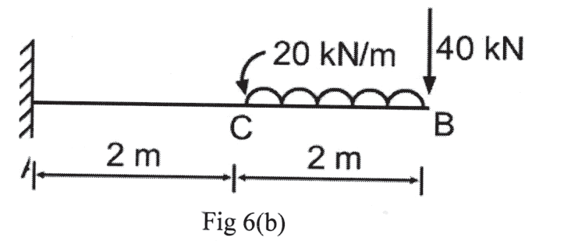
b) A square beam of 300 mm dimension is simply supported over a span of
4 meters. Evaluate the uniformly distributed load per meter which the
beam may carry if the bending stress is 120 MPa.
Take I = 8* 10∧6 mm∧4. [7]
[6582]-216 2
https://t.me/SPPU_TE_BE_COMP

Q7)a) Explain why hollow shafts are preferred over solid shafts in axles and propeller shafts. [6]
b) A hollow steel rod 200 mm long is to be used as a torsional spring. The ratio of inside to outside diameter is 1: 2. The required stiffness of this spring is 100 N.m /degree. Evaluate outside diameter of the rod. Value of G is 8*10∧4 N/mm∧2. [8]
OR
Q8)a) Distinguish between torsional rigidity and torsional strength of a shaft. Justify with an example where design is controlled by rigidity and another where it is controlled by strength. [6]
b) Determine the diameter of a solid shaft which will transmit 275 kW at 300 rpm. The maximum shear stress should not exceed 30 MPa and twist is one degree in a shaft length of 2 m. The modulus of rigidity of the material is 80 GPa. [8]
Q9)a) A plane element in a boiler is subjected to tensile stresses of 400 MPa on one plane and 150 MPa on the other at right angles to the former. Each of the above stresses is accompanied by a shear stress of 100 MPa such that when associated with the minor tensile stress tends to rotate the element in anticlockwise direction. [8]
Evaluate
i) Principal stresses and their directions.
ii) Maximum shearing stresses and the directions of the plane on which they act.
b) Write the analytical expressions for principal stresses in a two-dimensional stress System. Explain the significance of the principal planes. [6]
OR
Q10)a) Explain steps involved in determining principal stresses and directions analytically for a plane stress condition. [6]
b) A point is subjected to a tensile stress of 250 MPa in the horizontal direction and another tensile stress of 100 MPa in the vertical direction. The point is also subjected to a simple shear stress of 25 MPa, such that when it is associated with the major tensile stress, it tends to rotate the element in the clockwise direction. Evaluate magnitude of the normal and shear stresses inclined at a section 20º CCW with the major tensile stress.
[8]

[6582]-216 3
https://t.me/SPPU_TE_BE_COMP

Total No. of Questions : 10] PE3778

[6582]-217
S.E. (Automobile)

PCC-202-ABE : THERMAL SCIENCE
(2024 Pattern) (Semester - III)
Time : 2½ Hours] [Max. Marks : 70
Instructions to the candidates:
1) Answer Q.1 or Q.2, Q.3 or Q.4, Q.5 or Q.6, Q.7 or Q.8, Q.9 or Q.10.
2) Figures to the right indicate full marks.
3) Neat diagrams must be drawn wherever necessary.
4) Assume suitable data, if necessary.
Q1)a) Explain Various types of Systems considered in Thermal Science with
relevant real world examples. [6]
b) Explain Quasi-Static Process. [4]
c) Write a note on Thermodynamic Equilibrium. [4]
OR
Q2)a) Explain any three temperature measuring scales. [6]
b) Write a note on Dimensional Homogeneity with suitable example. [4]
c) Differentiate Intensive and Extensive Properties with examples. [4]
Q3)a) Explain Steady Flow Energy Equation. Apply it to Boiler, Turbine,
Condenser and Pump in Steam Power Plant. [8]
b) A domestic refrigerator is loaded with the food and door is closed. In
certain period, refrigerator consumes 1 kWh of electricity and internal energy
of system drops by 5000 kJ. Find net heat transferred from system. [6]
OR
Q4)a) Draw Pressure VS Volume Diagram for following gas expansion
processes with directions. [6]
i) Isobaric Process
ii) Isothermal Process
iii) Adiabatic Process
P.T.O.
https://t.me/SPPU_TE_BE_COMP

b) At inlet to a nozzle, enthalpy of fluid is 3000 kJ/kg and velocity is 60m/s.
At outlet of nozzle, enthalpy is 2762 kJ/kg. Nozzle is horizontal and it has
negligible heat loss. Then determine
i) Velocity of fluid at outlet
ii) Mass flow rate
iii) Outlet Area of Nozzle
(Cross-section Area at Inlet = 0.1 m2, Specific Volume of fluid at
Inlet = 0.0187 m3/kg, Specific Volume of fluid at Outlet = 0.498 m3/kg)[8]
Q5)a) Write a note on Compressibility Factor. [4]
b) Explain Ideal Gas Laws. [4]
c) Calculate Total Enthalpy, Total Entropy and Volume of 3 kg of steam
when it is at pressure of 11 bar and it is 60% dry. [6]
OR
Q6)a) Explain Throttling Calorimeter used for measurement of Dryness Fraction.[6]
b) The following data were obtained in a test on a combined separating and
throttling calorimeter:
Pressure of steam sample = 15 bar, pressure of steam at exit = 1 bar,
temperature of steam at the exit =150ºC, discharge from separating calorimeter
= 0.5 kg/min, discharge from throttling calorimeter = 10 kg/min.
Determine the dryness fraction of the sample steam. [8]
Q7)a) Explain limitations of First Law of Thermodynamics and Second Law of
Thermodynamics. [6]
b) A fish freezing plant requires 40 tons of refrigeration. The freezing
temperature is –35ºC while the ambient temperature is 30ºC. If the
performance of the plant is 20% of the theoretical reversed Carnot cycle
working within the same temperature limits, calculate the power required.
Given : 1 ton of refrigeration = 210 kJ/min. [8]
OR
[6582]-217 2
https://t.me/SPPU_TE_BE_COMP

Q8)a) Explain Principle of Increase of Entropy. [6]
b) 0.04 m3 of nitrogen contained in a cylinder behind a piston is initially at
1.05 bar and 15ºC. The gas is compressed isothermally and reversibly
until the pressure is 4.8 bar. [8]
Calculate:
i) Characteristic Gas Constant
ii) Entropy Change
iii) Heat Flow
iv) Work Done
Molecular Weight of Nitrogen = 28
Q9)a) Explain the concept of available and unavailable energy. When does the
system become dead? [8]
b) A reversible heat engine receives 3000 kJ heat from constant temperature
source at 650 K. If atmospheric temperature is 295 K then determine
Available Energy and Unavailable Energy. [6]
OR
Q10)a) Explain Sensible Heating and Sensible Cooling processes. [6]
b) Draw outline of Psychrometric Chart and Show WBT line, Sp. Volume
line, Relative humidity line, Saturation Curve. [8]
… … …
[6582]-217 3
https://t.me/SPPU_TE_BE_COMP

Total No. of Questions : 10] | [6582]-218 | SEAT No. :
PE3779 | [6582]-218 | SEAT No. :
PE3779 | [6582]-218 | [Total No. of Pages : 3
S.E. (Automobile)
PCC-203-ABE : MATERIAL SCIENCE AND METALLURGY
(2024 Pattern) (Semester - III)
Time : 2½ Hours] [Max. Marks : 70
Instructions to the candidates:
1) Answer Q.1 or Q.2, Q.3 or Q.4, Q.5 or Q.6, Q.7 or Q.8, Q.9 or Q.10.
2) Neat diagrams must be drawn wherever necessary.
3) Figures to the right indicate full marks.
4) Assume suitable data if necessary.
Q1)a) Compare the BCC, FCC, and HCP crystal structures with neat diagrams,
highlighting their coordination number, packing factor, atomic radius,
and suitable examples. [5]
b) Explain Metallic, Ionic, and Covalent Bonding with Suitable Examples
and Diagrams. [5]
c) Describe the different types of engineering materials and mention their
applications. [4]
OR
Q2)a) Define point defects in crystals and explain the vacancy defect, interstitial
defect, and substitutional defect with suitable example and diagram.[5]
b) Write short notes on the solidification of metals and alloys with suitable
diagram. [5]
c) Draw the plane in following F.C.C structures (11 2), (0 0 1) and (1 0 1).
[4]
Q3)a) State and explain Gibbs phase rule. Apply it to a binary alloy system and
determine degree of freedom in different regions of the phase diagram.[5]
b) What is a TTT diagram? Explain its significance in understanding phase
transformations in steels. [5]
c) Explain the concept of nucleation and describe homogeneous and
heterogeneous nucleation with the help of neat diagrams. [4]
OR
P.T.O.
https://t.me/SPPU_TE_BE_COMP

Q4)a)  b) | Draw the iron-iron carbon equilibrium diagram showing all details and
Q4)a)  b) | reactions. | [5]
Q4)a)  b) | Apply the data to plot the equilibrium diagram of Cu-Ni system, and
Q4)a)  b) | label the diagram. | [5]

Weight % Ni | 0 | 20 | 40 | 60 | 80 | 100
Liquidus  temperature, ºC | 1084 | 1200 | 1275 | 1345 | 1440 | 1455
Solidus  Temperature, ºc | 1084 | 1165 | 1235 | 1310 | 1380 | 1455
By using the lever and tie-line rule answer the following for 70% Ni alloy:
i) What is the composition of first solid crystallizing out from liquid?
ii) What is the composition of last solid formed at the end of
solidification?
iii) What are the amounts of solid and liquid at 1360ºc?
c) Explain cooling curves in CCT diagram and their effect on microstructure
formation. [4]
Q5)a) Explain the annealing heat treatment process with a neat diagram and
describe the stress-relief annealing and process annealing. [5]
b) What is tempering of steel? Why is tempering carried out after hardening,
and explain the changes in mechanical properties that occur during
c) | tempering? | [5]
c) | Differentiate between flame hardening and induction hardening. | [4]
OR
Q6)a) Explain the Jominy end-quench test with a neat diagram and how the
hardenability of steel is determined from the Jominy curve? [5]
b) Define recovery, recrystallization, and grain growth in metals. Explain
how the mechanical properties of a cold-worked metal change during
recrystallization stage. [5]
c) Differentiate between substitutional and interstitial solid solution
strengthening with examples. [4]
[6582]-218 2
https://t.me/SPPU_TE_BE_COMP

Q7)a) Explain the stress - strain behavior of materials with the help of a neat
diagram. [5]
b) Explain the Brinell hardness test, including its working principle, a diagram,
and the formula used for calculating hardness. [5]
c) Differentiate between ductile and brittle fracture. [4]
OR
Q8)a) Define fatigue and explain the S – N curve with a neat sketch. [5]
b) Explain the Ultrasonic Testing method, including its working principle,
advantages, applications with a neat diagram. [5]
c) Differentiate between Charpy and Izod impact test. [4]
Q9)a) What is alloy steel? Name four types of alloy steels used in automobiles
and give one application for each. [5]
b) What is cast irons? Explain gray cast iron and malleable cast iron with
properties, Composition and applications. [5]
c) Discuss the composition, mechanical properties, and applications of
titanium alloys in automobiles. [4]
OR
Q10)a) Explain sintering process mechanism, temperature range, and its
significance in powder metallurgy. [5]
b) What are stress corrosion and galvanic corrosion? Give one example of
each from automobile components. [5]
c) Define nanomaterials. Discuss the properties of nanomaterials that make
them suitable for automotive applications. [4]

[6582]-218 3
https://t.me/SPPU_TE_BE_COMP

Total No. of Questions : 10] | [6582]-219 | SEAT No. :
PE5712 | [6582]-219 | SEAT No. :
PE5712 | [6582]-219 | [Total No. of Pages : 3
S.E. (Automobile)
MDM-221-ABE : MATHEMATICAL METHODS IN ENGINEERING
(2024 Pattern) (Semester - III)
Time : 2½ Hours] [Max. Marks : 70
Instructions to the candidates:
1) Attempt Q.1 or Q.2, Q.3 or Q.4, Q.5 or Q.6, Q.7 or Q.8, Q.9 or Q.10.
2) Neat diagrams must be drawn wherever necessary.
3) Figures to the right indicate full marks.
4) Assume suitable data if necessary.
Q1)a) Use Euler’s methods to solve dy
dx=x 2+y , y(0)=1. Tabulated values of y
for x = 0 to x = 0.3, take h = 0.1. [6]
b) State and prove Laplace equation in 2D. [8]
OR
Q2)a)  b)  Q3)a)  b) | Solve the equation | dy  dx= | x | 3 | + | y | by second order Runge-Kutta method
Q2)a)  b)  Q3)a)  b) | subject to condition y(0) = 2 and calculate x = 0.2, taking h = 0.2 |  |  |  |  |  |  |  |  |  |  | [6]
Q2)a)  b)  Q3)a)  b) | Write down Steps for solving Rayleigh’s and Galerkin’s method. |  |  |  |  |  |  |  |  |  |  | [8]
Q2)a)  b)  Q3)a)  b) | Evaluate Using Simpsons 1/3rd Rule |  |  |  |  |  |  | 3∫0 | 1 | 2 | taking h = 0.5. | [6]
Q2)a)  b)  Q3)a)  b) |  |  |  |  |  |  |  | 3∫0 | 1x+ | 2 | taking h = 0.5. | [6]
Q2)a)  b)  Q3)a)  b) | Find the double integral of f(x, y) = x + y, for x = 1 to x = 3 and y = 0 to
Q2)a)  b)  Q3)a)  b) | y = 2 with step size of both x and y is 2 using Trapezoidal rule. |  |  |  |  |  |  |  |  |  |  | [8]
OR
Q4)a) b)  Q5)a) | Compute the integral I = | 2∫1 | xedx | using Gauss two point formula. | [6]
Q4)a) b)  Q5)a) | Find Double integral for f(x,y) = 2x + y + 1 for x = 0 to x = 2 and y = o to
Q4)a) b)  Q5)a) | y = 2 use Simpson’s 1/3rd rule. |  |  | [8]
Q4)a) b)  Q5)a) | For tabulated values of x and y given below fit a linear curve of the type
Q4)a) b)  Q5)a) | y = mx +c |  |  | [6]

x | 1 | 3 | 5 | 7 | 9
y | 1.5 | 2.8 | 4 | 4.7 | 6

[6582]-219 | 1 | P.T.O.
https://t.me/SPPU_TE_BE_COMP

b) From the tabulated values of x and y given below, prepare forward
difference table. Find the polynomial passing through the points and
estimate the value of y when x = 1 .5. Also find the slope of the curve at
x = 1.5 | [8]

x | 0 | 2 | 4 | 6 | 8
y | 5 | 29 | 125 | 341 | 725
OR
Q6)a) Find Lagrange’s Interpolation polynomial passing through the set of point[8]

use it to find y at x = 1 .5, dy dx at X = 0.5
and also find | 3  ∫0y dy

x | 0 | 1 | 2
y | 4 | 3 | 6

b)  Q7)a) | If the two lines of regression are 9x + y - λ= 0 and 4x + y = μ and the Means of x and y are 2 and-3 respectively, find the values of μ and λ
b)  Q7)a) | and the coefficient of correlation between x and y. | [6]
b)  Q7)a) | Calculate standard deviation for the frequency distribution. | [6]

Wages in Rs.  Earned per day | 0-10 | 10-20 | 20-30 | 30-40 | 40-50 | 50-60
No. of laborers | 5 | 9 | 15 | 12 | 10 | 3

b) | Illustrate the following term |  | [8]
b) | i) | skewness | [8]
b) | ii) | kurtosis | [8]
b) | iii) | Normal Distribution | [8]
b) | iv) | Weibull Distribution | [8]
OR
Q8)a)  b) | i) | State and explain Baye’s theorem. | [6]
Q8)a)  b) | ii) | Explain joint probability and conditional probability.
Q8)a)  b) | Calculate the correlation coefficients for the following weights (in Kg) of
Q8)a)  b) | husband X and wife Y |  | [8]

x | 65 | 66 | 67 | 67 | 68 | 69 | 70 | 72
y | 55 | 58 | 72 | 55 | 66 | 71 | 70 | 50

[6582]-219 | 2
https://t.me/SPPU_TE_BE_COMP

Q9)a) i) Explain the steps involved in conducting a hypothesis test. [6]
ii) Write any four applications of Chi-square test in manufacturing.
b) Explain significance of the following in engineering problem [8]
i) Statistical inference
ii) Null and Alternative Hypothesis
iii) P-Value
iv) Level of Significance
OR
Q10)a) | The table given below gives number of books issued a certain library on
Q10)a) | the various day of week | [6]

Days | Mon. | Tue. | Wed. | Thr. | Fri. | Sat.
No. of Books | 120 | 130 | 110 | 115 | 135 | 110
Test at 5% level of significance. Whether issuing book is day dependent
(Tabulated value 11.07)
b) | i) | State any four difference between t-test, ANOVA and ANCOVA.
b) | ii) | What is process validation in manufacturing? Explain its importance.
[8]
  
[6582]-219 3
https://t.me/SPPU_TE_BE_COMP

Total No. of Questions :8] PE3780

[6582]-220

S.E. (Automobile Engineering)/(Automation & Robotics Engineering)
VEC-233-ABE /AUR: UNIVERSAL HUMAN VALUES
(2024 Pattern) (Semester-III)
Time : 2 Hours] [Max. Marks : 35
Instructions to the candidates:
1) | Answer Q1 or Q2, Q3 or Q4, Q5 or Q6, Q7 or Q8. | [4]
2) | Neat diagrams must be drawn wherever necessary. | [4]
3) | Figures to the right side indicate full marks. | [4]
4) | Assume Suitable data if necessary. | [4]
Q1)a) | Explain the concepts of education and values? | [4]
b) | Describe objectives of value education. | [4]
OR
Q2)a) Explain the role of teachers, parents and mass media in value education
with their importance. [4]
b) Explain how the values are classified? [4]
Q3)a) Distinguish between the needs of the Self and the needs of the Body with
two examples each. [5]
b) Explain Maslow’s need hierarchy theory. [4]
OR
Q4)a) What is Harmony in the Self? Explain how correct understanding helps
achieve it. [5]
b) Explain Harmony of the self (I) with the body. [4]
Q5)a) Define Trust. Why is it the foundational value in all human relationships?
[5]
b) List any four values essential for healthy human-to-human relationships.
[4]
OR
Q6)a) | What is meant by Harmony in the Family? Explain its significance. | [5]
Q6)a) | Describe the vision of a Universal Human Order. | [4]
b) | Describe the vision of a Universal Human Order. | [4]
b) | Describe the vision of a Universal Human Order. | P.T.O. P.T.O.
https://t.me/SPPU_TE_BE_COMP

Q7)a) Explain Mutual Fulfilment among the four orders of nature with examples.
[5]
b) What is Co-existence? Explain its relevance in understanding nature.[4]
OR
Q8)a) | Explain four orders of nature. | [5]
b) | Discuss various factors of human conduct. | [4]
  
[6582]-220 2
https://t.me/SPPU_TE_BE_COMP

Total No. of Questions : 10] | [6582]-221 | SEAT No. :
PE3781 | [6582]-221 | SEAT No. :
PE3781 | [6582]-221 | [Total No. of Pages : 2
S.E. (Biotechnology)
PCC-201-BIO : MICROBIOLOGY
(2024 Pattern) (Semester - III)
Time : 2½ Hours] [Max. Marks : 70
Instructions to the candidates:
1) Attempt any one from Q.1 or Q.2, Q.3 or Q.4, Q.5 or Q.6, Q.7 or Q.8., Q.9 or Q.10.
2) Neat diagrams must be drawn wherever necessary.
Q1)a) Draw a neat labelled diagram and describe the structure and functions of
bacterial cell wall. [6]
b) Design an experiment using bright field microscope to observe the effect
of Grom’s staining on bacterial morphology and explain how you would
interpret the results. [8]
OR
Q2)a) Given bacterial strain is resistant to penicillin antibiotic. Analyze which
bacterial component is involved in resistance & why? [6]
b) Discuss the historical milestones in microbiology and how they influenced
modern microbiology. [8]
Q3)a) Explain the requirements and techniques used for anaerobic microbial
culture. [6]
b) Design an experimental set up to isolate a pore culture from a mixed
microbial sample. [8]
OR
Q4)a) Describe the spread plate and pour plate technique with their differences.
[6]
b) Evaluate the effect of oxygen concentration on growth of aerobic,
anaerobes, obligate and facultative micro-organisms. [8]
P.T.O.
https://t.me/SPPU_TE_BE_COMP

Q5)a) Explain in detail the phases of the bacterial growth curve with a neat
diagram. [6]
b) Describe the principle of standard plate count and calculate CFU/ml if
50 colonies grew from 0.1 ml of a 10–4 dilution. [8]
OR
Q6)a) What is biomass? Describe two methods to calculate biomass. [6]
b) Calculate the generation time of a bacterial population if the initial
population is 2 × 106 and it reaches 1.6 × 107 in 6 hrs. [8]
Q7)a) Describe the use of chemical agent in microbial control. Classify them
with examples. [6]
b) Explain pasteurization and describe its applications in food industry.[8]
OR
Q8)a) Analyze the mode of action, applications, advantages & dis-advantages
of moist heat sterilization. [6]
b) Analyze disc diffusion & MIC methods for antibiotic sensitivity testing.
Evaluate their principles, accuracy and suitability for clinical decision-
making. [8]
Q9)a) Define food spoilage and explain chemistry behind food spoilage. [6]
b) Describe the pathogenesis, stages, lab diagnosis and treatment of HIV.[8]
OR
Q10)a) With neat labeled diagram explain the principle of Trickling filters. [6]
b) Evaluate the mechanism of pathogenesis, epidemiology and treatment of
typhoid. [8]

[6582]-221 2
https://t.me/SPPU_TE_BE_COMP

Total No. of Questions : 10] PE-5713

[6582]-222
S.Y. (Biotechnology)

PCC-202-BIO : Fluid Flow and unit Operations
(2024 Pattern) (Semester - III)
Time : 2½ Hours] [Max. Marks : 70
Instructions to the candidates :
1) Attempt Q1 or Q2, Q3 or Q4, Q5 or Q6, Q7or Q8, Q9 or Q10.
2) Figures to the right indicate full marks.
3) Neat diagram must be drawn wherever necessary.
4) Assume suitable additional data if necessary.
5) Use of non-programmable calculator is allowed.
Q1)a) Explain Newton’s law of viscosity and elaborate on different types of
fluid along with their graphical representation of shear stress Vs velocity
gradient. [6]
b) Differentiate between Specific Weight, Specific Volume, and Specific
Gravity in terms of their units, formula, and practical significance. [8]
OR
Q2)a) Define Fluid and explain any two properties of Fluids. What is Ideal
fluid, Newtonian fluid and Ideal plastic fluid? [6]
b) Calculate the specific weight, density, and specific gravity of one litre of
a liquid which weighs 7N. [8]
Q3)a) Write a short note on: [6]
a) Effect of roughness and friction in a flowing fluid
b) Types of friction
c) Friction factor
b) Justify that the ball valve is suitable for the aseptic conditions, along with
its schematic diagram. [8]
P.T.O.
https://t.me/SPPU_TE_BE_COMP

OR
Q4)a) Explain the continuity equation with reference to conservation of mass.
[6]
b) Distinguish between a Venturi. meter and an Orifice meter in terms of
their construction and working principles. [8]
Q5)a) What is fluidization? Explain the applications, advantages and
disadvantages of fluidization. [6]
b) Describe the concept of Computational Fluid Dynamics (CFD) with
examples. [8]
OR
Q6)a) What is the function of impellers in mixed systems? Describe the various
types of impellers with neat labelled diagram. [6]
b) What is cavitation? How NPSH can avoid or limit the phenomena of
cavitation in case of pumps? [8]
Q7)a) Explain the working, construction and uses of Gyratory crusher with
neat sketch. [6]
b) Justify about energy for size reduction and explain Rittinger’s law, Bonds
law, Kick’s law. [8]
OR
Q8)a) Differentiate between: [6]
i) Open circuit and closed-circuit grinding.
ii) Ideal screen and actual screen
b) Calculate the operating speed of the Ball Mill from the following data:[8]
Diameter of the ball mill = 500 mm
Diameter of ball = 50 mm.
Operating speed of the ball is 35% of critical speed.
[6582]-222 2
https://t.me/SPPU_TE_BE_COMP

Q9)a) Explain about Centrifugal settling including its Advantages and
disadvantages. [6]
b) Explain in detail about cyclones and hydro-cyclones. [8]
OR
Q10)a) | Write note on Lift and drag forces, drag coefficients. | [6]
b) | Discuss Sink and Float method used in sedimentation. | [8]
  
[6582]-222 3
https://t.me/SPPU_TE_BE_COMP

Total No. of Questions : 10] PE-5714 | SEAT No. :
Total No. of Questions : 10] PE-5714 | [Total No. of Pages : 2
[6582]-223
S.E.
BIOTECHNOLOGY
PCC-203-BIO : Cell Biology and Tissue Culture (2024 Pattern) (Semester - III)
Time : 2½ Hours] [Max. Marks : 70 Instructions to the candidates :
Q1) | 1) | Answer Q1 or Q2, Q3 or Q4, Q5 or Q6, Q7 or Q8, Q9 or Q10.
Q1) | 2) | Neat diagrams must be drawn wherever necessary.
Q1) | 3) | Figures to right indicate full marks.
Q1) | 4) | Assume suitable data, if necessary.
Q1) | 5) | Use of non-programmable calculator is allowed.
Q1) | a) | Explain any three features that distinguish plant cells from animal cells.
[6]
b) Discuss the major components of cytoplasm, including cytosol and cytoskeleton. [8]
OR
Q2) | a) | Predict what would happen to a cell if Golgi vesicle formation is inhibited.
[6]
Q3) | b) | Describe in detail the structure of prokaryotic and eukaryotic cells.[8]
Q3) | a) | Describe the major phases of the cell cycle. | [6]
Q3) | b) | Describe how intracellular and extracellular pathways of apoptosis differ
Q3) | b) | in terms of activation signals. | [8]
OR
Q4) | a) | How is cancer cell different from normal cell? | [6]
Q4) | b) | Differentiate between mitosis and meiosis. | [8]
P.T.O.
https://t.me/SPPU_TE_BE_COMP

Q5) | a) | What are the two types of membrane protein? How do they contribute
Q5) | b) | to cell functioning? | [6]
Q5) | b) | List intracellular and extracellular signalling molecules. Explain any one
Q5) | b) | in detail. | [8]
OR
Q6) | a) | Which are three basic membrane transport mechanisms? How do they
Q6) | b) | differ from each other? | [6]
Q6) | b) | Describe the factors affecting rate of diffusion across the cell membrane.
[8]
Q7) | a) | What are stem cells? Enlist their characteristics. | [6]
Q7) | b) | Draw a diagram of nerve cell and explain the role of each part. | [8]
OR
Q8) | a) | Explain the hierarchical organization of a muscle tissue. | [6]
Q9) | b) | Explain the sliding filament theory of muscle contraction with a flow
Q9) | b) | sequence. | [8]
Q9) | a) | sequence. | [8]
Q9) | a) | What is plant tissue culture? Discuss the basic requirements for carrying
Q9) | b) | out plant tissue culturing. | [6]
Q9) | b) | What is suspension cell culture? What are the essential growth
Q9) | b) | requirements for suspension cell culture? | [8]
OR
Q10) a) Define primary cell culture and list its major characteristics. [6]
b) Explain in detail about callus culture and pollen culture with neat sketch.
[8]

[6582]-223 2
https://t.me/SPPU_TE_BE_COMP

Total No. of Questions : 10] | [6582]-224 | SEAT No. :
PE5715 | [6582]-224 | SEAT No. :
PE5715 | [6582]-224 | [Total No. of Pages : 2
S.E. (Biotechnology)
MDM-221-BIO : APPLIED BIOTECHNOLOGY
(2024 Pattern) (Semester - III)
Time : 2½Hours] [Max. Marks : 70
Instructions to the candidates:
1) Solve Q.1 or Q.2, Q.3 or Q.4, Q.5 or Q.6, Q.7 or Q.8, Q.9 or Q.10.
2) Neat diagrams should be drawn wherever necessary.
3) Use of Non-Programmable Calculator is allowed.
4) Assume suitable data if necessary.
Q1)a) Explain ancient crop rotation and relate it to modern biotech soil
management. [6]
b) Compare red, green, white and blue biotech : Applications, benefits and
regulatory challenges. [8]
OR
Q2)a) Examine blue biotech’s scope in marine drug discovery and environmental
protection with examples. [6]
b) Explain the discovery of DNA and its importance in modern
biotechnology. [8]
Q3)a) Describe two transgenic crops : improved trait, gene, agronomic and
economic impact. [6]
b) Discuss role of bioinformatics tools in genetic engineering and crop
improvement. [8]
OR
Q4)a) Discuss biofertilizer’s role and compare with chemical fertilizers. [6]
b) Justify how recombinant DNA technology revolutionized agriculture citing
three transgenic crop examples. [8]
P.T.O.
https://t.me/SPPU_TE_BE_COMP

Q5)a) Explain somatic gene therapy and germline gene therapy with their key
differences. [6]
b) Explain downstream processing (DSP) steps and why DSP accounts
for >50% of production costs. [8]
OR
Q6)a) Explain inactivated (killed) vaccines with reference to the Inactivated
polio vaccine (IPV). [6]
b) Critically evaluate the ethical concerns regarding gene editing, germline
therapy and “designer babies”. [8]
Q7)a) Explain bioaccumulation and biosorption in toxic metal ion removal.[6]
b) Describe bioethanol production from biomass with advantages &
limitations. [8]
OR
Q8)a) Discuss composting and landforming as ex situ bioremediation techniques
for solid waste treatment. [6]
b) Describe microorganisms and biofilms roles in waste water treatment.[8]
Q9)a) Write short notes on : [6]
i) Alpha Fold
ii) Deep Variant
b) Discuss the advantages AI brings to biotechnology in terms of speed,
cost, accuracy and scale. [8]
OR
Q10)a) Describe how AI in used in de novo drug design with examples. [6]
b) Explain the basics of AI in biotechnology, including key AI approaches
(ML,DL) and types of learning. [8]
b b b
[6582]-224 2
https://t.me/SPPU_TE_BE_COMP

Total No. of Questions :17] | [6582]-225 | SEAT No. :
PE5716 | [6582]-225 | SEAT No. :
PE5716 | [6582]-225 | [Total No. of Pages : 3
S.E. (Biotechnology)
VEC-231-BIO : UNIVERSAL HUMAN VALUES &
PROFESSIONAL ETHICS
(2024 Pattern) (Semester III)
Time : 2 Hours] [Max. Marks : 35
Instructions to the candidates:
1) Answer all the Sections.
2) Figures to the right indicate full marks.
SECTION-A
Attempt Any Four. [4×2=8] Q1)What are the basic requirements of Human being? Enlist.
Q2)Define Self-Regulation & Health.
Q3)Distinguish between the feeling of Love and Affection.
Q4)What are the four orders of the nature?
Q5)Describe the role of human being in existence.
Q6)What is the basis of an undivided society-the world family?
Q7)Define inheritance of Animal order.
SECTION-B
Attempt Any Three. [3×4=12] Q8)Critically analyse the role of Education-Sanskar in holistic development. Support your answer with examples.
Q9)Analyse the problems that arise when we try to fulfill the needs of the self with the needs of the body which are material things.
Q10)Explain the feelings of ‘care’ & ‘Guidance’. What role do these feelings have in the parents & child relationship?
[6582]-225 | 1 | P.T.O.
https://t.me/SPPU_TE_BE_COMP

Q11)Explain the term ‘Professional Ethics’. Discuss some of the prevailing approaches towards promotion of professional ethics & their inadequacy.
Q12)Critically analyse the statement “Nature is already in harmony” (except for human beings without right understanding), so there is a potential or provision for harmony is human being.
SECTION-C

Attempt Any three out of 13 to 17. Q13)Attempt Any one.

[3×5=15]

a) Evaluate how human consciousness leads to an undivided society and
universal human order. Explain with the help of diagram.
b) Explain the problems you see around when people live with animal
consciousness. Recommend a crisp solution.
Q14)Attempt Any one.
a) What do you mean by ‘inheritance’? Analyse the inheritance in the four
orders. What is the significance of Eduacation-Sanskar for the Human
order.
b) Explain the activities in the four orders of nature. How are the activities
in the human order qualitatively different from those of the other three
orders?
Q15)Attempt Any one.
a) What are the feelings (values) in human relationship? Are they naturally
acceptable to you?
b) Do you think these feelings are also naturally acceptable to others? If
yes, then give arguments for justification.
[6582]-225 2
https://t.me/SPPU_TE_BE_COMP

Q16)Attempt Any one.
a) Discuss the scope and characteristics of people friendly and eco-friendly
production systems.
b) Take any two such examples from the production system developed in
Indian history. Evaluate if they are holistic.
Q17)Attempt Any one.
a) Distinguish between reaction & response with the clarity of feeling of
trust. Give one example of each for a particular case of relationship.
b) Distinguish between intention & desire. Explain with one example.
  
[6582]-225 3
https://t.me/SPPU_TE_BE_COMP

Total No. of Questions : 10] PE-5717 | SEAT No. :
Total No. of Questions : 10] PE-5717 | [Total No. of Pages : 2
[6582]-226
S.E. Chemical
PCC-201-CEE : FLUID MECHANICS
(2024 Pattern) (Semester - III)
Time : 2½ Hours] [Max. Marks : 70
Instructions to the candidates:
1) Answer Q.1 or Q.2, Q.3 or Q.4, Q.5 or Q.6, Q.7 or Q.8. Q.9 or Q.10.
2) Neat diagrams must he drawn wherever necessary.
3) Figures to the right side indicate full marks.
4) Assume suitable data, if necessary.
Q1)a) What is rheology? How are fluids classified according to their Rheological
behavior? [8]
b) The specific weight of water at ordinary pressure and temperature is
9.81 kN/m3 ; the specific gravity of mercury is 13.56. Compute the density
of water, the specific weight and density of mercury. [6]
OR
Q2)a) Define and Explain the following properties [6]
i) Specific gravity
ii) Surface tension
iii) Capillarity
b) Water has a surface tension of 0.4 N/m. In a 0.3 cm diameter vertical
tube, if the liquid rises 0.6 cm above the liquid outside the tube, calculate
the wetting angle. [8]
Q3)a) State and verify Pascal’s Law. [7]
b) Discuss various pressure measuring devices along with schematic diagram.
[7]
OR
Q4)a) State and explain Hydrostatic law. [7]
b) A U-tube differential manometer connects two pressure pipes A and B.
The pipe A contains carbon Tetrachloride having a Sp. Gravity 1.6 under
a pressure of 120 kPa. The pipe B contains oil of Sp. Gravity 0.8 under
a pressure of 200 kPa. The pipe A lies 2.5m above pipe B. Find the
difference of pressures measured by mercury as fluid filling U-tube. [7]
P.T.O.
https://t.me/SPPU_TE_BE_COMP

Q5)a) Draw a neat sketch of an orifice meter and explain its working principle. Derive an equation for discharge through an orifice meter. [7]
b) What is a Pitot tube? Explain how a Pitot tube is used to determine the velocity at any point in a fluid flow? Derive the expression for determining the velocity of fluid flow with the help of a Pitot tube. [7]
OR
Q6)a) Derive Bernoulli’s equation with assumptions. [7]
b) An orifice meter with orifice diameter 15 cm is inserted in a pipe of 30 cm diameter the pressure difference measured by a mercury oil differential manometer on the two sides of the orifice meter gives a reading of 50 cm of mercury. Find the rate of flow of oil of sp.gr 0.9 when the coefficient of discharge of the meter = 0.64. [7]
Q7)a) A garden hose attached with a nozzle is used to fill a 10-gal bucket. The inner diameter of the hose is 2 cm and it reduces to 0.8 cm at the nozzle exit. If it takes 50 Sec to fill the bucket with water, determine: (a) the volume and mass flow rates of water through the hose and (b) the average velocity of water at the nozzle exit. [7]
b) Explain the method of dimensional analysis using Buckingham’s πtheorem. Illustrate your explanation with a suitable example [7]
OR
Q8)a) Explain the term “dimensionally homogeneous equation” with a suitable example. [7]
b) Derive “Darcy Weisbach” equation to find head loss due to friction?[7]
Q9)a) Explain operating characteristic of centrifugal pump with schematic diagram? [7]
b) What is boundary layer? Explain with neat sketch the development of boundary layer over a smooth flat plate. [7]
OR
Q10)a) Differentiate between particulate fluidization and aggregative fluidization. [8]
b) | What is cavitation in centrifugal pumps? How it can be prevented? | [6]

[6582]-226 2
https://t.me/SPPU_TE_BE_COMP

Total No. of Questions : 10] | [6582]-227 | SEAT No. :
PE3782 | [6582]-227 | SEAT No. :
PE3782 | [6582]-227 | [Total No. of Pages : 5
S.E. (Chemical)
PCC-202-CEE : PROCESS CALCULATIONS
(2024 Pattern) (Semester - III)
Time : 2½Hours] [Max. Marks : 70
Instructions to the candidates:
1) Answer Q.1 or Q.2, Q.3 or Q.4, Q.5 or Q.6, Q.7 or Q.8, Q.9 or Q.10.
2) Neat diagrams must be drawn wherever necessary.
3) Figures to the right the indicate full marks.
4) Use of logarithmic tables, slide rule, Mollier charts, electronic pocket calculator
and steam table is allowed.
5) Assume suitable data, if necessary.
Q1)a) Calculate the weight of 1m3 of chlorine gas at a temperature of 298 K and
pressure of 101.325Kpa. [6]
b) The composition of gas mixture in the manufacture of Nitric Acid at a
pressure of 810.325 KPa and the temperature of 923 K is as
follows: N2=70.5 %, O2 =18.8 %, H2O = 1.2 % and NH3 = 9.5 %.
Calculate. [8]
i) Average molecular weight of gas.
ii) The density of gas mixture.
OR
Q2)a) | A gas mixture has following composition by volume: SO2 = 8.5 %, O2 = 10 % and N2 = 81.5 %. Find [6]
Q2)a) | i) | The density of gas mixture at a temperature of 473 K and 303.975
Kpa.
b) | ii) | Composition by weight.
b) | An ideal gas mixture contains 40% N2, 30% CO and 30% H2 by volume at pressure 202.65 kPa and 338K. Calculate: [8]
b) | i) | The partial pressure of each component
b) | ii) | The mass fraction of nitrogen
b) | iii) | The average molecular weight of the gas
b) | iv) | The density of gas
P.T.O.
https://t.me/SPPU_TE_BE_COMP

Q3)a) An evaporator is fed with 15000 kg/h of a solution containing 10% NaCl, 15% NaOH and rest water. In the operation, water is evaporated and NaCl is precipitated as crystals. The thick liquor leaving the evaporator contains 45% NaOH, 2% NaCl and rest water. Calculate: [6]
i) Kg/h water evaporated.
ii) Kg/h salt precipitated.
iii) Kg/h thick liquor.
b) A gas mixture containing 15 mole % A and 85 mole % inerts is fed to an absorption tower where it is contacted with liquid solvent ‘B’ which absorb ‘A’. The mole ratio of solvent to gas entering tower is 2:1. The gas leaving the absorber contains 2.5 % A, 1.5 % B and the rest inerts on mole basis. Find: [8]
i) The percentage recovery of solute A
ii) The fraction of solvent (B) fed to the tower lost in gas leaving the
tower.
OR
Q4)a)  b) | The dilute acid containing 25% H2SO4 is concentrated by commercial grade sulphuric acid containing 98% H2SO4 to obtain desired acid containing 65% H2SO4. Find the quantities of the acids required to make 1000 kg of desired acid. [6]  A waste acid from a nitrating process contains 23% HNO3, 57% H2SO4 and 20% water by weight. This acid is concentrated to a mixture
containing 27% HNO3, 60% H2SO4 and 13% water by using sulphuric acid containing 93% H2SO4 and nitric acid containing 90% NHO3. Calculate the amount of waste acid and concentrated acids to get 100 kg
Q5)a)  b) | of desired mixed acid. | [8]
Q5)a)  b) | In the production of sulphur trioxide, 100 kmol of SO2 and 100 kmol O2 are fed to reactor. If the percentage conversion of SO2 is 80, calculate the composition product stream on mole basis. [6]  A feed containing 60 mole % A, 30 mole % B and 10 mole % inerts
enters a reactor. 80 % of the original A reacts according to the following
reaction: | → | C | [8]
2A+B | → | C | [8]
Find the composition of the products stream on mole basis.
OR
[6582]-227 2
https://t.me/SPPU_TE_BE_COMP

Q6)a) Oxidation of ethylene to produce ethylene oxide is given by reaction:
C2H4 + ½ O2→ C2H4O
If air is used 20 percent in excess of that theoretically required, calculate
the quantity of air supplied based on 100 Kmol ethylene fed to the
reactor. [6]
b) Pure sulphur is burnt in a Sulphur burner using dry air. Oxygen is used
20 % excess above that required for the complete combustion of sulphur
Q7)a) | to SO3. The burner efficiency is such that only 30 % of the sulphur burns to SO3 and the remaining burns to SO2. Calculate: [8]
Q7)a) | i) | The analysis of the resulting mixture in mole percent and
Q7)a) | ii) | The weight of the gas produced per kg of sulphur burnt.
Q7)a) | Calculate the heat of reaction at 298.15 K of the following reaction:[4]
C2H6 (g) → C2H4 (g) + H2 (g)
Data
Component | ΔHc 0 kJ/mol
C2H6 (g) | –1560.69
C2H4 (g) | –1411.2
H2 (g) | –285.83

b) | Obtain an empirical equation for calculating the heat of reaction at any
b) | temperature T (in K) for the following reaction: |  |  |  |  |  |  |  |  |  | [10]
b) | CO (g) + HO (g) 2 |  |  |  |  |  |  |  | → | CO (g) + H (g) 2 2
b) | Data: | Δ | H | 0 | = | Δ | H | 0 |  | = –41.16 kJ/mol
 |  |  |  | R | = | Δ | H | T=298K
b) | C = a + bT + cT2 + dT3, kJ/kmol.K p

Component | a | b×103 | c×106 | d×109
CO (g) | 29.0277 | –2.8165 | 11.6437 | – 4.7063
H2O (g) | 32.4921 | 0.0796 | 13.2107 | – 4.5474
CO2 (g) | 21.3655 | 64.2841 | – 41.0506 | 9.7999
H2 (g) | 28.6105 | 1.0194 | – 0.1476 | 0.769
OR
[6582]-227 3
https://t.me/SPPU_TE_BE_COMP

Q8)a) Calculate the heat of formation of gaseous ethyl alcohol at 298.15 K from its elements using the following data: [6]
Data:
Standard Heat of formation of CO2 (g) = – 393.51 kJ/mol
Standard Heat of formation of H2O (l) = – 285.83 kJ/mol
Heat of combustion of gaseous ethyl alcohol at 298.15K = –1410.09 kJ/mol
b) | A natural gas has following composition on mole basis CH4 = 84%, C2H6 = 13% and N2 = 3%. Calculate heat added to heat 10 kmol of natural gas from 298 K to 523 K using heat capacity data given
b) | below. | [8]

Gas | a | b×103 | c×106 | d×109
CH4 | 19.2494 | 52.1135 | 11.973 | –11.3173
C2H6 | 5.4129 | 178.0872 | – 67.3749 | 8.7147
N2 | 29.5909 | –5.141 | 13.1829 | – 4.968

Q9) a) | Explain the following: |  | [6]
b) | i) | Classification of fuels | [8]
b) | ii) | Calorific values of fuels | [8]
b) | The analysis of a refinery gas by volume is: |  | [8]
H2 =74%, CH4 = 13.5%, C2H6 = 7.4%, C3H8 = 3.6%, n-C4H10 = 1.2 % and n-C5HI2 = 0.3%.
Data:
Component | GCV kJ/mol | NCV kJ/mol
CH4 | 890.65 | 802.62
C2H6 | 1560.69 | 1428.64
C3H8 | 2219.17 | 2043.11
n-C4H10 | 2877.40 | 2657.32
n-C5H12 | 3535.77 | 3271.67

Δ | H | 0 | of H2O (g) = –241.82 kJ/mol at 298 K
Δ | H | f | of H2O (g) = –241.82 kJ/mol at 298 K
Δ | H | 0 | of H2O (g) = –241.82 kJ/mol at 298 K
Δ | H | 0 | of H2O (l) = –285.83 kJ/mol at 298 K
Δ | H | f | of H2O (l) = –285.83 kJ/mol at 298 K
Specific volume of the refinary gas at 298.15 K and 101.3 kPa = 24.465 m3/kmol. Calculate the GCV and NCV of the refinery gas in kJ/mol, kJ/kg and kJ/m3.
OR [6582]-227 4
https://t.me/SPPU_TE_BE_COMP

Q10)a) Explain the following: [6]
i) Gross Calorific Value
ii) Net Calorific Value
iii) Adiabatic Flame Temperature
b) The ultimate analysis of a coal sample is given below: carbon = 61.5%,
hydrogen = 3.5%, sulphur = 0.4%, ash = 14.2%, nitrogen = 1.8% and
rest oxygen. Calculate: [8]
i) Theoretical oxygen required per unit weight of coal kg/kg.
ii) Theoretical dry air required per unit weight of coal kg/kg.
iii) The Orsat analysis of fuel gases when the coal is burned with 90%
excess dry air.
b b b
[6582]-227 5
https://t.me/SPPU_TE_BE_COMP

Total No. of Questions : 10] PE-5971 | SEAT No. :
Total No. of Questions : 10] PE-5971 | [Total No. of Pages : 2
[6582]-228
S.E. (ChemicalEngineering)
PCC-203-CEE : APPLIED CHEMISTRY
(2024 Pattern) (Semester - III)
Time : 2½ Hours] [Max. Marks : 70
Instructions to the candidates:
1) Solve Q.1 or Q.2, Q.3 or Q.4, Q.5 or Q.6, Q.7 or Q.8. Q.9 or Q.10.
2) Neat diagrams must be drawn wherever necessary.
3) Figures to the right side indicate full marks.
4) Assume suitable data, if necessary.
Q1)a) Define and Explain the following terms : [6]
i) Normality
ii) Molarity
iii) Ideal solution
b) Sodium hydroxide solutions are used to neutralize acids, to treat cellulose.
in the preparation of rayon and to remove potato peels in commercial
use. 250 cm3 of 2M NaOH is mixed with 250 cm3 of water. Calculate the
Molarity of resulting solution. [8]
OR
Q2)a) What is the molarity and molality of a solution prepared by dissolving
45.0 grams of NaCl in enough water to give a total volume of 489 mL?[6]
b) Explain types of titration and describe strong Acid Vs strong base titration
with curve. [8]
Q3)a) Vapour pressure of water at 20°C is 17.54 mm of Hg and vapour pressure
of solution of 0.1 kg of non-volatile solute in 1 kg water at same
temperature is 17.3 mm of Hg. Calculate molar mass of solute. [8]
b) Define osmosis and osmotic pressure. Explain the principle of osmosis
with a neat labeled diagram. [6]
OR
Q4)a) Define Colligative properties And Explain elevation in boiling point.[6]
b) Explain Van’t Hoff factor and Henry’s law. [8]
P.T.O.
https://t.me/SPPU_TE_BE_COMP

Q5)a) Describe Any Two Methods for the preparation of pyrrole. [8]
b) Describe the classification of dyes on the basis of chemical structure.[6]
OR
Q6)a) Preparation of Any Two Methods in pyridine. [8]
b) Explain in dye degradation. [6]
Q7)a) Discuss crystal field splitting of d- orbitals in octahedral and tetrahedral
complex with diagram. [6]
b) Define EAN and Explain Any Two Examples and Calculate the EAN for
[Fe(CN)6]4–. [8]
OR
Q8)a) Discuss Werner’s coordination theory and its Structure and limitations.[6]
b) Explain the terms primary and secondary valency with examples. [8]
Q9)a) Explain the principle, instrumentation, and applications of Thin Layer
Chromatography (TLC). [6]
b) Explain the B.E.T. theory of adsorption of gases. [8]
OR
Q10)a) Describe the working, instrumentation, and applications of Gas
Chromatography. [6]
b) A piston filled with 0.04 mol of an ideal gas expands reversibly from
50.0 mL to 375 mL at a constant temperature of 37.0° C. As it does so,
it absorbs 208J of heat. The values of w for the process will be. [8]

[6582]-228 2
https://t.me/SPPU_TE_BE_COMP

Total No. of Questions : 6] | [6582]-229 | SEAT No. :
PE5718 | [6582]-229 | SEAT No. :
PE5718 | [6582]-229 | [Total No. of Pages : 4
S.E. (Chemical)
MDM-225-CEE : ENGINEERING MATHEMATICS - III
(2024 Pattern) (Semester - III)
Time : 2½ Hours] [Max. Marks : 70
Instructions to the candidates:
1) All questions are compulsory.
2) Figures to the right indicate full marks.
3) Use of electronic pocket calculator is allowed.
4) Assume suitable data, if necessary.
Q1)Write the correct option for the following multiple choice questions.
a) | Particular integral of (D2–5D+6) y = e5xis |  |  |  |  |  |  |  |  | [2]
e |  |  |  | 5 | x |  |  |  |  | e | 5 | x
i) |  |  | 3 |  |  | ii) |  |  |  | 6
e |  |  |  | 5 | x |  |  |  |  | e | 5 | x
iii) |  |  | −6 |  |  | iv) |  |  |  | −3
b) |  | A poisson distribution has mean is 4. What is the probability of getting
exactly 2 occurances |  |  |  |  |  |  |  |  |  | [2]
i) |  |  | 0.1465 |  |  |  | ii) |  |  | 0.1353
iii) |  |  | 0.2565 |  |  |  | iv) |  |  | 0.0733
c) | Using Gauss elimination method, the solution of system of equations,
2x + y + z = 10, y + 3z = 6, 7y + 17z = 22 is |  |  |  |  |  |  |  |  |  | [2]
i) |  |  | x = 9, y = 5, z = 7 |  |  |  |  |  | ii) | x = 7, y = –9, z = 5
iii) |  |  | x = 1, y = 3, z = 4 |  |  |  |  |  | iv) | x = 0, y = 3, z = 1
d) |  | Lagrange’s polynomial through the point |  |  |  |  |  |  |  | [2]
x | 0 | 1
y | 4 | 0 | 6
2 is given by
i) |  |  | y = 5x2 –3x + 4 |  |  |  |  | ii) |  | 5x2 + 3x + 4 = y
iii) |  |  | y = 5x2 –9x + 4 |  |  |  |  | iv) |  | y = x2 –9x + 4
[6582]-229 |  |  | 1 |  |  |  |  |  |  | P.T.O.
https://t.me/SPPU_TE_BE_COMP

e) | L [sin 4t] = |  |  |  |  |  |  |  |  |  |  |  |  |  |  |  |  |  |  |  |  |  |  |  |  |  |  |  |  | [2]
4 |  |  |  |  |  |  |  |  |  |  |  |  |  |  |  |  |  |  |  |  |  |  |  |  |  |  |  |  |  | 4
i) |  |  |  | s+1 |  |  |  |  |  |  |  |  |  |  |  |  |  |  |  |  |  |  |  |  |  |  |  |  |  | ii) |  |  |  |  |  |  |  | s+ |  |  |  |  | 4
16 |  |  |  |  |  |  |  |  |  |  |  |  |  |  |  |  |  |  |  |  |  |  |  |  |  |  |  |  |  | 4
iii) |  |  |  |  |  |  | s+16 |  |  |  |  |  |  |  |  |  |  |  |  |  |  |  |  |  |  |  |  |  |  | iv) |  |  |  |  |  |  |  | s+16
Q2)Solve any three: |  |  |  |  |  |  |  |  |  |  |  |  |  |  |  |  |  |  |  |  |  |  |  |  |  |  |  |  |  | [12]
a) |  |  | 2  dy |  |  |  |  | + |  | 2 |  | dy |  |  |  | + |  | y | = |  |  |  | 25cos |  |  |  |  |  |  | x | . |  |  |  |  |  |  |  |  | [4]
 |  |  | dx |  |  | 2 |  |  |  |  |  | dx
b) |  |  | 2  dy |  |  |  |  | + |  | y |  | = sec x by using method of variation of parameters. |  |  |  |  |  |  |  |  |  |  |  |  |  |  |  |  |  |  |  |  |  |  |  |  |  |  |  |  |  |  |  |  | [4]
 |  |  | dx |  |  | 2
c) | x |  |  | 2 | 2  dy |  |  |  |  |  | − |  | 2 |  | x |  | dy |  | − |  |  |  | 4 |  | y |  | = | x | 2 | . |  |  |  |  |  |  |  |  | [4]
c) |  |  |  |  | dx |  |  |  | 2 |  |  |  |  |  |  |  | dx
d) |  |  | 3  dy |  |  |  |  | − |  | 3 |  | 2  dy |  |  |  |  |  | + | 3 |  |  | dy |  |  |  | − |  | y |  | = | xe |  | x | . |  |  |  |  |  |  |  | [4]
 |  |  | dx |  |  | 3 |  |  |  |  |  | dx |  |  |  |  | 2 | + |  |  |  | dx
e) | In a heat exchange, the temperature u and v of two liquids satisfy the
equation 4 |  |  |  |  |  |  |  |  |  |  |  |  |  |  |  |  | du |  |  | = |  |  |  | v |  |  | − | u |  | = |  | 2 | dv |  | Solve the equation for u and v. |  |  |  |  |  |  |  |  |  |  | [4]
 |  |  |  |  |  |  |  |  |  |  |  |  |  |  |  |  | dx |  |  |  |  |  |  |  |  |  |  |  |  |  |  |  | dx |  |  |  |  |  |  |  |  |  |  |  |  | [4]
Q3)Solve (any three) of the following. |  |  |  |  |  |  |  |  |  |  |  |  |  |  |  |  |  |  |  |  |  |  |  |  |  |  |  |  |  |  |  |  |  |  |  |  |  |  |  |  | [12]
a) | Calculate the coefficient of variation for the data given as follows 8, 10,
12, 9, 11. |  |  |  |  |  |  |  |  |  |  |  |  |  |  |  |  |  |  |  |  |  |  |  |  |  |  |  |  |  | [4]
b) |  | The first four moments of a distribution about the value 2 are 1, 2.5, 5.5
and 16. From the given information obtain the first four central moment’s,
coefficient of skewness and kurtosis. |  |  |  |  |  |  |  |  |  |  |  |  |  |  |  |  |  |  |  |  |  |  |  |  |  |  |  |  |  |  |  |  |  |  |  |  |  |  |  |  |  |  |  | [4]
c) | Calculate the coefficient of correlation for the following data. |  |  |  |  |  |  |  |  |  |  |  |  |  |  |  |  |  |  |  |  |  |  |  |  |  |  |  |  |  |  |  |  |  |  |  |  |  |  |  |  |  |  |  | [4]
x |  |  |  | 35 |  |  |  |  |  |  |  |  |  | 34 |  |  |  |  |  |  | 40 |  |  |  |  |  |  |  |  | 43 |  |  | 56 |  |  | 20 | 38
y |  |  |  | 32 |  |  |  |  |  |  |  |  |  | 30 |  |  |  |  |  |  | 31 |  |  |  |  |  |  |  |  | 32 |  |  | 53 |  |  | 20 | 33
[6582]-229 |  |  |  |  |  |  |  |  |  |  |  |  |  |  |  |  |  |  |  |  |  |  |  |  |  |  |  |  |  | 2
https://t.me/SPPU_TE_BE_COMP


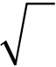
d) A dice is thrown 6 times. If “ getting an odd number” is a “success”.
What is the probability of [4]
i) 5 successess
ii) at least 5 successess
e) Assume the mean height of soldiers to be 68.22 inches with a variance of
10.8 inches. How many soldiers in a regiment of 10,000 would you
expect to be over 6 feet tall. [4]
Given : A(z = 1.15 = 0.3749)
Q4)Solve the following (any three) [12]
a) Find real root of the equation x3 + 2x –5 = 0 lies between 1and 2 by
Newton-Raphson method, at end third iteration. [4]
b) Solve the equation x2 –4x + 2 = 0 using method of succesipe
approximation taking x0 = 1. [4]
c) Solve the following system of linear equation using Gauss elimination
method. [4]
x1 + x2 + x3 = 6, 3x1 + 3x2 + 4x3 = 20, 2x1 + x2 + 3x3 = 13.
d) | Solve the following system of equations by Cholesky’s method | [4]
4x1 + 2x2 + 14x3 = 14, 2x1 + 17x2 –5x3 = –101, 14x1 –5x2 + 83x3 = 155.
e) Solve following system of equations by Jacobi’s iteration method, upto third
iteration 20x1 + x2 –2x3 = 17, 3x1 + 20x2 –x3 = –18, 2x1 –3x2 + 20x3 = 25.[4]
Q5)Solve (any three) of the following. |  | [12]
a) | Given the table of square roots, Calculate the value of 155 by Newton’s
backward difference formula. |  | [4]

x | 150 | 152 | 154 | 156
y = x | 12.247 | 12.329 | 12.410 | 12.490

b) | Find the value of y at x = 4 by using Lagranges interpolation formula for
b) | following data | [4]

x | 0 | 1 | 2 | 5
y | 2 | 3 | 12 | 147

[6582]-229 | 3
https://t.me/SPPU_TE_BE_COMP

c)  d)  e) | Evaluate |  |  | 1  ∫01 |  |  | dx |  |  | 2 | using Trapezoidal rule (Take h = 0.25 = 1 4). |  |  |  | [4]
c)  d)  e) |  |  |  |  |  |  | + |  | x | 2 |  |  |  |  | [4]
c)  d)  e) | Find the value of y at x = 0.2, by using modified Euler’s method, given
c)  d)  e) | that | dy  dx= |  |  | x | − |  | y | 2, |  | y |  | (0)1,= | Take h = 0.2. | [4]
c)  d)  e) | Using Adam’s Bashforth method, find y(0.4), given that
c)  d)  e) | dy  dx=+ |  | xyy |  |  |  |  | (0) |  |  |  | = | 2 |  | [4]
y (0.1) = 2.1103
y (0.2) = 2.243
y (0.3) = 2.4011
Q6)Solve the following (any three) |  |  |  |  |  |  |  |  |  |  |  |  |  |  |  |  |  |  |  |  |  |  |  | [12]
a) | Find Laplace transform of |  |  |  |  |  |  |  |  |  |  |  |  | 2cos 3 t . |  |  |  |  |  |  |  |  |  | [4]
b) |  | Find Inverse Laplace transform of |  |  |  |  |  |  |  |  |  |  |  |  |  |  | s | 22+4 s+  s+  5  13 |  |  |  |  |  | . |  |  |  |  |  |  |  |  | [4]
c) | Solve the differential equation by using Laplace transform method
dy |  |  |  | − | 3 | dy | = | 9, | y | (0) | = | 0 | = | y | ′(0) | . |  |  |  |  |  |  |  | [4]
dt |  |  | 2 |  |  | dt |  |  |  |  |  |  |  | y
d) |  | Evaluate by using Laplace transform |  |  |  |  |  |  |  |  |  |  |  |  |  |  |  |  | ∞ | e | −⎛⎜⎝ |  | e | − | at | − | e | − | bt | ⎞⎟⎠ | dt | . |  | [4]
 |  |  |  |  |  |  |  |  |  |  |  |  |  |  |  |  |  |  | ∫0 |  |  |  | e |  | at | t |  | −
e) | Find Inverse Laplace transform of |  |  |  |  |  |  |  |  |  |  |  |  |  |  |  | s | 21 (s1)+ |  |  |  | . |  | [4]
  
[6582]-229 4
https://t.me/SPPU_TE_BE_COMP

Total No. of Questions :8] PE3783

[6582]-230
S.E. (Chemical Engg.)

VEC-232-CEE : UNIVERSAL HUMAN VALUES AND
PROFESSIONAL ETHICS
(2024Pattern) (Semester-III)
Time : 2 Hours] [Max. Marks : 35
Instructions to the candidates:
1) Answer Q.1 or Q.2, Q.3 or Q.4, Q.5 or Q.6, Q.7 or Q.8.
2) Neat diagrams must be drwan wherever necessary.
3) Assume suitable data, if necessary.
4) Use of Scientific Calculator is allowed.
Q1)a) Explain the content and process of Self-exploration with the help of a
diagram. [4]
b) Critically analyze the role of Education-Sanskar in holistic development.[4]
OR
Q2)a) What are the four dimensions of a human being? How are they
interconnected? [4]
b) Evaluate why is right understanding required in relationship for mutual
Happiness? [4]
Q3)a) Distinguish between intention and desire with appropriate example. [4]
b) Analyse the problems that arise when we try to fulfil the needs of the Self
with the needs of the Body. [5]
OR
Q4)a) What do you mean by the right utilization of the body?. [4]
b) Discriminate the response of the ‘Self’ from the response of the ‘Body’?
Why response of the self is not definite? [5]
Q5)a) Critically evaluate “Trust” How does clarity between ‘ intention and
‘competence’ help develop trust in continuity? [4]
b) Illustrate with the help of two examples from your life, Why is right
understanding required in relationship for mutual happiness? [5]
OR
P.T.O. P.T.O.
https://t.me/SPPU_TE_BE_COMP

Q6)a) Define the feeling of Love as a value in relationships and Distinguish Love and Affection. [4]
b) What are comprehensive human goals? Write the state of society in the lack of identification of the goals. [5]
Q7)a) What do you mean by ‘inheritance’ ? Explain the inheritance in the four orders. [4]
b) Explore the issues in professional ethics in the current scenario. List any five unethical practices in the profession today. [5]
OR
Q8)a) Describe the abundance in the nature. How is human order dependent on the other three orders? [4]
b) Distinguish between units and space. In what types of units- material or consciousness, is there a scope for development? [5]
  
[6582]-230 2
https://t.me/SPPU_TE_BE_COMP

Total No. of Questions : 10] PE3784

[6582]-231
S.E. (Civil)

PCC-201-CVL : MECHANICS OF STRUCTURES
(2024 Pattern) (Semester-III)
Time : 2½ Hours] [Max. Marks : 70
Instructions to the candidates:
1) Solve Q1 or Q2, Q3 or Q4, Q5 or Q6, Q7 or Q8, Q9 or Q10.
2) Neat diagrams should be drawn wherever necessary.
3) Assume suitable data if necessary.
Q1)a) A brass bar, having cross-sectional area of 1000 mm2 is subjected to
axial forces as shown in Figure 1. Find the total elongation of the bar.
Take E = 1.05×105 N/mm2 [7]
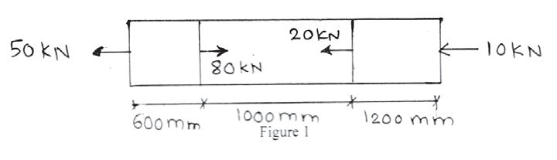
b) Find the Young’s Modulus of a brass rod of diameter 25 mm and of
length 250 mm which is subjected to a tensile load of 50 kN when the
extension of the rod Es equal to 0.3mm. [7]
OR
Q2)a) A load of 2 MN is applied on a short concrete column 500 mm×500 mm.
The column is reinforced with four steel bars of 10 mm diameter, one in
each corner. Find the stress in the concrete and steel bars. Take E for
steel as 2.1×105 N/mm2 and for concrete as 1.4×104 N/mm2 [7]
b) A steel rod a 10 mm diameter and 2 m length if the temperature is raised
to 70°C.Find the magnitude and nature of the force required to prevent
the expansion E=2×105 Nmm2, α = 1.2×10-6/°C [7]
P.T.O. P.T.O.
https://t.me/SPPU_TE_BE_COMP

Q3)a) Draw shear force and bending moment diagram for the simply supported
beam of length 6 m, carries point load of 3kN and 6 kN at distance of 2m
and 4m from left end. [7]
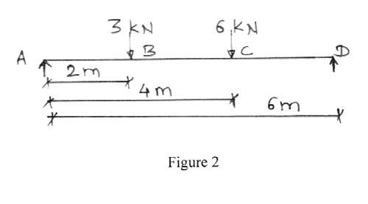
b) Draw shear force and bending moment diagram for cantilever beam is
loaded and supported as shown in figure 3. [7]
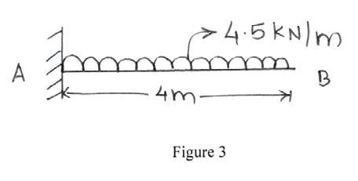
OR
Q4)a) Draw shear force and bending moment diagram for simply supported
beam is loaded and supported as shown in figure 4. [7]
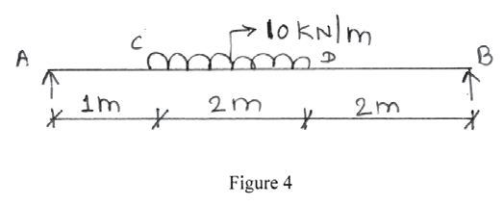
b) Draw shear force and bending moment diagram for cantilever beam is
loaded and supported as shown in figure 5. [7]
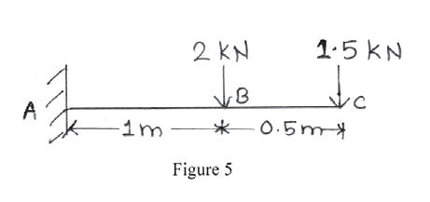
[6582]-231 2
https://t.me/SPPU_TE_BE_COMP

Q5)a) A cast iron beam is of I section has the dimension as flange 100mm×10mm and web 260×10mm. This beam of I section carries a UDL fo 30 kN/m run on a span of 10 m. Calculate the maximum stress produced due to bending. [7]
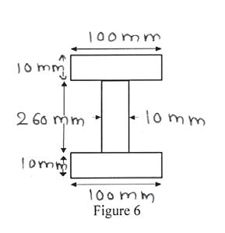
b) A wooden beam 100mm wide and 150 mm deep is simply supported over a span of 4 metre. If shear force at a section of the beam is 4500 N, find the shear stress at a distance of 25 mm above the N.A. [7]
OR
Q6)a) A rectangular beam 300 mm deep is simply supported over a span 4 metres. Determine the uniformly distributed load per metre which the beam may carry, if the bending stress should not exceed 120 N/mm2. Take I=8×106 mm4 [7]
b) The shear force acting on a section of a beam is 50 kN. The section of the beam is of T-shaped of dimensions 100mm×100mm × 20mm. The moment of inertia about the horizontal neutral axis is 314.221× 104 mm4. Calculate the shear stress at the neutral axis and at the junction of the web and the flange. [7]
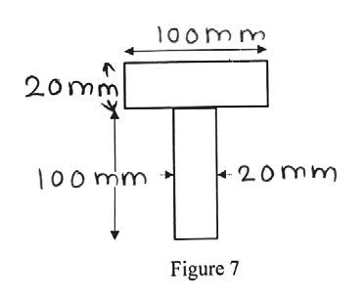
[6582]-231 3
https://t.me/SPPU_TE_BE_COMP

Q7)a) A hollow shaft of external diameter 140 mm transmits 500 kW power at
300 r.p.m. Determine the maximum internal diameter if the maximum stress
in the shaft is not to exceed 50 N/mm2. [7]
b) At a point within a body subjected to two mutually perpendicular
directions, the stresses are 60 N/mm2 tensile and 30 N/mm2 tensile. Each
of the above stresses is accompanied by a shear stress of 50 N/mm2.
Determine the normal stress, shear stress and resultant stress on an
oblique plane inclined at an angle of 45° with the axis of minor tensile
stress. [7]
OR
Q8)a) Find power transmitted by a shaft having 60 mm diameter rotating at 150
rpm, if maximum permissible shear stress = 80 MPa. [7]
b) Calculate major principal stress, minor principal stress and maximum
shear stress for an element subjected to state of stress as shown in
figure 8. [7]
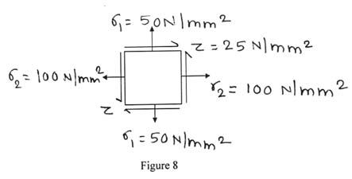
Q9)a) A mild steel tube 22 mm diameter, 3mm thick is 2m long. It is used as a
strut, hinged at two ends Calculate the crippling load by Euler’s formula.
Assume E= 200 GPa. [7]
b) A rectangular column 200 mm × 150 mm is carrying a compressive load
of 50 kN at an eccentricity of 50 mm in a plane bisecting 150 mm in a
plane bisecting 150 mm side. Neglecting self weight, determine maximum
and minimum stresses across the cross section and maximum
permissible eccentricity so as to develop no tension across the cross
section. [7]
OR
Q10)a) Determine core section for a hollow rectangular column of external size
B × D and internal size b × d respectively. [7]
b) A simply supported beam of span 3.0 m carries two point loads of 110
kN and 60 kN placed at distances 0.7 m and 2.0 m respectively from the
left support. For the beam, I=16×108 mm4 and E=2×105 N/mm2,
Calculate the deflection under the 120 kN load using Macaulay’s method.
[7]
[6582]-231 |     4
https://t.me/SPPU_TE_BE_COMP

Total No. of Questions : 10] | [6582]-232 | SEAT No. :
PE3785 | [6582]-232 | SEAT No. :
PE3785 | [6582]-232 | [Total No. of Pages : 4
S.E. (Civil Engineering)
PCC-202-CVL : SURVEYING
(2024 Pattern) (Semester - III)
Time : 2½Hours] [Max. Marks : 70 Instructions to the candidates:
1)  2)  3)  4)  5)  Q1)a)  b)  c) | Answer Q.1 or Q.2, Q.3 or Q.4, Q.5 or Q.6, Q.7 or Q.8, Q.9 or Q.10. Neat diagrams must be drawn wherever necessary.  Figures to the right indicate full marks.  Use of scientific calculator is allowed.  Assume suitable data, if necessary.
1)  2)  3)  4)  5)  Q1)a)  b)  c) | Define the following terms: |  | [3]
1)  2)  3)  4)  5)  Q1)a)  b)  c) | i) | Whole Circle Bearing
1)  2)  3)  4)  5)  Q1)a)  b)  c) | ii) | Dip of needle
1)  2)  3)  4)  5)  Q1)a)  b)  c) | iii) | True Meridian
1)  2)  3)  4)  5)  Q1)a)  b)  c) | Explain Segments and advantages of Space Based Positioning System.[5]  The following are the observed bearing of the lines of a traverse ABCDEA
1)  2)  3)  4)  5)  Q1)a)  b)  c) | with a compass in a place where local attraction was suspected. |  | [6]

Side | F.B. | B.B.
AB | 191º45' | 13º00'
BC | 39º30' | 222º30'
CD | 22º15' | 200º30'
DE | 242º45' | 62º45'
EA | 330º15' | 147º45'
Find the correct bearing of the lines.
OR
P.T.O.
https://t.me/SPPU_TE_BE_COMP


Q2)a) Define the following terms: [3]
i) Quadrantal Bearing
ii) Magnetic Declination
iii) True Bearing
b) What is Orientation in Plane Table Surveying? Enlist different orientation
methods and explain any one in detail. [5]
c) A closed traverse is conducted with five stations A, B, C, D and E taken
in anticlockwise order, in the form of a regular pentagon. If the FB of AB
is 30º 0’. Find the FBs of the other lines. [6]
Q3)a) Define the following terms: [3]
i) Height of Instrument
ii) Reduced Level
iii) Fly Levelling
b) Describe the two-peg method of permanent adjustment of a dumpy level
with a neat sketch. [4]
c) The following notes refer to an operation involving reciprocal levelling[7]
Instrument Staff readings on
Station A B Remark
A 1.850 3.150 Distance AB=600 m
B 1.550 3.000 RL of B=450.500 m
Find:
i) True R.L. of point A
ii) The Combined correction for curvature and refraction
iii) Collimation error
iv) Whether the line of collimation is inclined upwards or downwards.
OR
Q4)a) | Define the following terms: |  |  | 2 | [3]
i) |  |  | Collimation Plane | 2 | [4]
ii) |  |  | Bench Mark | 2 | [4]
iii) |  |  | Datum Surface | 2 | [4]
b) |  | Write a short note on: |  | 2 | [4]
i) |  |  | Profile Levelling | 2 | [4]
ii) |  |  | Longitudinal Levelling | 2 | [4]
[6582]-232 |  |  |  | 2 | [4]
https://t.me/SPPU_TE_BE_COMP

c) The following levels were observed during levelling on a continuously
sloping ground at a common interval of 30m. [7]
0.855 (on A), 1.545, 2.335, 3.115, 3.825, 0.455, 1.380,
2.055, 2.855, 3.455, 0.585, 1.015, 1.850, 2.755, 3.845 (on B).
The RL of A was 400 m. Tabulate the given readings and apply the usual
checks. Determine the Gradient of AB.
Q5)a)  b)  c) | Define the following terms: |  | [3]
Q5)a)  b)  c) | i) | Transiting
Q5)a)  b)  c) | ii) | Latitude
Q5)a)  b)  c) | iii) | Swinging of Telescope
Q5)a)  b)  c) | Explain with sketch method of measuring horizontal angle by repetition
Q5)a)  b)  c) | method. |  | [5]
Q5)a)  b)  c) | The record of a closed traverse is given below, |  | [6]

Line | Length (m) | Bearing
AB | 100.500 | N 30º30’ E
BC | ? | S 45º00’ E
CD | 75.000 | S 40º30’ W
DE | 50.500 | S 60º00’W
EA | ? | N 40º15’ W
Calculate the lengths of BC and EA.
OR
Q6)a)  b)  c) | Define the following terms: |  | [3]
Q6)a)  b)  c) | i) | Departure
Q6)a)  b)  c) | ii) | Telescope Normal
Q6)a)  b)  c) | iii) | Independent Coordinate
Q6)a)  b)  c) | Enlist fundamental axes of a theodolite & relation between them when
Q6)a)  b)  c) | theodolite is in perfect adjustment. |  | [5]
Q6)a)  b)  c) | A traverse is run to set out a line MQ = 1900 m at right angles to a given
Q6)a)  b)  c) | line MN. The lengths and bearings observed are as follows: |  | [6]

Line | Length (m) | Bearings
MN | - | 360º00’
MO | 850 | 120º00’
OP | 1000 | 86º30’
PQ | ? | ?
Calculate the lengths and bearing of the line PQ.
[6582]-232 3
https://t.me/SPPU_TE_BE_COMP

Q7)a) State characteristics of contours. [6]
b) A tacheometer with analytic lens having the value of constant 100 was
used and the following observations were made on staff held vertically.[8]
Inst.  Station | H.I. (m) | Vertical Angle | Staff at | Staff Reading
P | 1.5 | +2º40’ | M | 1.25, 1.93, 2.56
P | 1.5 | – 4º40’ | Q | 1.45, 1.85, 2.30
RL of station M is 100.00 m. Calculate the RL of P &Q, distance PQ
and gradient of PQ line.
OR
Q8)a) b) | Explain the procedure of determination of height of the building using
Q8)a) b) | Total Station. (by using REM function) | [6]
Q8)a) b) | The following observations were made using a tacheometer fitted with
Q8)a) b) | an analytic lens, multiplying constant being 100. | [8]

Inst.  Station | H.I  (m) | Staff  Station | Vertical Angle | Staff Reading
M | 1.8 | A | +4º30’ | 1.155, 1.755, 2.355
M | 1.8 | B | +10º15’ | 1.250, 2.000, 2.750
RL of M = 150 m. Find RL of point A and B also find distance AB.
Q9) a) State different types of curves. Explain compound curve with sketch.[6]
b) Two tangents AB and BC meet at chainage of 1350 m. The angle of
deflection is 30º. Tabulate the necessary data to layout the curve of 250
m radius by Rankine’s method of deflection angle. Take peg interval as
20 m and Least Count 20”. [8]
OR
Q10)a) What is the Transition Curve? State the various types of transition curves
with the help of a neat sketch. Explain briefly its necessity. [6]
b) Two tangents AB and BC meet at a chainage of 1125 m, the Intersection
angle being 150º. Calculate all data required to set out curve of radius
200 m by the method of offsets from the chord produced, taking a peg
interval of 20 m. [8]
b b b
[6582]-232 4
https://t.me/SPPU_TE_BE_COMP

Total No. of Questions : 10] | [6582]-233 | SEAT No. :
PE5719 | [6582]-233 | SEAT No. :
PE5719 | [6582]-233 | [Total No. of Pages : 3
S.E. (Civil Engineering)
PCC-203-CVL : BUILDING CONSTRUCTION AND MATERIALS
(2024 Pattern) (Semester - III)
Time : 2½Hours] [Max. Marks : 70
Instructions to the candidates:
1) Solve Q.1 or Q.2, Q.3 or Q.4, Q.5 or Q.6, Q.7 or Q.8, Q.9 or Q.10.
2) Use of drawings sheet is allowed for Q.9(b) and Q.10(b) only.
3) Neat diagrams should be drawn wherever necessary.
4) Use of a Non-Programmable Calculator is allowed.
5) Assume suitable data if necessary and clearly state.
6) Use of cell phone is prohibited in the examination hall.
Q1)a) Enlist types of buildings as per NBC (National Building Code). Explain
any two types in detail. [7]
b) Enlist any six types of floor finishes and explain wooden flooring. [7]
OR
Q2)a) Enlist various types of fixtures for doors and explain anyone with a neat
sketch. (to be drawn on answer sheet only) [7]
b) Explain different types of roofs along with the functional requirements
of good roofing materials. Also draw the sketch of queen post roof
truss. (to be drawn on answer sheet only) [7]
Q3)a) Write a short note on Battened & Ledged Doors with sketch.
(to be drawn on answer sheet only) [7]
b) Enlist various types of brick masonry bonds and explain any one with
neat sketch? (to be drawn on answer sheet only) [7]
OR
Q4)a) State and explain the selection criteria for windows. [7]
b) Explain various important requirements of bricks to be used for
construction purpose. [7]
P.T.O.
https://t.me/SPPU_TE_BE_COMP

Q5)a) Explain the necessity of Automation in the construction sector. Also give
the advantages of Automation in the construction sector. [7]
b) How would you apply the features of green building to design a small
residential layout? [7]
OR
Q6)a) Compare Traditional and Prefabricated construction. Also explain types
of Prefabrication used in Airport Construction. [7]
b) Discuss the philosophies of Green Construction with its advantages and
limitations. [7]
Q7)a) Identify the reason that why modular constructions are used in India.
Also give examples of Modular construction technique. [7]
b) Discuss the key aspects and policies of Solar PV in Smart domains.
Also explain carbon credits with its purpose. [7]
OR
Q8)a) Explain the working procedure of 3D Printing Building with its
opportunities and challenges. [7]
b) Explain important features of Green Roof with its benefits. [7]
Q9)a) What is TDR in construction? State its applications. [4]
b) It is proposed to construct a Computer Training Institute with the following
requirements: [10]
i) Reception: 15 Sqm.
ii) Administrative Office: 25 Sqm
iii) Cabin for head of the institute : 20 Sqm
iv) Seminar Hall (2Nos): 60 Sqm each
v) Class Room (3 Nos): 50 Sqm each
vi) Computer Lab(2 Nos): 70 Sqm each
vii) Store Room: 15 Sqm
viii)Staff Room with attached toilet: 30 Sqm
ix) All passage : 2 m wide
x) Sanitary units : as per standards
xi) Assume any suitable data if necessary
xii)Draw to scale of 1:50 or suitable - line plan showing location of
doors and windows
[6582]-233 2
https://t.me/SPPU_TE_BE_COMP

Note- 1)To be drawn on Drawing sheet.
2)Assume suitable data if required.
3)North direction.
4)Position of doors and windows.
OR
Q10)a) Interpret the features of a location plan. [4] b) Develop and draw a detailed ground floor plan (with scale 1:50 or any suitable scale) for a bungalow proposed to be constructed for a lawyer.
The following are the accommodation requirements: [10] i) Drawing Room - 12 Sqm.
ii) Living Room -24 Sqm.
iii) Kitchen with attached Store - 14 Sqm.
iv) Dining Room - 16 Sqm.
v) Children’s Bedroom -15 Sqm.
vi) Master Bedroom with attached Toilet - 20 Sqm.
vii)Study Room / Office Room - 12 Sqm.
Note - 1)To be drawn on Drawing sheet.
2) Assume suitable data if required.
3)North direction.
4)Position of doors and windows.
5)Opening Schedule.
b b b
[6582]-233 3
https://t.me/SPPU_TE_BE_COMP

Total No. of Questions : 6] PE3786

[6582]-234
S.E. (Civil)

MDM-221-CVL : ENGINEERING MATHEMATICS - III (2024 Pattern) (Semester - III)
Time : 2½ Hours] [Max. Marks : 70 Instructions to the candidates:
1) | All questions are compulsory.
2) | Figures to the right indicate full marks.
3) | Use of electronic pocket calculator is allowed.
4) | Assume suitable data, if necessary.
Q1)Write the correct option for following MCQs. |  |  |  |  |  |  |  |  |  | [10]
a) | The complementary function of (D2 + 1)y = 0 is
i) |  | C1cos x – C2sin x  C1ex + C2e–x |  |  |  |  |  |  |  | ii) |  |  | C1cos x + C2sin x None
iii) |  |  |  |  |  |  |  |  |  | iv)
b) | If two regression coefficients are 8− and 5− the correlation coefficient is  15 6
i) |  |  | 2 | ii) |  |  |  |  |  |  |  |  |  | −2
 |  |  | 3 |  |  |  |  |  |  |  |  |  |  | 3
iii) |  |  | 1 | iv) |  |  |  |  |  |  |  |  | 3
 |  |  | 2
c) | The divergence of vector field |  |  |  | f | = | 3 | 2  xi | + |  | 3 | 2 2  yxj |  |  | + | 2 | xzk | at point (1, 1, 1)
is
d) | i) | 14 |  |  |  | ii) | 12
d) | iii) | 2 |  |  |  | iv) | 8
d) | Inverse shifting operator E–1 is equivalent to  i) 1 – δii)  iii) 1 + δ2iv) |  |  |  |  |  | 1 + δ
d) |  |  |  |  |  |  | 1– ∇
e) | If Lagranges polynomial pass through |  |  |  |  |  | 1– ∇
e) |  |  |  |  |  |  | 1– ∇
  x | 0 | 1
  y | 1 | 2
e) |  |  |  |  |  |  | 3
e) | Then |  |  | 1  ∫0y dx = |  | ______ . | 3
e) | i) |  | 2 |  | ii) |  | 3
 |  |  | 3 |  |  |  | 2
 | iii) |  | 1 |  | iv)
 |  |  | 2 |  |  |  | 3
P.T.O.
https://t.me/SPPU_TE_BE_COMP

Q2)Solve any three of the following.
a) | (D2 + 2D + 1) y = 3ex + 2 cos x |  |  |  |  |  |  |  |  |  |  |  |  |  |  |  |  |  |  |  |  |  |  |  |  |  |  |  |  |  |  |  |  |  |  |  | [4]
b) | (D2 + 1)y = sec x tan x (By method of variation of Parameters) |  |  |  |  |  |  |  |  |  |  |  |  |  |  |  |  |  |  |  |  |  |  |  |  |  |  |  |  |  |  |  |  |  |  |  | [4]
c) | x | 2 | 2  dy |  |  | − | x | dy |  | + | 4 |  | y | = |  | cos(log) |  |  |  |  |  |  |  |  |  |  |  |  |  |  |  |  |  |  |  |  | [4]
c) | x |  | dx | 2 |  | − | x | dx
d) | dx  dt+ |  |  | y | = |  | 1 |  |  |  |  |  |  |  |  |  |  |  |  |  |  |  |  |  |  |  |  |  |  |  |  |  |  |  |  |  | [4]
dy  dt+ |  |  |  | x | = |  | 0
e) | The differential equation satisfied by a beam uniformly loaded with one
end fixed and second subjected to a tensile force ‘p’ is given by |  |  |  |  |  |  |  |  |  |  |  |  |  |  |  |  |  |  |  |  |  |  |  |  |  |  |  |  |  |  |  |  |  |  |  |  | [4]
EI |  |  | 2  dy  dx− |  |  |  | py |  | =− |  |  | W |  | x | 2 |  | .
 |  |  |  |  |  |  |  |  |  |  |  | 2 |  | x
Show that the elastic curve for the beam under conditions y = 0, |  |  |  |  |  |  |  |  |  |  |  |  |  |  |  |  |  |  |  |  |  |  |  |  |  |  |  |  |  |  |  |  |  |  |  |  |  | dy  dx= | 0
when x = 0 is given by |  |  |  |  |  |  |  |  |  |  |  |  |  |  |  |  |  | y | = | W |  | ⎡ | x | 2 | + | 2 |  | − | e | nx |  | − | e | − | nx | ⎤  ⎥⎦ where EI = | p  n.
 |  |  |  |  |  |  |  |  |  |  |  |  |  |  |  |  |  |  |  | 2 | p | ⎢⎣ |  |  |  | n | 2 | − | n |  | 2 |  | n |  | 2 | ⎤  ⎥⎦ where EI =
Q3)Solve any three of the following. |  |  |  |  |  |  |  |  |  |  |  |  |  |  |  |  |  |  |  |  |  |  |  |  |  |  |  |  |  |  |  |  |  |  |  |  | [12]
a) | The number of points scored by two teams A & B in a Hockey match is
given below. Determine which team is more consistent. |  |  |  |  |  |  |  |  |  |  |  |  |  |  |  |  |  |  |  |  |  |  |  |  |  |  |  |  |  |  |  |  |  |  |  |  | [4]

No. of points scored | 0 | 1 | 2 | 3
Team A | 7 | 15 | 10 | 3
Team B | 20 | 6 | 4 | 10

b) | The first four moments about the value 3 are 1, 3, 6, 11 respectively.
Calculate the first four central moments, coefficient of skewness and
kurtosis. |  |  |  | [4]
c) | Find the correlation coefficient r (x,y) between x & y for the following data,
 |  |  |  | [4]
  x | 4 | 5 | 6 | 7 | 10
  y | 8 | 7 | 5 | 7 | 4
d) | Out of 2000 families with 4 children each, how many families would be
expected to have, |  |  |  | [4]
i) |  | No or 1 girl
ii) |  | At most two girls?
[6582]-234 |  |  | 2
https://t.me/SPPU_TE_BE_COMP

e) In a certain examination test, 2000 students appeared in a subject of
statistics. Average marks obtained were 50% with standard deviation 5%.
How many students do you expect to obtain marks between 60% to
65%, assuming that the marks are distributed normally? [4]
[Given : A (2) = 0.4772, A (3) = 0.4987]
Q4)Solve any three of the following
a) Find a positive real root of x log10x = 1.2 using bisection method at the
end of fourth iteration. [4]
b) Solve 3x – 1 – cosx = 0 by using the method of successive approximations
correct to two decimal places. [4]
c) Use Gauss elimination method to solve the following system of equations[4]
x1 + x2 + x3 = 6
3x1 + 3x2 + 4x3 = 20
2x1 + x2 + 3x3 = 13
d) | Solve the equation by LU decomposition method : | [4]
2x1 + 3x2 + x3 = 9
x1 + 2x2 + 3x3 = 6
3x1 + x2 + 2x3 = 8
e) Use Gauss-Seidel method to solve the following system of equations[4]
10x1 + x2 + x3 = 12
2x1 + 10x2 + x3 = 13
2x1 + 2x2 + 10x3 = 14
Q5)Solve (any three) of the following.
a) | Find the value of y for n = 0.5 using Newton’s forward difference formula
a) | for following data. | [4]

x | 0 | 1 | 2 | 3 | 4
y | 1 | 5 | 25 | 100 | 250

[6582]-234 | 3
https://t.me/SPPU_TE_BE_COMP

b) | Find f (2.5) by using lagranges interpolation formula, for the following
b) | data. | [4]

x | 1 | 2 | 3 | 4
f (x) | 1 | 4 | 9 | 16

 |  | 3 |  | 1 |  | dx | by using simpson’s 3⎛  ⎝8 |  |  | th  ⎞  ⎠rule take h = 0.5
c)  d)  e) | Find the value of | ∫0 | 1 | + | x
c)  d)  e) | and correct the solution upto four decimal places. |  |  |  |  |  |  |  |  |  |  |  | [4]
c)  d)  e) | Using modified Enter method, find y (0.2), given |  |  |  |  |  |  | dy  dx+ |  |  | xy |  | 2 | = |  | 0 |  | , y (0) = 2,
c)  d)  e) | take h = 0.2 (Two iterations only). |  |  |  |  |  |  |  |  |  |  |  | [4]
c)  d)  e) | Use Runge-Kutta method of fourth order to solve |  |  |  |  |  |  |  | dy  dx= |  |  | x | + |  | y |  | 2,(0) |  | =as
c)  d)  e) | x = 0.1 with h = 0.1. |  |  |  |  |  |  |  |  |  |  |  | [4]
Q6)Solve any three of the following.
a) | In what direction from the point (2, 1, –1) is the directional derivative of
a) | φ =x2y z3 maximum? What is the magnitude? |  |  |  |  |  |  |  |  |  |  |  |  |  |  |  |  |  |  |  |  |  |  |  |  |  |  |  |  |  |  |  |  |  |  |  |  |  |  |  |  |  |  |  |  |  | [4]
a) | Show that F |  |  |  |  |  |  |  |  |  |  | = |  | ye |  |  | xy |  | cos |  |  |  | zi |  | + |  |  |  | xe |  | xy |  | cos |  |  |  | − |  |  | xy | sin |  | zk |  | is irrotational and hence
b)  c) |  |  |  |  |  |  |  |  |  |  |  |  |  |  |  |  |  |  |  |  |  |  |  |  |  |  |  |  |  |  |  |  |  |  |  | zj |  |  | e
b)  c) | find φ such that F |  |  |  |  |  |  |  |  |  |  |  |  |  |  |  |  | =∇. |  |  |  |  |  |  |  |  |  |  |  |  |  |  |  |  |  |  |  |  |  |  |  |  |  | [4]
b)  c) | Show that (any one) |  |  |  |  |  |  |  |  |  |  |  |  |  |  |  |  |  |  |  |  |  |  |  |  |  |  |  |  |  |  |  |  |  |  |  |  |  |  |  |  |  | [4]
b)  c) | i) | ∇ |  |  |  | 2 | ⎡⎢⎣ | ∇ |  | □ |  | ⎛  ⎜  ⎝ |  | r |  |  | ⎞⎟⎠ | ⎤⎥⎦ |  | = |  | 2
 |  |  |  |  |  |  |  |  |  |  |  |  |  | r |  | 2 | ⎞⎟⎠ |  |  |  |  | r |  | 4
 | ii) | ∇ |  |  |  | ⎛⎜⎝ | ar□ |  |  |  |  |  | ⎞⎟⎠ |  | = |  | a |  |  | − |  |  | 5( |  | arr 7□  r
d) | ii) |  |  |  |  | ⎛⎜⎝ | r |  |  | 5 |  |  |  |  |  |  | r |  | 5
d) | Evaluate |  |  |  |  |  |  |  |  |  | the |  |  |  |  |  |  | line |  |  |  |  |  |  |  |  | integral |  |  |  |  |  |  |  |  |  |  | of |  |  |  | vector |  |  |  | point |  | function
d) | F | = |  |  |  | − | y |  | 2 | ) |  | i | + |  |  | 2 | xyj |  |  |  | along the curve y2 = x from (0, 0) to (1, 1) in
 | F | = | ( | x | 2
 | x□y-plane. |  |  |  |  |  |  |  |  |  |  |  |  |  |  |  |  | [4]
 | Show that |  |  |  |  |  |  |  |  |  | ∫∫∫ |  |  |  | 1 |  | d |  | V |  | = |  | S |  |  | ⎛⎜⎝ |  | rn□ˆ |  |  |  | ⎞⎟⎠ |  | dS | where V is the volume bounded by
e) |  |  |  |  |  |  |  |  |  |  |  |  |  |  | r | 2 |  |  |  |  |  |  |  |  |  |  |  | r |  | 2
e) |  |  |  |  |  |  |  |  |  |  | V
e) | closed surface S. |  |  |  |  |  |  |  |  |  |  |  |  |  |  |  |  | [4]
… … …
[6582]-234 4
https://t.me/SPPU_TE_BE_COMP

Total No. of Questions : 8] PE-5957 | SEAT No. :
Total No. of Questions : 8] PE-5957 | [Total No. of Pages : 2
[6582]-235
S.E. (Civil Engineering)
VEC-232-CVL : UNIVERSAL HUMAN VALUES AND
PROFESSIONAL ETHICS
(2024 Pattern) (Semester - III)
Time : 2 Hours] [Max. Marks : 35
Instructions to the candidates :
1) Answer Q1 or Q2, Q3 or Q4, Q5 or Q6, Q7 or Q8.
2) Neat diagrams must be drawn wherever necessary.
3) Figures to the right indicate full marks.
4) Assume suitable data, if necessary.
Q1)a) What is the need for value education in technical and other professional
institutions? [4]
b) What is the content of self-exploration? [4]
OR
Q2)a) What is continuous happiness and prosperity. How can they be achieved?
[4]
b) What is the program to fulfil the basic human aspirations? Name the
different levels of human living? [4]
Q3)a) Distinguish between the needs of the Self and the needs of the Body.[5]
b) What is the difference between Svatantratã and Partantratã? What is the
program to become Svatantra? [4]
OR
Q4)a) What is our present attitude towards the Body? What are its consequences?
[5]
b) | What is harmony in the self? | [4]
Q5)a) | What are the human values and explain any two in detail? | [5]
b) | Write a short note on harmony in human-to-human relationship? | [4]
OR
Q6)a) How is ‘trust’ the foundation value of relationships? [5]
b) What is the basis of ‘respect’ for a human being? Do you see that the
other human being is also similar to you? [4]
P.T.O.
https://t.me/SPPU_TE_BE_COMP

Q7)a) What are the four orders in nature? Briefly explain them. [5]
b) Suggest practical steps an individual can take to live and work ethically in
today’s world. [4]
OR
Q8)a) What do you mean by co-existence? How are units in co- existence being
in space? [5]
b) What do you mean by mutual fulfilment in nature? Cite a few examples.[4]
♦♦♦
[6582]-235 2
https://t.me/SPPU_TE_BE_COMP

Total No. of Questions : 10] PE3919

[6582]-236

S.E. (Computer Engineering/Computer Science and Engineering) PCC-201-COM-CSE : DATA STRUCTURES
(2024 Pattern) (Semester-III)
Time : 2½ Hours] [Max. Marks : 70 Instructions to the candidates:
1) Answer Q1 or Q2, Q3 or Q4, Q5 or Q6, Q7 or Q8, Q9 or Q10.
2) Neat diagrams must be drawn wherever necessary.
3) Figures to the right indicate full marks.
4) Use of electronic pocket calculator is allowed.
5) Assume suitable data, if necessary.
Q1)a) Explain different Asymptotic notations with graph of order of growth.
[6] b) Define ADT and Explain Types of Data structures Compare Linear and Non-linear Data Structures. [8] OR
Q2)a) Compare Static and Dynamic Data Structures. Discuss the significance of Persistent and Ephemeral Data Structures. [6] b) Apply step count method to evaluate time complexity of the following python code [8] def oddEven (n=100):
for num in range (1, n):
if num % 2 ==0:
print (num, ‘is Even’)
else:
print (num, ‘is Odd’)
Justify that the above algorithm is having linear, non-linear, quadratic time complexity. List various Algorithmic Strategies and explain any one with suitable example.
P.T.O. P.T.O.
https://t.me/SPPU_TE_BE_COMP

Q3)a) Define the terms [6]
i) Sparse Matrix
ii) Sorting Stability
iii) Internal and External Sort
b) Apply Binary Search algorithm on the following numbers stored in array
from A [0] to A [09] as 9, 17, 23, 38, 45, 50, 57, 76, 90, 100 to search
numbers 23 and 90. Also note on the time complexity of each search.
[8]
OR
Q4)a) Define ADT for Arrays and discuss at least 4 operations that are
performed on arrays. [6]
b) Explain Bubble sort algorithm and sort the given list using bubble sort:
7, 4, 10, 6, 3, 12, 1, 8, 2, 15 Enlist the number of passes required to
Q5)a) | complete the sort. | [8]
Q5)a) | Explain with neat diagram: | [6]
i) SLL
ii) DLL
iii) CLL
b) Explain Stack as an ADT and Convert the infix expressions
(A+B)*D+E/(F+A*D)+C into postfix representation using stack, Show
the status after every step in tabular form. [8]
OR
[6582]-236 2
https://t.me/SPPU_TE_BE_COMP

Q6)a) Define and Draw diagram for [6]
i) Queue
ii) Circular Queue
iii) Dequeue
b) Write a pseudo code for Stack implementation using Linked List for the
following operations [8]
i) Create
ii) Push
iii) Pop
iv) Display
Q7)a) Explain characteristics of Good Hash function and Explain any four types
of Hash Functions. [6]
b) Represent the following key in memory using Linear probing without
replacement. Use modulo 10 as your hashing function. 24, 13, 16, 15, 19,
20, 22, 14, 17, 26 Estimate average search time for any element in Hash
Table. [8]
OR
Q8)a) Write a short note on any three hashing techniques. [6]
b) Given the Inputs: 4371, 1323, 6173, 4199, 4344, 9679, 1989} Hash table
size = 10 and Hash function = key mod 10. Show the results for the
following: [8]
i) Open addressing hash table using Linear Probing
ii) Open addressing hash table using Quadratic Probing
[6582]-236 3
https://t.me/SPPU_TE_BE_COMP

Q9)a) Compare Tree and Graph, Enlist at least two real time applications of
each. [6]
b) Write Prime’s algorithm and apply it on given graph to find Minimum
Spanning Tree. Estimate the cost of MST [8]
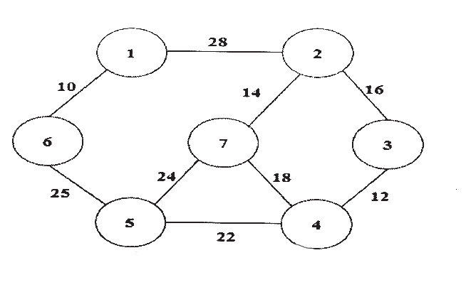
OR
Q10)a) Apply Tree traversal techniques and find in-order, pre-order and
post-order traversal sequence of given binary tree. [6]
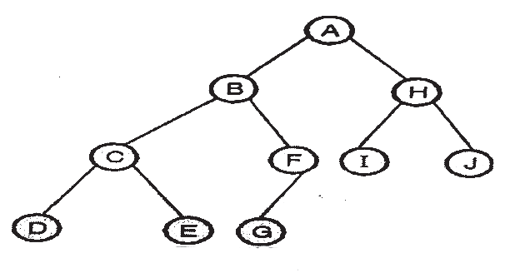
b) Write Kruskal’s algorithm and apply it on given graph to find Minimum
Spanning Tree. Estimate the cost of MST [8]
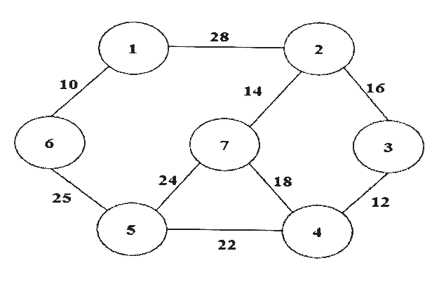
  
[6582]-236 4
https://t.me/SPPU_TE_BE_COMP

Total No. of Questions : 10] | [6582]-237 | SEAT No. :
PE-5720 | [6582]-237 | [Total No. of Pages : 3
S.E. (Computer / Computer Science Engineering)
PCC - 202 - COM : Object Oriented Programming & Computer Graphics
(2024 Pattern) (Semester - III)
Time : 2½ Hours] [Max. Marks : 70 Instructions to the candidates:
1) Answer Q.1 or Q.2, Q3. or Q.4, Q.5 or Q.6, Q.7 or Q.8, Q.9 or Q.10.
2) Figures to the right indicate full marks.
3) Neat diagrams must be drawn wherever necessary.
Q1) | 4) | Make suitable assumption whenever necessary.
Q1) | a) | What are classes and objects? Explain their relationship with the help of
Q1) | b) | a real-world example. |  | [5]
Q1) | b) | What is JVM? Explain how java achieves platform independence using
Q1) | c) | JVM and Bytecode. |  | [5]
Q1) | c) | Write and explain a Java program using: |  | [4]
Q1) | c) | • | If-else decision structure
Q1) | c) | • | for or while loop
OR
Q2) | a) | What are data members and methods? Describe how they are used in
Q3) | b) | Java to define an object’s characteristics and behavior. | [5]
Q3) | b) | What are Java Class Libraries? Explain how import statements help in
Q3) | b) | accessing predefined classes. | [5]
Q3) | c) | accessing predefined classes. | [5]
Q3) | c) | What are programming paradigms? Describe the four main programming
Q3) | c) | paradigms with suitable examples. | [4]
Q3) | a) | paradigms with suitable examples. | [4]
Q3) | a) | What is a constructor? Explain parameterized constructor and default
Q3) | b) | constructor with examples. | [5]
Q3) | b) | What are arrays? Demonstrate declaration, creation, and initialization of
a 1-D and 2-D array with examples. Also explain passing arrays to methods. [5] c) Define a class in Java. Write a Java class with field declaration, method declaration, and method definition. [4] OR
P.T.O.
https://t.me/SPPU_TE_BE_COMP

Q4) | a) | What is method overloading? Write a Java program that overloads a
Q5) | b) | method to calculate the area of a square and rectangle. | [5]
Q5) | b) | What are set (mutator) and get (accessor) methods? Write an example
Q5) | b) | demonstrating their use. | [5]
Q5) | c) | demonstrating their use. | [5]
Q5) | c) | What are Java API packages? Explain the use of the import statement
Q5) | c) | with an example. | [4]
Q5) | a) | with an example. | [4]
Q5) | a) | What is inheritance? Explain superclass and subclass with a Java example.[5]
Q5) | b) | What is multiple catch? Write a Java program demonstrating handling of
Q5) | c) | different exception types using mutliple catch blocks. | [5]
Q5) | c) | Explain runtime polymorphism with a suitable Java example demonstrating
Q5) | c) | method overriding. | [4]
OR
Q6) | a) | What is protected access specifier? How does it affect accessibility in
Q7) | b) | inheritance? | [5]
Q7) | b) | Explain try, catch, throw, throws and finally keywords with example
Q7) | b) | code? | [5]
Q7) | c) | code? | [5]
Q7) | c) | What are abstract classes and abstract methods? How are they different
Q7) | c) | from interfaces? | [4]
Q7) | a) | from interfaces? | [4]
Q7) | a) | What are the applications of computer graphics in various fields? Explain
Q7) | b) | with examples. | [5]
Q7) | b) | Write Bresenham circle drawing algorithm. Also explain mathematical
Q7) | c) | foundation of it. | [5]
Q7) | c) | What is the inside-outside test? How is it used in polygon processing?[4]
OR
Q8) a) Explain Scan Line Polygon Fill algorithm. Compare it with Flood Fill
and Seed Fill methods. [5]
b) Explain DDA line drawing algorithm. Consider line segment from A (-2, -1)
to B (6, 3) use DDA line drawing algorithm to rasterize this line [5]
c) Explain the following term with example: [4]
i) Windowing
ii) Clipping
[6582]-237 2
https://t.me/SPPU_TE_BE_COMP

Q9) | a) | Define 2D transformations. Explain translation, scaling, rotation, and
Q9) | b) | shear with their matrix representations. | [5]
Q9) | b) | Describe rotation about an arbitrary axis in 3D. Explain the steps involved.
[5] c) What is Oblique projection? Explain Cavilier and Cabinet projection.[4] OR
Q10) a) What is orthographic projection? Explain Isometric, Diametric, and Trimetric projections with suitable examples. [5] b) Explain 3D translation, scaling, rotation, and shear with their matrix forms.
[5] c) Perform x shear on a triangle having A (2, 1), B (4, 3), C (2, 3) consider shx=2. [4]
♣♣♣
[6582]-237 3
https://t.me/SPPU_TE_BE_COMP

Total No. of Questions : 10] PE-5721 | SEAT No. :
Total No. of Questions : 10] PE-5721 | [Total No. of Pages : 3
[6582]-238
S.E. (Computer/Computer Science& Engg.)
PCC-203-COM : OPERATING SYSTEMS
(2024 Pattern) (Semester - III)
Time : 2½ Hours] [Max. Marks : 70
Instructions to the candidates :
1) Attempt Q.1, or Q.2, Q.3 or Q.4, Q.5 or Q.6, Q.7 or Q.8 and Q.9 or Q.10.
2) Neat diagrams must be drawn wherever necessary.
3) Numeric figures in square brackets [] indicate full marks.
4) Use of electronic pocket calculator is allowed.
5) Assume suitable data, if necessary.
Q1)a) List different types of Operating Systems? Describe any two of them.[5]
b) What is a system call? Explain its need in operating systems. [5]
c) Describe the various functions of an Operating System. [4]
OR
Q2)a) Explain the layered approach of OS design with the help of diagram.
Discuss its advantages and disadvantages. [5]
b) Explain the main objectives of an Operating System. How does an OS
act as a resource manager and control program? Give examples. [5]
c) Explain Microkernel Operating Systems? [4]
Q3)a) Explain Process States and Transitions diagram? [7]
b) Explain the following types of Schedulers. [7]
i) Short Term
ii) Long Term
iii) Medium Term
OR
P.T.O.
https://t.me/SPPU_TE_BE_COMP

Q4)a) Explain the Process Control block in detail with the help of a diagram.[7]
b) Draw Gantt chart and calculate Avg. turnaround time, Avg. waiting time
for the following process using SJF non-pre-emptive and round robin
with time quantum 0.5 Unit. | [7]

Process | Burst time | Arrival Time
P1 | 2 | 10
P2 | 1 | 10
P3 | 1 | 11
P4 | 1 | 12

Q5)a) b) c) | Write and explain Deadlock Avoidance Bankers Algorithm. | [6]
Q5)a) b) c) | Explain necessary conditions for occurrence of deadlock. | [4]
Q5)a) b) c) | What is semaphore? Justify how semaphore is used to solve critical section
Q5)a) b) c) | problems. | [4]
OR
Q6)a) Write a short note on the following with an example? [6]
i) Semaphore
ii) Monitors
iii) Mutex
b) Explain Deadlock prevention and deadlock recovery with example?[4]
c) What is semaphore? Write a solution to the Reader Writer problem using
Semaphore with Readers as priority. [4]
Q7)a) Explain FIFO and LRU page replacement policies? Consider page
sequences 2, 3, 2, 1, 5, 4, 5, 3, 2, 2,2, 5, 2 and discuss working with FIFO
b) | replacement policy. Also count page faults. (Use no. of frames = 3). |  | [7]
b) | Write a short note on following with diagram. |  | [7]
b) | i) | Segmentation | [7]
b) | ii) | Demand Paging | [7]
OR
Q8)a) Explain following placement strategies: First Fit, Best Fit and Worst Fit.[7]
b) What is internal fragmentation? Explain with a suitable diagram and
example. [7]
[6582]-238 2
https://t.me/SPPU_TE_BE_COMP

Q9)a) Explain File operation and Directory structure? [5]
b) Explain File Allocation Methods? [5]
c) Compare FAT, NTFS, EXT, and HFS file systems based on structure,
performance, and security. [4]
OR
Q10)a) | Describe Boot-block and Bad blocks? | [5]
b) | Explain Disk formatting? | [5]
c) | Explain LOOK scheduling. How is it different from SCAN? | [4]
♦♦♦
[6582]-238 3
https://t.me/SPPU_TE_BE_COMP

Total No. of Questions : 10] PE-5722 | SEAT No. :
Total No. of Questions : 10] PE-5722 | [Total No. of Pages : 3
[6582]-239
S.E. (Computer/Computer Science & Engineering)
MDM-221 : DIGITAL ELECTRONICS & LOGIC DESIGN (2024 Pattern) (Semester - III)
Time : 2½ Hours] [Max. Marks : 70 Instructions to the candidates :
1) | Attempt Q.1, or Q.2, Q.3 or Q.4, Q.5 or Q.6, Q.7 or Q.8 and Q.9 or Q.10. | [5]
2) | Neat diagrams must be drawn wherever necessary. | [5]
3) | Numeric figures in square brackets [] indicate full marks. | [5]
4) | Use of electronic pocket calculator is allowed. | [5]
5) | Assume suitable data, if necessary. | [5]
Q1)a) | Simplify and implement following expression using K-Map | [5]
Y = ∑m (0, 1, 2, 5, 7, 8, 9, 10, 13, 15)
b) | Minimise the following expression and implement using logic gates.[5]
(Y = (A + B + C) (A + B+ C) (A + B + C) (A + B + C) (A + B + C)
c) Perform the subtraction using l’s Complement and 2’s Complement method (151)10 -(76)10. [4]
OR
Q2)a) Derive the POS of the following expression using K-Map and implement using logic gates. [5]
F(A, B, C, D) = ∏M (0, 2, 3, 8, 9, 12, 13, 15)
b) Using Boolean algebra theorems, simplify the following expression and implement using logic gates. [5]
F= (A + B) (A + C) ( A + B)
c) | Differentiate between Signed Magnitude, l’s Complement, and 2’s Complement representation. Represent –23 using all three methods.[4]
P.T.O.
https://t.me/SPPU_TE_BE_COMP

Q3)a) Explain the working of a 4-bit Binary Adder using IC-7483. Write its
features and applications. [5]
b) Explain the working of a BCD-to-Excess-3 code converter with truth
table and circuit diagram. [5]
c) State the difference between half and full adder. [4]
OR
Q4)a)  b) | Draw and explain 4 bit BCD subtractor using IC-7483. Explain the
Q4)a)  b) | operation on BCD number 5-7. | [7]
Q4)a)  b) | Implement the following Boolean function using 8 : 1 multiplexer | [7]
(A B D) + (A B D ) + (A C D) + (B C D) + (AC D)
Q5)a) Convert the following flip-flops : [5]
i) SRtoJK.
ii) JK to T
b) Draw and explain 4-bit asynchronous up-counter using JK flip flop. Also
draw the necessary timing diagram. [5]
c) With neat diagrams explain the working of the following types of shift
registers [4]
i) Serial-in, serial-out
ii) Parallel-in, serial-out
OR
Q6)a) Define the term “Excitation Table”. Write the excitation tables for SR,
JK, D, and T flip-flops and explain their importance. [5]
b) Design a Mod-6 asynchronous counter using T flipflop. [5]
c) Differentiate between Combinational Circuit and Sequential Circuit.[4]
[6582]-239 2
https://t.me/SPPU_TE_BE_COMP

Q7)a) Design a synchronous sequential circuit using JK flipflop for the given state diagram. [5]
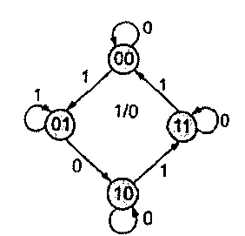
b) Write a short note on characteristics of logic families. [5] c) Explain the differences between a Finite State Machine (FSM) and an Algorithmic State Machine (ASM) with examples. [4] OR
Q8)a) Explain in detail Mealy and Moore machine [5] i) State diagram and
ii) State table
b)
Draw an ASM chart and state table for 2 bit up down counter having mode control input : [5] M=1 : Up counting
M=0 : Down counting
The circuit should generate a output 1 whenever the count becomes minimum or maximum
c) Compare Mealy Machine with Moore Machine [4]
Q9)a) Draw and explain the architecture of PLA. [7] b) Explain the difference between PLA, PAL, and ROM in terms of programmability and flexibility. [7] OR
Q10)a) | Design a Programmable Logic Array (PLA) to implement the following
Q10)a) | functions : |  | [5]
Q10)a) | i) | F1 = A B + AB + C
 | ii) | F2 = A BC +AB
b)  c) | ii)
b)  c) | Design BCD to excess-3 code converter and implement it using PAL.[5]
b)  c) | Write short note on different types of PLD’ s. |  | [4]
♦♦♦
[6582]-239 3
https://t.me/SPPU_TE_BE_COMP

Total No. of Questions :8] | [6582]-240 | SEAT No. :
PE3920 | [6582]-240 | SEAT No. :
PE3920 | [6582]-240 | [Total No. of Pages : 2
S.E. (Comp. Engg.)/(Comp. Sc.& Engg.)/AI & DS/
Comp. Sc.& Engg. (AI)/Comp. Sc.& Engg. (D.S.)/Comp. Sc./
Comp. Sc.& Design)
VEC-232 : UNIVERSAL HUMAN VALUES AND
PROFESSIONAL ETHICS
(2024 Pattern) (Semester-III)
Time : 2 Hours] [Max. Marks : 35
Instructions to the candidates:
1) Answer Q.1 or Q.2, Q.3 or Q.4, Q.5 or Q.6, Q.7 or Q.8.
2) Neat diagrams must be drawn wherever necessary.
3) Numeric figures in square brackets [] indicate full marks.
4) Use of electronic pocket calculator is allowed.
5) Assume suitable data, if necessary.
Q1)a) What do you mean by ‘Value Education’? Explain the basic guidelines
for Value Education. [5]
b) What is the Basic Human Aspiration? Is it the same for everyone? [3]
OR
Q2)a) Why is right understanding required for ensuring physical facility? How
does it result in mutual prosperity? Illustrate with the help of two personal
examples. [5]
b) Explain the process of Self-exploration with the help of a diagram.[3]
Q3)a) Human being is the co-existence of the Self and the Body. What are the
three specific distinguishing attributes of the Self and the Body? Explain
b) | with examples. | [5]
b) | Body is the instrument of the Self. Explain. | [4]
OR
Q4)a) What is the purpose of the Self? What is the purpose of the Body? What
would be the right utilization of the Body? [5]
b) Distinguish between intention and desire. [4]
P.T.O. P.T.O.
https://t.me/SPPU_TE_BE_COMP

Q5)a) Give one example each of over evaluation, under evaluation and otherwise
evaluation. Why are these evaluations leading to disrespect? [5]
b) Differentiate between Glory and Gratitude. [4]
OR
Q6)a) Distinguish between intention and competence. What is the outcome when
we confuse between the two and we doubt the intention of the other?[5]
b) What is the role of physical facility in the fulfilment of relationship? [4]
Q7)a) Explain the activities in the four orders of nature. How are the activities in
the human order qualitatively different from those of other three orders?
[5]
b) | What are the Professional Ethics? | [4]
OR
Q8)a) What do you understand by the terms ‘holistic development’ and ‘universal
human order’? [5]
b) Explain Ethical Human Conduct. Discuss its characteristics. [4]
  
[6582]-240 2
https://t.me/SPPU_TE_BE_COMP

Total No. of Questions : 10] PE-5723 | SEAT No. :
Total No. of Questions : 10] PE-5723 | [Total No. of Pages : 2
[6582]-241
S.E. (Computer Science and Design Engineering)
PCC-201-CSD : DATA STRUCTURES & ALGORITHMS
(2024 Pattern) (Semester - III)
Time : 2½ Hours] [Max. Marks : 70
Instructions to the candidates :
1) Attempt Q.1, or Q.2, Q.3 or Q.4, Q.5 or Q.6, Q.7 or Q.8 and Q.9 or Q.10.
2) Neat diagrams must be drawn wherever necessary.
3) Figures to the right side indicate full marks.
4) Assume Suitable data if necessary.
Q1)a) Define abstract data type (ADT) with one example. [5]
b) Explain the difference between Big-O and Big Ω notation. [5]
c) Differentiate between static and dynamic data structures with examples.[4]
OR
Q2)a) Differentiate between primitive and non primitive data types. [5]
b) Apply best case and worst case analysis to the linear search algorithm.[5]
c) Explain time complexity and space complexity with proper illustration.[4]
Q3)a) What is the difference between row-major and column-major. [5]
b) Summarise the steps involved in inserting an element in an array. [5]
c) Trace Binary search for the list [5, 12, 18, 25, 32, 41, 56] where search -
key = 32. [4]
OR
Q4)a) Define array as an ADT. [4]
b) Compare Linear and Binary search using comlexity analysis. [5]
c) Trace Fibonacci search on the array [5,9,14,19,23,30,42] where key = 23.
[5]
P.T.O.
https://t.me/SPPU_TE_BE_COMP

Q5)a) Perform Bubble sort on the list [42,17,8,23,15]. Also explain bubble sort.
[7]
b) | Write an algorithm for selection sort with example. | [7]
OR
Q6)a) Perform Quick sort for [17,5,22,9,40,11]. [7]
b) Perform Radix sort on the list [329,457,657,839,436,720,355]. [7]
Q7)a) Compare sequential and linked organisation. [6]
b) Explain the insertion algorithm to insert new node at the middle position
and end position for the singly linked list. [8]
OR
Q8)a) | Explain why insertion in a linked list is easier than in an array. | [6]
b) | Insert a new node containing 50 at position 3 in the list | [8]
Show the pointer adjustments step by step.
Q9)a) | Describe the difference between push and pop operations. | [6]
b) | Evaluate the postfix expression : | [8]
5,3 * 8,2/+4–
OR
Q10)a) Compare the advantages of circular queue over linear queue and also
explain why a queue is called as FIFO structure. [6]
b) Write an algorithm to insert element in to circular queue. Apply the circular
queue logic : For a circular queue of size 4 with rear = 2 and front = 0,
after performing enqueue (50), what will be the new rear value? [8]
♦♦♦
[6582]-241 2
https://t.me/SPPU_TE_BE_COMP

Total No. of Questions : 10] PE-5724

[6582]-242

S.E. (Computer Science and Design)
PCC-202-CSD : Database Management System
(2024 Pattern) (Semester - III)
Time : 2½ Hours] [Max. Marks : 70
Instructions to the candidates :
1) Answer Q.1 or Q.2, Q.3 or Q.4, Q.5 or Q.6, Q.7 or Q.8, Q.9 or Q.10.
2) Figures to the right indicate full marks.
Q1)a) Draw an ER diagram for the banking system. Assume the banking
requirements are as given below.
   | The bank is organized into branches. Each branch is located in a particular city  The bank offers two types of accounts: saving and current. Accounts can be held by more than one customer and a customer can have
more than one account.
 | A loan originates at a particular branch and can be held by one or more customers.
Identify the relationship among the entites along with the mapping
cardinalities, Keys in the ER diagram. [6]
b) Enlist the components of DBMS architecture and draw neat labelled
diagram of it. [4]
c) What are the database languages. Describe DDL and DML. [4]
OR
Q2)a) Elaborate the significance of codd’s rule. Illustrate on 12 rules proposed
by codd’s [6]
b) For the database system to be usable, it must retrieve data efficiently.
The need for efficiency has led designers to use complex data structures
to represent data in the database. Developers hide this complexity from
the database system users through several levels of abstraction. Explain
those levels of abstraction in detail with examples. [4]
c) How the generalization differs from specialization? Explain with example.
[4]
P.T.O.
https://t.me/SPPU_TE_BE_COMP

Q3)a) Consider the following schema-supplier (SNo, Sname, Status, City)
Parts (Pno, Pname, color, weight, city)
Shipments (SNo, PNo, Qty)
Write SQL queries for following :
i) Find shipment information (Sno, Sname, Pno, Pname, Qty) for those
having quantity less than 157.
ii) List Sno, Sname, Pno, Pname for those suppliers who made
shipments of parts whose quantity is larger than the average quantitys.
iii) Find aggregate quantity of Pno 1692 of color green for which
shipments made by supplier number residing in Mumbai. [6]
b) Write a syntax for creating an index on specific table and describe the
importance of index. [4]
c) Demonstrate how to create a view in SQL and show whether it can be
updated using an example. [4]
OR
Q4)a) What is a trigger? How to create it ? Discuss various types of triggers.
Consider the following schema
Student - fee- details (rollno, name, fee-deposit, date)
Write a trigger to preserve old values of student fee details before updating
in the table. [6]
b) Define stored procedure. Explain the creating and calling stored procedure
with an example as accept roll no and display name of student. [4]
c) Explain the concept of candidate key, primary key and foreign key [4]
Identify above listed key for the following schema :
Personal (driver-id, name, address, contact no)
Car (license, model, year)
Own (driver_ id, license)
[6582]-242 2
https://t.me/SPPU_TE_BE_COMP

Q5)a) Given a relation, illustrate the desirable properties of decomposition by
working through and example. [6]
b) Using an example table, demonstrate how anomalies occur and show
how normalization resolves them. [4]
c) Evaluate the importance of ACID properties in transaction management
and justify why they are essential for reliable database systems. [4]
OR
Q6)a) Explain why database normalization is required for good relational database
design? Write rule sets for 1 NF, 2 NF and 3 NF. [6]
b) Compare and contrast 3NF and BCNF by analyzing their definitions,
examples and structural differences. [4]
c) Identify partial and transitive dependencies in a given relation and
demonstrate them with examples. [4]
Q7)a) Suppose a transation Ti issues a read command on data item Q. How
time -stamp based protocol decides whether to allow the operation to be
executed or not using time stamp based protocol of concurrency control,
explain in detail time stamp based protocol. [7]
b) Apply the test for conflict serializability to any schedule and show through
an example whether it is serializable or not. [7]
OR
Q8)a) Explain the concept of conflict serializability with suitable examples. Since
every conflict- serializable schedule is view serializable, why do we
emphasize conflict serializability rather than view serializability. [7]
b) Paraphrase the following recovery methods in detail [7]
i) Shadow paging
ii) Log-based Recovery
iii) Checkpoints
[6582]-242 3
https://t.me/SPPU_TE_BE_COMP

Q9)a) Compare and analyze column-oriented, graph, document-oriented and
key value databases by examining examples and typical application
scenarios. [6]
b) Demonstrate the use of an XML database by applying it to a real - world
scenario that involves hierarchical or Semi-structured data. [4]
c) Differentiate between ACID and BASE properties and analyze how the
CAP theorem influences database design. [4]
OR
Q10)a) Differentiate between relational databases and object relational databases
with example [6]
b) Explain how JSON objects are encoded and decoded in Java and Illustrate
the process with simple examples. [4]
c) Illustrate on [4]
i) Geometric Data
ii) Geographic Data
  
[6582]-242 4
https://t.me/SPPU_TE_BE_COMP

Total No. of Questions : 10] PE-5725 | SEAT No. :
Total No. of Questions : 10] PE-5725 | [Total No. of Pages : 5
[6582]-243
S.E. (Computer Science and Design)
PCC-203-CSD : DISCRETE MATHEMATICS
(2024 Pattern) (Semester - III)
Time : 2½ Hours] [Max. Marks : 70
Instructions to the candidates:
1) Neat diagrams must be drawn wherever necessary.
2) Figures to the right indicate full marks.
3) Use of electronic pocket calculator is allowed.
4) Assume suitable data, if necessary.
Q1)a) Explain terms Tautology and Contradiction in truth table with an
example. [5]
b) By using mathematical induction prove that
2 + 4 + 6 + .... +2n = n (n+1), for all integers n > l. [5]
c) Let p: “Sara is intelligent” and q: “Sara works hard” Write the following
statements in symbolic form: [4]
i) Sara is intelligent but does not work hard
ii) Sara is neither intelligent nor hardworking
iii) Sara is intelligent or hardworking
iv) Sara is not intelligent but works hard
OR
Q2)a) A survey of 100 students revealed the following: 48 like Cricket (C),
42 like Football (F), 36 like Hockey (H) ,20 like both C and F, 18 like
both C and H, 15 like both F and H, 22 like none of the three sports.
Find : [5]
i) The number of students who like all three sports
ii) The values in each region of the corresponding Venn diagram
iii) The number of students who like exactly one sport
b) Let A = {2, 4, 6, 8, 10, 12, 14} B= {4, 5, 6, 7}. Find:
i) P(A∪B) ii) P(A∩B) iii) A – B [5]
P.T.O.
https://t.me/SPPU_TE_BE_COMP

c) Use p : I will study discrete mathematics, q : I will go to a movie, r: I
am in a good mood. Write the following in English sentence : [4]
i) ~r→ q
ii) ~q ∧ p
iii) q → ~p
iv) ~p → ~r
Q3)a) What is Equivalence relation? Explain properties of binary relations.[5]
b) Let f(x) = 5x, g(x) = x + 4, h(x) = x2. Compute [5]
i) gof ii) fog iii) hof iv) fof v) goh
c) Let A= {1, 3, 6, 9, 18} and let the relation R be “a divides b”. Write all
ordered pairs in R and draw the Hasse diagram for (A, R) [4]
OR
Q4)a) Explain the various types of functions. [5]
b) Let A={a,b,c,d} R={(a,b), (b,d), (a,c), (c,b)}. Find the transitive closure
of relation R using Warshall’s algorithm. [5]
c) Let A={ 1,2,3} and consider the relation R={(1,1), (1,2), (2,1), (2,2),
(3,3)}. Determine whether the relation R is reflexive, symmetric,
antisymmetric and transitive. [4]
Q5)a) Define Tree with respect to following terms and give suitable example[8]
i) Degree of the Node
ii) Height of a Tree
iii) Binary Tree
iv) Complete Binary Tree
b) Consider the following tree and apply Tree Traversal Techniques for
the same and give traversal order for the same. [6]
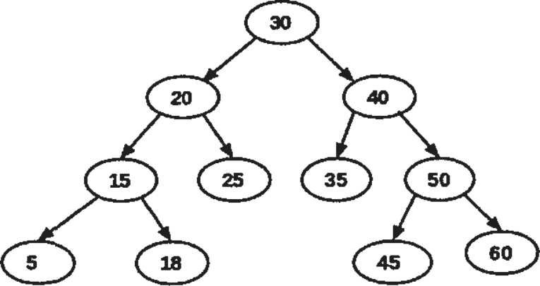
[6582]-243 2
https://t.me/SPPU_TE_BE_COMP

OR
Q6)a) | Construct the Huffman Tree for | [7]

P | 4
Q | 7
R | 8
S | 12
T | 15

b) | Find maximum flow in the transport network using labelling procedure.
b) | Determine the corresponding min-cut. | [7]
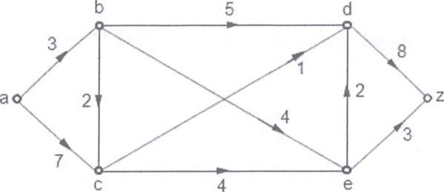
Q7)a) Define following Terms with the help of suitable Example [8]
i) Eulerian Path
ii) Eulerian Circuit
iii) Hamiltonian Path
iv) Hamiltonian Circuit
b) Use Kruskal’s algorithm to find the minimum spanning tree for the
connected weighted graph G as shown in fig. below [6]
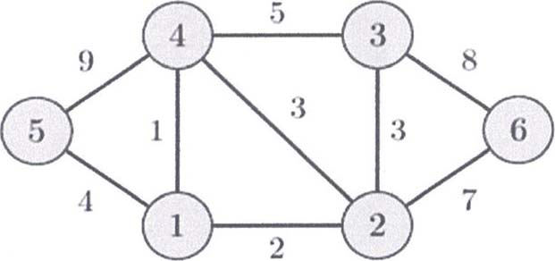
OR
[6582]-243 3
https://t.me/SPPU_TE_BE_COMP

Q8)a) Give the stepwise construction of minimum spanning tree using Prims
algorithm for the following graph. Obtain the total cost of minimum
spanning tree. [7]
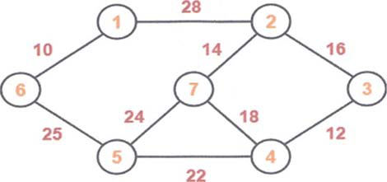
b) Explain DFS and BFS. Construct DFS and BFS Traversal orders for
the following example. [7]
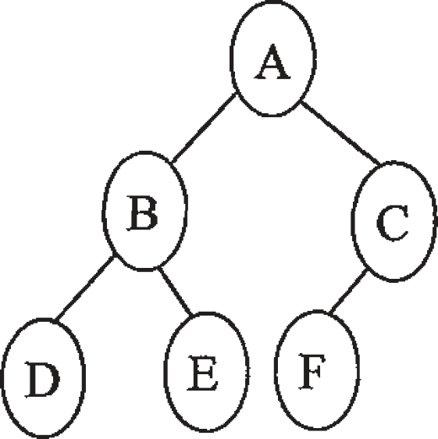
Q9)a) A sports club has 8 committee members. In how many ways can they
choose a captain, vice-captain, manager and assistant manager? [5]
b) Find the seventh term in the expansion of (a + b)12 [5]
c) Suppose repetitions are permitted : [4]
i) How many three-digit numbers can be formed using the digits
1, 4, 6, 8, 9 and 0?
ii) How many of these numbers are multiples of 5?
OR
Q10)a) Explain Algebraic system and properties of binary operations [5]
b) Let (A, x) be monoid such that for every x ∈ A, x * x = e where e is the
identity element. Show that (A,*) is an abelian group. [5]
[6582]-243 4
https://t.me/SPPU_TE_BE_COMP

c) Consider the set Z of integers and define the binary operation a*b by
a*b = a + b + ab. Answer the following: [4]
i) Compute 3 * (–2)
ii) Compute 4*5
iii) Compute (–1) * 7
Determine whether (Z, *) is a semigroup.

[6582]-243 5
https://t.me/SPPU_TE_BE_COMP

Total No. of Questions : 10] PE-5726 | SEAT No. :
Total No. of Questions : 10] PE-5726 | [Total No. of Pages : 2
[6582]-244
S.E. (Comp. Sc. &Design)
MDM-221-CSD : DIGITAL ELECTRONICS
(2024 Pattern) (Semester - III)
Time : 2½ Hours] [Max. Marks : 70
Instructions to the candidates:
1) Attempt any one of Q.1 or Q. 2, Q.3 or Q4, Q.5 or Q.6, Q. 7 or Q.8, Q.9 or
Q. 10.
2)  3)  4)  Q1)a) | Assume suitable data if necessary,  Draw neat diagrams wherever necessary. Figures to the right indicate full marks.  Explain steps to convert SOP to standard SOP, and Convert the given
2)  3)  4)  Q1)a) | function in standard SOP form. | [7]
F1 = AC + CD + ABC
b) Reduce the following function using Karnaugh map technique and
implement using basic gates. [7]
f(A,B,C,D)=ABD +ABD +ABD+ABC
OR
Q2)a) | Implement the following function using NAND gates. | [7]
f(A,B,C) = Σm(0,2,5,6,7,10) + d(8,15)
b) | Reduce the following function using Karnaugh map technique. | [7]
f(A,B,C,D) = Πm(1,2,3,8,9,12,13,14,15)
Q3)a) What is BCD adder? Design with help of Kmap. [7]
b) Explain 4 bit BCD to Excess 3 code converter and write the logic
diagram. [7]
OR
Q4)a) Write the look ahead carry adder with logic diagram. [7]
b) What is binary substractor explain the full substractor with K-map.[7]
P.T.O.
https://t.me/SPPU_TE_BE_COMP

Q5)a) What is multiplexer tree? Design 16:1 multiplexer using 8:1
multiplexer. [7]
b) Implement 3 bit binary to gray code using 3:8 decoders. [7]
OR
Q6)a)  b)  Q7)a)  b) | What is decoder, define with block diagram? Implement F1 (A,B,C) =
Q6)a)  b)  Q7)a)  b) | Σ(2,5,6) using 3:8 decoder. | [7]
Q6)a)  b)  Q7)a)  b) | Write the difference between encoder and decoder. | [7]
Q6)a)  b)  Q7)a)  b) | Explain the JK Flip Flop with block diagram, truth table, characteristic
Q6)a)  b)  Q7)a)  b) | equation excitation table. | [7]
Q6)a)  b)  Q7)a)  b) | Design a 3 bit Asynchronous ups counter. | [7]
OR
Q8)a) Convert JK Flip Flop to D Flip Flop. [7]
b) Design MOD 56 Counter using IC7490. [7]
Q9)a) Explain the SISO left shift register with timing diagram using D Flip
Flop. [7]
b) Perform state reduction for given state diagram and also draw reduces
state table and state diagram. [7]
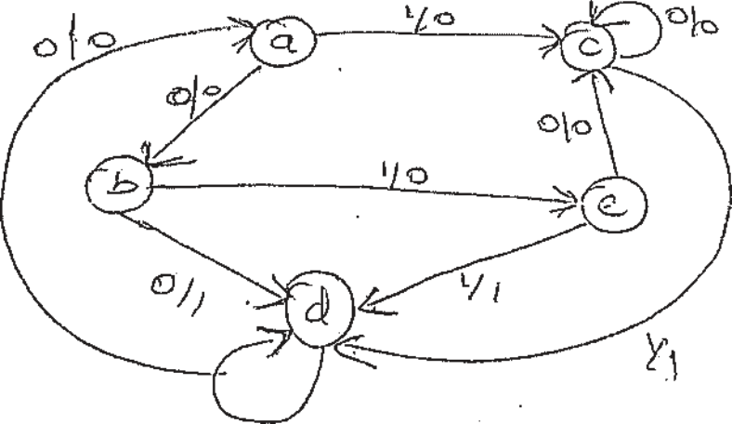
OR
Q10)a) Explain the Twisted /Johnson counter. [7]
b) What is Moore model, mealy model explain with state diagram state
table. [7]

[6582]-244 2
https://t.me/SPPU_TE_BE_COMP

Total No. of Questions : 8] PE-5727 | SEAT No. :
Total No. of Questions : 8] PE-5727 | [Total No. of Pages : 2
[6582]-246
S.E. (Computer Science and Engineering/Data Science)
PCC-201-CDS : DATA STRUCTURES & ALGORITHMS
(2024 Pattern) (Semester - III)
Time : 2½ Hours] [Max. Marks : 70
Instructions to the candidates :
1) Attempt Q.1, or Q.2, Q.3 or Q.4, Q.5 or Q.6, Q.7 or Q.8 and Q.9 or Q.10.
2) Neat diagrams must be drawn wherever necessary.
3) Figures to the right side indicate full marks.
4) Assume Suitable data if necessary.
Q1)a) What is frequency count? Why is frequency count important in the analysis
of algorithm. [5]
b) What is meant by time and space complexity? Explain the asymptotic
notations used for time complexity? [5]
c) Explain what is Linear and non-linear data structure with example. [4]
OR
Q2)a) What is meant by sparse Matrix? Write an algorithm to perform addition
of two sparse matrices. [5]
b) Explain divide & conquer Strategy and Greedy strategy with suitable
example. [5]
c) Explain what is static and dynamic data structure. [4]
Q3)a) Explain binary search algorithm with the given example: Search no: 23 and 100.
9,17,23,40,45,52,58,80,85,95,100 [7]
b) Write a short note on sentinel search & Index sequential search with
suitable example. [7]
OR
Q4)a) Explain selection sort with the algorithm. Sort the following numbers
using selection sort and show the content of array after every pass.[7]
27,76,17,9,45,58,90,79,100.
b) Explain quick sort algorithm with suitable example. What is time complexity
of quick sort algorithm. [7]
P.T.O.
https://t.me/SPPU_TE_BE_COMP

Q5)a) Write a pseudo code for basic operation of stack. [7]
b) What is circular queue? Explain the advantages of circular queue area
linear queue. [7]
OR
Q6)a) What is need to convert the infix expression into postfix; convert the
following expression into postfix expression (a+b) * d + e/(f + a*d) + c.
[7]
b) Explain array implementation of priority queue with all basic operations.[7]
Q7)a) Describe binary search tree deletion with example. [7]
b) Differentiate between tree and graph . [7]
OR
Q8)a) Explain how to convert general tree to binary tree with example. [7]
b) Write Floyd Warshall Algortihm. [7]
Q9)a) What is hashing? Explain the properties of good hash function with
examples. [7]
b) Differentiate between Sequential file and index sequential file. [7]
OR
Q10)a) Insert the following data in the hash table of size 10 using linear probing
with chaining by applying with replacement : 11, 33, 20, 88,79; 98, 68, 44,
66, 24. Calculate average number of comparisons required to search
given data from hash table. [7]
b) Explain Sequential and Direct Access file organization. Also list out
advantages and disadvantages of the same. [7]
♦♦♦
[6582]-246 2
https://t.me/SPPU_TE_BE_COMP

Total No. of Questions : 10] PE-5728

[6582]-247

S.E. (Computer Science and Engineering (Data Science))
PCC-202-CDS : Computer Graphics
(2024 Pattern) (Semester - III)
Time : 2½ Hours] [Max. Marks : 70
Instructions to the candidates :
1) Answer Q.1 or Q.2, Q.3 or Q.4, Q.5 or Q.6, Q.7 or Q.8, Q.9 or Q.10.
2) Neat diagrams must be drawn wherever necessary.
3) Numeric figures in square brackets [ ] indicate full marks.
4) Use of electronic pocket calculator is allowed.
5) Assume suitable data, if necessary.
Q1)a) Explain DDA Line drawing Algorithm with example. [5]
b) Explain Randum scan display and Raster Scan Display. [5]
c) Write a short note on [4]
i) Pixel
ii) Resolution
iii) Aspect Ratio
iv) Fram Buffer
OR
Q2)a) Explain Bresenham Circle Drawing algorithm and derive necessary
mathematical expression used in algorithm. [5]
b) What is Display Device?
Explain :
c) | i) OLED ii) QLED iii) AMOLED. | [5]
c) | Explain aliasing and antialiasing. | [4]
P.T.O.
https://t.me/SPPU_TE_BE_COMP

Q3)a) Explain Cohen Sutherland line clipping algorithm in polygon. [7]
b) Explain Different method for Testing a pixel inside or outside the Polygon.
[7]
OR
Q4)a) Explain Boundary filled algorithm for Polygon. [7]
b) Explain Sutherland Hodgeman polygon clipping algorithm. [7]
Q5)a) Perform 45° rotation of a triangle A(0, 0), B(1, 1) and C(5, 2).
Find transformed coordinates after rotation, [6]
i) About origin,
ii) About P(–. 1, 1).
b) | Describe w.r.t. 2D transformation |  | [4]
b) | i) | scaling | [4]
b) | ii) | translation | [4]
iii) Rotation
c) | Difference between parallel projection and perspective Projection. | [4]
OR
Q6)a) Derive 3D transformation matrix for rotation about arbitrary axis. [6]
b) What are the types of projection and write in brief about each type of
projections [4]
c) What is shearing? Explain X shearing and Y shearing. [4]
[6582]-247 2
https://t.me/SPPU_TE_BE_COMP

Q7)a) | Explain Bezier Curve generation algorithm. | [7]
b) | Explain Hubert curve with example. | [7]
OR
Q8)a) Explain B-spline Curve generation algorithm. [7]
b) List Different Animation Tool. Explain method for controlling Animation.
[7]
Q9)a) Explain the structure of a basic OpenGL program. Describe the role of
graphics functions, control functions, and primitives with suitable
examples. [7]
b) Write short notes on Augmented Reality (AR) and Virtual Reality (VR)[7]
OR
Q10)a) Explain the steps involved in publishing a Unity game for Windows or
Android. Describe build settings, platform selection, and packaging. [7]
b) Explain the role of transformations in OpenGL. Discuss translation,
rotation, and scaling with suitable examples. [7]
  
[6582]-247 3
https://t.me/SPPU_TE_BE_COMP

Total No. of Questions : 10] PE-5729 | SEAT No. :
Total No. of Questions : 10] PE-5729 | [Total No. of Pages : 3
[6582]-248
S.E. (Computer Science and Engineering) (Data Scinece) PCC-203-CDS : DATA STORYTELLING AND
VISUALIZATION
(2024 Pattern) (Semester - III)
Time : 2½ Hours] [Max. Marks : 70 Instructions to the candidates :
Q1) | 1) | Answer Q1 or Q2, Q3 or Q4, Q5 or Q6, Q7 or Q8, Q9 or Q10.
Q1) | 2) | Neat diagrams must be drawn wherever necessary.
Q1) | 3) | Figures to the right side indicate full marks.
Q1) | 4) | Assume suitable data, if necessary.
Q1) | 5) | Use of non-programmable calculator is allowed.
Q1) | a) | How Data is Communicated in Data Story telling and Visualization.[5]
Q1) | b) | Understanding the Target Audience in Data Storytelling and Visualization
[5]
c) | i) | Who is Your Audience? | [4]
c) | ii) | What Does Your Audience Need? | [4]
c) | iii) | What’s Their Level of Data Literacy? | [4]
c) | Why is Storytelling Powerful? |  | [4]
OR
Q2) | a) | Steps to Explore and Discover Data. | [5]
Q3) | b) | Differentiate between Ethical Data Storytelling and Unethical Data
Q3) | b) | Storytelling. | [5]
Q3) | c) | Storytelling. | [5]
Q3) | c) | Explain the Psychology And Anatomy of Storytelling. | [4]
Q3) | a) | Explain the structure of storyline in data science and visualization. | [7]
Q3) | b) | What is the importance of capturing valuable insights from data. | [7]
OR
P.T.O.
https://t.me/SPPU_TE_BE_COMP

Q4) | a) | Explain the factors that should be considered when selecting the
Q5) | b) | appropriate design for a data story. | [7]
Q5) | b) | How to design and deliver a storyline? Explain with examples. | [7]
Q5) | a) | Explain the data preprocessing in detail with its advantages and
Q5) | b) | disadvantages. | [6]
Q5) | b) | Explain the Shape Of Data in Brief. | [4]
Q5) | c) | Differentiate between Cognitive and Perceptual Visualization. | [4]
OR
Q6) | a) | What is data visualization? State the importance of data visualization.
[6]
Q7) | b) | How to Make Visuals More Effective. |  | [4]
Q7) | c) | Explain the following : |  | [4]
Q7) | a) | i) | Power BI
Q7) | a) | ii) | Tableau
Q7) | a) | What is the Gestalt principle? How does it help in designing effective
Q7) | b) | Visualizations? |  | [7]
Q7) | b) | Differentiate between Exploratory and Explanatory data analysis. |  | [7]
OR
Q8) | a) | Differentiate between static and interactive visualizations. Provide an
Q8) | b) | example of each. | [7]
Q8) | b) | What is Accessible Visualization? Why is Accessible Visualization
important? How to make visualization more accessible? Explain With
Example. | 2 | [7]
[6582]-248 | 2 | [7]
https://t.me/SPPU_TE_BE_COMP

Q9) | a) | Explain the geospatial visualization with its types. | [5]
Q9) | b) | What is Sentiment Visualization? How Sentiment Visualization Works?
[5]
c) | Why Temporal Visualizations Are Important? | [4]
OR
Q10) a) Explain the Time Series Visualization with its Techniques. [5]
b) Explain the Hierarchical visualization with its types. [5]
c) What is High-Dimensional Data? Why is Text Visualization Important?
[4]

[6582]-248 3
https://t.me/SPPU_TE_BE_COMP

Total No. of Questions : 10] PE-5730 | SEAT No. :
Total No. of Questions : 10] PE-5730 | [Total No. of Pages : 3
[6582]-249
S.E. (Computer Science and Engineering) (Data Science) MDM-221-CDS : DIGITAL ELECTRONICS AND LOGIC DESIGN
(2024 Pattern) (Semester - III)
Time : 2½ Hours] [Max. Marks : 70 Instructions to the candidates :
Q1) | 1) | Answer Q1 or Q2, Q3 or Q4, Q5 or Q6, Q7 or Q8, Q9 or Q10.
Q1) | 2) | Neat diagrams must be drawn wherever necessary.
Q1) | 3) | Figures to right indicate full marks.
Q1) | 4) | Assume suitable data, if necessary.
Q1) | 5) | Use of electronic packet calculator is allowed.
Q1) | a) | Minimize the following Boolean function using a 4-variable K-map and
Q1) | a) | express the result in simplified SOP form: | [7]
F (A, B, C, D) = Σm (0, 1, 2, 5, 6, 7, 8, 9, 13, 15)
Show all grouping steps.
b) Convert the following decimal numbers into their 8-bit signed representations: [7]
i) – 43 in sign-magnitude, l’s complement, and 2’s complement
ii) + 57 in sign-magnitude, l’s complement, and 2’s complement
OR
Q2) | a) | Using the Quine-McCluskey method, find the essential prime implicants
and obtain the minimized Boolean expression for the following function: [7]
F (W, X, Y, Z) = Σm (1, 4, 5, 6, 7, 12, 13, 14)
b) | Convert the Boolean expression into its equivalent SOP and POS
b) | canonical forms. Show steps for expansion and reduction. |  |  |  |  |  |  |  |  | [7]
b) | F | = | ( | A | + | BC | + | D | )
P.T.O.
https://t.me/SPPU_TE_BE_COMP

Q3) | a) | Design a combinational circuit to convert a 4-bit binary number into its
Gray code equivalent. Explain how this converter helps in reducing
b) | swiching errors. | [7]
b) | Design 4-bit Parallel Adder Using IC-7483. | [7]
OR
Q4) | a) | Realize the following Boolean function using 8:1 multiplexer. |  |  |  |  |  |  |  | [7]
Q4) | a) | FABC |  |  |  |  |  |  | AC
Q5) | b) | FABC | ) | = | AB | + | BC | +
Q5) | b) | Design a 4 bit data even parity generator using XOR gates. |  |  |  |  |  |  |  | [7]
Q5) | a) | Design a method to convert a JK Flip-Flop into a T Flip-Flop. |  |  |  |  |  |  |  | [7]
Q5) | b) | Explain working of 3-bit asynchronous up counter using JK Flip flop
Q5) | b) | with suitable diagram. |  |  |  |  |  |  |  | [7]
OR
Q6) | a) | Design a MOD-12 synchronous binary counter using four JK flip-flops.
[7]
Q7) | b) | Design a Moore state machine that generates the repeating output
Q7) | a) | sequence: 1, 0, 1, 1 | [7]
Q7) | a) | Draw the ASM chart & Briefly explain how the circuit transitions occurs
Q7) | a) | for single-bit (A0 and B0) comparator and produces outputs: | [7]
X = 1 if A > B
Y = 1 if A = B
Z = 1 if A < B
b) | Design a Programmable Logic Array (PLA) to implement the following
b) | functions: |  |  |  |  |  | [7]
b) | F 1 |  | = | AB |  | + | AB |  | + | C
b) | F | 2 | = |  | ABC |  | + | AB
OR
[6582]-249 2
https://t.me/SPPU_TE_BE_COMP

Q8) | a) | Design a PAL to implement the following Boolean functions: | [7]
F l = A + BC
F 2 = B +AC
b) | Draw ASM chart consisting of three states S0, S1, S2 with transitions [7]
S0→ S1 when X = 1
S0→ S2 when X = 0
S1→ S0 always
S2→ S0 always
Q9) | a) | Explain the architecture of an ideal microprocessor with the help of a
Q9) | b) | neat diagram. | [7]
Q9) | b) | Elaborate on Functional Units of Microprocessor - ALU 74181 | [7]
OR
Q10) a) Explain the memory organization in a microprocessor system. [7]
b) Design a 4-bit binary multiplier using : 74181 ALU, 4-bit shift registers & control unit. [7]

[6582]-249 3
https://t.me/SPPU_TE_BE_COMP

Total No. of Questions : 10] | [6582]-251 | SEAT No. :
PE5731 | [6582]-251 | SEAT No. :
PE5731 | [6582]-251 | [Total No. of Pages : 3
S.E. (Computer Science)
PCC-201-CSC : DATA STRUCTURES (2024 Pattern) (Semester - III)
Time : 2½ Hours] [Max. Marks : 70 Instructions to the candidates:
1) Answer Q.1 or Q.2, Q.3 or Q.4, Q.5 or Q.6, Q.7 or Q.8, Q.9 or Q.10.
2) Neat diagrams must be drawn wherever necessary.
3) Figures to the right indicate full marks.
4) Use of electronic pocket calculator is allowed.
5) Assume suitable data, if necessary.
Q1)a) What is meant by time and space complexity? Explain Big-Oh, Big-theta and Big-Omega notation. [5] b) Write pseudocode to check whether given number is an Armstrong number or not. Draw the flowchart for the same. [5] c) Define the following terms with suitable example. [4] i) Linear and Non-Linear Data structures.
ii) Abstract Data Type
iii) Persistent and Ephemeral data structures Static Vs Dynamic Data Structure.
OR
Q2)a) Write an algorithm to compute the sum of the digits of the given number. Justify that your algorithm satisfies all the characteristics of an algorithm.
[5] b) Determine the frequency count and time complexity of the following :[5] algorithm Fibonacci(n)
{
int n = 0;
for (i=n; i>=1;i/=2)
{
for (j=1; j<=m; j*=2)
{
f=f1 + f2;
}
output 'f '
}
c) | Discuss any 4 classes of time complexity with sample code. | [4]
P.T.O.
https://t.me/SPPU_TE_BE_COMP

Q3)a) An array P[50] [60] is stored in the memory along with each of the element
occupying 2 bytes, find row major, column major address of memory
location for element P[10] [20], if base address of array is 6800. [4]
b) Explain each with diagram. [4]
i) Generalized linked list.
ii) Doubly linked list.
c) Write pseudo code for following function using singly linked list of integer
number. [6]
i) Insert given value as last value in the list. Draw diagrams of operation.
ii) Delete first node from the list. Draw diagrams of operation.
OR
Q4)a) | Represent following polynomial using generalized linked list. | [4]
((x12 + 2x9) y4 + 4x9 y2) z3 + ((x5 + 6x3) y5 + 3y) z
b) Write pseudocode to perform merging of two sorted singly linked lists of
integers into third list. [4]
c) Write pseudo code for following function using Doubly Linked List of
integer numbers. [6]
i) Insert given value as last value in the list. Draw diagram of operation.
ii) Delete first node from the list. Draw diagram of operation.
Q5)a) Write algorithm for binary search. Apply your algorithm on the following
numbers stored in array from A[0] to A[10] 10, 18, 24, 38, 45, 51, 57, 77,
b) | 90, 100 to search numbers 100. State its time complexity. | [7]
b) | Sort the following numbers step by step using insertion sort : | [7]
55, 85, 45, 11, 34, 5, 89, 99. Comment on time complexity of insertion sort.
OR
Q6)a) Explain Fibonacci Search algorithm with suitable example. What is it’s
time complexity? [7]
b) Write Algorithm of selection sort and sort following numbers using
selection sort and show the contents of array after each pass :-[7]
91, 37, –7, 61, 93, 4, 8, 116
[6582]-251 2
https://t.me/SPPU_TE_BE_COMP

Q7)a) Explain stack as ADT. Write pseudo –C/C+ + code to implement stack using array with overflow and underflow conditions. [7]
b) Write an algorithm for converting infix expression into postfix expression. Convert following expression into postfix. (A + B) – ((C/D–E) + (F + G/K) [7]
OR
Q8)a) | Convert the following expression into infix to postfix expression. | [7]
K + L – M* N + (O^P)*W/U/V*T + Q
b) Convert the following infix expression into postfix expression by showing the contents of stack for every iteration and analyze the time complexity of the same. Evaluate the postfix expression obtained by you using stack forA = 30, B = 4, C = 5, D = 4, E = 17 [7]
(((A/(B^C)) + (D*E)) – (A/C))
Q9)a) What are the advantages of Circular Queue over normal queue? Write C/C++ code to array implement enqueue & dequeue operation on simple queue. [7]
b) Draw and explain array implementation of Priority Queue. State any real-life application. [7]
OR
Q10)a) Draw and explain implementation of Linear Queue using Singly Linked List. Explain enqueue, dequeue, Queue Full and Queue Empty operations.
[7]
b) What is Doubly Ended Queue? Draw Diagram with labelling four basic Operations at appropriate places. Which two data structures are combined in it and how? [7]

[6582]-251 3
https://t.me/SPPU_TE_BE_COMP

Total No. of Questions : 10] PE5732

[6582]-252
S.E. (Computer Science)

PCC-202-CSC : OPERATING SYSTEMS
(2024 Pattern) (Semester - III)
Time : 2½ Hours] [Max. Marks : 70
Instructions to the candidates:
1) Answer Q.1 or Q.2, Q.3 or Q.4, Q.5 or Q.6, Q.7 or Q.8, Q.9 or Q.10.
2) Figures to the right indicate full marks.
3) Neat diagrams must be drawn wherever necessary.
4) Assume suitable data, if necessary.
5) Use of an electronic pocket calculator is allowed.
Q1)a) List different types of Operating Systems? Describe any two of them.[5]
b) What is system booting? Describe the steps involved in System Booting.[5]
c) Describe Distributed & Real Time operating systems. [4]
OR
Q2)a) Discuss the structure of an Operating System with suitable diagrams.[5]
b) Explain the system calls briefly with examples. [5]
c) Explain the Protection & Security aspects of an operating system. [4]
Q3)a) Explain FCFS scheduling algorithm. Draw a Gantt chart and calculate the
average waiting time of the following processes using FCFS algorithm.[8]
Process ID | Arrival Time | Burst Time
P1 | 2 | 2
P2 | 5 | 6
P3 | 0 | 4
P4 | 1 | 7

b) | Explain the working of Round Robin (RR) scheduling with a detailed
b) | example. | [6]
OR
Q4)a) Compare FCFS and SJF scheduling algorithms with examples. [6]
b) Explain the concept of a thread. Differentiate between process and thread.
Describe the advantages of multithreading in an operating system. [8]
P.T.O.
https://t.me/SPPU_TE_BE_COMP

Q5)a) Explain the Banker’s algorithm for deadlock avoidance in detail with a
suitable example. [7]
b) What is a semaphore? Write a solution to Reader Writer problem using
Semaphore with Readers have priority. [7]
OR
Q6)a) What is a deadlock? State and explain the conditions for deadlock. Explain
them with an example. [8]
b) Explain producer Consumer problem & Dining Philosopher problem with
a Solution. [6]
Q7)a) Compare Paging and Segmentation with the help of an example. [7]
b) What is virtual memory management? Explain address translation in the
paging system. [7]
OR
Q8)a) What is the Least Recently Used (LRU) Page Replacement Algorithm?
Explain LRU with an example. [7]
b) What is internal fragmentation? Explain the same with a suitable example.[7]
Q9)a) Explain the need for disk scheduling in operating systems. Describe various
disk scheduling algorithms, such as FCFS, SCAN, CSCAN. [8]
b) What do you understand by the term I/O Hardware? Explain Polling,
Interrupts, and Direct Memory Access in the context of it. [6]
OR
Q10)a) Describe the Shortest Seek Time First (SSTF) disk scheduling algorithm.
Explain how it works with an example. [8]
b) What is I/O buffering? Explain any two types of I/O buffering. [6]
… … …
[6582]-252 2
https://t.me/SPPU_TE_BE_COMP

Total No. of Questions : 10] PE-5733 | SEAT No. :
Total No. of Questions : 10] PE-5733 | [Total No. of Pages : 4
[6582]-253
S.E. (Computer Science)
PCC-203-CSC : DISCRETE MATHEMATICS (2024 Pattern) (Semester - III)
Time : 2½ Hours] [Max. Marks : 70 Instructions to the candidates :
1) | Attempt Q.1, or Q.2, Q.3 or Q.4, Q.5 or Q.6, Q.7 or Q.8 and Q.9 or Q.10. |  | [5]
2) | Neat diagrams must be drawn wherever necessary. |  | [5]
3) | Figures to the right side indicate full marks. |  | [5]
4) | Assume Suitable data if necessary. |  | [5]
Q1)a) | Let P:I will study hard and |  | [5]
Q1)a) | Q | :I will get admission in IIT. | [5]
Statement : If I study hard then I will get admission in IIT.
Write the converse, Inverse & contra positive of the above. Statement. b) A large software development company employes 100 computer programmers, of them, 45 are proficient in Java, 30 in C#, 20 in python, 6 in C# and Java, 1 in Java and python, 5 in C# and Python, 5 in C # and python and Just One programmer is proficient in all three languages above. [5] i)
Determine the number of computer programmers that are not proficient in any of these three languages.
ii) Determine the number of computer programmers that are like only proficient in python.
c) | Use the principle of mathematical Induction to prove that, |  |  |  |  |  |  | [4]
c) |  | n | = | nn | + | 1) |  | [4]
 | 1 + 2 + 3 + .... + |  |  | 2 |  |  | for all natural numbers n.
OR
Q2)a)  b)  c) | Construct truth tables to determine the truth values of the following
Q2)a)  b)  c) | statements. |  | [5]
Q2)a)  b)  c) | i) | (p ∧ q) ∧ ~ (p ∨ q)
Q2)a)  b)  c) | ii) | (p → q) ↔ (q ∨ ~ p)
Q2)a)  b)  c) | From the set of integers between 1 and 500, determine how many number
Q2)a)  b)  c) | are divisible by 3, or 5, or 11. |  | [5]
Q2)a)  b)  c) | Define POWER SET. Write POWER SET of following sets. |  | [4]
Q2)a)  b)  c) | i) | A = {a, b, c, d}
Q2)a)  b)  c) | ii) | B = {(a, b), c, d}
P.T.O.
https://t.me/SPPU_TE_BE_COMP

Q3)a) b)  c)  Q4)a) b) c) | Let A = {1, 2, 3, 4} and R = {(1, 2), (2, 4), (1, 3), (3, 2)}. Find transitive
Q3)a) b)  c)  Q4)a) b) c) | closure of relation R using Warshall's algorithm. |  | [6]
Q3)a) b)  c)  Q4)a) b) c) | Define the following terms |  | [4]
Q3)a) b)  c)  Q4)a) b) c) | i) | Hasse Diagram
Q3)a) b)  c)  Q4)a) b) c) | ii) | Lattice
Q3)a) b)  c)  Q4)a) b) c) | Determine whether the function, f : R → R defined by f(x) = 2x + 3, x ∈ R is bijective. If the function is bijective, find its inverse function f –1(x).[4]  OR  Let A = {1, 2, 3, 4. 12} and Let aRb if a divides b, ∀ a , b ∈ A, write a
Q3)a) b)  c)  Q4)a) b) c) | relation and draw it's Hasse diagram. |  | [6]
Q3)a) b)  c)  Q4)a) b) c) | What is Equivalence relation? Explain properties of binary relations.[4] Given the functions f(x) = 2x + 5 and g(x) = 5x + 2 Find fog (5) + gof (5).
[4]
Q5)a) Construct an optimal binary tree for the set of weights as {8, 9, 10, 11, 13, 15, 22}.
Find the weight of an optimal tree. Also assign the prefix codes and write the code words. [7] b) For the following transport network find the maximum flow. Using flow min cut theorem. [7]
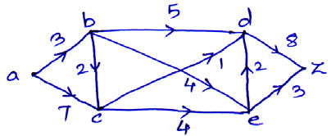
OR
Q6)a) Construct Binary search Tree :
21, 28, 14, 18, 11, 32, 25, 23, 37, 27, 5, 15, 19, 30, 12, 26.
After constructing the BST, determine the following tree traversals :[7] i) Inorder Traversal
ii) Preorder Traversal
iii) Postorder Traversal
b)
For the following graph find different cut set and identify the max flow in given network? [7]
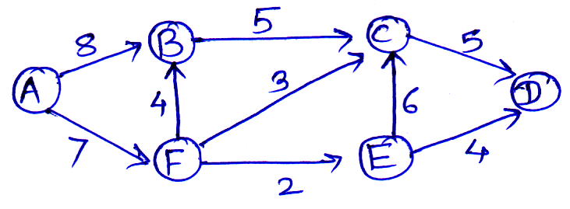
[6582]-253 2
https://t.me/SPPU_TE_BE_COMP

Q7)a) Using Difkstra's Algorithm, determine the shortest path from vertex o to vertex 4 in the given weighted graph. [7]
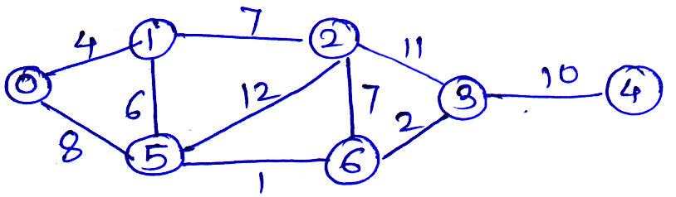
b) Using Kruskal's Algorithm, construct the Minimum Spanning Tree (MST). For the weighted graph shown below. [7]
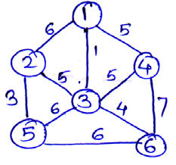
OR
Q8)a) | Explain the following concepts : |  | [7]
Q8)a) | i) | Euler path and Euler circuit | [7]
Q8)a) | ii) | Hamilton path and Hamilton circuit | [7]
For the given graph, determine whether it. Contains an Eulerian circuit,an Eulerian path, a Hamiltonian circuit or a Hamiltonian path. Provide proper justification.
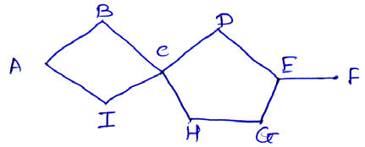
b) Using Prim's Algorithm, find the Minimum Spanning Tree (MST) of the weighted graph shown below. [7]
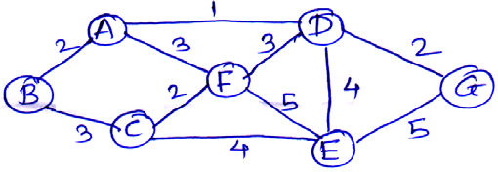
[6582]-253 3
https://t.me/SPPU_TE_BE_COMP

Q9)a) A committee of 5 members is to be formed from 7 men and 6 women.
In how many ways can be committee be selected if it must contain at
least 3 men? [5]
b) How many 4- letter words with or without meaning, can be formed out of
the letters of the word, 'LOGARITHMS', if repetition of letters is not
c) | allowed? | [5]
c) | Prove that the set Z of all integers forms an abelian group under the
c) | binary operation * defined by a * b = a + b + 1 for all a, b ∈ z. | [4]
OR
Q10)a) How many 4 digit number can be formed by using the digits 1 to 9.[5]
i) If repetition of digits is not allowed?
ii) If repetition of digits is allowed?
b) Find the 8th term in the binomial expansion of (x + y)13. [5]
c) Define the following algebraic concepts. [4]
i) Properties of binary operation
ii) Semi-group
♦♦♦
[6582]-253 4
https://t.me/SPPU_TE_BE_COMP

Total No. of Questions :10] PE3921

[6582]-254
S.E. (Computer Science)

MDM-221-CSC: DIGITAL ELECTRONICS AND LOGIC
DESIGN
(2024 Pattern) (Semester-III)
Time : 2½ Hours] [Max. Marks : 70
Instructions to the candidates:
1) Solve Q.1 or Q.2, Q.3 or Q.4, Q.5 or Q.6, Q.7 or Q.8, Q.9 or Q.10.
2) Neat diagrams must be drawn wherever necessary.
3) Figures to the right indicate full marks.
4) Assume suitable data if necessary.
Q1)a) Define Number System and Convert Decimal to Binary, Octal,
Hexadecimal. [5]
i) (174)2
ii) (247)8
iii) (95.5)16
b) Minimize the following Boolean expression using a K-map and realize it
using the basic gates Y=∑m (1,5,7,9,11,13,15). [5]
c) Minimize the function in POS form and also draw the diagram [4]
F(A,B,C, D)=ΠM (0,1,3,5,6,7,9,10,15)
OR
Q2)a) | Define Boolean Algebra and State and Prove Demorgan’s theorem | [5]
Simplify the Boolean Function 1) F= AB+ A'B+ AB' 2) F= (A+B) (A+C)
b) Minimize the following Boolean expression using K-map and realize[5]
it using the basic gates Y=∑m (0,2,4,5,6,7,8,10,13,15)
c) Simplify the following Function F (A,B,C,D)=
∑m (1,5,7,13,15)+d(0,6,12,14) [4]
Q3)a) What is an Adder and explain the Half Adder with a suitable diagram? [5]
b) Explain 8:1 Multiplexer and implement the following function using 8:1
Multiplexer [5]
F(A,B,C,D)=∑m(2,4,5,7,10,14)
c) | Write a short note on Encoder and Decoder. | [4]
OR
P.T.O. P.T.O.
https://t.me/SPPU_TE_BE_COMP

Q4)a) Design and Explain Full subtraction with the help of two Half-Subtractors.
[5]
b) Define a Multiplexer and explain an 8:1 Multiplexer. [5]
c) Design a BCD to 7 Segment Display Controller and explain an example.
[4]
Q5)a) | Define Latch and Flip-Flop and convert Flip-Flop |  | [5]
Q5)a) | i) | JK TOD | [5]
Q5)a) | ii) | DTOT | [5]
b) | Differentiate between Asynchronous and Synchronous Counter. |  | [5]
c) | Explain the Shift Register with types. |  | [4]
OR
Q6)a) Distinguish between Combinational and Sequential Circuits and write an
example. [5]
b) Design and explain a 3-bit synchronous Up Counter. [5]
c) Explain the working of the JK Flip-Flop with a neat block diagram and
Truth table. [4]
Q7)a) What is VHDL? Explain different Modelling Styles in VHDL. [7]
b) Explain difference between Concurrent and Sequential statements in VHDL
with examples. [7]
OR
Q8)a) What are Data Objects in VHDL? Explain Signal Variable and Constant
with examples. [7]
b) Write VHDL code for a simple 4:1 Multiplexer using behavior modelling
[7]
Q9)a) | Explain CPLD Architecture. | [7]
b) | Explain the fundamentals of Digital Signal Processing. | [7]
OR
Q10)a) Explain the block diagram for the Microcontroller and explain how it
works? [7]
b) What is an FPGA and How does it differ from a Microcontroller? [7]
  
[6582]-254 2
https://t.me/SPPU_TE_BE_COMP

Total No. of Questions : 10] | [6582]-256 | SEAT No. :
PE5734 | [6582]-256 | SEAT No. :
PE5734 | [6582]-256 | [Total No. of Pages : 2
S.E. (Electrical Engineering)
PCC-201-ELE : ELECTRICAL MEASUREMENTS &
INSTRUMENTATION
(2024 Pattern) (Semester - III)
Time : 2½ Hours] [Max. Marks : 70
Instructions to the candidates:
1) Attempt any one from Q1 and Q2, Q3 and Q4, Q5 and Q6, Q7 and Q8, Q9 and Q10.
2) Figures to the right indicate full marks.
3) Neat diagrams must be drawn wherever necessary.
4) Assume suitable data, if necessary.
5) Use of Non-programmable calculator is allowed.
Q1)a) Describe the construction and working of the permanent magnet moving
coil (PMMC) instrument with a suitable diagram. [8]
b) Define the following terms for the current transformer (CT) and potential
transformer (PT). [6]
i) Nominal ratio
ii) Turns ratio
iii) Burden
OR
Q2)a)  b)  Q3)a)  b) | Which three forces are required for satisfactory operation of an analog
Q2)a)  b)  Q3)a)  b) | indicating instrument? State the function of each force. |  |  |  |  |  |  |  |  |  |  |  |  |  |  |  |  |  | [8]
Q2)a)  b)  Q3)a)  b) | Find the deflection of the moving iron ammeter having the following data : Spring control constant = 8 × 10–6(Nm/rad), Current = 6(A)
Q2)a)  b)  Q3)a)  b) | L = 6 + 3θ – 0.5θ2 (μH). |  |  |  |  |  |  |  |  |  |  |  |  |  | [6]
Q2)a)  b)  Q3)a)  b) | Draw the circuit diagram of Kelvin’s double bridge. Derive an expression
Q2)a)  b)  Q3)a)  b) | for unknown resistance with usual notations. |  |  |  |  |  |  |  |  |  |  |  |  |  | [8]
Q2)a)  b)  Q3)a)  b) | The four impedances of an bridge are |  |  |  |  |  |  |  | Z  1 |  | = | 400 |  | Ω∠50º, | Z | 2 | = | 200Ω∠30º,
Q2)a)  b)  Q3)a)  b) | Z=3 | 800 | Ω∠− | 50º | and | Z=4 | 400 | Ω∠− |  | 40º |  |  | Find out weather the bridge
Q2)a)  b)  Q3)a)  b) | is balanced under this condition. |  |  |  |  |  |  |  |  |  |  |  |  |  | [6]
OR
P.T.O.
https://t.me/SPPU_TE_BE_COMP

Q4)a)  b)  Q5)a)  b) | A Maxwell’s Bridge is used to measure an unknown inductance in comparison with capacitance. The various values at balance are R2 = 400Ω, R3 = 600Ω, R4 = 1000Ω, in parallel with C4 = 0.5μF, Calculate the values of R1 and L1. Also calculate the values of Q factor of coil if
Q4)a)  b)  Q5)a)  b) | frequency is 1000Hz. | [8]
Q4)a)  b)  Q5)a)  b) | Explain the construction and working principle of a megger with a neat
Q4)a)  b)  Q5)a)  b) | diagram. | [6]
Q4)a)  b)  Q5)a)  b) | Draw and explain the working principle of the dynamometer-type wattmeter
Q4)a)  b)  Q5)a)  b) | and derive its torque equation. | [8]
Q4)a)  b)  Q5)a)  b) | An energy meter with a constant of 3200 impulses per kWh makes 1600
impulses in 30 minutes when connected to a 220 V, 5 A circuits. Calculate the error percentages for power factor is 1. [6] OR
Q6)a) With a neat block diagram, explain the operation of a single-phase static energy meter and list out its two advantages. [8] b) Two wattmeter connected to measure power supplied in a three-phase 500(V) circuit indicate a total input power of 10(kW). The power factor is 0,4. Find [6] i) Line current
ii) Reading of both the wattmeter.
Q7)a) Explain the construction and working of a piezoelectric sensor. State its advantages and applications in vibration and pressure measurement.[8] b) With neat block diagram, explain the ultrasonic method of level measurement. [6] OR
Q8)a) With a neat diagram, explain the construction and working of an LVDT (Linear Variable Differential Transformer) and list out its two advantages.
[8] b) Explain the construction and working principle of a McLeod Gauge with a neat diagram. [6]
Q9)a) Explain the operation of a Digital Storage Oscilloscope (DSO) with a neat block diagram and list out its any two applications. [8] b) Compare the performance of analog and digital measuring instruments.
[6] OR
Q10)a) Explain the construction and operation of a Digital Multimeter with a neat block diagram and list out its any two applications. [8] b) Write short notes on the Resolution and Sensitivity of digital meters. [6]

[6582]-256 2
https://t.me/SPPU_TE_BE_COMP

Total No. of Questions : 10] | [6582]-257 | SEAT No. :
PE5735 | [6582]-257 | SEAT No. :
PE5735 | [6582]-257 | [Total No. of Pages : 2
S.E. (Electrical)
PCC-202-ELE : ANALOG & DIGITAL ELECTRONICS
(2024 Pattern) (Semester-III)
Time : 2½ Hours] [Max. Marks : 70
Instructions to the candidates:
1) Attempt any one from Q.1 or Q.2, Q.3 or Q.4, Q.5 or Q6, Q.7 or Q8, Q9 or Q10.
2) Figures to the right indicates full marks.
3) Assume Suitable data if necessary.
4) Use of non-programmable calculator is allowed.
Q1)a) What is SOP form of reduction. Mention an example of non-standard
form of SOP and convert it to standard form. [6]
b) Along with K-map design a 2*4 decoder circuit. Draw logic diagram.[8]
OR
Q2)a) Compare combinational and sequential circuits. [6]
b) Along with K-map design a full adder circuit. Draw its logic diagram.[8]
Q3)a) Mention the steps to design the counter. [6]
b) Draw a 3 bit SISO right shift register & explain its working with timing
diagram. [8]
OR
Q4)a) With neat diagram explain the shifting of data in various types of shift
registers. [6]
b) Explain with the neat diagram working of 3 bit Ring counter. [8]
Q5) a) Explain OPAMP as voltage to current converter. [6]
b) Explain working of OPAMP as instrumentation amplifier. State any two
applications for IA. [8]
OR
P.T.O.
https://t.me/SPPU_TE_BE_COMP

Q6)a) Explain op-amp as zero crossing detector. Draw neat waveforms. [6]
b) With the help of neat diagrams, explain OPAMP as peak detector. [8]
Q7)a) With the frequency response explain the types of filters. Also explain
cut-off frequency. [6]
b) Explain the operation of IC555 as astable multivibrator along with
waveforms. [8]
OR
Q8)a) Explain the function of LM 317 as adjustable voltage regulator. [6]
b) Explain High pass filter using op-amp with its frequency response.[8]
Q9)a) Compare single phase full ware centre tapped and bridge rectifier
circuits.(Minimum 6 points) [6]
b) Explain in detail the working of centre tapped rectifier connected to the
R-L load. [8]
OR
Q10)a) Explain in detail the working of single phase half wave diode rectifier
with R Load. [6]
b) With the help of circuit diagram and relevant waveforms, explain the
operation of a 3-phase bridge rectifier with resistive load. [8]
eeee
[6582]-257 2
https://t.me/SPPU_TE_BE_COMP

Total No. of Questions : 10] PE5736

[6582]-258
S.E. (Electrical Engg.)

PCC-203-ELE : POWER SYSTEM ENGINEERING - I (2024 Pattern) (Semester - III)
Time : 2½ Hours] [Max. Marks : 70 Instructions to the candidates:
1) Attempt Q1 or Q2, Q3 or Q4, Q5 or Q6, Q7 or Q8, Q9 or Q10.
2) Figures to the right indicate full marks.
3) Neat diagrams must be drawn wherever necessary.
4) Assume suitable data, if necessary.
5) Use of non-programmable calculator is allowed.
Q1)a) What is mean by interconnected system? State the advantages and disadvantages of interconnected system. [6]
b) A consumer has a maximum demand of 200 kW at 40% load factor. If the tariff is Rs. 100 per kW of maximum demand plus 10 paise per kWh, find the overall cost per kWh. [8]
OR
Q2)a) Write a short note on : Time of Day (ToD) tariff for L.T commercial consumers. [6]
b) A residential consumer has the following connected load : 5 bulbs of 100W each, 6 fans of 60W each and 4 light plug points of 100W each.
His use of electricity during a day is as under : | [8]

12 Midnight to 5 AM | 2 Fan
5AM to 7AM | 2 Fans and 1 Light point
7AM to 9AM | Nil
9AM to 6PM | 4 Fans
6PM to Midnight | 2 Fans and 4 Bulbs
Find the connected load, maximum demand and demand factor.
P.T.O.
https://t.me/SPPU_TE_BE_COMP

Q3)a) Enlist the main components of overhead lines, and discuss any two in detail. [6]
b) A 132 kV transmission line has the following data : Wt. of conductor = 780 kg/km; Length of span = 250 m; Ultimate strength = 3500 kg; Safety factor = 2, Calculate the height above ground at which the conductor should be supported. Ground clearance required is 12 metres. [8]
OR
Q4)a) Write a short note on : Methods of improving string efficiency. [6]
b) Each line of a 3-phase system is suspended by a string of 3 similar insulators. If the voltage across the line unit is 17.5 kV, calculate the line to neutral voltage. Assume that the shunt capacitance between each insulator and earth is 1/8th of the capacitance of the insulator itself. Also find the string efficiency. [8]
Q5)a) State proximity effect, enlist the factors responsible for proximity effect.[6]
b) Derive an expression for the inductance of three phase overhead transmission line with symmetrical spacing considering transposition.[8]
OR
Q6)a) A single phase line has two parallel conductors 1m apart. The diameter of each conductor is 0.5cm. Calculate the inductance per km of the line. [6]
b) Derive an expression for internal and external flux linkages due to single current carrying conductor. [8]
Q7)a) Derive an expression for capacitance of a single phase overhead line.[6]
b) A 3-phase overhead transmission line has its conductors arranged at the corners of an equilateral triangle of 3 m side. Calculate the capacitance of each line conductor per km. Given that diameter of each conductor is 1.75cm. [8]
OR
Q8)a) A single phase transmission line has two parallel conductors 4 meters apart, radius of each conductor being 2 cm. Calculate the capacitance of line per km. Given that ε0 = 8.854 × 10−12 F/m. [6]
b) Derive the expression of capacitance of 3-phase overhead line with symmetrical spacing considering transposition. [8]
[6582]-258 2
https://t.me/SPPU_TE_BE_COMP

Q9)a) Obtain the relationship between sending end voltage and current in terms
of receiving end voltage and current for a medium transmission line using
‘nominal Π’ method. Draw a neat phasor diagram. [6]
b) A 3-phase, 50 Hz, 150 km line has a resistance, inductive reactance and
capacitive shunt admittance of 0.1 Ω, 0.5 Ω and 3 ×10–6Ω per km per
phase. If the line delivers 50 MW at 110 kV and 0.8 p.f. lagging, determine
the sending end voltage and current. Assume a nominal π circuit for the
line. [8]
OR
Q10)a) Derive an expression for ABCD constants of medium transmission line.[6]
b) A single phase overhead transmission line delivers 1200kW at 33kV at
0.85pf lagging. The total resistance and inductive reactance of the line are
12 Ω and 15 Ω respectively. [8]
Determine
i) sending end voltage
ii) line losses
iii) transmission efficiency
  
[6582]-258 3
https://t.me/SPPU_TE_BE_COMP

Total No. of Questions : 6] PE5783

[6582]-259
S.E. (Electrical)

MDM-222-ELE : ENGINEERING MATHEMATICS - III (2024 Pattern) (Semester - III)
Time : 2½ Hours] [Max. Marks : 70 Instructions to the candidates:
1) | All questions are compulsory. |  |  |  |  |  |  |  |  |  |  |  |  |  |  |  |  |  |  |  |  |  |  |  |  |  |  |  |  |  |  |  |  | [2]
2) | Figures to the right indicate full marks. |  |  |  |  |  |  |  |  |  |  |  |  |  |  |  |  |  |  |  |  |  |  |  |  |  |  |  |  |  |  |  |  | [2]
3) | Use of electronic pocket calculator is allowed. |  |  |  |  |  |  |  |  |  |  |  |  |  |  |  |  |  |  |  |  |  |  |  |  |  |  |  |  |  |  |  |  | [2]
4) | Assume suitable data, if necessary. |  |  |  |  |  |  |  |  |  |  |  |  |  |  |  |  |  |  |  |  |  |  |  |  |  |  |  |  |  |  |  |  | [2]
5) | Neat diagrams must be drawn wherever necessary. |  |  |  |  |  |  |  |  |  |  |  |  |  |  |  |  |  |  |  |  |  |  |  |  |  |  |  |  |  |  |  |  | [2]
Q1)Write the correct option of the following MCQs. |  |  |  |  |  |  |  |  |  |  |  |  |  |  |  |  |  |  |  |  |  |  |  |  |  |  |  |  |  |  |  |  |  | [2]
a) | Particular Integral of differential equation (D2 –2D +1)y = e2x is |  |  |  |  |  |  |  |  |  |  |  |  |  |  |  |  |  |  |  |  |  |  |  |  |  |  |  |  |  |  |  |  | [2]
i) |  |  |  | 1 |  | e |  | 2 | x |  |  |  |  |  |  |  |  | ii) |  |  |  |  |  |  | − |  | 1 |  | e |  | 2 | x |  | [2]
 |  |  |  | 2 |  |  |  |  |  |  |  |  |  |  |  |  |  |  |  |  |  |  |  |  |  |  | 2
iii) |  | e |  |  | 2x |  |  |  | iv) |  |  |  |  |  |  |  |  |  |  |  |  |  |  |  |  | 1 | e |  | 2 | x
 |  |  |  |  |  |  |  |  |  |  |  |  |  |  |  |  |  |  |  |  |  |  |  |  |  | 4 |  |  | 2 |  |  |  |  | [2]
b) | Laplace transform of the function et t2 |  |  |  |  |  |  |  |  |  |  |  |  |  |  |  |  |  |  |  |  |  |  |  |  |  |  |  |  |  |  |  |  | [2]
i) |  |  |  | 2 |  |  |  | ii) |  |  |  |  |  |  |  |  |  |  |  |  |  |  |  |  | (s |  |  | 2 |  |  |  |  | 3 | [2]
 |  |  |  |  |  |  |  |  |  |  |  |  |  |  |  |  |  |  |  |  |  |  |  |  |  |  |  | + |  | 1) |  |  | 3
 |  |  |  | s |  | 2
iii) |  | ( |  |  | s |  | 1 |  |  | ) | 3 |  |  |  |  |  |  |  | iv) |  |  |  |  |  |  | 1
 |  |  |  |  |  |  | − |  | 1
 |  |  |  |  |  |  |  |  |  |  |  |  |  |  |  |  |  |  |  |  |  |  |  |  |  | s | 3 |  |  |  |  |  |  | [2]
c) | If f(k) = sin (3k-2), K≥0 then z–transform of {f(k)} is. |  |  |  |  |  |  |  |  |  |  |  |  |  |  |  |  |  |  |  |  |  |  |  |  |  |  |  |  |  |  |  |  | [2]
i) |  | z |  |  |  | 2 | − |  | z | sin3 |  |  |  |  |  |  |  |  |  |  |  |  |  |  |  |  |  |  |  |  |  |  |  | [2]
 |  |  |  |  |  |  |  |  | 2cos31+
ii) |  | z |  |  |  |  | z | ( | z | − |  | cos3 | )
 |  |  |  |  |  | 2 |  | − | 2cos31+
iii) |  | z |  |  |  | zz( |  |  |  | − |  | sin3 | )
 |  |  |  |  |  | 2 | − |  | 2sin31+
iv) |  |  | z |  | 2 |  | z | sin3cos2 |  |  |  |  |  | − | z | sin 2 |  |  |  | ( | z | − | cos3 | )
 |  |  |  |  |  |  | − |  | 2cos31+ |  |  |  |  |  | z |  | 2 | − | 2cos31+
P.T.O.
https://t.me/SPPU_TE_BE_COMP

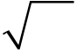
d)  e) | The first & second moments of distribution about value 2 are 1 and 16
d)  e) | than variance of distribution is. |  |  |  |  |  |  |  |  |  |  |  |  |  |  |  |  |  |  | [2]
d)  e) | i) | 15 |  |  |  |  |  |  |  |  |  |  |  |  | ii) |  | 16
d)  e) | iii) | 15 |  |  |  |  |  |  |  |  |  |  |  |  | iv) |  | 4
d)  e) | If scaler point function φ= |  |  |  |  |  |  |  |  |  |  |  |  | xyz | then | ∇ at the point (2,1,–2) is. |  |  |  |  |  |  |  |  |  |  |  |  |  | [2]
d)  e) | i) | 2 | i | + |  | 4 |  | j | + |  | 4 | k |  |  | ii) |  | − | 2 | i |  | − |  | 4 |  | j | − |  | 2 | k
d)  e) | iii) | − | 2 | i | − |  | 4 |  | j | + |  | 2 | k |  | iv) |  | 2 | i | + |  |  | 4 |  | j | + |  | 2 | k
Q2)Attempt the following: (Any 03)
a) | Solve the differential equation.
a) | 3  dy |  |  | − | 7 | dy |  |  | − |  |  | 6 |  | y | = |  | e | 2 |  | x | (1 |  | + |  | x |  | ) | [4]
b) | dx |  | 3 | − | 7 | dx
b) | Use method of Variation of parameters to solve.
b) | ( | D | 2 | − | 2 | D |  | + |  |  | 2 |  | ) | y | = |  | e | x |  | tan. |  |  |  |  |  |  |  | [4]
b) | Solve : |  |  |  |  |  | (2 |  |  | x |  | + |  | 1) | 2 |  | 2  dy |  |  |  |  | − |  | 2(2 |  |  |  | x | + | 1) | dy | − | 12 | y | = | 6 | x | [4]
c) |  |  |  |  |  |  |  |  |  |  |  |  |  |  |  |  | dx |  |  | 2 |  |  |  |  |  |  |  |  |  |  | dx |  |  |  |  |  | x | [4]
c) | Solve : |  |  |  |  |  | dx |  |  |  | = |  |  | dy |  | = |  |  | dz |  |  |  |  |  |  | 2 |  | [4]
d)  e) |  |  |  |  |  |  | y |  | 2 |  |  |  |  | x | 2 |  |  |  | 2 2  xyz
d)  e) | An electric circuit consists of an inductance 0.1 henry, a resistance R of
20 ohms & a condenser of capacitance C of 25 micro farads. If the
 | L | 2  dq |  | + | R | dq | + | q | =
differential equation of electric circuit is |  | dt | 2 |  |  | dt |  | c | then find
the charge q & current i atany time t, give that at t=0, q=0.05 coulumbs,
i | = | dq | =
 |  | dt | when t = 0. | [4]
Q3)Attempt any three of the following.
a) | Obtain Laplace transform of 1 | − | cost |  |  |  |  |  |  |  |  |  |  |  |  |  | [4]
 | Obtain Laplace transform of 1 |  | t |  |  |  |  |  |  |  |  |  |  |  |  |  | [4]
b) | −t  Obtain Laplace transform of ecos |  |  | t |  |  |  |  |  |  |  |  |  |  |  |  | [4]
c) | Obtain Inverse Laplace transform of |  |  |  |  |  | s | + |  | 7 |  |  | 2 |  |  |  | [4]
c) |  |  |  |  | s | 2 | + | 2 |  | s |  | + |  |  |  |  | [4]
d) | Obtain Inverse Laplace transform of |  |  |  | 2 |  |  | s | 2 |  | − |  | 6 | s | + | 5 | [4]
d) |  |  |  |  | (s1)(s2)(s3)−−− |  |  |  |  |  |  |  |  |  |  |  | [4]
[6582]-259 |  | 2 |  |  |  |  |  |  |  |  |  |  |  |  |  |  | [4]
https://t.me/SPPU_TE_BE_COMP

e) | Using Laplace transform solve the differential equation | [4]
y''–y = e–t
y(0) = 0,
y'(0) = 0
Q4)Solve Any Three.
a) | Find fourier sine transform of |  |  |  |  |  |  |  |  |  |  |  |  |  |  |  |  |  |  |  |  |  | [4]
a) | fx () | ⎧=⎨  ⎩ | x | 0 |  | ≤ |  | x | < | 1 |  |  |  |  |  |  |  |  |  |  |  |  | [4]
b) | fx () | ⎧=⎨  ⎩ | 0 |  |  | x |  | > | 1 |  |  |  |  |  |  |  |  |  |  |  |  |  | [4]
b) | Using inverse fourier cosine transform find f(x) for |  |  |  |  |  |  |  |  |  |  |  |  |  |  |  |  |  |  |  |  |  | [4]
c) | F() c λ |  |  | = |  | e | − | λ  , | λ |  | > | 0 |  |  |  |  |  |  |  |  |  |  | [4]
c) | Find z–transform of |  |  |  |  |  |  |  |  |  |  | fk () |  |  | = | e | −2 | k | cos3, kk |  | ≥ | 0 | [4]
d) |  |  |  |  |  |  |  |  |  |  |  |  |  |  |  |  |  |  |  |  |  |  | [4]
d) | Find inverse z– transform of |  |  |  |  |  |  |  |  |  |  |  |  |  |  |  |  |  |  |  |  |  | [4]
d) | F()= |  |  |  | z | − |  | z |  | 2 | − | y |  | 1 ,  )2 | < | z |  | < |  | 1 |  |  | [4]
e) |  |  |  | ( | z |  |  | 1)( |  | z | − | y | 2 |  |  |  |  |  |  |  |  |  | [4]
e) | Solve the difference question: |  |  |  |  |  |  |  |  |  |  |  |  |  |  |  |  |  |  |  |  |  | [4]
f (k+1) – f (k) = (2)k, k ≥0, f (0) = 0
Q5)Attempt the following: (Any 03)
a) The first four moments about the working mean 30.2 of a distribution
are 0.255, 6.222, 30.211, 400.25. Calculate the first four moments
about the mean. Also evaluate ββ. 1 2 [4]
b) From a group of 10 students, marks obtained by each in papers of
mathematics (x) & mechanics (y) are given as: [4]
x 23 28 42 17 26 35 29 37 16 46
y 25 22 38 21 27 39 24 32 18 44
calculate Karl Pearson’s coefficient of correlation.
c) Obtain regression lines for the following data: [4]
x 6 2 10 4 8
y 9 11 5 8 7
[6582]-259 3
https://t.me/SPPU_TE_BE_COMP

d) 20%of bolts produced by a machine are defective. Determine the
probability that out of 4 bolts chosen at random. [4]
i) 1 is defective
ii) at most 2 bolts are defective
e) In a normal distribution 10% of items are under 40 and 5% are over 80.
Find the mean and standard deviation of distribution. [4]
[Given A= 0.4, Z=1.29, A= 0.45, Z =1.65]
Q6)Solve any three:
a) | Find directional derivative of φ= x |  |  |  |  |  |  |  |  |  |  |  |  |  |  |  |  |  | 2 | − |  | y |  | 2 | − |  | 2 |  | z | 2 | at the point P(2,–1,3) in
a) | the direction of |  |  |  |  |  | u | = | 3 i |  | + | 7 |  | + | k |  |  |  |  |  |  |  |  |  | [4]
b)  c) |  |  |  |  |  |  |  |  |  |  |  |  | j | +
b)  c) | Show that the vector field F = ( |  |  |  |  |  |  |  |  |  |  |  |  |  |  |  |  |  |  |  |  |  |  | y |  | + |  | zi |  |  |  | + | ( | z | + | xj | + |  | ( | x | + |  | yk | is
b)  c) | irrotational. Find scalar potential function φ such that F=φ |  |  |  |  |  |  |  |  |  |  |  |  |  |  |  |  |  |  |  |  |  |  |  |  |  |  |  |  |  |  |  |  |  |  |  |  |  |  |  |  | [4]
b)  c) | Prove: | ∇ | 2 | 2  (rlog r) |  |  |  |  | = | 5 | + |  | 6log(r) |  |  |  |  |  |  |  |  |  |  |  | [4]
b)  c) | Evaluate F.∫  c |  |  |  | dr |  | where |  |  |  |  | 2  F = xi |  |  |  |  | yzj |  |  | + |  |  | zk |  | along the curve ‘c’ given by
d) |  |  |  |  |  |  |  |  |  |  |  |  |  |  |  | +
d) | x =2t, y =t, z =3t where t varies from t=0 to t=1. |  |  |  |  |  |  |  |  |  |  |  |  |  |  |  |  |  |  |  |  |  |  |  |  |  |  |  |  |  |  |  |  |  |  |  |  | [4]
d) | Apply stoke’s theorem to evaluate |  |  |  |  |  |  |  |  |  |  |  |  |  |  |  |  | ∫∫ |  |  | (∇× |  |  |  | F).ds |  |  |  |  |  |  | where |  |  |  |  |  |  |  | [4]
e)
e) | s
e) | F =3(-) xyi |  |  |  | + | 2 | xzj |  | + |  | xyk |  |  | and ‘S’ is the surface x2+ y2 –2z = 4 above the
plane z=0
  
[6582]-259 4
https://t.me/SPPU_TE_BE_COMP

Total No. of Questions : 8] PE-5958 | SEAT No. :
Total No. of Questions : 8] PE-5958 | [Total No. of Pages : 2
[6582]-260
S.E. (Electrical Engineering)
VEC-232-ELE : UNIVERSAL HUMAN VALUES &
PROFESSIONAL ETHICS
(2024 Pattern) (Semester - III)
Time : 2 Hours] [Max. Marks : 35
Instructions to the candidates:
1) Attempt any one from Q1 or Q2, Q3 or Q4, Q5 or Q6, Q7 or Q8.
2) Figures to the right indicate full marks.
3) Neat diagrams must be drawn wherever necessary.
Q1)a) What are two domains of Value education? Define them as discussed
in the course. [2]
b) What is the Basic Human Aspiration? Is it the same for everyone?[3]
c) Explain the content and process of Self-exploration with the help of
diagram. [3]
OR
Q2)a) Define Happiness and Prosperity as discussed in the course. [2]
b) How ‘human consciousness’ is different than ‘animal consciousness’?[3]
c) Why is right understanding required in relationship for mutual
happiness? Explain with the two examples from your life. [3]
Q3)a) What is a Human Being? What are their needs? [2]
b) List the three sources, of imagination in the self and illustrate the same
with the help of a diagram. [3]
c) Explain how desires, thoughts and expectations when largely set by
pre conditionings or sensations leads to conflicts. [4]
OR
Q4)a) | Define Self-Regulation and Health. | [2]
b) | ‘Body is the instrument of the self. Explain. | [3]
P.T.O.
https://t.me/SPPU_TE_BE_COMP

c) Differentiate between the needs of the Self and Body with a suitable
diagram, based on the following parameters -[4]
i) Are they temporary or continuous
ii) Quality and quantity
iii) Fulfilment
Q5)a) Define Trust as a foundation value and Love as complete value. [2]
b) Is it possible to live in a relationship without understanding the
relationship? How is a family, the basic ground for understanding
relationships? Explain. [3]
c) What ‘Respect’ is as discussed in the course? What are the wrong
evaluations we generally do in the absence of right evaluation, explain
with suitable examples. [4]
OR
Q6)a) Define the term ‘Justice’ in the context of harmony in the family.[2]
b) Distinguish between Reverence, Glory and Gratitude. [3]
c) List down the comprehensive human goals to ensure harmony in the
society. What are the goals that can be achieved through the dimensions
of production and work? [4]
Q7)a) Explain the term ‘Submergence’ with respect to coexistence in existence.
[2]
b) What is Utility value and Artistic value? Explain with example. [3]
c) What are the four orders in Nature? Demonstrate their
interconnectedness and mutual fulfilment with the help of diagram.
Explain problems arises from Human Order due to the lack of the
right understanding. [4]
OR
Q8)a) What are the characteristics of 'Space'? [2]
b) What is the role of material order and bio-order in the fulfilment of
human needs? How does understanding of existence help in right
identification of the above? [3]
c) What do you mean by Ethical Human Conduct? Illustrate the same in
terms of Values, Policy and Character. [4]

[6582]-260 2
https://t.me/SPPU_TE_BE_COMP

Total No. of Questions : 10] | [6582]-262 | SEAT No. :
PE5737 | [6582]-262 | SEAT No. :
PE5737 | [6582]-262 | [Total No. of Pages : 2
S.E. (E & C - Advanced Communication Technology) PCC-203-ECA : ANALOG COMMUNICATION (2024 Pattern) (Semester-III)
Time : 2½ Hours] [Max. Marks : 70 Instructions to the candidates:
1) | Answer Q.1 or Q.2, Q.3 or Q.4, Q.5 or Q.6, Q.7 or Q.8, Q.9 or Q.10. | [7]
2) | Neat diagrams must be drawn wherever necessary. | [7]
3) | Use of non-programmable calculator is allowed. | [7]
4) | Assume Suitable data if necessary. | [7]
Q1)a) | Explain types of signals with suitable examples. | [7]
b) | Draw & explain the block diagram of a communication system. | [7]
OR
Q2)a)  b)  Q3)a)  b) | Define Fourier transform and obtain Fourier transform of the signal,
Q2)a)  b)  Q3)a)  b) | X(t) = e–5t. u(t) |  | [7]
Q2)a)  b)  Q3)a)  b) | Define signal and explain the following signals with an example. |  | [7]
Q2)a)  b)  Q3)a)  b) | i) | Deterministic signal
Q2)a)  b)  Q3)a)  b) | ii) | Periodic signal
Q2)a)  b)  Q3)a)  b) | iii) | Digital signal
Q2)a)  b)  Q3)a)  b) | Explain the working of super heterodyne AM receiver with help of neat
Q2)a)  b)  Q3)a)  b) | block diagram. |  | [7]
Q2)a)  b)  Q3)a)  b) | Calculate power saving for DSB-SC signal for the percentage modulation
Q2)a)  b)  Q3)a)  b) | of i) 100% ii) 50 %. |  | [7]
OR
Q4)a) Explain the working of phase shift module with help of neat block diagram. [7]
b) Explain vestigial sideband modulation with help of neat block diagram.[7]
P.T.O.
https://t.me/SPPU_TE_BE_COMP

Q5) a) | A frequency modulated signal is given by | [7]
Xc= l0cos (2π × 108t)+sine (2π × 200t)
Determine:
i) The carrier frequency
ii) Peak frequency deviation
iii) The modulation Index
b) Explain FM generation by Armstrong method with help of neat block
diagram. [7]
OR
Q6)a) Explain in detail FM detection using Phase lock loop (PLL) with help of
block diagram. [7]
b) Compare frequency modulation & phase modulation. [7]
Q7)a) What is Nyquist criterion? State sampling theorem in time domain. Draw
the spectrum aliasing and guard band. [7]
b) Explain the concept of Time Division Multiplexing with help of neat
diagram. [7]
OR
Q8)a) Explain different types of sampling with help of neat diagram. [7]
b) Describe SSB generation using filter method & phase shift method.[7]
Q9)a) Draw the following data formats of bit stream 10110100 [8]
i) unipolar RZ
ii) unipolar NRZ,
iii) polar RZ
iv) Polar NRZ.
b) Explain delta modulation with diagram. [6]
OR
Q10)a) What is Quantization? Explain mid tread quantizer and mid-ris quantizer.
[8]
b) | Explain Adaptive delta modulation with diagram. | [6]
eeee
[6582]-262 2
https://t.me/SPPU_TE_BE_COMP

Total No. of Questions : 10] |  | SEAT No. :
PE5738 | [6582]-266  S.E. (E & CE/Internet of Things) |  | [Total No. of Pages : 2
PCC-201-ECE : ANALOG AND DIGITAL ELECTRONICS CIRCUITS
(2024 Pattern) (Semester - III)
Time : 2½ Hours] [Max. Marks : 70
Instructions to the candidates:
1)  2)  3)  4)  5)  Q1)a)  b)  c) | Attempt Q1 or Q2, Q3 or Q4, Q5 or Q6, Q7 or Q8, Q9 or Q10. Figures to the right indicate full marks.  Neat diagrams must be drawn wherever necessary.  Use of electronic pocket calculator is allowed. Assume suitable data, if necessary.  Draw and explain the construction N or P channel EMOSFET and its
1)  2)  3)  4)  5)  Q1)a)  b)  c) | working with its drain and transfer characteristics. | [8]
1)  2)  3)  4)  5)  Q1)a)  b)  c) | Calculate the drain current and drain to source voltage of a common source circuit with N-channel E-MOSFET. Assume R1 = 100MΩ, R2 = 50MΩ, RD = 1KΩ, RS = 200Ω, VDD = 15V, VTH = 2V and
1)  2)  3)  4)  5)  Q1)a)  b)  c) | KN = 50mA/V2. | [4]
1)  2)  3)  4)  5)  Q1)a)  b)  c) | Explain any one non ideal characteristics in EMOSFET. | [2]
OR
Q2)a) b) c)  Q3)a)  b)  c) | Draw and explain frequency response of CS amplifier with amplifier ckt
Q2)a) b) c)  Q3)a)  b)  c) | diagram. | [8]
Q2)a) b) c)  Q3)a)  b)  c) | Explain body effect in EMOSFET. | [2]
Q2)a) b) c)  Q3)a)  b)  c) | Determine ID and VDS for a common source amplifier with N-channel E-MOSFET. Assume R1 = 50MΩ, R2 = 25MΩ, RD = 500Ω, RS = 200Ω, VDD = 10V, VTH = 2V and KN = 50mA/V2. [4]  State the Barkhausen criteria to get sustained oscillations. For RC phase shift oscillator, if R1 = R2 = R3 = 220KΩ and C1 = C2 = C3 = 250pF,
Q2)a) b) c)  Q3)a)  b)  c) | determine frequency of oscillation. | [6]
Q2)a) b) c)  Q3)a)  b)  c) | Explain E-MOSFET as CMOS inverter with truth table. | [4]
Q2)a) b) c)  Q3)a)  b)  c) | Draw and explain the working of comparator using operational amplifier.
[4]
OR
Q4)a) Draw and explain triangular waveform generator with input and output
waveforms at various stages. [6]
b) Draw and explain any one LC oscillator. [4]
c) Define any four performance parameters of operational amplifier. [4]
P.T.O.
https://t.me/SPPU_TE_BE_COMP

Q5)a) | Draw and explain asynchronous UP-DOWN counter. | [6]
b) | Draw and explain 1:8 DEMUX with its truth table. | [4]
c) | Compare asynchronous and synchronous sequential circuits. | [4]
OR
Q6)a) Draw and explain working of 3-bit synchronous UP-DOWN counter.[6]
b) Compare combinational and sequential circuits. [4]
c) Draw 8:1 MUX using 4:1 mux with its truth table. [4]
Q7)a) Draw the architecture of CPLD and explain the function of each block.[6]
b) Define : [4]
i) Fan-In
ii) Figure of merit
c) Explain Moore Machines. [4]
OR
Q8)a) Draw the architecture of FPGA and explain the function of each block.[6]
b) Compare between PROM and ROM. [4]
c) State and explain following with respect to digital logic circuit. [4]
i) Speed
ii) State diagram
Q9)a) Explain traffic light controller using state diagram. [6]
b) Explain successive approximation type of ADC. [4]
c) Draw and explain triangular waveform generator. [4]
OR
Q10)a) | Draw and explain square waveform generator. | [6]
b) | Explain R-2R ladder type of DAC. | [4]
c) | Explain any 2 performance parameters of ADC. | [4]

[6582]-266 2
https://t.me/SPPU_TE_BE_COMP

Total No. of Questions : 10] | [6582]-267 | SEAT No. :
PE5739 | [6582]-267 | SEAT No. :
PE5739 | [6582]-267 | [Total No. of Pages : 3
S.E. (Electronics and Computer Engineering)
PCC-202-ECE : DATA STRUCTURE & ALGORITHMS
(2024 Pattern) (Semester-III)
Time : 2½ Hours] [Max. Marks : 70
Instructions to the candidates:
1) Answer Q.1 or Q.2, Q.3 or Q.4, Q.5 or Q.6, Q.7 or Q.8, Q.9 and Q.10.
2) Figures to the right indicate full marks.
3) Assume Suitable data if necessary.
Q1)a) What is Function Overloading? Write a program to illustrate it. [7]
b) Write a program of Student Class and use parameterized constructor to
set the values and use display function to display the values. [7]
OR
Q2)a) What is Parameter Passing? Explain with Example Parameter passing in
C++. using pass by value and pass by reference. [7]
b) What is Constructor? Explain its types with Syntax. [7]
Q3)a) Compare linear search and binary search. Write an algorithm to search
elements in a list using Binary Search. [7]
b) Explain steps of Insertion Sort and Write a program to sort 5, 3, 8, 6, 2
using insertion sort. [7]
OR
Q4)a) Write a Program to Search key element 10 from given integer array. 38,
27, 43, 3, 9, 82, 10. What will be time complexity of the program. [7]
b) Explain Selection sort in details. Consider integer array elements 7 4 9 8
2. [7]
P.T.O.
https://t.me/SPPU_TE_BE_COMP

Q5) a) Write a difference between Array and Linked list. Write a search function
to search a key element in singly linked list. Using linear Search. [8]
b) What is a doubly linked list? Write a C++ function for Inserting a number
at the end of the doubly linked list. [6]
OR
Q6)a) Draw and Explain Structure of Circular linked list. Write a ‘CPP’ function
for Inserting a number at the front of the circular linked list. [8]
b) Write following C++ functions in SLL: [6]
i) Insert a node at the beginning
ii) Delete a node at the end
Q7)a) List the common operations on the stack. Write PUSH and POP function
for stack using array. [7]
b) What is Queue? Explain Circular Queue and Priority Queue with suitable
diagram. [7]
OR
Q8)a) Explain the algorithm for evaluating a postfix expression using a stack.
Evaluate a sample postfix expression step-by-step for 9 6 3 * + 2 –[7]
b) | Explain with code Enqueue and Dequeue Operations in Queue. |  |  | [7]
Q9)a) | Explain Binary Search Tree traversal Order for following data. |  |  | [8]
b) | In order: |  | 5 10 15 25 37 50 75 | [6]
b) | Pre order |  | 25 10 5 15 50 37 75 | [6]
b) | Post order |  | 5 15 10 37 75 50 25 | [6]
b) | Define with an example: |  |  | [6]
b) | i) | Undirected Graph |  | [6]
b) | ii) | Directed Graph |  | [6]
b) | iii) | Weighted Graph |  | [6]
OR
[6582]-267 2
https://t.me/SPPU_TE_BE_COMP

Q10)a) Find the minimal spanning tree of the following graph using Prim’s
algorithm. Show all the steps. [8]
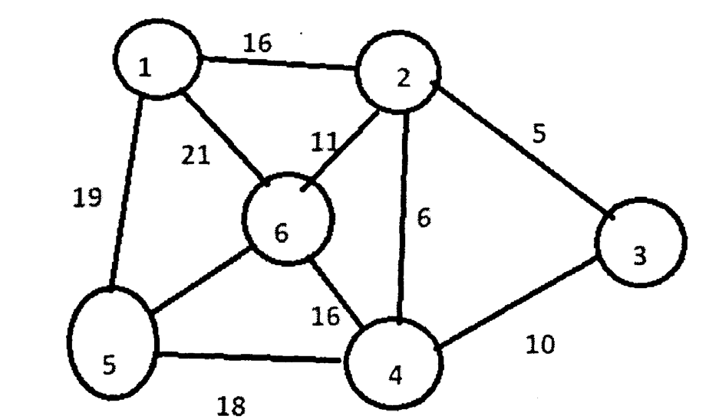
b) | Define the following terms with respect to Trees: |  | [6]
b) | i) | Root | [6]
b) | ii) | Subtree | [6]
b) | iii) | Ancestor Nodes | [6]
b) | iv) | Level of node | [6]
b) | v) | Depth of Tree | [6]
b) | vi) | Siblings | [6]
eeee
[6582]-267 3
https://t.me/SPPU_TE_BE_COMP

Total No. of Questions : 10] PE-12113 | SEAT No. :
Total No. of Questions : 10] PE-12113 | [Total No. of Pages : 3
[6582]-268
S.E. (Electronics and Computer Engineering)
MDM-221-ECE : STATISTICAL DATA ANALYSIS &
VISUALIZATION
(2024 Pattern) (Semester - III)
Time : 2½ Hours] [Max. Marks : 70
Instructions to the candidates :
1) Answer Q.1, or Q.2, Q.3 or Q.4, Q.5 or Q.6, Q.7 or Q.8 and Q.9 or Q.10.
2) Neat diagrams must be drawn wherever necessary.
3) Figures to the right side indicate full marks.
4) Use of non-programmable scientific calculator is allowed.
5) Assume Suitable data if necessary.
Q1)a) Explain the phases of the data analytics lifecycle with the help of a diagram.
[8]
b) | Ages of five randomly selected students from a math class are : | [6]
17, 15, 16, 18, 14. Calculate sample variance and standard deviation.
OR
Q2)a) | Describe different measures of central tendency. | [8]
Calculate mean, median, mode for the data 41, 52, 64, 65, 86, 86, 86, 86, 86,
b) Differentiate between Categorical data and Numerical data. [6]
Q3)a) A pair of dice is thrown 7 times. If getting a total of 7 is considered a
success, calculate the probability of [8]
i) No success
ii) Atleast 6 success
b) Describe skewness and explain its different types with examples. [6]
OR
Q4)a) Describe normal distribution along with its advantages, disadvantages
and applications. [8]
b) Explain the concept of probability distribution and illustrate its types with
examples. [6]
P.T.O.
https://t.me/SPPU_TE_BE_COMP

Q5)a) Explain hypothesis testing in detail. Solve the numerical : A company
claims that the average battery life of its smartphone is 10 hours. A
consumer group tests 50 phones and finds a sample mean of 9.6 hours
b) | with a standard deviation of 1.2 hours. Test the company's claim at a 5%
b) | significance level. (at α = 0.05, Z = + 1.96). | [8]
b) | Describe the concept of null hypothesis H0 and alternate Hypothesis H1
b) | in hypothesis testing with illustrations. | [6]
OR
Q6)a) Explain Chi-square test. Solve the given numerical : A researcher wants to
check if there is an association between gender and preference for a new
product. A survey was conducted with 100 people. The data collected is
shown below : | [8]

Preference | Male | Female | Total
Like | 20 | 30 | 50
Dislike | 30 | 20 | 50
Total | 50 | 50 | 100
Test at 5% significance level whether gender and product preference are
independent. (at α = 0.5, χ2 = 3.841 for df = 1, χ2 = 5.991 for df = 2)
b) Differentiate between simple random sampling and stratified sampling
with suitable examples. [6]
Q7)a) Describe in detail : [8]
i) Scatter Plot
ii) Correlation Matrix
b) Calculate the correlation coefficient for the following data by the help of
Pearson's correlation coefficient formula : X = 10, 13, 15, 17, 19
Y = 5, 10, 15, 20, 25 [6]
OR
Q8)a) Explain any 4 techniques for handling missing data with suitable examples.
[8]
b) Differentiate between global and local outliers with an example. [6]
[6582]-268 2
https://t.me/SPPU_TE_BE_COMP

Q9)a) Explain time series analysis along with concepts of trend, seasonality and
autocorrelation using suitable examples. [8]
b) Describe in detail [6]
i) Describe storytelling
ii) Data reporting
OR
Q10)a) | You are given the following 2D data points : | [8]
P1 (2, 3), P2 (3, 4), P3(5, 8), P4 (8, 7), P5 (9,6)
The initial centroids for k = 2 clusters are : C1 = (2, 3), C2 = (8, 7), Solve :
i) Compute the Euclidean distance of each point from both centroids
C1 and C2.
ii) Assign each point to its nearest cluster based on distance.
iii) Recalculate the new centroids after the first iteration and state whether
the centroids changed or remained the same.
b) Describe the concept of PCA and illustrate the steps using a simple dataset.
[6]
♦♦♦
[6582]-268 3
https://t.me/SPPU_TE_BE_COMP

Total No. of Questions : 6] PE-5740 | SEAT No. :
Total No. of Questions : 6] PE-5740 | [Total No. of Pages : 5
[6582]-269
S.E. (Electronics & Computer Engineering)
PCC-203-ECE : DISCRETE MATHEMATICS
(2024 Pattern) (Semester - III)
Time : 2½ Hours] [Max. Marks : 70
Instructions to the candidates:
1) All questions are compulsory.
2) Figures to the right indicate full marks.
3) Neat diagrams must be drawn wherever necessary.
4) Use of electronic pocket calculator is allowed.
Q1)Write the correct option for the each of the multiple choice questions
(MCQ's). [10]
i) The statement "At least one of your friend is perfect" Let p(x) be "x is
perfect" & f(x) be " x is your friend" & Let the domain be all people.
a) ∀x[f(x)→p(x)] b) ∀x[f(x)∧p(x)]
c) ∃x[f(x)∧p(x)] d) ∃x[f(x)→p(x)]
ii) Which of the following relations is symmetric but neither reflexive nor
Transitive.
a) R = {(1, 2), (1, 3), (1, 4)}
b) R = {(1, 2), (2, 1)}
c) R = {(1, 1), (2,2), (3, 3)}
d) R = {(1, 1), (1, 2), (2, 3)}
iii) The number of edges must a planar graph have if it has 7 regions & 5
vertices is _______
a) | 14 | b) | 20
c) | 10 | d) | 12
P.T.O.
https://t.me/SPPU_TE_BE_COMP

iv) A M-ary tree is called a regular M-ary tree or full M-ary tree if every
internal vertex has ______
a) exactly (M-1) children or o-children
b) atleast M children or o-children
c) exactly M children or o-children
d) None of the above mentioned
v) Identity element of an abelian group (Q+, *), where a * b = ab 3 ,
a, b ∈ Q+ is ______
a) 3 b) –2
c) –3 d) 3/a
Q2)Solve Any three of the following : [12]
a) Using principle of inclusion - exclusion, among integers 1 to 100, inclusive both
i) How many of them are not divisible by 3 nor by 5?
ii) How many are not divisible by 5 but divisible by 3?
b) Obtain the Principal Conjunctive Normal Form (PCNF) and principal
disjunctive normal form (PDNF) of the statement (~p∨~q) → (p↔~∨q)
by using truth table method.
c) | Use mathematical induction to prove that
c) | n  ∑  i=1 |  | 2 | = | 2 1 | + |  | 2 | + | 2 3 | + | ..... | + | n | 2 | = | nn | + | 1)(2 | n | + | 1) | , for all integers n > 1.
d) | n  ∑  i=1 |  |  |  |  |  |  |  |  |  |  |  |  |  |  |  |  |  | 6 |  |  |  | , for all integers n > 1.
d) | Use rules of inference to check the validity of the following argument :
"If there was a meeting then catching the bus was difficult. If they arrived
on time then catching the bus was not difficult. They arrived on time".
"Therefore, There was no meeting".
e) A student has to answer 10 out of 13 questions in examination.
i) How many choices he has?
ii) How many choices he has if first two questions are compulsory?
iii) How many choices he has if he must answer the first or second but
not both?
[6582]-269 2
https://t.me/SPPU_TE_BE_COMP

Q3)Solve any three of the following : [12]
a) Let A = {1, 2, 3, 4, 6, 9} & relation R defined on the set A be such that
"a divides b", a, b ∈ A. Represent the relation R on set A using
i) Ordered pairs
ii) Diagraph
b) Draw the Hasse diagram of the partial ordered relation R on a set
A = {1, 2, 3, 4}, where R is defined as a R b if and only if a < b. Also find
its minimal elements.
c) By using Warshall's algorithm, find the transitive closure of the relation
R = {(2, 1), (2, 3), (3, 1), (3, 4), (4, 1), (4, 3)} on A = {1, 2, 3, 4}
d) Let R be the set of all real numbers and f : R→R be a function defined
by f(x) = 7 – x, x∈R. Show that f is bijective and also find f–1(x).
e) Solve the recurrence relation an + 5an–1 + 4an–2 = 30, where a0 = 3 & a1 = –2.
Q4)Solve any three : [12]
a) Explain the terms with suitable example
i) Weighted Graph
ii) Bipartite Graph
b) Determine whether graph G1 and G2 are isomorphic or not. Justify your
answer.
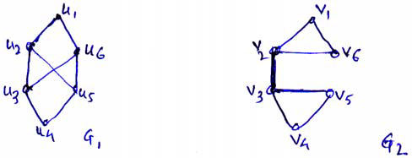
c) Determine which of the graph represents Eulerian circuit, Eulerian path.
Hamiltonian circuit and Hamiltonian path. Justify.
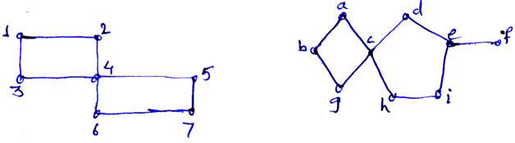
d) Use Dijkstra's Algorithm to find shortest path from a to f
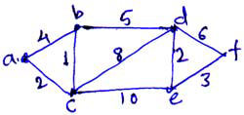
e) Show that the connected graph with 6 vertices and 12 edges each of the
region is bounded by 3 edges.
[6582]-269 3
https://t.me/SPPU_TE_BE_COMP

Q5)Solve any three of the following : [12]
a) Construct an optimal tree for the weights 8, 9, 10, 11, 13, 15, 22. Find
the weight of optimal tree.
b) For the following transport network find the maximum flow using max
flow min cut theorem.
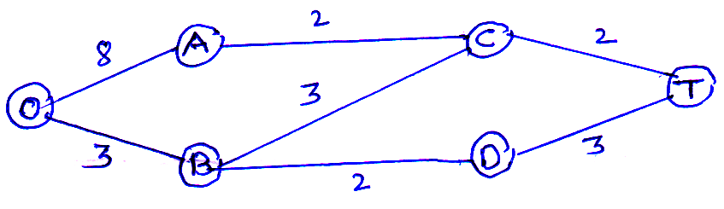
c) Define :
i) Forest
ii) Fundamental cut set
d) Find minimum spanning tree for the graph using prim's Algorithm.
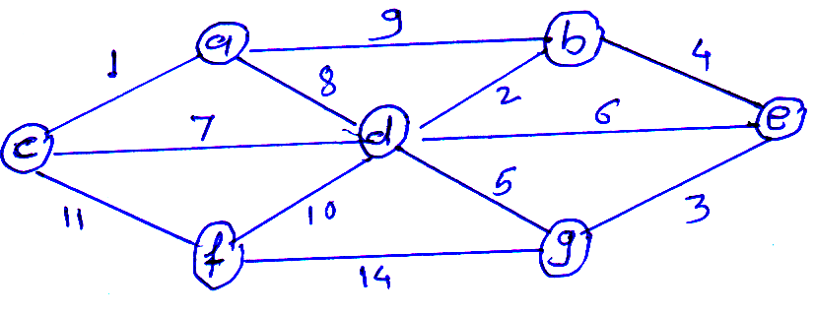
e) Determine the minimum spanning tree using Kruskal's algorithm.
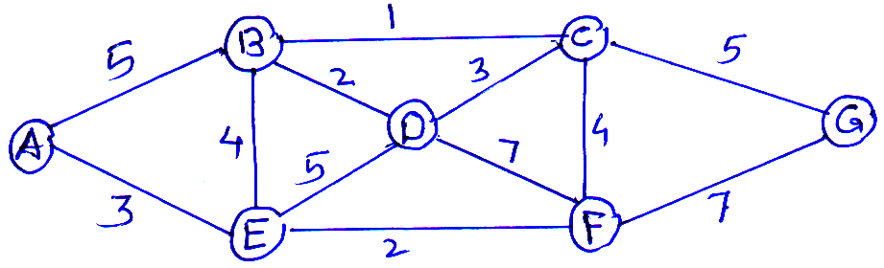
[6582]-269 4
https://t.me/SPPU_TE_BE_COMP

Q6)Solve any three of the following : [12]
a) Determine whether the set of real numbers not equal to–1 with binary
operation a * b = a + b + ab is an abelian group? Justify your answer.
b) For a group G Let Ha = {x/x∈ G, xa = ax}. Prove that Ha is a subgroup
of G.
c)  d) | Let G be an abelian group and 'n' is a fixed integer. Define f : G → G as f(x) = xn∀x∈ G. Prove that f is an Homomorphism.
c)  d) | Let | H | = | ⎡⎢⎢⎢⎢⎢⎢⎣ | 0 | 1 | 1 | ⎤⎥⎥⎥⎥⎥⎥⎦ | be a parity check matrix. Determine the (2, 5) group
 |  |  |  |  | 0 | 1 | 1 | ⎤⎥⎥⎥⎥⎥⎥⎦ | be a parity check matrix. Determine the (2, 5) group
 |  |  |  |  | 1 | 0 | 0 | ⎤⎥⎥⎥⎥⎥⎥⎦ | be a parity check matrix. Determine the (2, 5) group
 |  |  |  |  | 0 | 1 | 0 | ⎤⎥⎥⎥⎥⎥⎥⎦ | be a parity check matrix. Determine the (2, 5) group
 |  |  |  |  | 0 | 0 | 1 | ⎤⎥⎥⎥⎥⎥⎥⎦ | be a parity check matrix. Determine the (2, 5) group
code function.
e) Consider a (2, 5) encoding function e : B2→ B5 given by e(00) = 00000,
e(10) = 10101, e(01) = 01110, e(11) = 11011. Decode the following
words relative to a maximum likelihood decoding function.
i) 11110
ii) 10011
♦♦♦
[6582]-269 5
https://t.me/SPPU_TE_BE_COMP

Total No. of Questions : 10] PE-5784 | SEAT No. :
Total No. of Questions : 10] PE-5784 | [Total No. of Pages : 3
[6582]-271
S.E. (E & TC/Electronics (VISI Design and Technology)) / Electronics Engg./E.C(A.C.T.))
ELECTRONICS CIRCUIT
PCC-201 ETC : Electronics Engineering
(2024 Pattern) (Semester - III)
Time : 2½ Hours] [Max. Marks : 70
Instructions to the candidates :
Q1) | 1) | Solve Q1 or Q2, Q3 or Q4, Q5 or Q6, Q7 or Q8, Q9 or Q10.
Q1) | 2) | Neat diagrams must be drawn wherever necessary.
Q1) | 3) | Figures to right indicate full marks.
Q1) | 4) | Assume suitable data, if necessary.
Q1) | 5) | Use of non-programmable calculator is allowed.
Q1) | a) | Design a DC load line and determine the Q-point for an enhancement
Q1) | b) | MOSFET biased using voltage divider bias. |  | [7]
Q1) | b) | Define and explain the significance of non-ideal V-I characteristics of
Q1) | b) | E-MOSFET: |  | [7]
Q1) | b) | i) | Finite output resistance.
Q1) | b) | ii) | Sub threshold Conduction.
Q1) | b) | iii) | Channel Length Modulation.
OR
Q2) | a) | Explain with diagrams the frequency response of the common-source
amplifier and identify the components in the circuits which affect its
b) | upper and lower cut-off frequencies. | [7]
b) | Determine the small signal voltage gain of a MOSFET circuit shown in Fig. Assume VGSQ = 2.12 V, VDD = 5 V, RD = 2.5 KΩ. Assume transistor parameters are VT = 1 V, k = 0.80 mA/V2 and λ = 0.02/V. Assume the
b) | transistor biased in the saturation region. | [7]
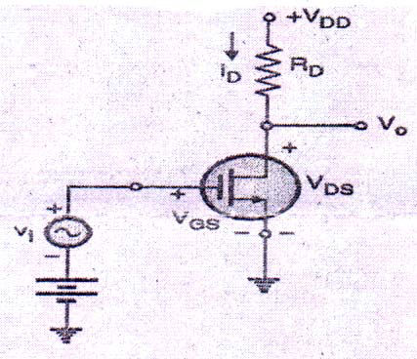
P.T.O.
https://t.me/SPPU_TE_BE_COMP

Q3) | a) | Explain and identify the region of operation, working of E - MOSFET
Q3) | b) | as diode and active resistor. | [7]
Q3) | b) | Calculate the negative feedback gain, and bandwidth of an amplifier
when a negative feedback factor of 0.02 is applied to an amplifier with A = 100 and BW = 10 kHz. List advantages of negative feedback.[7]
OR
Q4) | a) | Explain Voltage Series negative feedback amplifier with block diagram.
[7]
b) Compare the operation of a common-source amplifier with and without source resistor, focusing on gain, input resistance, and comment on the
Q5) | a) | result. | [7]
Q5) | a) | Compare Inverting and Non-inverting Operational Amplifiers in terms
Q5) | b) | of gain and input resistance with the equation. | [7]
Q5) | b) | Evaluate the performance limitations of the integrator at low frequencies
Q5) | b) | and suggest improvements. | [7]
OR
Q6) | a) | Describe the non inverting amplifier configuration of op amp, suggest
the modification to operate it as voltage follower circuit and list applications of voltage follower. [7]
b) Define precision rectifier. Draw and explain the circuit of a precision Half-wave rectifier using op-amps and sketch the input and output
Q7) | a) | waveforms for a sinusoidal input. | [7]
Q7) | a) | Analyze the circuit of an op-amp Schmitt trigger and apply the relevant
equations to obtain UTP = + 4 V and LTP = – 4 V Show the hysteresis curve and explain its operation. [8]
b) Analyze and compare the speed, accuracy and complexity of Flash, SAR, and Dual Slope ADCs. [6]
OR
Q8) a) Explain with a diagram the weighted-resistor DAC. Discuss its principle, resolution, and limitations. [8]
b) An 8 bit DAC has a resolution of 10 mV / bit. Find the analog output voltage for the following digital inputs. [6]
i) 10001010
ii) 00010001
[6582]-271 2
https://t.me/SPPU_TE_BE_COMP

Q9) | a) | Determine the range over which the output voltage can be varied in
Q9) | a) | LM317 voltage regulator if values of R1 = 240 Ω and R2 is taken as 7kΩpotentiometer. Assume Iadj = 100μA.Draw the typical connection diagram.
Q9) | b)
Q9) | b) | [7]
Q9) | b) | Compare linear and switch mode power supply. | [7]
OR
Q10) a) | Draw the block diagram of SMPS and explain in detail. | [7]
b) | Write a short note on Low Dropout Voltage Regulator. | [7]

[6582]-271 3
https://t.me/SPPU_TE_BE_COMP

Total No. of Questions : 10] PE-5935 | SEAT No. :
Total No. of Questions : 10] PE-5935 | [Total No. of Pages : 2
[6582]-272
S.Y. (E & TC/Electronics Engineering) (VLSI Design &
Technology)/Electronic
PCC-203-ETC : DIGITAL ELECTRONICS
(2024 Pattern) (Semester - III)
Time : 2½ Hours] [Max. Marks : 70
Instructions to the candidates :
1) | Attempt Q.1 or Q.2, Q.3 or Q.4, Q.5 or Q.6, Q.7 or Q.8 and Q.9 or Q.10. | [5]
2) | Neat diagrams must be drawn wherever necessary. | [5]
3) | Figures to the right side indicate full marks. | [5]
4) | Assume Suitable data if necessary. | [5]
5) | Use of electronic pocket calculator is allowed. | [5]
Q1)a) | Design a Full Adder using two Half Adders. | [5]
b) | Design BCD to Excess-3 code converter. | [5]
c) | Design and implement the Full Adder using Suitable Mux. | [4]
OR
Q2)a) | Design BCD to Gray code converter using logic gates. | [5]
b) | Design and explain a 1-bit magnitude comparator. | [5]
c) | Design and explain a 3:8 Decoder with logic diagram. | [4]
Q3)a) | Explain 1-bit memory cell with neat logic diagram and truth table. | [5]
b) | Explain Clocked SR flip-flop with truth table and timing diagram. | [5]
c) | State characteristic equations of D and T flip-flops. | [4]
OR
Q4)a) Write Excitation Table of SR, JK, D, and T flip-flops. [5]
b) Convert SR flip-flop into JK flip-flop. [5]
c) Explain SISO, SIPO, PISO, PIPO shift registers with diagrams. [4]
Q5)a) Design a sequence detector using Moore machine for detecting the
sequence....101.... using D Flip-flop. [5]
b) Draw the ASM chart for 2-bit binary counter having enable line E such
that : E=1 (counting enabled), E=0 (counting disabled) [5]
c) Compare Moore and Mealy state machine. [4]
OR
P.T.O.
https://t.me/SPPU_TE_BE_COMP

Q6)a) Design a sequence detector using Moore machine for detecting the
sequence.... 110.... using D Flip-flop. [5]
b) Explain why State Reduction used in flip-flop with Example. [5]
c) Explain different components used in the ASM charts. [4]
Q7)a) Implement the following functions using PLA. [5]
Y1 = ∑ m (0, 2, 5, 7) and Y2 = ∑ m (2, 3, 4, 5)
b) Draw and explain Two input CMOS NOR gate. [5]
c) Explain-Fan In, fan out, noise margin, Propagation delay, Power
dissipation. [4]
OR
Q8)a) Design a 3-bit gray to binary code conveter using suitable PLA and draw
the logic diagram. [5]
b) Explain: Fan out, Noise margin, Propagation delay [5]
c) What is PLD? State its types and write advantages of PLD. [4]
Q9)a) Compare different modeling Styles used in VHDL. [5]
b) Write VHDL code of NAND Gate using behavioral modeling style.[5]
c) Write VHDL Code for Half Adder. [4]
OR
Q10)a) | Explain in short different Modeling Styles used in VHDL. | [5]
b) | Explain sequential Statements. | [5]
c) | Explain: Library, Entity and Architecture | [4]
♦♦♦
[6582]-272 2
https://t.me/SPPU_TE_BE_COMP

Total No. of Questions : 10] | [6582]-273 | SEAT No. :
PE5741 | [6582]-273 | SEAT No. :
PE5741 | [6582]-273 | [Total No. of Pages : 3
S.E. (E &T.C./Electronics/ElectronicsEngineering
(VLSI Design & Technology)/E.E(A.C.T.))
MDM-221 : DATA STRUCTURES & ALGORITHMS
(2024 Pattern) (Semester-III)
Time : 2½ Hours] [Max. Marks : 70
Instructions to the candidates:
1) Solve Q.1 or Q.2, Q.3 or Q.4, Q.5 or Q.6, Q.7 or Q.8, Q.9 and Q.10.
2) Figures to the right indicates full marks.
Q1)a) Explain asymptotic notations Big O, Big Ω Big θ. Illustrate each with an
example. [8]
b) Perform insertion sort on the following list and show all passes: [6]
45, 12, 35, 2, 19
OR
Q2)a) What are the different types of sorting techniques? Analyse and explain
their worst case time complexity? [6]
b) Given array is A [10] = {3, 5, 0, 10, 8, 15, 7, 6, 20, 4}. Apply binary
search for given array to search following cases, write detail steps to
search number. [8]
i) Search 0
ii) Search 20
iii) Search 6
Q3)a) Convert the infix expression (A + B*C) / (D – E/F^G) to postfix, showing
stack contents stepwise. [8]
b) Compare linear queue, circular queue, and priority queue. [6]
OR
Q4)a) Write a C function to implement circular queue using array. Demonstrate
one enqueue and one dequeue operation through code. [8]
b) Write a ‘C’ Function to PUSH and POP elements from a stack of integers
using an array. [6]
P.T.O.
https://t.me/SPPU_TE_BE_COMP

Q5)a) | Represent polynomial 15 | x | 5 | − | 3 | x | 3 | + | 7 | x | − | 2 | using a linked list and explain
how addition of two polynomials can be performed using linked lists.[5]
b) Write structure definition for Singly Linked List. Differentiate between
static memory and dynamic memory allocation. [5]
c) Define pointer. How are pointers useful in linked list operations? [4]
OR
Q6)a) Explain working of malloc(), calloc() and realloc() in dynamic memory
allocation. [6]
b) Write a C function to delete a node at a given position in a doubly linked
list. Give any four advantages of linked lists over arrays. [8]
Q7)a) Construct a Binary Search Tree (BST) using: [8]
40, 22, 10, 30, 50, 45, 60, 55
Show inorder traversal and check if tree is balanced.
b) Explain all four AVL rotations using diagrams. Construct AVL tree from
sequence: 32, 16, 48, 8, 24, 40, 56, 20 [6]
OR
Q8)a) | Reconstruct a binary tree from the following: | [8]
inorder: H D I B E A F C
Postorder: H I D E B F C A
b)  Q9)a)  b)  c) | Define binary tree. Explain following terms with suitable Examples:[6]
b)  Q9)a)  b)  c) | i) | Root node
b)  Q9)a)  b)  c) | ii) | Left and right sub tree
b)  Q9)a)  b)  c) | iii) | Depth of tree
b)  Q9)a)  b)  c) | Represent the following graph using adjacency matrix and adjacency
b)  Q9)a)  b)  c) | list. | [6]
b)  Q9)a)  b)  c) | 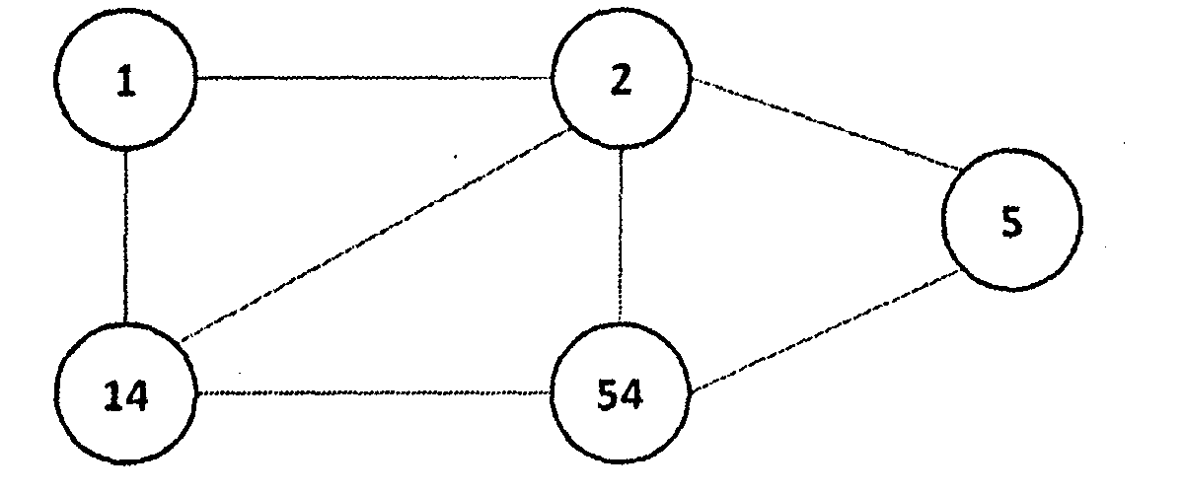
b)  Q9)a)  b)  c) | What is spanning tree? Define minimum spanning tree. |  |  | [4]
b)  Q9)a)  b)  c) | Define simple graph, directed graph and weighted graph with suitable
b)  Q9)a)  b)  c) | diagrams. |  | [4]
OR
[6582]-273 2
https://t.me/SPPU_TE_BE_COMP

Q10)a) Find out Minimum spanning Tree of the following graph using Kruskal’s
algorithm. [8]
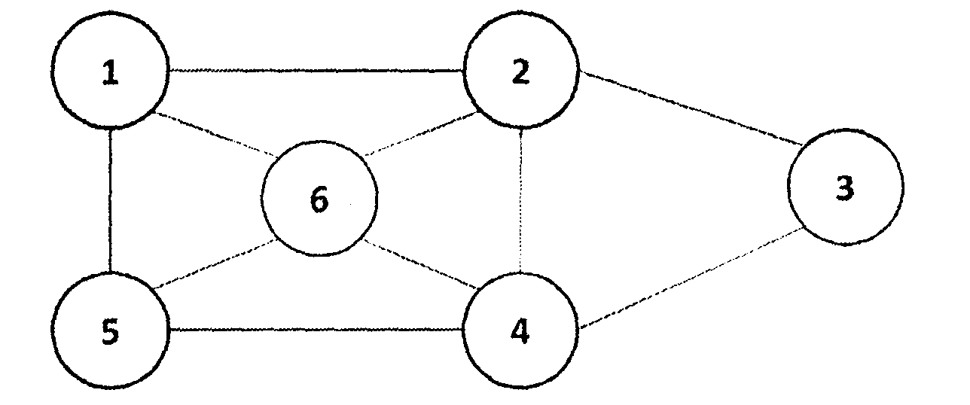
b) Find the shortest path from node ‘a’ to all nodes in the graph shown
below using Dijkstra’s algorithm. [6]
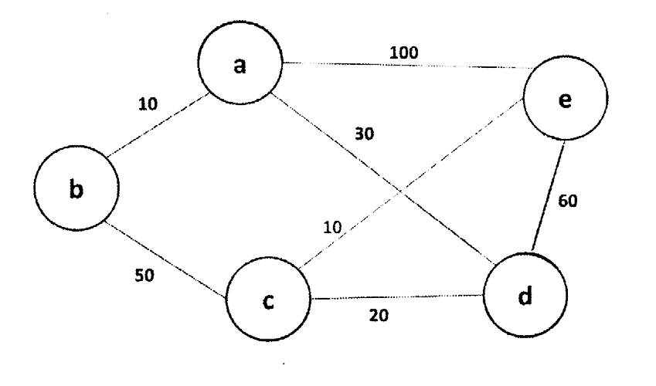
eeee
[6582]-273 3
https://t.me/SPPU_TE_BE_COMP

Total No. of Questions : 6] PE-5742 | SEAT No. :
Total No. of Questions : 6] PE-5742 | [Total No. of Pages : 4
[6582]-274
S.E. (E & TC / Electronics Engineering / VLSI Design and Technology/E.C.(A.C.T.))
PCC-202-ECV : ENGINEERING MATHEMATICS - III (2024 Pattern) (Semester - III)
Time : 2½ Hours] [Max. Marks : 70 Instructions to the candidates :
Q1) | 1) | Neat diagrams must be drawn wherever necessary.
Q1) | 2) | Figures to the right indicate full marks.
Q1) | 3) | Assume suitable data, if necessary.
Q1) | 4) | Use of electronic pocket calculator is allowed.
Q1) | Write the correct option for the following :
Q1) | a) | Particular Integral of differential equation. |  |  |  |  |  |  |  |  |  |  |  |  |  |  |  |  |  |  |  |  |  | [2]
Q1) | ( |  | D | 2 | + | 8) | y | = | 40 | is
Q1) | i) |  |  | 40 |  |  |  |  |  |  |  | ii) |  |  |  |  |  |  | 320
Q1) | iii) |  |  | 5 |  |  |  |  |  |  |  | iv) |  |  |  |  |  |  | –5
Q1) | b) | Differential equation |  |  |  |  |  |  |  |  |  | dy  dx= | x | 2 | + | y | 2 | , with y(1) = 2.3 & h = 0.1 is to be
Q1) | solved using Euler's method, the value of y at x = 1.1 is given by. |  |  |  |  |  |  |  |  |  |  |  |  |  |  |  |  |  |  |  |  |  |  |  |  | [2]
Q1) | i) |  |  | 3.389 |  |  |  |  |  |  |  | ii) |  |  |  |  |  |  | 2.929
Q1) | iii) |  |  | 0.629 |  |  |  |  |  |  |  | iv) |  |  |  |  |  |  | 1.523
Q1) | c) | The z-transform of {cosπk}, k > 0 is given by |  |  |  |  |  |  |  |  |  |  |  |  |  |  |  |  |  |  |  |  |  | [2]
Q1) | i) |  |  | (  zz  z +  -  1)  1) ,||1 2 |  |  |  |  |  |  |  | ii) |  |  |  |  |  |  |  | z | - | 1,| 1 |  | z | |1 >
 |  |  |  |  |  |  |  |  |  |  |  |  |  |  |  |  |  |  |  | z | + |  |  | z
 | iii) |  |  | zz ( z-+ 1) 1) ,| 2 |  |  |  |  |  | z | |1 > | iv) |  |  |  |  |  |  |  |  | z |  | ,| | z | |1 >
 |  |  |  |  |  |  |  |  |  |  | |1 > |  |  |  |  |  |  |  |  | z | + | 1 | ,| | z
P.T.O.
https://t.me/SPPU_TE_BE_COMP

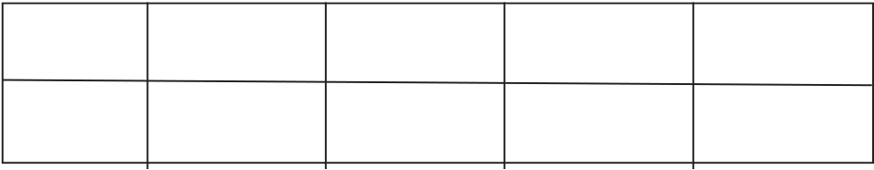
Q2) | d) | If r | = | xi |  |  | + |  |  | yj |  |  |  |  | + |  |  |  | zk |  |  |  | , then value of |  |  |  |  |  |  |  |  |  |  |  |  | ´ is |  |  |  |  |  |  |  |  |  |  |  |  |  |  |  |  |  | [2]
Q2) | i) |  | 0 | ii) |  |  |  |  |  |  |  |  |  |  |  |  |  |  |  |  |  |  |  |  |  |  |  |  |  |  |  |  |  |  |  |  | r
Q2) | iii) |  | 1 | iv) |  |  |  |  |  |  |  |  |  |  |  |  |  |  |  |  |  |  |  |  |  |  |  |  |  |  |  |  |  |  |  |  |  |  | r
Q2) | e) | The line of regressions are 8x – 10y + 66 = 0 and 40x – 18y = 214, then
Q2) | the values of mean of x and y are |  |  |  |  |  |  |  |  |  |  |  |  |  |  |  |  |  |  |  |  |  |  |  |  |  |  |  |  |  |  |  |  |  |  |  | [2]
Q2) | i) |  | x |  | = |  | 12, |  |  |  | y |  |  |  | = |  |  | 17 |  |  |  |  |  |  |  |  |  |  | ii) |  |  |  |  |  |  |  | x |  |  |  |  | = |  |  | 13, |  |  |  | y |  | = |  | 15
Q2) | iii) |  | x |  | = |  | 13, |  |  |  | y |  |  |  | = |  |  | 17 |  |  |  |  |  |  |  |  |  |  | iv) |  |  |  |  |  |  |  |  |  | x |  |  | = |  |  | 9, |  |  | y |  | = |  | 8
Q2) | Solve any Three :
Q2) | a) | Solve (D2 – 2D + 1)y = x sin x. |  |  |  |  |  |  |  |  |  |  |  |  |  |  |  |  |  |  |  |  |  |  |  |  |  |  |  |  |  |  |  |  |  |  | [4]
Q2) | b) | Solve |  | 2  dy  dx+ |  |  |  |  |  |  |  | y |  |  | = |  |  |  | cot |  |  |  |  | x |  | (By variation of parameter method) |  |  |  |  |  |  |  |  |  |  |  |  |  |  |  |  |  |  |  |  |  |  |  |  |  |  |  |  |  |  | [4]
Q2) | c) | Solve |  | (2 |  | x |  | + |  | 1) |  |  |  | 2 |  | 2  dy |  |  |  |  |  | - |  |  |  | 2(2 |  | x | + |  | 1) |  | dy |  | - |  | 12 |  |  | y |  | = |  |  | 8 |  | x | . |  |  |  |  |  |  |  | [4]
 |  |  |  |  |  |  |  |  |  |  |  |  |  |  |  | dx |  |  |  | 2 |  |  |  |  |  |  |  |  |  |  |  |  | dx
 | d) | Solve |  |  | dx |  |  |  |  |  |  |  | z |  |  | ) | = |  |  |  | - |  |  |  | dy |  |  |  |  | z |  | = |  | zx |  |  |  | dz |  |  | y |  |  | ) |  | . |  |  |  |  |  |  |  |  | [4]
 | d) |  |  |  | xy |  |  | 2 | + |  |  |  |  |  |  |  |  |  |  |  |  |  |  |  | yx |  | 2 | + |  | z | ) |  |  |  |  |  |  | 2 | - |  |  |  | 2
 | e) | An electrical circuit consist of an inductance L of 0.5 Henry, a resistance
R of 20 ohms and a condensor of capacitance C of 100 micro farads.
Find the charge 'q' at any time 't', if the differential equation is
 | L |  | 2  dq |  | + | R | dq | + | q | = | 0 |  | [4]
Q3) |  |  | dt | 2 |  |  | dt |  | C |  |  | . | [4]
Q3) | Solve any Three of the following :
Q3) | a) | By using Newton's Backward interpolation formula find the values of
Q3) | y for x = 4.5 from the following table of x and y values |  |  |  |  |  |  |  |  |  |  |  | [4]

x | 1 | 2 | 3 | 4 | 5
y | 14 | 30 | 62 | 116 | 198

b) | The velocity distribution of a fluid near flat surface is given below |  |  |  |  | [4]
b) | x | 0.1 | 0.3 | 0.6 | 0.8 | [4]
b) | v | 0.72 | 1.81 | 2.73 | 3.47 | [4]
Use Lagrange interpolation formula to obtain velocity v at x = 0.4.
[6582]-274 2
https://t.me/SPPU_TE_BE_COMP

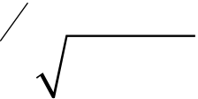
c) | Find the approximate value of | I | p  2 = ò | cos() xdx | by dividing the interval
0
in to six subintervals by using Simpson's (1/3)rd rule. |  |  |  |  |  |  |  |  |  |  |  |  |  |  |  |  |  |  |  |  |  |  |  |  |  |  |  |  |  |  |  |  |  |  |  |  |  |  |  |  |  |  |  |  |  |  |  |  |  |  |  |  |  | [4]
d) |  | Using Modified Euler's method find an approximate value of y when
x = 0.1 given that |  |  |  |  |  |  |  |  |  |  |  |  |  |  |  |  |  | dy  dx= |  |  |  |  |  |  | x | + |  | yy :(0) |  |  |  |  |  |  |  |  | = and h = 0.1. |  |  |  |  |  |  |  |  |  |  |  |  |  |  |  |  | [4]
e) |  | Use Runge-Kutta method of fourth order to solve |  |  |  |  |  |  |  |  |  |  |  |  |  |  |  |  |  |  |  |  |  |  |  |  |  |  |  |  |  |  |  |  |  |  |  |  |  |  |  |  |  |  |  |  |  |  |  |  | dy  dx= |  |  |  | xyy |  |  | (1) |  |  | = | 2 | .
Find y at x = 1.2 by taking h = 0.2. |  |  |  |  |  |  |  |  |  |  |  |  |  |  |  |  |  |  |  |  |  |  |  |  |  |  |  |  |  |  |  |  |  |  |  |  |  |  |  |  |  |  |  |  |  |  |  |  |  |  |  |  |  | [4]
Q4) | Solve any three :
a) |  | Find Fourier sine transform of |  |  |  |  |  |  |  |  |  |  |  |  |  |  |  |  |  |  |  |  |  |  |  |  |  |  |  |  |  | fx () |  |  |  |  | = |  | ì  ïïïï2íïïïïî | x |  | x |  |  | 0 |  | ££1 |  |  |  |  |  | . | [4]
 |  |  |  |  |  |  |  |  |  |  |  |  |  |  |  |  |  |  |  |  |  |  |  |  |  |  |  |  |  |  |  |  |  |  |  |  |  |  |  | - |  |  |  |  | 1 |  | £< |  |  |  |  | 2 | .
 |  |  |  |  |  |  |  |  |  |  |  |  |  |  |  |  |  |  |  |  |  |  |  |  |  |  |  |  |  |  |  |  |  |  |  |  |  |  |  | 0 |  |  |  |  | x |  |  |  | ³ |  | 2 |  | .
b) |  | Using |  |  |  |  |  | Fourier |  |  |  |  |  |  |  |  |  |  |  |  | integral |  |  |  |  |  |  |  |  |  |  |  |  |  | representation |  |  |  |  |  |  |  |  |  |  |  |  |  |  |  |  |  |  | show |  |  |  |  |  | that
2 |  |  | ¥ | k |  | cos |  | l |  | xd 2 |  |  |  |  | l | = |  | -e |  | kx |  | , |  | k |  | ³ |  | 0 |  | . |  |  |  |  |  |  |  |  |  |  |  |  |  |  |  |  |  |  |  |  |  |  |  | [4]
 |  |  | ò
p |  |  | ò | x |  | 2 | + | k
 |  |  | 0
c) |  | Find z-transform of f(k) = k, k > 0. |  |  |  |  |  |  |  |  |  |  |  |  |  |  |  |  |  |  |  |  |  |  |  |  |  |  |  |  |  |  |  |  |  |  |  |  |  |  |  |  |  |  |  |  |  |  |  |  |  |  |  | [4]
d) |  | Find inverse z-transform of |  |  |  |  |  |  |  |  |  |  |  |  |  |  |  |  |  |  |  |  |  |  |  |  |  |  | Fz () |  |  |  |  | = æçççè |  |  |  | z | - |  | z |  | 2 | z |  | - |  | 1 |  | if 1 3 |  |  |  | < | |  | z | | < | 1 |  | .[4]
 |  |  |  |  |  |  |  |  |  |  |  |  |  |  |  |  |  |  |  |  |  |  |  |  |  |  |  |  |  |  |  |  |  |  |  |  |  |  |  | 1 |  |  |  |  |  |  |  | 1 | ö÷ |  |  |  |  |  |  |  |  | 2
 |  |  |  |  |  |  |  |  |  |  |  |  |  |  |  |  |  |  |  |  |  |  |  |  |  |  |  |  |  |  |  |  |  |  |  |  |  |  |  |  | öæ÷÷ç÷øèç
 |  |  |  |  |  |  |  |  |  |  |  |  |  |  |  |  |  |  |  |  |  |  |  |  |  |  |  |  |  |  |  |  |  |  |  |  |  |  |  | 2 |  |  |  |  |  |  |  | 3 | ÷÷ø
e) |  | Solve the following difference equation
fk |  |  |  | + |  |  | 1) | + |  |  | 1 |  |  | fk () |  |  |  | = |  | æö÷ç÷çèø÷  k |  |  |  |  |  | , | k | ³ |  |  | 0, |  |  | f | (0) |  |  |  | = | 0 |  |  |  |  |  |  |  |  |  |  |  |  |  | [4]
 |  |  |  |  |  |  |  |  |  |  | 4
Q5) | Solve any Three of the following :
a) |  | Find the directional derivative (D • D) of φ = 4xz3 – 3x2y2z at point p(2, –1, 2) along the line equally inclined with co-ordinate axes. [4]
b) |  | Show that F |  |  |  |  |  |  |  |  |  |  | ❒ is irrotational and find scalar function φ such that F |  |  |  |  |  |  |  |  |  |  |  |  |  |  |  |  |  |  |  |  |  |  |  |  |  |  |  |  |  |  |  |  |  |  |  |  |  |  |  |  |  |  |  |  |  | = f
F |  |  | = |  | (6 |  | xy |  | + |  |  | 3  zi |  |  |  |  | + |  | (3 |  | x |  | 2 |  | - |  | zj |  |  |  | + |  | (3 |  |  | xz |  | 2 | - | yk |  |  |  |  |  |  |  |  |  |  |  |  |  | [4]
[6582]-274 |  |  |  |  |  |  |  |  |  |  |  |  |  |  |  |  |  |  |  |  |  |  |  |  |  |  |  | 3
https://t.me/SPPU_TE_BE_COMP

c) | Solve (any one) : |  |  |  |  |  |  |  |  |  |  |  |  |  |  |  | [4]
c) | i) | ∇2(r2logr) = 5 + 6 logr |  |  |  |  |  |  |  |  |  |  |  |  |  |  | [4]
c) | Evaluate [cosò |  |  |  |  |  |  |  | a |  | - |  | 3( |  |  |  | [4]
  r | 5 | r
d) |  |  |  |  |  |  |  |  | r | 3 |  |  |  |  |  |  | for closed curve C which is given

Total No. of Questions : 8] PE-5959 | SEAT No. :
Total No. of Questions : 8] PE-5959 | [Total No. of Pages : 2
[6582]-275
S.E. (Electronics/E&TC/E.E.-VLSI Design & Technology/
E.C.-A.C.T/Internet of Things/
Electronics & Computer Engg.)
VEC-232 : UNIVERSAL HUMAN VALUES &
PROFESSIONAL ETHICS
(2024 Pattern) (Semester - III)
Time : 2 Hours] [Max. Marks : 35
Instructions to the candidates:
1) Answer Q1 or Q2, Q3 or Q4, Q5 or Q6, Q7 or Q8.
2) Figures to the right indicate full marks.
3) Neat diagrams must be drawn wherever necessary.
4) Assume Suitable data, if necessary.
Q1)a) What is aspiration? Explain the basic requirement for fulfillment of the
human aspirations? [4]
b) What is value education? Explain the need and guidelines of value
education? [4]
OR
Q2)a) Explain Right understanding, Relationship and Physical facility in
detail. How it can be utilized for the development of Human being.[4]
b) | Explain Happiness and Prosperity - Current scenario in detail. | [4]
Q3)a) | Distinguish between the needs of Self and Body? | [5]
b) | Explain Harmony of the Self with the Body? | [4]
OR
Q4)a) Explain Coexistence of Self and Body in Human being in detail?[5]
b) Explain Body as an Instrument of the Self? [4]
P.T.O.
https://t.me/SPPU_TE_BE_COMP

Q5)a) | Explain "Respect” as the Right Evaluation? | [5]
b) | Explain about Understanding Harmony in the Society? | [4]
OR
Q6)a) Explain “Trust”- the foundational value in Relationship? [5]
b) Explain about the vision for the Universal Human Order? [4]
Q7)a) Explain about Understanding Harmony in Nature? [5]
b) Explain about the Professional Ethics in the light of Right
Understanding? [4]
OR
Q8)a) Explain about interconnectedness, self-regulation and Mutual
Fulfillment among the four Orders of Nature? [5]
b) Explain the Strategies for Transition towards Value based Life and
Profession? [4]

[6582]-275 2
https://t.me/SPPU_TE_BE_COMP

Total No. of Questions : 10] | [6582]-276 | SEAT No. :
PE5743 | [6582]-276 | SEAT No. :
PE5743 | [6582]-276 | [Total No. of Pages : 3
S.E. (Information Technology)
PCC-201-ITT : DATA STRUCTURES & ALGORITHMS
(2024 Pattern) (Semester - III)
Time : 2½ Hours] [Max. Marks : 70
Instructions to the candidates:
1) Attempt Q1 or Q2, Q3 or Q4, Q5 or Q6, Q7 or Q8, Q9 or Q10.
2) Figures to the right indicate full marks.
3) Neat diagrams must be drawn wherever necessary.
4) Use of electronic pocket calculator is allowed.
5) Assume suitable data, if necessary.
Q1)a) For the list : [44 33 11 55 77 90 40 60 99 22 88], Perform bubble sort
step-by-step. Find the number of comparisons and swaps required to
sort the elements in ascending order. Also mention time complexity of
bubble sort. [5]
b) What is meant by time and space complexity of an algorithm? What are
asymptotic notations used for it? [5]
c) Describe in detail following classification of data structures : [4]
i) Linear and Non-linear
ii) Static and Dynamic
OR
Q2)a) What is time complexity? Explain its significance. Also find time
complexity using step count method for the below algorithm : [5]
sum = 0
for i = 1 to n:
for j = 1 to n:
sum = sum + 1
b) What is an algorithm? Explain key characteristics of a good algorithm
with suitable examples. [5]
c) Differentiate between linear search and Binary search. [4]
Q3)a) What is stack? How can a stack be implemented using linked lists? [7]
b) How can a node be inserted in singly linked list? Explain it with suitable
diagrams. Also write down basic steps used for insertion. [7]
OR
P.T.O.
https://t.me/SPPU_TE_BE_COMP

Q4)a) What is linked list? With the help of neat diagrams explain different types
of Linked list. [6]
b) What is a queue? How it is different from a stack? [4]
c) Convert the following Infix expression to Prefix and Postfix expression
using tabular form. Also write down basic steps used for conversion.
(A*B+C*D). [4]
Q5)a) What is binary tree? Describe the preorder, inorder and postorder traversal
of a binary tree with an example. [6]
b) Write down steps of Heap sort algorithm? What is the role of “heapify”
function. State any two real time applications of heap. [4]
c) Convert the following generic tree to binary tree. Also explain the method
used for conversion. (Show step by step conversion). [4]
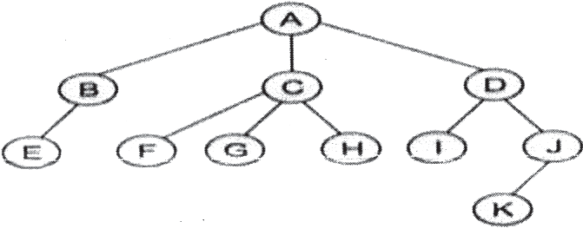
OR
Q6)a) | Consider the graph represented by the following adjacency matrix. | [6]

Vertex | 1 | 2 | 3 | 4 | 5 | 6
1 | 0 | 3 | 1 | 6 | 0 | 0
2 | 3 | 0 | 5 | 0 | 3 | 0
3 | 1 | 5 | 0 | 5 | 6 | 4
4 | 6 | 0 | 5 | 0 | 0 | 2
5 | 0 | 3 | 6 | 0 | 0 | 6
6 | 0 | 0 | 2 | 2 | 6 | 0
Find its minimum spanning tree and minimal cost using Prim’s Algorithm.
b) | What is Heap? | [4]
Sort the following elements in descending order using heap sort (show all
steps) :
100, 34, 24, 45, 12, 89, 21.
c) | Make a binary search tree for the following sequence of numbers : | [4]
45, 36, 76, 23, 89, 115, 98, 39, 41, 56, 69, 48
Traverse the tree in Preorder, Inorder and Postorder.
[6582]-276 2
https://t.me/SPPU_TE_BE_COMP

Q7)a) Explain the applications of DSA in Social Network Graph Analysis and in AI Search Algorithms. [7]
b) For the given set of values. 11, 33, 20, 88, 79, 98, 44, 68, 66, 22 Create a hash table with size 10 and resolve collision using chaining with replacement and without replacement. Use the modulus Hash function. (Key % size) [7]
OR
Q8)a) For string matching, working module q = 11, how many spurious hits does the Rabin-Karp matcher encounters in Text T = 3141592653589793 when looking for the pattern P = 26. (Show all steps of Rabin Karp string matching algorithm) [7]
b) Differentiate between chaining and open addressing collision resolution techniques? [4]
c) What are the advantages and disadvantages of quadratic probing over linear probing? [3]
Q9)a) Explain “Divide and conquer” principle of algorithm. How it is used in merge sort. [5]
b) Consider a knapsack with a capacity of 50kg and the following items :[5]
Item 1 : Weight = 10 kg, Profit = 60
Item 2 : Weight = 20 kg, Profit = 100
Item 3 : Weight = 30 kg, Profit = 120
Determine the maximum profit value using fractional knapsack greedy algorithm.
c) | Write down steps of Floyd-Warshall algorithm. | [4]
OR
Q10)a) What is Longest Common Subsequence (LCS) problem? How principle of dynamic programming is used to find LCS. Give suitable example.[5]
b) Perform Huffman encoding for the string : “ABBCCCDDDDEEEEE”. Show the steps of frequency calculation, Huffman tree construction and obtain final codes. [5]
c) Write down the steps of quick sort. Mention its best case, average case and worst case time complexity. [4]

[6582]-276 3
https://t.me/SPPU_TE_BE_COMP

Total No. of Questions : 10] | [6582]-277 | SEAT No. :
PE5744 | [6582]-277 | SEAT No. :
PE5744 | [6582]-277 | [Total No. of Pages : 2
S.E. (Information Technology)
PCC-202- ITT : OBJECT ORIENTED PROGRAMMING
(2024 Pattern) (Semester-III)
Time : 2½ Hours] [Max. Marks : 70
Instructions to the candidates:
1) Answer Q.1 or Q.2, Q.3 or Q.4, Q.5 or Q.6, Q.7 or Q.8, Q.9 or Q.10.
2) Figures to the right indicates full marks.
3) Use of non-programmable calculator is allowed.
4) Assume Suitable data, if necessary.
Q1)a) Write a short notes on: [6]
i) Polymorphism
ii) Data Encapsulation
b) Explain in detail the different visibility/access modifiers in Object-Oriented
Programming. How does the ‘private’ access modifier support the
concept of information hiding? Illustrate with a suitable example. [8]
OR
Q2)a) Model a real-world scenario ‘fruit’ class using Object Oriented Paradigm.
[6]
b) Explain the four pillars of object- oriented programming with an example.
[8]
Q3)a) What is garbage collection? Explain the finalize () method in detail.[6]
b) Design a class ‘employee’ with suitable instance variables and methods.
Create the database of the employees and display the records using an
array of objects. [8]
OR
Q4)a) How do we use the static variables and static functions in the class?
Explain with a suitable example. [6]
b) Can we overload the constructor? Explain with Example. [8]
P.T.O.
https://t.me/SPPU_TE_BE_COMP

Q5)a) | Define polymorphism. What are the types of Polymorphism? | [6]
b) | Write a Java program to implement multilevel inheritance. | [8]
OR
Q6)a) What is an interface in Java? How to declare an interface, and write
syntax? Can we achieve multiple inheritance by using an interface? [6]
b) Differentiate between method overriding and method overloading. Explain
method overriding concept with an example. [8]
Q7)a) Demonstrate at least 3 methods of ArrayList collection class. [6]
b) What is an exception? Demonstrate with the example. how to handle the
ArrayIndex out of Bound exception. [8]
OR
Q8)a) Explain the use of throw, throws, and finally with the help of example.[6]
b) Write a generic method to count the number of elements in a collection
that have a specific properties like odd integers, prime numbers and
Q9)a) | palindrome. |  | [8]
Q9)a) | Define the term Stream. Explain various stream classes. |  | [6]
b) | Write a short note on: |  | [8]
b) | i) | Iterator | [8]
b) | ii) | Singleton | [8]
OR
Q10)a) Which are different types of Design patterns? [6]
b) Design a Java program for employee management with following
operations: [8]
i) Create file
ii) Write data into file
iii) Read data from file. Consider Name, employee id and department
as attributes of employee.
eeee
[6582]-277 2
https://t.me/SPPU_TE_BE_COMP

Total No. of Questions : 10] PE5785

[6582]-278

S.E. (Information Technology)
PCC-203-ITT : BASICS OF COMPUTER NETWORK
(2024 Pattern) (Semester - III)
Time : 2½ Hours] [Max. Marks : 70
Instructions to the candidates:
1) Answer Q.1 or Q.2, Q.3 or Q.4, Q.5 or Q.6, Q.7 or Q.8.
2) Figures to the right indicate full marks.
3) Neat diagrams must be drawn wherever necessary.
4) Assume suitable data, if necessary.
Q1)a) Explain Star Topology with advantages and disadvantages. [5]
b) Explain the data communications system with its five components and discuss
the fundamental characteristics of the data communication system. [5]
c) Compare LAN, WAN & MAN. [4]
OR
Q2)a) Compare OSI & TCP/IP reference model. [5]
b) Explain Mesh Topology with advantages and disadvantages. [5]
c) Explain the functions of data link layer & transport layer. [4]
Q3)a) Compare and contrast circuit switching and packet switching techniques.
[5]
b) Explain following guided transmission media with suitable diagrams. [5]
i) Twisted Pair Cable
ii) Coaxial Cable
c) Define simplex, half duplex and full duplex transmission mode. Give one
example for each. [4]
OR
Q4)a) Explain the process involved in PCM with neat diagrams. [5]
b) What is Time Division Multiplexing (TDM)? Explain in detail. [5]
c) Describe Digital-to-Analog modulation techniques with examples. [4]
Q5)a) Explain Framing, Flow Control, and Error Control mechanisms used
in Data Link Layer. [5]
b) Describe the working of HDLC and PPP protocols and highlight their
frame structures and modes of operation. [5]
c) Explain Pure ALOHA and Slotted ALOHA in detail. [4]
OR
P.T.O.
https://t.me/SPPU_TE_BE_COMP

Q6)a) Explain FDMA, TDMA and CDMA in detail. [5]
b) Discuss CSMA/CD random access technique. How is collision detection
achieved in this technique? [5]
c) Write short notes on: [4]
i) Go Back N ARQ
ii) Selective Repeat ARQ
Q7)a) Explain network layer services with example. [5]
b) Compare between IPv4 and IPv6. [5]
c) Explain virtual circuit network with suitable diagram. [4]
OR
Q8)a) Explain IP addressing and its classes. [5]
b) What is routing? List out and explain different metrics used in various
routing protocols. [5]
c) Compare Frame Relay and ATM in terms of reliability and QoS. [4]
Q9)a) Explain Process-to-Process Delivery in detail. [5]
b) Write a note on Applications of IOT in Home Automation. [5]
c) Write a short note on MQTT. [4]
OR
Q10)a) What is remote logging ? Explain with suitable examples. [5]
b) What is congestion control and quality of service in Transport layer.[5]
c) Write Short Notes On(Any Two) [4]
i) HTTP
ii) FTP
ii) SMTP
  
[6582]-278 2
https://t.me/SPPU_TE_BE_COMP

Total No. of Questions : 10] | [6582]-279 | SEAT No. :
PE5786 | [6582]-279 | SEAT No. :
PE5786 | [6582]-279 | [Total No. of Pages : 2
S.E. (Information Technology)
MDM-221-ITT:DIGITAL ELECTRONICS AND LOGIC DESIGN
(2024 Pattern) (Semester - III)
Time : 2½Hours] [Max. Marks : 70
Instructions to the candidates:
1)  2)  3)  4)  Q1)a)  b)  c) | Answer Q.1 or Q.2, Q.3 or Q.4, Q.5 or Q.6, Q.7 or Q.8, Q.9 or Q.10. Neat diagrams must be drawn wherever necessary.  Figures to the right indicate full marks.  Assume suitable data, if necessary.
1)  2)  3)  4)  Q1)a)  b)  c) | Draw and explain the working of 2 input TTL NAND gate. | [7]
1)  2)  3)  4)  Q1)a)  b)  c) | Represent (–42)10 in sign magnitude form, l’s complement form and 2’s complement form. [3]
1)  2)  3)  4)  Q1)a)  b)  c) | Write short note on IEEE floating-point single precision standard. | [4]
OR
Q2)a) Explain any four characteristics of digital ICs. [4]
b) Find the decimal equivalent of the following binary numbers assuming
sign magnitude representation: [4]
i) 101101
ii) 011001
c) Represent (l37)10 in following codes: [6]
i) BCD
ii) Excess-3
iii) Octal
Q3)a) Explain rules of BCD addition with example. [6]
b) Design and explain full subtractor using IC 74138. [8]
OR
Q4)a) Implement the following Boolean function using single 8:1 multiplexer
f(A, B, C, D) = ∑m (1, 4, 6, 9, 13). [6]
b) Design BCD to excess-3 code converter with logic diagram. [8]
P.T.O.
https://t.me/SPPU_TE_BE_COMP

Q5)a) Draw SR flip flop using gates. Explain in detail the truth table and excitation
table of the SR flip flop. [6]
b) Design 3-bit synchronous up counter with MSJK flip-flops. [8]
OR
Q6)a) Convert SR flip flop to JK flip flop. [6]
b) Write short note on: [8]
i) IC 7474
ii) Race around condition
Q7)a) Draw and explain 4 bit ring counter. Also draw necessary timing
diagram. [6]
b) Design a sequence detector to detect three or more consecutive 1s in a
string of bits coming through an input line. [8]
OR
Q8)a) What is shift register? State different types of shift registers. Explain any
one type of shift registers with diagram. [6]
b) Design a sequence generator using T flip flops [8]
----0---1---7---4---2----
Q9) a) What are the drawbacks of single bus system? How Hierarchical Bus
Architecture helps to overcome these drawbacks? [7]
b) Write short note on Micro Programmed Control Unit. [7]
OR
Q10)a) With suitable diagram explain Von Neumman architecture. Explain the
functions of PC, MAR, MBR, IR. [7]
b) Name the different buses and typical control signals in the CPU. What is
system bus? State the drawbacks of single bus organization. [7]
b b b
[6582]-279 2
https://t.me/SPPU_TE_BE_COMP

Total No. of Questions : 3] | [6582]-280 | SEAT No. :
PE5745 | [6582]-280 | SEAT No. :
PE5745 | [6582]-280 | [Total No. of Pages : 2
S.E. (Information Technology)
VEC - 232-ITT : UNIVERSAL HUMAN VALUES AND
PROFESSIONAL ETHICS
(2024 Pattern) (Semester - III)
Time : 2 Hours] [Max. Marks : 35
Instructions to the candidates:
1) All questions are compulsory.
2) Figures to the right indicate full marks.
3) Assume suitable data, if necessary.
Q1)Attempt any four. [4×2=8]
a) State the two basic human aspirations. [2]
b) Describe Self exploration. [2]
c) Explain family Harmony. [2]
d) What are the nine values which bounds the human relationships? [2]
e) What is fearlessness in society? [2]
f) What do you mean by self-regulation? What is/are its outcomes? [2]
g) Define the profession in context with the Comprehensive Human Goal.[2]
Q2)Attempt any three. [3×4=12]
a) Classify the aspirations in four categories such as individual, in family, in
society and in nature. [4]
b) Write justice and human responsibilities. [4]
c) What do you mean by holistic development? Is it just do better in the
professional field or something more than that? Justify your answer with
a suitable examples. |  |  |  | [4]  [4]  [4]  P.T.O.
d) |  | Illustrate ethical human conduct. |  | [4]  [4]  [4]  P.T.O.
e) | State any three implications of imbalance in nature. |  |  | [4]  [4]  [4]  P.T.O.
[6582]-280 |  |  | 1 | [4]  [4]  [4]  P.T.O.
https://t.me/SPPU_TE_BE_COMP

Q3)Attempt any three. [3×5=15]
a) Explain the co-existence nature of the Self and Body with suitable examples
from daily life. [5]
b) Explain how justice leads to societal harmony. [5]
c) Elaborate the Co-Existence with nature/Existence to create Harmony is
Society. [5]
d) What do you understand by natural acceptance? Illustrate with examples.
Is it invariant with time and place. [5]
e) Illustrate ethical human conduct. [5]
  
[6582]-280 2
https://t.me/SPPU_TE_BE_COMP

Total No. of Questions : 10] PE-5934 | SEAT No. :
Total No. of Questions : 10] PE-5934 | [Total No. of Pages : 2
[6582]-281
S.E. (Instrumentation and Control Engineering)
PCC-201-INC : SENSORS & TRANSDUCERS
(2024 Pattern) (Semester - III)
Time : 2½ Hours] [Max. Marks : 70
Instructions to the candidates:
1) Solve Q.1 or Q.2, Q.3 or Q.4, Q.5 or Q.6, Q.7 or Q.8, Q.9 or Q.10.
2) Neat diagrams must be drawn wherever necessary.
3) Figures to the right indicate full marks.
4) Use of Calculator is allowed.
5) Assume suitable data if necessary.
Q1)a) List different types of manometers for the measurement of Pressure.
And Explain the construction and working of an inclined tube
manometer. [7]
b) Explain the pressure measuring devices like bellows, diaphragm and
Bourdon tube in short and compare in terms of sensitivity and pressure
range. [7]
OR
Q2)a) Explain with detailed diagram how a piezoelectric pressure transducer
converts pressure into electrical signal. [7]
b) Explain the working principle of dead weight tester used for pressure
calibration. [7]
Q3)a) Explain the working principle of a bimetallic thermometer with a
neat sketch and state its application. [7]
b) Describe in detail the difference between NTC and PTC thermometers
with examples. [7]
OR
Q4)a)  b) | Differentiate between RTD and Thermistor based on their working
Q4)a)  b) | principle, material used and range. | [7]
Q4)a)  b) | What is RTD? and for a Pt-100 RTD has a resistance of 100Ω at 0°C and a temperature coefficient (α) of 0.00385/°C. Calculate the resistance
Q4)a)  b) | at 175°C. | [7]
P.T.O.
https://t.me/SPPU_TE_BE_COMP

Q5)a) Explain the terms laminar flow and turbulent flow with the help of
neat sketches. Also explain how we differentiate them. [7]
b) Classify flow transducers, and explain orifice plate type flow measuring
transducers with neat sketch. [7]
OR
Q6)a) Explain the principle of operation of a rotameter with the help of a
neat sketch. And also explain why the rotameter must be installed
vertically in a flow system. [7]
b) Describe the construction and principle of operation of an
electromagnetic flow meter. Also explain its application. [7]
Q7)a) Describe how a bubbler-type level measurement system operates.
Also explain its disadvantages. [7]
b) Explain the operation of a radar level sensor and state its advantages
over ultrasonic type. [7]
OR
Q8)a) Explain the working principle of a capacitive levelsensor for
conductive and non-conductive liquids. [7]
b) Develop an application for level measurement of liquid tank 4000
liters using DPT. [7]
Q9)a) Enlist different types of transducers used to measure viscosity. Explain
the basic working of a Saybolt viscometer in detail with neat sketch.[7]
b) Define the term density and Describe how the air bubbler method is
used to determine. [7]
OR
Q10)a) Design a Searle's rotating cylinder viscometer and explain how torque
measurement is used to determine viscosity. [7]
b) Define the term density and describe the working principle of a
U-tube density measurement system for the measurement of density.
[7]

[6582]-281 2
https://t.me/SPPU_TE_BE_COMP

Total No. of Questions : 10] PE-5787 | SEAT No. :
Total No. of Questions : 10] PE-5787 | [Total No. of Pages : 3
[6582]-282
S.E. (Instrumentation and Control Engineering)
PCC-202 INC : SIGNALS AND SYSTEMS
(2024 Pattern) (Semester - III)
Time : 2½ Hours] [Max. Marks : 70
Instructions to the candidates :
Q1) | 1) | Solve Q1 or Q2, Q3 or Q4, Q5 or Q6, Q7 or Q8, Q9 or Q10.
Q1) | 2) | Neat diagrams must be drawn wherever necessary.
Q1) | 3) | Figures to the right indicate full marks.
Q1) | 4) | Assume suitable data, if necessary.
Q1) | 5) | Use of programmable calculator is not permitced.
Q1) | a) | Differentiate between signals with suitable example:
i) Periodic and Aperiodic signal [4]
ii) Even and odd signal [4]
b) Perform following signal operation on following signal and redraw the
signal [6]
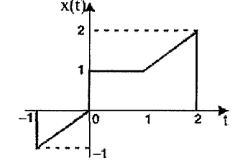
i) Amplitude scaling by factor of 3
ii) Time scaling by factor of 2
iii) Advancing signal by 4sec
OR
P.T.O.
https://t.me/SPPU_TE_BE_COMP

Q2) | a) | Sketch the continuous-time signal x(t) = 4 sin(Pi*t) at interval 0 < = t < = 4.
Sample the discrete time signal with sampling period of T = 0.4 sec and
Q3) | b) | then sketch the discreet time signal. |  | [6]
Q3) | b) | Define energy and power signal. Determine whether following signals
Q3) | a) | are energy or power signal |  | [8]
Q3) | a) | i) | x(n) = 2 u(3 – n)
Q3) | a) | ii) | x(n) = u(2n)
Q3) | a) | iii) | x(t) = 0.9e–3tu(t)
Q3) | a) | Differentiate between: |  | [4]
Q3) | b) | i) | Continuous and Discrete Time Systems.
Q3) | b) | ii) | Static and Dynamic Systems.
Q3) | b) | Differentiate between: |  | [10]
Q3) | b) | i) | Linear or non-linear
Q3) | b) | ii) | Causal or non causal
OR
Q4) | a) | Find the Convolution of | [9]
x1(n) = (1, –2, 3, 1}
x2(n) = {2, –3, –2}
Q5) | b) | Illustrate the properties of Linear Time-Invariant Systems. | [5]
Q5) | a) | State and explain the Dirichlet’s conditions for the existence of a Fourier
Q5) | b) | Series. | [4]
Q5) | b) | Determine the trigonometric form of Fourier series of the waveform as
Q5) | b) | shown in figure: | [10]
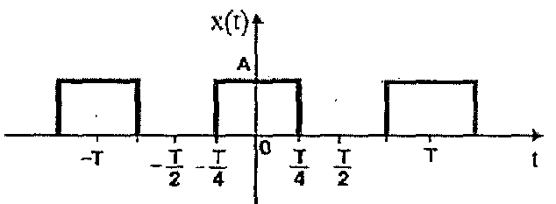
OR
[6582]-282 2
https://t.me/SPPU_TE_BE_COMP

Q6) | a) | State equation of Fourier transform and apply it to find Fourier transform
Q6) | a) | of x(t) = eat cos(Ω0t) u(t). | [10]
Q6) | b) | of x(t) = eat cos(Ω0t) u(t). | [10]
Q6) | b) | Sate any four properties of Fourier transform | [4]
Q7) | b) | Sate any four properties of Fourier transform | [4]
Q7) | a) | Find the Laplace Transform and ROC of Unit Step function and Unit
Q7) | b) | impulse function: | [10]
Q7) | b) | Sate and prove any two properties of Laplace Transform. | [4]
OR
Q8) | a) | Find inverse Laplace transform |  |  |  |  |  |  |  |  |  |  | [8]
Q8) | a) | i) | Xs ( | = | ( | s |  | s | s | + | 3) |  | [8]
 |  | i) |  | = | ( | s | + | 1)( | s | +
 |  | ii) | Xs ( | = | ( | s | + | 3 | s | + |  | 3)
Q9) | b) | ii) |  |  |  |  |  | 5)( | s |  |  | 3) | [6]
Q9) | b) | Find Laplace transform and draw ROC of x(t) = t u(t). |  |  |  |  |  |  |  |  |  |  | [6]
Q9) | a) | State and prove any two properties of the Z-Transform. |  |  |  |  |  |  |  |  |  |  | [6]
Statement
Proof
b) Solve the difference equation: 2x(k) – 2x(k –1) + x(k – 2) = u(k) where x(k) = 0 for k > = 0 and u(k) = 1 if k k > = 0 and u(k) = 0 if k < 0.[8] OR
Q10) a) Find the inverse z transform x(z) = (z – 4)/(z – 1)(z – 2)2.
[9] b) Discuss relationship between Z-transform and Fourier Transform.[5]

[6582]-282 3
https://t.me/SPPU_TE_BE_COMP

Total No. of Questions : 10] PE5788

[6582]-283

S.E. (Instrumentation and Control)
PCC-203-INC : LINEAR INTEGRATED CIRCUITS
(2024 Pattern) (Semester - III)
Time : 2½ Hours] [Max. Marks : 70
Instructions to the candidates:
1) Answer Q1 or Q2, Q3 or Q4, Q5 or Q6, Q7 or Q8, Q9 or Q10.
2) Neat diagrams must be drawn wherever necessary.
3) Figures to the right indicate full marks.
4) Assume suitable data, if necessary.
Q1)a) Draw the neat circuit diagram of inverting amplifier and elaborate its
operation. [7]
b) Draw the neat circuit diagram and design non-inverting amplifier for gain
of 3.2. [7]
OR
Q2)a) Draw the neat circuit diagram of unity gain amplifier and elaborate its
operation. [7]
b) Derive the gain equation for an inverting amplifier. Draw neat circuit
diagram. [7]
Q3)a) Illustrate the working principle of practical integrator circuit with neat
circuit diagram and derivation of output equation. [7]
b) Write short note on I-V converter. [7]
OR
Q4)a) Draw the neat circuit diagram of three op-amp instrumentation amplifier
and elaborate the operation. [7]
b) Design and implement the circuit using op-amp to get the output
expression as V0 = 2V1 – 4V2+5V3 [7]
Q5)a) Explain working of Non-inverting comparator and state its
characteristics. [7]
b) Design a wein bridge oscillator to generate oscillations at 1 KHz. Draw
circuit diagram. [7]
OR
P.T.O.
https://t.me/SPPU_TE_BE_COMP

Q6)a) Explain the working of Half wave Precision Rectifier with appropriate
equations. [7]
b) Design a phase shift oscillator to oscillate at 200 Hz. [7]
Q7)a) Describe working of astable multivibrator with necessary diagrams and
derivations. [7]
b) Explain with one application, the working of IC CD 4051 as analog
multiplexer. [7]
OR
Q8)a) Draw pin diagram of IC 555 and explain working of each pin. [7]
b) Describe working of monostable multivibrator with necessary diagrams
and derivations. [7]
Q9)a) Define filter. Draw practical and ideal frequency response plots of low
pass, high pass, band pass, band stop filter. [7]
b) Design low pass first order Butterworth filter having cut off frequency
1 kHz with passband gain of 2. [7]
OR
Q10)a) Draw the neat circuit diagram and elaborate the operation of wide band
pass filter. [7]
b) Draw and explain circuit for generating 15V supply using IC7815.[7]
  
[6582]-283 2
https://t.me/SPPU_TE_BE_COMP

Total No. of Questions : 8] | [6582]-284 | SEAT No. :
PE-5789 | [6582]-284 | [Total No. of Pages : 2
S.E. (Instrumentation & Control Engineering)
MDM - 221 - INC : Data Structures (Multidisciplinary Minor - I) (2024 Pattern) (Semester - III)
Time : 2½ Hours] [Max. Marks : 70 Instructions to the candidates:
1) Answer Q.1 or Q.2, Q3. or Q.4, Q.5 or Q.6, Q.7 or Q.8.
2) Neat diagrams must be drawn wherever necessary. 3) Figures to the right side indicate full marks.
Q1) | 4) | Assume suitable data, if necessary. | [9]
Q1) | a) | Analyze the output of the following Python program. | [9]
def myfunc(n):
return lambda a : a * n
mydoubler = myfunc(2)
print(mydoubler(11))
Explain what a lambda function is and when it is typically used.
b) Develop a program to generate a list of squares of numbers from 1 to 10 by using list comprehension. [8] OR
Q2) | a) | Develop the Python program to input the marks of 5 students and show
Q3) | b) | their total, average, maximum and minimum marks. | [9]
Q3) | b) | Analyze what happens when a local variable has the same name as a
Q3) | b) | global variable inside a function with program. | [8]
Q3) | a) | global variable inside a function with program. | [8]
Q3) | a) | Develop a linked list with 3 nodes containing values 10, 20, and 30. [9]
Q3) | b) | Analyze a function to search for a value in a singly linked list. | [8]
OR
P.T.O.
https://t.me/SPPU_TE_BE_COMP

Q4) | a) | Comment on a Python class for a singly linked list that supports inserting
Q5) | b) | at the beginning and end. | [9]
Q5) | b) | Examine why a linked list implementation may be slower than a Python
Q5) | b) | list for small datasets despite having better theoretical complexity. | [8]
Q5) | a) |  | [8]
Q5) | a) | Elaborate the base case and recursive case using example. | [9]
Q5) | b) | Develop a program to display given numbers sequence in order using
Q5) | b) | stable sorting. N = 123, 45, 65, 32, 24, 99, 96, 95 | [9]
OR
Q6) | a) | Develop a program that uses recursion to solve the Tower of Hanoi.[9]
Q7) | b) | Examine how binary search fails it the list is unsorted. | [9]
Q7) | a) | Illustrate tree terminology and binary tree structure. | [9]
Q7) | b) | Analyze the traversing methods In order, Preorder and Post order of
Q7) | b) | binary search tree. | [9]
OR
Q8) | a) | Elaborate the graph representation using adjacency matrix and adjacency
Q8) | b) | list. | [9]
Q8) | b) | Create a Python program implementing insert, delete, search, and traversals
Q8) | b) | for a binary search tree. | [9]
♣♣♣
[6582]-284 2
https://t.me/SPPU_TE_BE_COMP

Total No. of Questions : 8] | [6582]-285 | SEAT No. :
PE-5790 | [6582]-285 | [Total No. of Pages : 2
S.E. (Instrumentation & Control)
VEC - 232 - INC : Universal Human Values and Professional Ethics (2024 Pattern) (Semester - III)
Time : 2 Hours] [Max. Marks : 35 Instructions to the candidates:
1) Answer any four questions.
2) Neat diagrams must be drawn wherever necessary. 3) Figures to the right indicate full marks.
4) Use of Calculator is allowed.
5) Assume suitable data, if necessary.
Q1) How does self-exploration promote self-awareness and personal growth?[8] OR
Q2) Explain the interconnectedness between Right Understanding, Relationship, and Physical Facility. [8]
Q3) Describe how right understanding helps in identifying and fulfilling the needs of the Self and the Body correctly. [9] OR
Q4) Explain how right utilization of physical facilities supports harmony between the Self and the Body. [9]
Q5) Explain the role of trust in establishing harmony within a family. [9] OR
Q6) Describe the four elements of social harmony. Justice, trust, partcipation, and reciprocity. [9]
P.T.O.
https://t.me/SPPU_TE_BE_COMP

Q7) Explain how harmony is maintained naturally among the four orders of nature
(material, plant, animal, human) [9]
OR
Q8) | Explain interconnectedness among the four orders of nature. | [9]
♣♣♣
[6582]-285 2
https://t.me/SPPU_TE_BE_COMP

Total No. of Questions : 6] PE-5940 | SEAT No. :
Total No. of Questions : 6] PE-5940 | [Total No. of Pages : 5
[6582]-287
S.E. (Internet of Things)
PCC-202-IOT : DISCRETE MATHEMATICS
(2019 Pattern) (Semester - III)
Time : 2½ Hours] [Max. Marks : 70
Instructions to the candidates:
1) All questions are compulsory.
2) Figures to the right indicate full marks.
3) Neat diagrams must be drawn wherever necessary.
4) Use of electronic pocket calculator and is allowed.
Q1)Write the correct option for the following multiple choice questions
(MCQ's). [10]
i) If the statement is p→q then the converse is
a) ~p→~q b) ~q→~p
c) q→p d) p↔q
ii) In a function f from set A to set B, every element of set A has _____
image in Set B.
a) Different b) Same
c) Many d) One & only one
iii) Total no. of edges in a graph with 5 vertices out of which two vertices
of degree 3 & three vertices of degree 2 is _______
a) 6 b) 12
c) 15 d) 10
iv) In a full 4-ary tree if pendant vertices are 22, then internal vertices are
________
a) 8 b) 5
c) 6 d) 7
v) The set G = {0, 1, 2, 3, 4} is an abelian group with respect to addition
modulo 5 with identity element is _______
a) | 0 | b) | 1
c) | 2 | d) | 3
P.T.O.
https://t.me/SPPU_TE_BE_COMP

Q2)Solve Any three of the following : [12]
a) In a survey of 85 people it is found that 31 like to drink milk, 43 like
coffee & 39 like tea. Also 13 like both milk & tea, 15 like milk & coffee
20 like tea & coffee and 12 none of the three drinks using principle of
inclusion - exclusion find the number of people who like all the three
drinks.
b) | Obtain the principal Conjunctive Normal Form (PCNF) and Principal Disjunctive Normal Form (PDNF) of the statement ~(p∧q) → (p↔~q)
using truth table.
c) Prove that the validity of the following argument. "Radha works hard".
If Radha works hard then she is a dull girl and "If Radha is a dull girl
then she will not get the job". Therefore, "Radha will not get the job".
d) Use mathematical induction to prove that
n
i=∑(4i – 2) = 2 + 6 + 10 + .... + (4n–2) = 2n2 for all integers n > 1.
e) In how many ways can 30 late admitted students be assigned to three
practical batches A,B,C if A can accommodates 10 students, B can
accommodates 15 students, C can accommodates 5 students only.
Q3)Solve any three of the following : [12]
a) Let R be a Relation on a Set A = {1, 2, 3, 4, 5} given by
R = {(a,b)|a + b < 5, a,b∈ A}. Find the relation on Set A & represent the
relation R using diagraph.
b) Let R be a relation defined on Set A = {1, 3, 6, 9, 12} such that
R = {(a,b)| b is divisible by a}. Draw the Hasse diagram for the relation R.
c) Find the Transitive closure of a relation R = {(2,1), (2,3), (3,1), (3,4)
(4,1), (4,3)} on set A = {1, 2, 3, 4}. Using Warshall's Algorithm.
d) | Let f, g and h be the function from the set of all the real numbers to set of all real numbers defined by f(x) = x2 + 2, g(x) = 6x & h(x) = 5 – x then
find.
i) (fohog) (x)
ii) (hofog) (x)
e) Solve the recurrence relation an – 7an–1 + 10 an–2 = 4 where a0=2 & a1 = 2.
[6582]-287 2
https://t.me/SPPU_TE_BE_COMP

Q4)Solve any three : [12]
a) Explain the terms [4]
i) Adjacency matrix
ii) Incidency matrix
b) Show that the given pairs of graphs are isomorphic. [4]
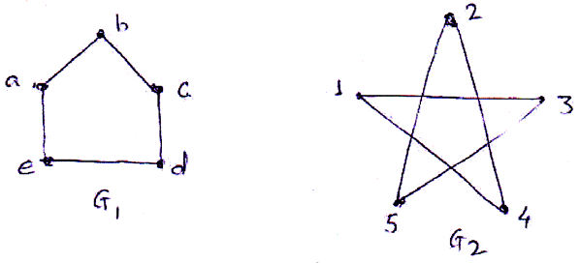
c) Determine whether the following graph has a Hamiltonian circuit or
Hamiltonian path. [4]
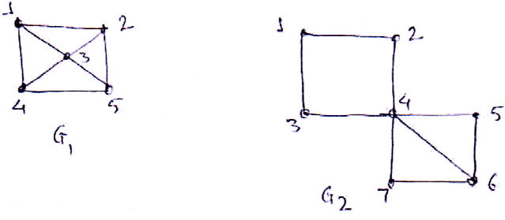
d) | Use Dijkstra's algorithm to find the shortest path between A and Z. | [4]
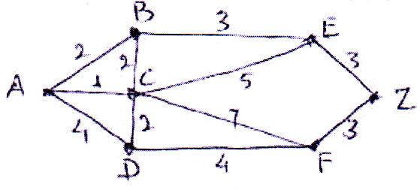
e) | Define the graph Kn and Kmn. | 3 | [4]
[6582]-287 |  | 3 | [4]
https://t.me/SPPU_TE_BE_COMP

Q5)Solve any three of the following : |  |  |  | [12]
a) | Define the following |  |  | [12]
i) |  |  | Rooted tree | [12]
ii) |  |  | M - ary tree | [12]
b) |  | For the following set of weights, construct binary prefix code : |  | [12]

α | β | γ | σ | ∈
5 | 6 | 6 | 11 | 20

c) | Find the minimum spanning tree for the following graph using Kruskal
algorithm.
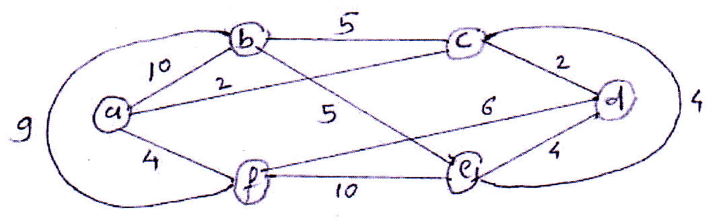
d) Discuss Max - flow - min cut theorem with an example.
e) Find the minimum spanning tree using Prim's algorithm.
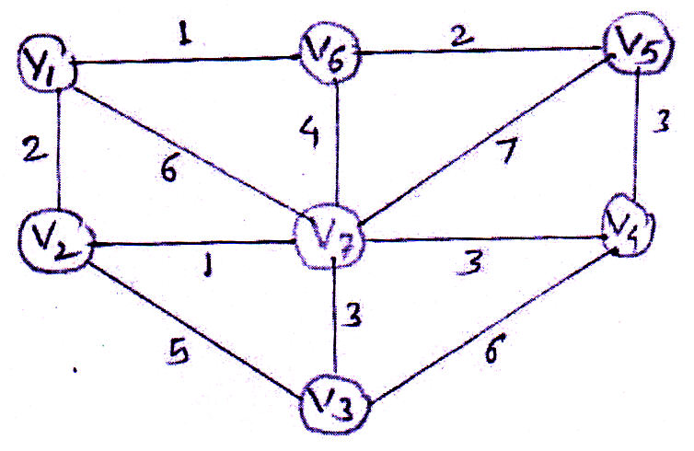
[6582]-287 4
https://t.me/SPPU_TE_BE_COMP

Q6)Solve any three : [12]
a) Explain properties of Binary operation. [4]
b) Let (Z, *) and the binary operation * on set Z is defined as a * b = a + b + 1
for a,b ∈Z then show that (Z, *) is an abelian group. [4]
c) Let (Z6, +6) be a group. Show that Z6 is a cyclic group. [4]
⎧⎡a b⎤⎫
d) Let G=⎨
⎩
⎢
⎣c d⎥
⎦
:,,, abcd∈Z⎬
⎭ is a group with matrix addition and
(Z,+) be a group. The mapping f (G, +) → (Z, +) is defined as
e) | f | ⎧⎨⎩ | ⎡⎢⎣ | a |  | b | ⎤⎥⎦ | ⎫⎬⎭ | = | a | then show that f is homomorphism. |  |  | [4]
 |  |  |  | c |  | d
e) | Find code words generated by the encoding function e : B2→ B5 with
e) | respect to parity check matrix. |  |  |  |  |  |  |  |  |  |  |  |  | [4]
e) | H | ⎡  ⎢  =⎢⎢⎣ |  |  | 1 | 1 | 1 |  | 0 |  |  | 0 | ⎤  ⎥  ⎥  ⎥⎦
e) | H |  |  |  | 0 | 1 | 0 |  | 1 |  |  | 0
e) | H |  |  |  | 1 | 0 | 0 |  | 0 |  |  | 1
♦♦♦
[6582]-287 5
https://t.me/SPPU_TE_BE_COMP

Total No. of Questions : 10] PE-5941 | SEAT No. :
Total No. of Questions : 10] PE-5941 | [Total No. of Pages : 2
[6582]-288R
S.E. (Internet of Things)
PCC-203-IOT : SENSORS, ACTUATORS & SIGNAL
PROCESSING
(2024 Pattern) (Semester - III)
Time : 2½ Hours] [Max. Marks : 70
Instructions to the candidates:
1) Answer Q.1 or Q.2, Q.3 or Q.4, Q.5 or Q.6, Q.7 or Q.8, Q.9 or Q.10.
2) Neat diagrams must be drawn where ever necessary, labelled correct diagram
carries full marks.
3) Assume suitable data, if necessary.
4) Use of non-programmable scientific calculator is allowed.
Q1)a) What is the difference between sensors and actuators? [4]
b) What is the role of sensors in IoT applications? [4]
c) Illustrate the concept of Smart Material Actuators, explain working of
Piezoelectric transducers. [6]
OR
Q2)a) What are the different types of actuators? [4]
b) What is the Selection criteria sensors and actuators? [6]
c) What are some common applications of sensors and actuators in
industries? [4]
Q3)a) Explain the stroboscopic method of measuring angular velocity and its
applications. [7]
b) Describe the working principle of a potentiometer and its application in
displacement measurement. [7]
OR
Q4)a) Compare and contrast the working principles of ultrasonic level detectors
and radar level transmitters. [7]
b) Describe the construction and working of a piezoelectric accelerometer.[7]
P.T.O.
https://t.me/SPPU_TE_BE_COMP

Q5)a) Describe the architecture of a Wireless Sensor Network (WSN) and its
applications. [6]
b) Compare and contrast the characteristics of conventional and smart
sensors. [4]
c) Describe the components of a Data Acquisition System (DAQ) in smart
sensors. [4]
OR
Q6)a) Describe the working principle of a piezoelectric pressure sensor and its
application in pressure measurement. [6]
b) Discuss the key components of a smart sensor architecture and their
functions. [4]
c) Difference between smart sensor & conventional sensor. [4]
Q7)a) Describe the properties of energy and power signals and provide examples
of each. [6]
b) Classify signals into different types. [4]
c) Define and explain the characteristics of a unit step signal and its
applications. [4]
OR
Q8)a) Explain the representation of continuous time signals in discrete time
domain using sampling process. [6]
b) Discuss the differences between deterministic and random signals with
examples. [4]
c) Explain the concept of periodicity in continuous and discrete time signals
with examples. [4]
Q9)a) Derive the Radix-2 Decimation-In-Time (DIT) Fast Fourier Transform
(FFT) algorithm and explain its computational efficiency. [6]
b) Explain the properties of DFT, specifically periodicity and symmetry,
with examples. [4]
c) Discuss the advantages and applications of FFT in signal processing.[4]
OR
Q10)a) Describe the twiddle factor and its role in FFT computation. [4]
b) Compare and contrast the computational complexity of DFT and FFT
algorithms. [6]
c) Describe the circular convolution property of DFT and its application.[4]

[6582]-288R 2
https://t.me/SPPU_TE_BE_COMP

Total No. of Questions : 10] PE-5950 | SEAT No. :
Total No. of Questions : 10] PE-5950 | [Total No. of Pages : 3
[6582]-289
S.E. (Internet of Things)
MDM-221-IOT : DATA STRUCTURES AND ALGORITHMS
(2024 Pattern) (Semester - III)
Time : 2½ Hours] [Max. Marks : 70
Instructions to the candidates :
1) Answer Q.1, or Q.2, Q.3 or Q.4, Q.5 or Q.6, Q.7 or Q.8 and Q.9 or Q.10.
2) Figures to the right side indicate full marks.
3) Assume Suitable data if necessary.
4) Neat diagrams must be drawn wherever necessary.
Q1)a) Describe the following characteristics of object oriented programming
with the help of example. [6]
i) Encapsulation
ii) Polymorphism
iii) Inheritance
b) Define a class and an object in C++. Write the declaration syntax for
both. [4]
c) Explain function overloading with example. [4]
OR
Q2)a) What do you mean by operator overloading? Explain Binary operator
overloading for addition plus operator with example. [6]
b) What is Construct? Explain constructor type with example. [4]
c) What are the rules for overloading operators? [4]
Q3)a) Define and explain order of growth Big - O, Omega and Theta notation.
[7]
b) Write a C++ function for Insertion sort to sort integer's numbers with an
example. [7]
OR
Q4)a) Sort the given numbers {75, 15, 58, -5, -22, 34, 54, 28, 27, 1} [7]
i) Bubble sort
ii) Selection sort
b) Write a C++ function for binary search. Compare the time complexities
of Linear search and Binary search. [7]
P.T.O.
https://t.me/SPPU_TE_BE_COMP

Q5)a) Write an algorithm with appropriate illustrations to perform the following
operations on single linked list (SLL) for Delete a node (Start, End).[6]
b) What is doubly linked list? Explain insert operation in Doubly Linked
List. [4]
c) Compare Array and Linked List. [4]
OR
Q6)a) Write a C++ function for the following in DLL : [6]
i) Display the complete list
ii) Search an element in the list
b) What is Singly Linked list? Explain transversal operation in Singly Linked
List. [4]
c) Write a function PUSH and POP in 'C++' for stack using Linked List.[4]
Q7)a) Explain in brief common operations on the stack. Write PUSH and POP
function for stack using array. [7]
b) Write a C++ function insert and delete to implement queue using array.
Explain Types of queues in short. [7]
OR
Q8)a) Given following infix expression, find their prefix and postfix notations.[7]
i) a * b/c * d - e/f
ii) (a + b) / (c + d)
iii) a + b + c + d
b) Compare Stack and Queue. Explain any three Queue operations. [7]
[6582]-289 2
https://t.me/SPPU_TE_BE_COMP

Q9)a) Find out Minimum spanning Tree of the following graph (figure 1) using
Kruskal's algorithm. [5]
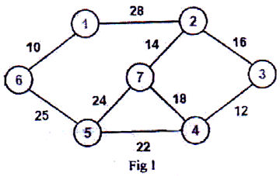
b) Explain graph traversal method with suitable example. [5]
c) Explain all the rotations in AVL tree. Construct AVL tree for the following
data : [4]
{1, 2, 3, 4, 5, 6}
OR
Q10)a) Represent the following graph shown in Fig. 2 using the adjacency matrix
and adjacency list. [5]
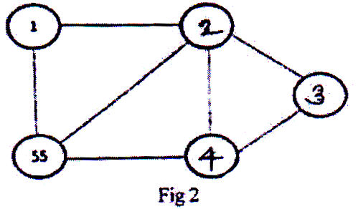
b) Explain with suitable example, DFS and BFS traversal of a graph. [5]
c) Find the shortest path from node 'a' to node 'c' and node 'a' to node 'd' in
the graph shown in fig. 3 using Dijkstra's algorithm. [4]
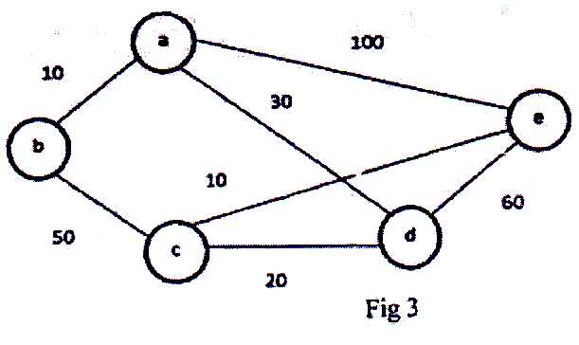
♦♦♦
[6582]-289 3
https://t.me/SPPU_TE_BE_COMP

Total No. of Questions : 10] PE-5936 | SEAT No. :
Total No. of Questions : 10] PE-5936 | [Total No. of Pages : 2
[6582]-292
S.E. (MechanicalSandwich)
PCC-202-MSW : THERMAL ENGINEERING - I (2024 Pattern) (Semester - III)
Time : 2½ Hours] [Max. Marks : 70 Instructions to the candidates:
1) Answer Q.1 or Q.2, Q.3 or Q.4, Q.5 or Q.6, Q.7 or Q.8, Q.9 or Q.10.
2) Figures to the right indicate full marks.
3) Neat diagrams must be drawn wherever necessary.
4) Make suitable assumptions whenever necessary.
5) Scientific calculator, steam table & Mollier chart is allowed.
Q1)a) State zeroth law and first law of thermodynamics and give its application. [8] b) Obtain SFEE for Boiler, turbine and nozzle. [6] OR
Q2)a) Compare between Open cycle and Closed cycle. [6] b) Steam enters turbine with velocity of 20m/sec and enthalpy 2000kJ/kg and leaves with velocity 70m/sec and enthalpy 1500kJ/kg.
Heat losses from turbine to surrounding are 2kJ/sec and steam flow rate is l.5kg/sec. Neglect change in PE and find power developed by turbine. [8]
Q3)a) Explain Boyle's law, Charle’s Law, Avogadro’s law and equation of state. [8] b) A closed vessel contains 2 kg of carbon dioxide at temperature 20°C and pressure 0.7 bar, Heat is supplied to the vessel till the gas acquires a pressure of 1.4 bar, Calculate: i) Final temperature ii) Work done on or by the gas iii) heat added iv) Change in internal energy. Take specific heat of gas at constant volume as 0.657 kJ/kg-K. [6] OR
Q4)a) Describe limitations of first law of thermodynamics? State second law of thermodynamics. Give examples. [6] b) A reversed heat engine working as a refrigerator absorbs heat from low temperature region of 650 kJ, when work input is 250 kJ. Find its COP and heat transferred to surroundings. If reversed heat engine works as a heat pump, find its COP. If system works as engine find its efficiency. [8]
P.T.O.
https://t.me/SPPU_TE_BE_COMP

Q5)a) Prove that entropy is a property of the system. [8]
b) Explain the terms; i) Available energy ii) Dead state iii) Unavailable
energy. [6]
OR
Q6)a) What do you mean by Clausius inequality? [6]
b) A constant volume chamber of 0.3 m3 capacity contains 1 kg of air at
20°C. Heat is transferred to the air until its temperature is 200°C. Find
i) Heat transferred ii) Change in entropy. [8]
Q7)a) Compare Carnot and Rankine cycle. [6]
b) A pressure cooker contains 2 Kg of steam at 5 bar and 0.9 dry. Calculate
the quantity of heat which must be rejected so as the quality of steam
becomes 0.5 dry. Draw process on PV and TS diagram. [8]
OR
Q8)a) Explain with neat sketch the working of throttling calorimeter. [6]
b) Calculate cycle efficiency & steam consumption in kg/ kwhr for Carnot
cycle & Ranking cycle using steam between two pressures of 20 bar &
0.1 bar. The steam is dry & saturated at 20 bar. [8]
Q9)a) Explain with neat sketch Benson boiler. [7]
b) A boiler generates 4000 kg/hr of steam at 20 bar and 400°C from feed
water at 30°C. Coal used is 600 kg/hr of CV 30000 kJ/kg. Find Boiler
efficiency and equivalent of evaporation. [7]
OR
Q10)a) Compare Natural draught and artificial draught in boiler. [7]
b) Explain significance of heat balance sheet in boiler. Also explain all
parameters of heat balance sheet along with formula in boiler. [7]

[6582]-292 2
https://t.me/SPPU_TE_BE_COMP

Total No. of Questions : 10] PE5746

[6582]-296

S.E. (Mechanical/Mechanical S.W.)
PCC 201 MEC : SOLID MECHANICS
(2024 Pattern) (Semester - III)
Time : 2½ Hours] [Max. Marks : 70 Instructions to the candidates:
1) Answer any five questions only (Que.1 or 2, Que.3 or 4, Que.5 or 6, Que.7 or 8, Que.9 or 10).
2) Assume suitable data if necessary.
Q1)a) Find the value of load P that will not exceed maximum overall deformation of 2mm, or a stress in steel of 140MPa, that in Aluminum 80MPa, and in brass 120MPa. Es = 200GPa, EAl = 70GPa, EBr = 83GPa [8]
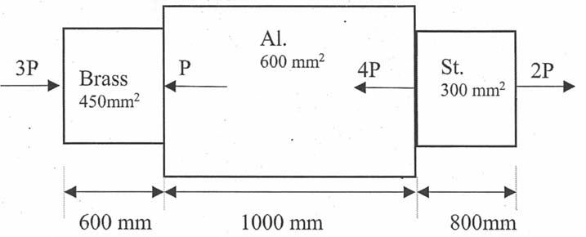
b) A flat plate is fastened to a gusset plate using four rivets. The plate is subjected to a normal stress of 120 MPa caused by a load P. Determine an appropriate rivet diameter if the allowable shear stress in each rivet is 90 MPa. The reduction in plate strength due to rivet holes may be neglected. Thickness of flat plate is 15 mm. [6]
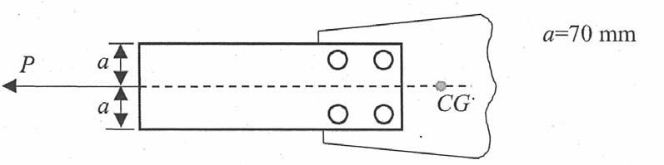
OR
P.T.O.
https://t.me/SPPU_TE_BE_COMP

Q2)a) A 16m long steel rail is laid at a temperature of 25°C, and the maximum
expected temperature is 48 °C. [8]
i) Determine the minimum clearance that should be left between two
rails to prevent the formation of thermal stresses.
ii) Compute the thermal stresses in the rails under the following
conditions:
a) When no expansion joint is used, and
b) When a 2 mm expansion gap is provided.
[Given: E = 2.1×105N/mm2, α = 12×10–6 /°C]
b) Figure shows the aluminum bar inserted in a steel tube. The rod and tube
are fixed together at 150°C. Calculate the stresses induced in the rod and
Q3)a) | in the tube when temperature falls to 30°C. Take αs = 12×10–6/°C,
Q3)a) | αA = 23×10–6/°C, Es = 210GPa, EA = 70GPa. | [6]
Q3)a) | 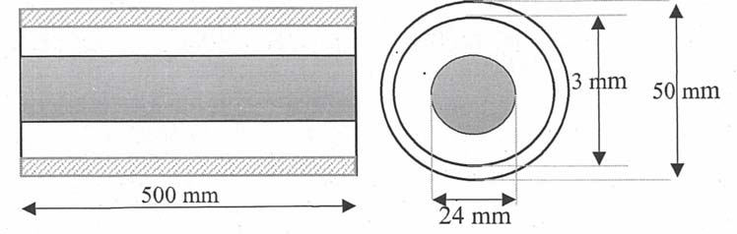  A simply supported beam carrying UDL as shown in Figure. Draw shear
Q3)a) | force and bending moment diagram. | [8]
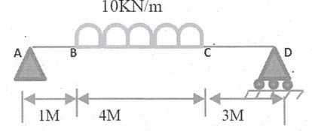
b) Draw shear force and bending moment diagrams for a cantilever beam of
span 2 m carrying loads as shown in Figure. [6]
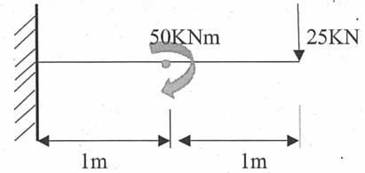
OR
[6582]-296 2
https://t.me/SPPU_TE_BE_COMP

Q4)a) A simple supported beam AB of span 10m carries a concentrated loads
of 4kN, 10kN and 7kN at distance of 1.5m, 4m and 6m from left support,
Draw Shear Force and Bending Moment diagram. [8]
b) A cantilever beam of length 2m carries point loads as showi in fig. Draw
shear force and bending moments diagrams for the cantilever. [6]
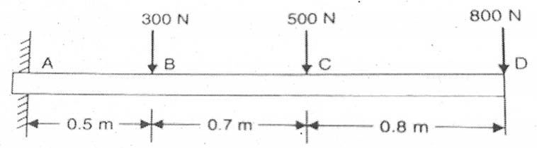
Q5)a) As shown in figure, allowable stress in bending is 50MPa. Find the intensity
of UDL the beam can carry over simply supported span of 4m. [8]
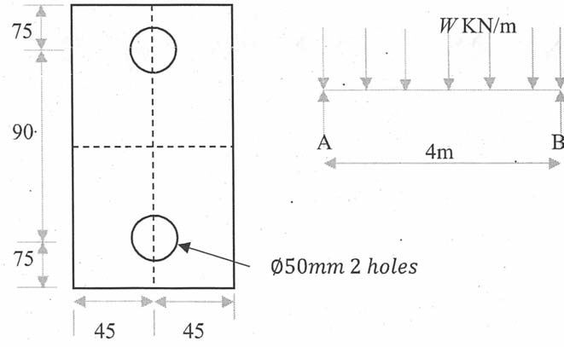
b) For the beam shown in figure, find the share stress at 50 mm away from
neutral axis, under a UDL of 10KN/m over a span of 4m. [6]
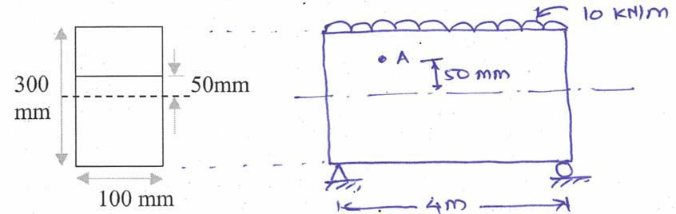
OR
[6582]-296 3
https://t.me/SPPU_TE_BE_COMP

Q6)a) For the shown c/s of beam determine moment of Inertia, maximum tensile
stress, and compressive stress under UDL of 2 KN/m over a span of 3m
for cantilever beam. [8]
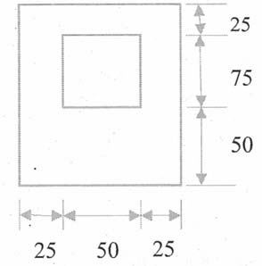
b) Find moment of resistance of the beam section shown in figure when
permissible stress in bending is 100MPa [6]
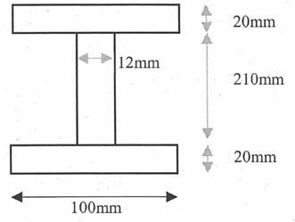
Q7)a) A solid circular bar 25 m long and 120 mm is used as a MS column.
Determine critical load and safe load taking FOS = 3 with following end
conditions i) Both ends fixed and ii) one end fixed and other end hinged.
Assume Modulus of Elasticity 210GPa. [8]
b) A hollow shaft of 150 mm inner diameter is transmitting power of 200 Kw
at 1400 RPM. Determine the angle of twist and torsional shear stress if
modulus of rigidity is 100 GPa of a shaft material. [6]
OR
Q8)a) A compound shaft consisting of a steel segment and an aluminum segment
is acted upon by two torques as shown in Fig. Determine the maximum,
permissible value of T subject to the following conditions: τst = 83 MPa,
τAl = 55 MPa, and the angle of rotation of the free end is limited to 6°.
For steel, G = 83 GPa and for aluminum, G = 28 GPa. [8]
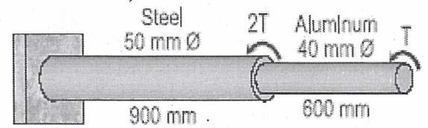
[6582]-296 4
https://t.me/SPPU_TE_BE_COMP

b) A hollow circular shaft of 150mm external diameter, thickness of metal
20mm is rotating at 200rpm. The angle of twist on 3m length was found
to be 0.7°. find the power transmitted. [6]
Q9)a) State of stress for an element of unit thickness is shown in Figure. Find
the normal stress and shear stress that must act on an inclined dotted
plane to keep the element in equilibrium. [8]
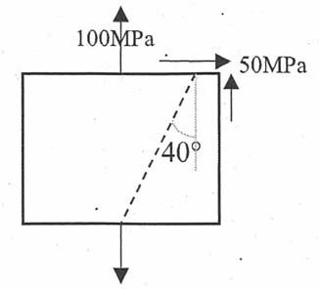
b) Write a short not on theories of elastic failure, types and application. [6]
OR
Q10) a) For the given state of plane stress, Construct Mohr’s circle with
proper scale on graph paper. [8]
i) Determine principal stresses and principal plane
ii) Determine maximum shear stress and shear plane
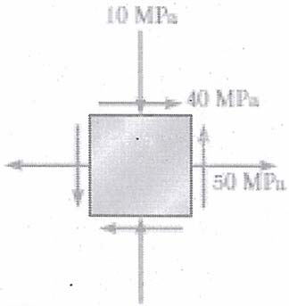
b) | Explain |  | [6]
b) | i) | Maximum Shear Stress Theory | [6]
b) | ii) | Distortion energy theory | [6]
  
[6582]-296 5
https://t.me/SPPU_TE_BE_COMP

Total No. of Questions : 10] PE-5792 | SEAT No. :
Total No. of Questions : 10] PE-5792 | [Total No. of Pages : 3
[6582]-297
S.E. (Mechanical Engineering)
PCC-202-MEC : ENGINEERING THERMODYNAMICS
(2024 Pattern) (Semester - III)
Time : 2½ Hours] [Max. Marks : 70
Instructions to the candidates:
1) Solve Q.1 or Q.2, Q.3 or Q.4, Q.5 or Q.6, Q.7 or Q.8. Q.9 or Q.10.
2) Neat diagrams must be drawn wherever necessary.
3) Figures to the right side indicate full marks.
4) Assume suitable data if necessary.
5) Use of Scientific calculator, Steam tables & Mollier chart is allowed.
Q1)a) What is Perpetual Motion Machine of the First Kind (PMM-I)? Explain why it is impossible based on the First Law of Thermodynamics. [6]
b) Differentiate between macroscopic and microscopic approaches in thermodynamics. Explain their importance with suitable examples. [8]
OR
Q2)a) Explain the Zeroth Law of Thermodynamics. Discuss its significance in defining temperature and describe how thermocouples use this principle for temperature measurement. [6]
b) At the inlet of a certain nozzle the enthalpy of a fluid passing is 2800 kJ/kg and the velocity is 50 m/s. At the discharge the enthalpy is 2600 kJ/kg. The nozzle is horizontal and there is negligible heat loss from it. Find: [8]
i) The velocity at the exit of the nozzle
ii) If the inlet area is 900 cm2 and specific volume at inlet is 0.187 m3/kg, find the mass flow rate,
iii) If the specific volume at the nozzle exit is 0.498 m3/kg, find the exit area of the nozzle.
P.T.O.
https://t.me/SPPU_TE_BE_COMP

Q3)a) Explain the concept of Heat Engine, Refrigerator and Heat pump with
schematic diagram. [6]
b) A certain gas occupies a space of 0.3 m3 at a pressure of 2 bar and
temperature 77 °C. It is heated at constant volume until the pressure is 7
bar. Determine [8]
i) Temperature at the end of process.
ii) Mass of the gas.
iii) Change in internal energy.
iv) Heat transfer.
v) Work done.
Given Cp = 1.005 kJ/kg.K. Cv = 0.712 kJ/kg.K.
OR
Q4)a) Define Ideal Gas and Explain ideal gas laws Boyle’s law, Charle’s law,
Avogadro’s Law. [7]
b) A Camot engine operates between 800 K and 400 K. The engine absorbs
2000 kJ of heat per cycle. Find: [7]
i) Carnot efficiency,
ii) Work output,
iii) Heat rejected.
Q5)a) Prove that entropy is a property of the system. [7]
b) Derive maximum useful work available during non-flow system. [7]
OR
Q6)a) | 25 kg of copper block, Cp 0.387 kJ/Kg K at 100°C is dropped in 20 litres of water at 30 °C. Assume perfect heat transfer and no lost due to
the surroundings. Find the final equilibrium temperature reached for water
and copper block and entropy generation. [7]
b) Explain the concepts of available energy, unavailable energy, and dead
state in thermodynamics. Represent these concepts on a T-S diagram.[7]
Q7)a) Explain briefly effect of varying boiler pressure, condenser pressure and
superheat pressure on the performance of Rankine Cycle. [6]
b) A sample of steam at 200 °C and a pressure of 7 bar is first expanded at
a constant enthalpy to 3 bar and then at constant entropy to 0.5 bar with
the help of Mollier chart or diagram. Determine the change of entropy
and enthalpy during the process. [8]
OR
[6582]-297 2
https://t.me/SPPU_TE_BE_COMP

Q8)a) Define the following terms and write their equations. [6] i) Enthalpy of latent heat
ii) Enthalpy of sensible heat
iii)
Enthalpy of superheat iv) Degree of superheat
v) Critical point
vi) Enthalpy of Steam
b)
Determine the efficiency of Simple Rankine cycle working pressure of 2 MPa and condenser pressure of 10.0 kPa steam leaves the boiler and enters the turbine as dry saturated. Determine of Efficiency of Rankine cycle. [8]
Q9)a) Explain the necessity of providing draught in a boiler. Draw & explain working of the Natural draught. [6] b) A steam generator evaporates 18000 kg/hr of steam at 12.5 bar and quality of is 0.97 dry; from feed water at 105 °C, when coal is fired at the rate of 2040 kg/hr. If the HCV of the coal is 27400 KJ/kg, Determine:[8] i) The heat rate of boiler in kJ/hr;
ii) The equivalent evaporation;
iii) The thermal efficiency of the Boiler
OR
Q10)a)
Explain the function of Boiler Accessories. Explain with neat sketches any one of the accessories. [6] b) The following data refer to a boiler plant consisting of an economizer, a boiler and a superheater. [8] Mass of water evaporated per hour = 5940 kg
Mass of coal burnt per hour = 675 kg
LCV of coal =31600 kJ/kg
Pressure of steam at boiler stop valve = 14 bar
Temperature of feed water entering economizer = 32 °C
Temperature of feed water leaving economizer = 115 °C
Dryness fraction of steam leaving boiler and entering superheaer = 0.96 Temperature of steam leaving superheater = 260 °C
Specific heat of superheated steam = 2.33 kJkg.K
Deermine (i) Percentage of heat in coal utilized in economizer, boiler and superheater (ii) Overall efficiency of boiler plant.
[6582]-297 3
https://t.me/SPPU_TE_BE_COMP

Total No. of Questions : 10] PE-5793 | SEAT No. :
Total No. of Questions : 10] PE-5793 | [Total No. of Pages : 3
[6582]-298
S.Y. (Mechanical/Mechanical S.W.)
PCC-203-MEC : ENGINEERING MATERIALS & METALLURGY
(2024 Pattern) (Semester - III)
Time : 2½ Hours] [Max. Marks : 70
Instructions to the candidates :
1) Answer Q.1 or Q.2, Q.3 or Q.4, Q.5 or Q.6, Q.7 or Q.8 and Q.9 or Q.10.
2) Neat diagrams must be drawn wherever necessary.
3) Figures to the right side indicate full marks.
4) Assume Suitable data if necessary.
Q1)a) Draw the planes for [6]
i) (10-1)
ii) (2 1 0)
iii) (11 –1)
b) Differentiate between destructive testing and nondestructive testing. State
principle and explain radiographic testing with suitable diagram. Enlist its
applications. [8]
OR
Q2)a) Is etching of a metallographic sample always necessary? Justify. Enlist
and explain steps in process used for preparation of metallographic sample
under optical microscope. [7]
b) With the help of a neat sketch explain the difference in the flow lines
observed in forged components and cast components. [7]
Q3)a) Explain the terms 1] Solid solution 2] Alloy. Explain the factors that govern
Hume Rothery’s rules of solid solubility. [6]
b) Draw Iron Carbon equilibrium diagram showing all the details like
temperature, composition, phases, critical lines & invariant reactions.[8]
OR
Q4)a) Explain the Eutectic, Partial Eutectic and Isomorphous systems. [8]
b) Draw the cooling curve for pure metal and binary solid solution and
apply phase rule for it. [6]
P.T.O.
https://t.me/SPPU_TE_BE_COMP

Q5)a) State the importance of Time Temperature Transformation (TTT) diagram
in heat treatment processes. Plot the isothermal TTT diagram with proper
details. [8]
b) Differentiate between Annealed and Normalized components with the help
of the following criteria : [6]
i) Tensile strength
ii) Microstructure
iii) Grain size distribution
iv) Internal stresses
OR
Q6)a) State whether the following statements are True or False and justify your
choice correctly. [6]
i) Martensite is a soft phase.
ii) Hardening of steel is always followed by tempering.
iii) Hardness is the same property as hardenability.
b) State the difference between Case hardening and surface hardening.
Explain with neat sketch Flame hardening and its applications. [8]
Q7)a) Explain in detail IS, AISI, SAE designations. Mention the names of alloying
elements used and the amount of alloy present the following steels. [7]
i) AISI 1040
ii) Fe 410 K
iii) 80 T 11
iv) 30Ni4Cr2Mo1
b) Explain the term Stainless Steel? Classify and explain the types of it. Also
explain the term Sensitization of Stainless Steel. How to avoid sensitization
of stainless steel? [7]
OR
Q8)a) What are the different types of cast iron? Draw white & gray cast iron
microstructure and their compositions. State and justify the use of white
and grey cast iron in the applications. [8]
b) Explain classification of Alloying Elements of Steel with respect to the
relation with carbon and allotropic forms of iron. Give examples for each
category. | 2 | [6]
[6582]-298 | 2 | [6]
https://t.me/SPPU_TE_BE_COMP

Q9)a) List any two types of brasses and bronzes (each) along with their
composition and applications. Differentiate between brass and bronze.[8]
b) | State the composition, properties and applications of |  | [6]
b) | i) | Invar | [6]
b) | ii) | Inconel | [6]
b) | iii) | Duralumin | [6]
OR
Q10)a) Suggest suitable Non-Ferrous material for following applications. Justify?
[4]
i) Space Craft
ii) Dental Implants
iii) Turbine Blades
iv) Electric Vehicles
b) What is Additive Manufacturing? Enlist any two Additive Manufacturing
materials with its application? Explain required properties and importance
of Additive Manufacturing material. [6]
c) What are general properties and applications of Nickel and its alloys?
List all alloys of Nickel. [4]
♦♦♦
[6582]-298 3
https://t.me/SPPU_TE_BE_COMP

Total No. of Questions : 6] PE-5794 | SEAT No. :
Total No. of Questions : 6] PE-5794 | [Total No. of Pages : 5
[6582]-299
S.E. (Automobile/Mechanical/Mechanical S.W)
MDM-221-MEC : ENGINEERING MATHEMATICS - III
(2024 Pattern) (Semester - III)
Time : 2½ Hours] [Max. Marks : 70
Instructions to the candidates:
1) All questions are compulsory.
2) Figures to the right indicate full marks.
3) Neat diagrams must be drawn wherever necessary.
4) Use of electronic non porgrammable calculator is allowed.
5) Assume suitable data if necessary.
Q1)Write the correct option for the following multiple choice questions.[10]
 | The solution of differential equation |  |  |  |  |  |  | 3  dy |  | − | 4 | dy | = | 0 | is ________ | [2]
i)  ii) |  |  |  |  |  |  |  | dx | 3 |  |  | dx |  |  | is ________ | [2]
i)  ii) | a) | C1 ex + C2 e–2x + C3 e–3xb) |  |  |  | C1 + C2 e2x + C3 e–2x
i)  ii) | c) | C1 e2x + C2 e–2x |  |  | d) | C1 + C2 cos 2x + C3 sin 2x
i)  ii) | Two cards are drawn from a well shuffled pack of 52 cards. If the first card
i)  ii) | drawn is replaced, the probability that they are both king's is ______ |  |  |  |  |  |  |  |  |  |  |  |  |  |  | [2]
i)  ii) | a) |  | 1 | b) |  |  | 1
 |  |  | 169 |  |  |  | 221
 | c) |  | 2 | d) |  | 1
iii) |  |  | 221 |  |  | 15
iii) | A cube root of 100 using secant method, lies between ______ |  |  |  |  |  |  |  |  |  |  |  |  |  |  | [2]
iii) | a) | 1 and 2 |  |  | b) | 4 and 5
iii) | c) | 5 and 6 |  |  | d) | 0 and 1
P.T.O.
https://t.me/SPPU_TE_BE_COMP

iv) | Differential equation |  |  |  |  |  |  |  |  |  |  |  |  |  |  |  |  |  |  |  |  |  |  |  |  | dy  dx= |  |  |  |  | x | − |  | y |  | 2 | , with y(0) = 1, h = 0.1 is to be solved
usign Euler's method. If y(0.1) = 0.9 then y at x = 0.2 is ______ |  |  |  |  |  |  |  |  |  |  |  |  |  |  |  |  |  |  |  |  |  |  |  |  |  |  |  |  |  |  |  |  |  |  |  |  |  |  |  |  |  |  |  |  |  |  |  |  | [2]
a) |  |  |  |  |  |  | 0.991 |  |  |  |  |  |  |  |  |  |  |  |  |  |  |  |  |  |  | b) |  |  |  |  |  |  |  |  |  |  | 1.892
c) |  |  |  |  |  |  | 0.829 |  |  |  |  |  |  |  |  |  |  |  |  |  |  |  |  |  |  | d) |  |  |  |  |  |  |  |  |  |  | 0.289
v) | A curve is given by |  |  |  |  |  |  |  |  |  |  |  |  |  |  |  |  |  |  |  |  |  |  | r |  | = |  | ( | e | t | cos) ti |  |  |  |  |  |  | + | ( | e | t | sin) tj |  |  | + | t  e k | Tangent vector to
the curve at t = 0 is _____ |  |  |  |  |  |  |  |  |  |  |  |  |  |  |  |  |  |  |  |  |  |  |  |  |  |  |  |  |  |  |  |  |  |  |  |  | [2]
a) |  |  |  |  |  |  | i |  | − |  | j | − |  |  | k |  |  |  |  |  |  |  |  |  |  | b) |  |  |  |  |  |  |  |  |  |  | j |  |  | + |  | k
c) |  |  |  |  |  |  | 2 |  | i |  | + | 2 |  | j |  | + |  |  | k |  |  |  |  |  |  | d) |  |  |  |  |  |  |  |  |  |  | i |  |  | + |  | j | + | k
Q2)Solve (any three) of the following : |  |  |  |  |  |  |  |  |  |  |  |  |  |  |  |  |  |  |  |  |  |  |  |  |  |  |  |  |  |  |  |  |  |  |  |  | [12]
a) |  | 2  dy |  |  |  | − |  |  | 3 | dy |  |  | + |  |  | 2 |  | y |  | = |  | xe |  |  | 3 | x | + |  | sin 2 |  |  |  | x |  | . |  | [4]
 |  | dx |  |  | 2 |  |  |  | 3 | dx
b) | (D2 + 4) y = sec 2x (Use method of variation of parameter). |  |  |  |  |  |  |  |  |  |  |  |  |  |  |  |  |  |  |  |  |  |  |  |  |  |  |  |  |  |  |  |  |  |  |  |  |  |  |  |  |  |  |  |  |  |  | [4]
c) | x |  | 2 | 2  dy |  |  |  |  | − |  | 4 | x |  | dy |  |  | + |  |  | 6 | y |  | = |  |  | 3 x |  | . |  |  |  |  |  |  |  |  | [4]
c) |  |  |  | dx |  |  |  | 2 |  |  | 4 |  |  | dx
d) | Solve the simultaneous equations |  |  |  |  |  |  |  |  |  |  |  |  |  |  |  |  |  |  |  |  |  |  |  |  |  |  |  |  |  |  |  |  |  |  |  | [4]
dy  dt+ |  |  |  |  |  |  | y |  | = |  | sin |  |  |  | t
dy  dt+ |  |  |  |  |  |  | x |  | = |  | cos |  |  |  | t
e) | A body weighing W = 20 N is hung from a spring. A pull of 40 N will
stretch the spring to 10 cm. The body is pulled down to 20 cm below the static equillibrium position and then released. Find the displacement & velocity of the body from its equillibrium position in time 't' seconds.[4]
[6582]-299 2
https://t.me/SPPU_TE_BE_COMP

Q3)Solve (Any three) of the following : |  | [12]
a) | Find arithmetic mean and coefficient of variation for x if the data is,[4]

x | 1 | 2 | 3 | 4
f | 9 | 6 | 5 | 3

b)  c)  d)  e) | The first four moments of a distribution about the value 5 are 2,20,40 and 50. Obtain the first Four central moments, also Find B1 and B2.[4] The regression equations are 8x – 10y + 66 = 0 and 40x – 18y = 214.
b)  c)  d)  e) | The value of variance of x is 9. Find |  | [4]
b)  c)  d)  e) | i) | The mean values of x & y
b)  c)  d)  e) | ii) | The correlation of x & y
b)  c)  d)  e) | A fair coin is tossed 5 times. What is the probability of getting atleast
b)  c)  d)  e) | two tails? |  | [4]
b)  c)  d)  e) | The height of students in a class follows a normal distribution with mean
190 cm and variance 80 cm2. Among the 1,000 students from the school
how many are expected to have height above 200 cm? [4]
[Given : z = 1.118, A = 0.3686]
Q4)Solve (any three) of the following : [12]
a) Solve the following equation f(x) = x4 – x – 10 = 0 using Newton -
Raphson method. Show 3 iterations Take x0 = 2. [4]
b) Solve 3x – 1 – cos x = 0 by using method of successive approximations
correct to 2 decimal places : [Initial value x0 = 0]. [4]
c) Solve the following system of equations by Gauss elimination method.[4]
4x1 + x2 + x3 = 4
x1 + 4x2 – 2x3 = 4
3x1 + 2x2 – 4x3 = 6
d) | Solve the following system by Cholesky's method | [4]
4x1 + 2x2 + 14x3 = 14
2x1 + 17x2 – 5x3 = –101
14x1 – 5x2 + 83x3 = 155
e) Solve the following system of equations by the Gauss - Seidal method.[4]
10x1 + x2 + x3 = 12
2x1 + 10x2 + x3 = 13
2x1 + 2x2 + 10x3 = 14
[6582]-299 3
https://t.me/SPPU_TE_BE_COMP


Q5)Solve (any three) of the following : |  | [12]
a) | From the tabulated values of x and y given below, prepare Forward
difference table. Find the value of y when x = 1.5. |  | [4]

x | 0 | 2 | 4 | 6 | 8
y | 5 | 29 | 125 | 341 | 725

b) | Following table shows enthalpy at different pressures | [4]

Pressure (bar) | 1.9 | 2.2 | 2.4 | 2.6
Enthalpy (kJ/kg. k) | 497.9 | 517.6 | 529.6 | 540.9
Find out the enthalpy at pressure 2.1 bar by Lagrange's interpolation method.
c) | The table shows the temperature F(t) as Fn of time | [4]

Time t | 1 | 2 | 3 | 4 | 5 | 6 | 7
Temperature F(t) | 81 | 75 | 80 | 83 | 78 | 70 | 60

Use Simpson's 13 |  |  |  |  |  |  |  |  | rd method, evaluate |  |  |  |  |  | 7  ∫ | Ftdt | . | [4]
 |  |  |  |  |  |  |  |  |  |  |  |  |  |  | 1 | Ftdt | .
d) |  | Sovle the equation |  |  |  |  |  |  |  | dy  dx=+ | xyx 0 | = | 0, | y 0 |  | = to find y at x = 0.1 using
modified Euler's method taking h = 0.1. |  |  |  |  |  |  |  |  |  |  |  |  |  |  |  | [4]
e) | Using Fourth order Runge - Kutta method solve the differential equation
dy  dx= |  |  | x | 2 | + | y | 2 | . Assuming y(1) = 1.5 estimate y(1.1). |  |  |  |  |  |  |  |  |  |  | [4]
Q6)Solve any three : |  |  |  |  |  |  |  |  |  |  |  |  |  |  |  | [12]
a) | Find the directional derivative of φ = xy2 + yz3 at the point (1, –1, 1)
along the vector i + 2j + 2k. |  |  |  |  |  |  |  |  |  |  |  |  |  |  |  | [4]
b) |  | Show that F = (6xy + z3) i + (3x2 – z) j + (3xz2 – y) k is irrotational. Also find the scalar potential φ such that F = ∇ φ. [4]
[6582]-299 |  |  | 4
https://t.me/SPPU_TE_BE_COMP

c) | Find the workdone in moving a particle once round the ellipse
c) | x | 2 | + | y | 2 | = | 1, | z | = | 0
 | 25 |  |  | 16 |  |  |  |  |  |  | under the field of force given by | [4]
F = (2x – y + z) i + (x + y – z2) j + (3x – 2y + 4z)k
d) | Prove that |  | ∫∫ |  | (φ∇ψ |  | −ψ | ∇ | φ) | . ds | = | ∫∫∫ | (φ | ∇ | 2ψ | −∇ | 2φ) | dv | . | [4]
d) | s |  |  |  | v
d) |  | ∫∫ |  | rnˆ. |  | ds where S is the closed surface & r = xi + yj + zk[4]
e) | Evaluate
e) | Evaluate | s
(V is the volume enclosed by the surface S)
♦♦♦
[6582]-299 5
https://t.me/SPPU_TE_BE_COMP

Total No. of Questions : 8] PE-5747

[6582]-300

S.E. (Mechanical /Mechanical S.W.)
VEC233MEC/VEC207BMEC: Universal Human Values
(2024 Pattern) (Semester - III)
Time : 2 Hours] [Max. Marks : 35
Instructions to the candidates :
1) Solve Q.1 or Q.2, Q.3 or Q.4, Q.5 or Q.6, Q.7or Q.8
2) Neat diagrams must be drawn wherever necessary.
3) Figures to the right indicate full marks.
4) Assume suitable data, if necessary.
Q1)a) What are the basic requirements of Human Being and Enlist the same.
[2]
b) What do you mean by ‘Value Education’? Explain the basic guidelines
for Value Education. [3]
c) Define happiness and prosperity. How these are different from excitement
and wealth accumulation? [3]
OR
Q2)a) How Happiness is different from Excitement? [2]
b) Explain the content and process of Self-exploration with the help of a
diagram? [3]
c) What are basic human aspirations and what are the requirements to fulfill
them? [3]
Q3)a) Explain a difference between ‘Preconditioning’ and ‘Sensation’? [2]
b)‘Body is the instrument of the Self’. Explain. [3]
c) Self is the ‘Seer’, ‘Doer’ and ‘Enjoyer’ in this way it’s central to Human
Existence while the body is just an instrument for the ‘Self. Illustrate the
statement with the help of an example. [4]
P.T.O.
https://t.me/SPPU_TE_BE_COMP

OR
Q4)a) Illustrate the meaning of ‘seer’ as described in the course? [2]
b) List any three desires. Now analyze each of being related to Self or Body
giving appropriate reasons. [3]
c) What is the purpose of the Self? What is the purpose of the Body? What
would be the right utilization of the Body? [4]
Q5)a) Define Trust as the foundation value. [2]
b) Distinguish between Reverence, Gratitude and Glory. [3]
c) Why is education and Sanskar the first human goal? Distinguish between
education and Sanskar. [4]
OR
Q6)a) What is the right evaluation? [2]
b) Define affection. How does affection lead to harmony in the family?[3]
c) Explain the feelings of ‘Care’ and ‘Guidance’. What role do these feelings
have in the parents and child relationship? [4]
Q7)a) Compare the inheritance of Bio order and Physical order. [2]
b) Explain problems emanating from human order due to the lack of the
right understanding. [3]
c) Write a short note on the recyclability and self-regulation in nature. [4]
OR
Q8)a) Explain the term ‘submergence’ with reference to “coexistence in
existence”. [2]
b) Critically analyze four orders in Nature and demonstrate their
interconnectedness and mutual fulfillment. [3]
c) Discuss the scope and characteristics of people-friendly and eco-friendly
production systems. [4]
  
[6582]-300 2
https://t.me/SPPU_TE_BE_COMP

Total No. of Questions : 10] PE5748

[6582]-301

S.E. (Mechatronics Engineering)
PCC-201-MXE : SENSORS & INSTRUMENTATION
(2024 Pattern) (Semester - III)
Time : 2½ Hours] [Max. Marks : 70
Instructions to the candidates:
1) Answer Q.1 or Q.2, Q.3 or Q.4, Q.5 or Q.6, Q.7 or Q.8, Q.9 or Q.10.
2) Neat diagrams must be drawn wherever necessary.
3) Figres to the right indicate full marks.
4) Your answer will be valued as a whole.
5) Assume suitable data, if necessary.
Q1)a) Explain the significance of sensor measurements in mechatronics
system. [7]
b) Define & explain following characteristics of the sensors. [7]
i) Accuracy
ii) Precision
iii) Hysteresis
iv) Speed of response
OR
Q2)a) Explain the components of a data aquisition system with block diagram.[7]
b) Explain the selection criteria of a sensors for mechatronics system. [7]
Q3)a) Explain the working principle, construction of a LVDT with neat diagram.[7]
b) Write a note on optical encoders. Explain the working of an incremental
optical encoder with diagram. [7]
OR
Q4)a) Describe the construction and working of strain gauge based column
type load cell. [7]
b) Explain construction and working of digital tachometer with advantages
& disadvantages. [7]
P.T.O.
https://t.me/SPPU_TE_BE_COMP

Q5)a) Explain the construction and working of a U-tube manometer with a neat diagram. [7] b) Explain construction & working of a venturimeter with a neat diagram.[7] OR
Q6)a)
Describe the construction and working of an ultrasonic flowmeter. [7] b) Describe the working construction of a thermocouple with diagram.[7]
Q7)a) Describe the working of a general - purpose CRO with a neat diagram.[7] b) Define deflection sensitivity of CRO and explain in detail an oscilloscope probes 1 : 1 and 10 : 1. [7] OR
Q8)a)
What is a digital storage oscilloscope? Draw and explain the block diagram of a DSO. [7] b) What is sampling rate and roll mode in a DSO? Explain in detail. [7]
Q9)a) Describe the evolution of traditional sensors to smart sensors. Explain each stage with suitable examples. [7] b) Explain the concept of DAQ in smart sensor. Discuss its components with neat diagram. [7] OR
Q10)a) Compare conventional sensors & smart sensors based on any four parameters. [7] b) Define smart sensor and explain the architecture of a smart sensor with a neat block diagram. [7]
  
[6582]-301 2
https://t.me/SPPU_TE_BE_COMP

Total No. of Questions : 10] PE5749

[6582]-302

S.E. (Mechatronics Engineering)
PCC-202-MXE : ENGINEERING THERMODYNAMICS (2024 Pattern) (Semester - III)
Time : 2½ Hours] [Max. Marks : 70 Instructions to the candidates:
1) Answer Q.1 or Q.2, Q.3 or Q.4, Q.5 or Q.6, Q.7 or Q.8, Q.9 or Q.10.
2) Figures to the right indicates full marks.
3) Neat diagrams must be drawn wherever necessary.
4) Use of logarithmic tables slide rule, Mollier charts, electronic pocket calculator and steam tables is allowed.
5) | Assume Suitable data, if necessary. | [7]
Q1)a) | Explain with neat sketch constant volume gas thermometer. | [7]
b) | Differentiate between microscopic and macroscopic approach. | [7]
OR
Q2)a) What is Quasi-static process? Explain in detail. [7]
b) Explain temperature measuring scales and write their conversions. [7]
Q3)a) State the Kelvin-Planck and Clausius statements of second law of thermodynamics and prove the violation of Kelvin-Planck statement leads to violation of Clausius statement. [7]
b) A heat pump is used to maintain a house of 23ºC. The house is loosing the heat to outside air through walls at 60,000 kJ/hr. While energy generated in house by various appliances is 4000 kJ/hr. For a coefficient of performance of 1.5, find required power input in kW, supplied to heat pump. [7]
OR
Q4)a) Prove that internal energy is a property of the system. [7]
b) A reversible heat engine operates on Carnot cycle between source and sink temperatures of 225ºC and 25ºC respectively. If the heat engine receives 40 kW from the source, Find the net work done, heat rejected to sink and efficiency of the engine. [7] P.T.O.
https://t.me/SPPU_TE_BE_COMP

Q5)a) Define and give significance for following terms: [7]
i) Thermal conductivity
ii) Thermal diffusivity
b) A plane wall is 15 cm thick of surface area 4.5m2. Thermal conductivity
of the wall is 9.5 w/mk. The inner and outer surface temperatures of the
wall are maintained at 150ºC and 45ºC respectively. [7]
Determine:
i) Heat flow rate across the wall.
ii) Temperature gradient in the heat flow direction, and
iii) Temperature of surfaces at 5 cm and 10 cm away from the inner
surface.
OR
Q6)a) Explain various modes of heat transfer with suitable real-life applications.[7]
b) A horizontal steel pipe having a diameter of 5cm is maintained at a
temperature of 50ºC in a large room where the air and wall temperatures
are at 20ºC. The surface emissivity of the steel may be taken as 0.8 and
convection heat transfer coefficient as 25 w/m2k. Calculate the total heat
lost by the pipe per unit length. [7]
Q7)a) Define the following terms : [6]
i) Mass fraction
ii) Mole fraction
iii) Stoichiometric Air-fuel ratio
b) The percentage analysis by mass of a solid fuel is as follows : C = 87%,
H2 = 3%, N2 = 1%, S = 1% and reminder is ash. If 50% of excess air is
supplied, Find. [8]
i) The theoretical amount of air required for complete combustion of fuel.
ii) The volumetric analysis of wet flue gases.
iii) The mass of flue gases per kg of fuel.
OR
[6582]-302 2
https://t.me/SPPU_TE_BE_COMP

Q8)a) Explain bomb colorimeter with a neat schematic diagram. [6]
b) A sample of fuel has the following percentage composition by weight :
carbon = 84%, hydrogen = 10%, oxygen = 3.5%, nitrogen = 1.5% and
ash = 1%. Determine [8]
i) The stoichiometric air-fuel ratio by mass
ii) If 20% excess air is supplied, find percentage composition of
dry-flue gases by volume.
Q9)a) | Differentiate between boiler mountings and boiler accessories. | [7]
b) | Explain the boiler heat balance sheet with formulae used. | [7]
OR
Q10)a) Give functions and locations of the following. [7]
i) Super heater
ii) Water level indicator
iii) Safety valve
iv) Fusible plug
b) Explain construction and working of Cochran boiler with a neat sketch.[7]
eeee
[6582]-302 3
https://t.me/SPPU_TE_BE_COMP

Total No. of Questions : 8] PE5750

[6582]-304

S.E. (Mechatronics Engineering)
PCC-203-MXE : LINEAR INTEGRATED CIRCUITS
(2024 Pattern) (Semester - III)
Time : 2½ Hours] [Max. Marks : 70
Instructions to the candidates:
1) Solve Q1 or Q2, Q3 or Q4, Q5 or Q6, Q7 or Q8.
2) Neat diagrams must be drawn wherever necessary.
3) Use of logarithmic tables slide rule, Mollier chart, electronic pocket Calculator
and steam tables is allowed.
4) | Assume suitable data, if necessary. | [6]
Q1)a) | Explain an integrator using op-amp with neat diagram. | [6]
b) | Explain current to voltage converter using op-amp. | [6]
c) | Explain differentiator using op-amp neat diagram. | [6]
OR
Q2)a) With neat diagram explain three input summing amplifier using op-amp
and derive the equation. [6]
b) Draw neat diagram of R-C phase shift oscillator and explain operation.[6]
c) Design wein bridge oscillator using operational amplifier for output
frequency of 5kHz. Draw circuit diagram. Assum suitable data. [6]
Q3)a) Explain the voltage to frequency converter circuit using op-amp. [6]
b) Draw the circuit diagram and explain precession half wave rectifier with
waveforms. [6]
c) Compare low pass, high pass, band pass, and band stop filters. [5]
OR
P.T.O.
https://t.me/SPPU_TE_BE_COMP

Q4)a) Explain triangular wave generator using circuit using op-amp. [6]
b) Explain the working of inverting and non-inverting comparators. [6]
c) Describe inverting and non – inverting Schmitt trigger operation using
op-amp. [5]
Q5)a) Explain the dual slop ADC in detail with neat diagram. [6]
b) Explain with neat diagram binary weighted resistor type of DAC. [6]
c) Explain with neat diagram ADC using DAC. [6]
OR
Q6)a) Explain with neat circuit diagram of R/2R ladder type DAC. [6]
b) Describe the working of successive approximation ADC with block
diagram and timing diagram. [6]
c) Write a short note on performance parameter of ADC. [6]
Q7)a) Explain the working and application of PLL (IC 565). [6]
b) Draw circuit diagram of wave form generator XR 2206. [6]
c) Explain the design of positive and negative voltage regulator using 78XX
and 79XX series. [5]
OR
Q8)a) | Explain the working of functional block diagram of IC555 timer. | [6]
b) | Explain the operation of audio power amplifier LM380. | [6]
c) | Explain the working and application of VCD (IC566). | [5]
  
[6582]-304 2
https://t.me/SPPU_TE_BE_COMP

Total No. of Questions : 10] | [6582]-305 | SEAT No. :
PE-5751 | [6582]-305 | [Total No. of Pages : 2
S.E. (Mechatronic Engineering)
MDM - 221 - MXE : Control System Components (2024 Pattern) (Semester - III)
Time : 2½ Hours] [Max. Marks : 70 Instructions to the candidates:
1) Answer Q.1 or Q.2, Q3. or Q.4, Q.5 or Q.6, Q.7 or Q.8, Q.9 or Q.10.
2) Neat diagrams must be drawn wherever necessary.
3) Figures to the right indicate full marks.
Q1) | 4) | Assume suitable data, if necessary.
Q1) | a) | Explain the construction & working of Toggle switch with neat symbolic
Q1) | b) | representation.State its applications. | [7]
Q1) | b) | Differentiate between Relays & Contactors. | [7]
OR
Q2) | a) | Explain construction, working of electro-mechanical relay with neat
Q3) | b) | diagram. State its application. | [7]
Q3) | b) | Write short note on Limit Switch. Temperature switch with their
Q3) | b) | application. | [7]
Q3) | a) | application. | [7]
Q3) | a) | Explain the construction & working principle of a DC motor. Draw neat
Q3) | b) | diagram and describe the function of each part. | [7]
Q3) | b) | Enumerate & explain the types of DC motor with respect to their field &
armature connections. Mention one industrial application for each type.[7]
OR
Q4) | a) | Derive the EMF equation for DC motor. | [7]
Q4) | b) | With suitable diagrams. Explain the speed control method of DC motor.[7]
P.T.O.
https://t.me/SPPU_TE_BE_COMP

Q5) | a) | Explain construction & working principle of single-phase induction motor
Q5) | b) | with neat labelled diagram. | [7]
Q5) | b) | Write short note on methods of speed control of three - phase Induction
Q5) | b) | motor. | [7]
OR
Q6) | a) | Explain construction & working principle of three phase induction motor.[7]
Q7) | b) | Explain following motor protection techniques |  | [7]
Q7) | b) | i) | Short - circuit protection
Q7) | b) | ii) | Overload Protection
Q7) | a) | ii)
Q7) | a) | iii) | Under - voltage protection
Q7) | a) | Explain the pneumatic power supply system with a neat labelled diagram.
Q7) | b) | Describe the function of each block / component. |  | [7]
Q7) | b) | Write short note on |  | [7]
Q7) | b) | i) | Cushion Cylinder
Q7) | b) | ii) | Double rod Cylinder
OR
Q8) | a) | Explain construction & working of single - acting pneumatic cylinder
Q9) | b) | with neat diagram. |  | [7]
Q9) | b) | Write short note on following pneumatic circuits. |  | [7]
Q9) | b) | i) | Direction control
Q9) | b) | ii) | Speed Regulation.
Q9) | a) | ii)
Q9) | a) | Explain the hydraulic power supply system with neat labelled diagram.[7]
Q9) | b) | Enlist different types of hydraulic pumps. Explain working of gear pump
Q9) | b) | with diagram. |  | [7]
OR
Q10) a) Draw the standard symbols used in hydraulic circuits as per ISO standards. Explain the function of each. [7]
b) Compare pneumatic, hydraulic system. [7]
♣♣♣
[6582]-305 2
https://t.me/SPPU_TE_BE_COMP

Total No. of Questions : 10] | [6582]-306 | SEAT No. :
PE-5795 | [6582]-306 | [Total No. of Pages : 2
S.E. (Mechatronic Engineering)
VEC - 232 - MXE : Universal Human Values and Professional Ethics
(2024 Pattern) (Semester - III)
Time : 2 Hours] [Max. Marks : 35 Instructions to the candidates:
1) Answer Q.1 or Q.2, Q3. or Q.4, Q.5 or Q.6, Q.7 or Q.8, Q.9 or Q.10.
2) Neat diagrams must be drawn wherever necessary.
3) Figures to the right side indicate full marks.
Q1) | a) | What do you understand about the Value of Unit? | [3]
Q1) | b) | What are the basic requirements of Human Being? Enlist | [2]
OR
Q2) | a) | What do you mean by Holistic Development? | [3]
Q3) | b) | Define self - organization. | [2]
Q3) | a) | What do you mean by right utilization of the body? | [3]
Q3) | b) | Human being is the Coexistence of self and Body. Explain | [2]
OR
Q4) | a) | Distinguish between Intention and Desire. | [3]
Q5) | b) | Define Self-Regulation and Health. | [2]
Q5) | a) | Define Exchange-storage as a dimension of the Human Order. | [4]
Q5) | b) | Is Working for competition the same as working for excellence? Analyze.[4]
P.T.O.
https://t.me/SPPU_TE_BE_COMP

OR
Q6) | a) | What is the role of physical facility in the fulfilment of relationship?[4]
Q7) | b) | Define affection. How does affection lead to harmony in the family?[4]
Q7) | a) | Explain the four orders of nature. | [4]
Q7) | b) | What is the outcome of harmony with the whole of nature/existence?[4]
OR
Q8) | a) | What is our role concerning innateness in nature? | [4]
Q9) | b) | Explain Self-regulation in Nature. | [4]
Q9) | a) | Explain the term ‘Professional Ethics’ with its characteristics? | [5]
Q9) | b) | How do you presently decide what is Valuable to you? | [4]
OR
Q10) a) Explore the issues in professional ethics in the current scenario. List any five unethical practices in the profession today. [5]
b) How Values and Ethics are related? [4]
♣♣♣
[6582]-306 2
https://t.me/SPPU_TE_BE_COMP

Total No. of Questions : 10] PE-5796 | SEAT No. :
Total No. of Questions : 10] PE-5796 | [Total No. of Pages : 2
[6582]-307
S.E. (Printing & Packaging Technology)
PCC-201-PPT : INTRODUCTION TO PRINTING
PROCESSES
(2024 Pattern) (Semester - III)
Time : 2½ Hours] [Max. Marks : 70
Instructions to the candidates:
1) Answer Q.1 or Q.2, Q.3 or Q.4, Q.5 or Q.6, Q.7 or Q.8. Q.9 or Q.10.
2) Neat diagrams must be drawn wherever necessary.
3) Figures to the right side indicate full marks.
4) Assume suitable data if necessary.
5) Use of non-Programmable calculator is allowed.
Q1)a) Draw the schematic diagram of Flexographic printing process and label
all the units/parts. [6]
b) Differentiate between ‘Analog and Digital workflow’ used in conventional
printing processes. [8]
OR
Q2)a) Explain in brief Negative, Positive and Tracing. [6]
b) Explain the working of Flexographic printing mechanism in detail. [8]
Q3)a) Explain the principle of Silk Screen printing process with suitable diagram.
[6]
b) Explain in brief ‘Lamination’ operation used in post press with suitable
diagram/ applications. [8]
OR
Q4)a) Explain in brief ‘Varnishing’ operation used in post press with applications.
[6]
b) What do you mean by ‘Mechanical loose leaf Binding’? Explain any 2
types of mechanical loose leaf binding methods with diagram. [8]
P.T.O.
https://t.me/SPPU_TE_BE_COMP

Q5)a) | Explain the Additive color theory with suitable examples. | [6]
b) | Explain in detail ‘Shape, Size and Color’ with suitable diagram. | [8]
OR
Q6)a) Explain the Subtractive color theory with suitable examples. [6]
b) Explain in detail ‘Rhythm, Unity and Contrast’ with suitable diagram. [8]
Q7)a) List down various equipments required for the screen printing process.[6]
b) Explain in detail about aluminium frames used for the screen printing
process. [8]
OR
Q8)a) Explain in detail about any two types of screen printing fabric materials.
[6]
b) With suitable diagram, explain the terms ‘Mesh opening, Percentage open
area and color of mesh. [8]
Q9)a) Explain the role of sensitivity of coating solution and lamp in screen
exposing. [6]
b) Differentiate between Mechanical and Pneumatic screen stretching device.
[8]
OR
Q10)a) Explain the purpose of squeegee in screen printing process in detail.[6]
b) Explain in detail the method of preparing the screen by hand duffing
method. [8]

[6582]-307 2
https://t.me/SPPU_TE_BE_COMP

Total No. of Questions : 10] | [6582]-308 | SEAT No. :
PE5752 | [6582]-308 | SEAT No. :
PE5752 | [6582]-308 | [Total No. of Pages : 2
S.E. (Printing and Packaging Technology)
PCC-202- PPT : MATERIAL SCIENCE IN PRINTING AND
PACKAGING
(2024 Pattern) (Semester-III)
Time : 2½ Hours] [Max. Marks : 70
Instructions to the candidates:
1) Answer Q.1 or Q.2, Q.3 or Q.4, Q.5 or Q.6, Q.7 or Q.8, Q.9 and Q.10.
2) Figures to the right indicates full marks.
3) Neat diagrams must be drawn wherever necessary.
4) Use of non-programmable calculator is allowed.
5) Assume Suitable data if necessary.
Q1)a) Classify metals: ferrous & non-ferrous with examples and application as
an image carrier. [6]
b) Describe anodizing process for offset plate making with neat sketch.[8]
OR
Q2)a) Explain materials used for flexographic printing plate. [6]
b) Describe construction of screen-printing mesh & frame materials. [8]
Q3)a) List additives used in paste inks and state their role. [6]
b) Describe Chalking, Mottling, Set-off and ghosting as problems in printing.
Also suggest remedies for the same. [8]
OR
Q4)a) | Explain gloss, density and print contrast. | [6]
b) | Classify inks based on end-use applications. | [8]
Q5)a) | Describe calendaring and water marking process. | [6]
b) | Explain the importance of waste-paper utilization and de-inking. | [8]
OR
P.T.O.
https://t.me/SPPU_TE_BE_COMP

Q6)a) Discuss tensile and compressive strength of paper along with its usage
for specific application/purpose. [6]
b) Explain Cobb test & importance of moisture control. [8]
Q7)a) Give properties and applications of PP & PS. [6]
b) Explain puncture resistance, tensile strength properties of packaging
materials. [8]
OR
Q8)a) | Discuss characteristics and applications of aluminium foil. | [6]
b) | Compare paper-based & plastic-based packaging materials. | [8]
Q9)a) | Explain water-based adhesives with examples. | [6]
b) | Explain adhesives used in folding cartons and labels. | [8]
OR
Q10)a) | Describe plate maintenance chemicals in offset printing. |  | [6]
b) | Write short notes on: |  | [8]
b) | i) | Blanket washes | [8]
b) | ii) | Anti-setoff powders | [8]
eeee
[6582]-308 2
https://t.me/SPPU_TE_BE_COMP

Total No. of Questions : 10] PE5753

[6582]-309

S.E. (Printing and Packaging Technology)
PCC-203-PPT : INTRODUCTION TO PACKAGING CONCEPTS
(2024 Pattern) (Semester - III)
Time : 2½ Hours] [Max. Marks : 70
Instructions to the candidates:
1) Attempt any one from Q1 or Q2, Q3 or Q4, Q5 or Q6, Q7 or Q8, Q9 or Q10.
2) Figures to the right indicate full marks.
3) Neat diagrams must be drawn wherever necessary.
4) Assume suitable additional data, if necessary.
5) Use of non-programmable calculator is allowed.
Q1)a) Discuss packaging, its basic needs and applications. [6]
b) Describe the types of Packaging with advantages, limitations and
applications. [8]
OR
Q2)a) Describe the different types of hazards that affect on packaging. [6]
b) Discuss the Problems faced while Packaging the products and reasons
for packaging design. [8]
Q3)a) Illustrate with examples the key elements of package design. [6]
b) Apply the use of iconography, typography, symbols and imagery in
packaging design. [8]
OR
Q4)a) Describe the significance of shape and size in package design. [6]
b) Interpret the branding be reinforced through design elements in packaging.[8]
Q5)a) Explain product’s physical characteristics. [6]
b) Explain the paper characteristics. [8]
OR
Q6)a)  b) | Discuss packaging is providing protection to product from biological
Q6)a)  b) | effects. | [6]
Q6)a)  b) | Describe plastic characteristics. | [8]
P.T.O.
https://t.me/SPPU_TE_BE_COMP

Q7)a) | Explain retail market of packaging industry. | [6]
b) | Explain the importance of demography with example. | [8]
OR
Q8)a) Describe the packaging is promoting the product in market explain in
detail. [6]
b) Explain market considerations for package design. [8]
Q9)a) Explain the significance of specifications in quality standards. [6]
b) Describe the need of quality control in packaging. [8]
OR
Q10)a) Explain different packaging standards used to manufacture or maintain
quality in packaging products. [6]
b) Explain ISO standards are important in packaging industry. [8]
  
[6582]-309 2
https://t.me/SPPU_TE_BE_COMP

Total No. of Questions : 6] PE-5754 | SEAT No. :
Total No. of Questions : 6] PE-5754 | [Total No. of Pages : 4
[6582]-310
S.E. (Printing & Packaging Tech.)
MDM-221-PPT : ENGINEERING MATHEMATICS - III
(2024 Pattern) (Semester - III)
Time : 2½ Hours] [Max. Marks : 70
Instructions to the candidates:
1) Attempt all Questions.
2) Figures to the right indicate full marks.
3) Neat diagrams must be drawn wherever necessary.
4) Assume suitable additional data, if necessary.
5) Use ofnon-programmable calculator is allowed.
Q1)Write the correct option for the following multiple choice questions.
a) Interpolation technique is mainly based on: [2]
i) Theory of differentiation ii) Theory of integration
iii) Finite differences iv) Regression
b) The bisection method requires which condition on the initial interval
[a, b]? [2]
i) f(a)·f(b)>0 ii) f(a)·f(b)<0
iii) f(a) = f(b) iv) No condition
c) Standard deviation of the values 5,7,9 is: [2]
i) 1.63 ii) 2
iii) 4 iv) 3
d) If in a Poisson distribution, mean = 4, find P (r = 0): [2]
i) 0.018 ii) 0.047
iii) 0.135 iv) 0.200
e) Feasible region in LPP is: [2]
i) Always circular
ii) Always bounded
iii) The region that satisfies all constraints
iv) The region that violates constraints
P.T.O.
https://t.me/SPPU_TE_BE_COMP

Q2)Solve any three :
a) | Find the cubic polynomial with given set of points | [4]

x | 1 | 2 | 3 | 4
y | 6 | 11 | 18 | 27
Hence, evaluate f(1.4) by using Newton Forward Interpolation formula b) Find the polynomial of the lowest possible degree which assumes the values –21, 15, 12, 3 for x taking the values –1,1,2,3 respectively,
c) | using Langrage's Interpolation formula, find f(2.5). | [4]
c) | Given set of points for the function f(x), Evaluate f (2.8) by using
c) | Newton Forward Interpolation formula. | [4]

x | 0 | 1 | 2 | 3
f(x) | 1 | 2 | 1 | 10

d) | Estimate f (10) from the following data, using Lagrange’s Interpolation
d) | Formula. | [4]

x | 5 | 6 | 9 | 11
y | 12 | 13 | 14 | 16

e) | Given set of points for the function f(x) | [4]

x | 1 | 2 | 3 | 4
y | 3 | 9 | 18 | 30
Evaluate f (3.5) using Newton backward Interpolation.
Q3)Solve any three :
a) Find the root of the following polynomial function using the bisection method : [4] x3 – 4x – 1
b)  c)  d) | Find a root of an equation f(x) = x3 – 2x – 1 using Newton-Raphson
b)  c)  d) | Method. |  |  | [4]
b)  c)  d) | Estimate |  |  | ò1 | 3 | 1 dx x | using the Trapezoidal rule with four subintervals
b)  c)  d) | round your answer to one decimal place. |  |  |  |  |  |  | [4]
b)  c)  d) | Evaluate |  |  | [4]
b)  c)  d) | 1 xò0 1 + | x | dx
Take h = 0.25
By Simpson’s 1/3 rule.
e) | Evaluate |  |  | [4]
e) | 1 xò0 1 + | x | dx | [4]
By Simpson’s 3/8 rule.
[6582]-310 2
https://t.me/SPPU_TE_BE_COMP

Q4)Solve any three :
a) The first four moments of a distribution about the value 5 are 2, 20, 40 and 50. From the given information obtain the first four central moments, mean, standard deviation and coefficient of skewness and
b) | kurtosis. | [4]
b) | Find the correlation coefficient between x and y for the given values.[4]

x | 10 | 14 | 18 | 22 | 26 | 30
y | 18 | 12 | 24 | 26 | 30 | 36

c) | Determine the equations of regression lines for the following data :[4]

x | 1 | 2 | 3 | 4 | 5 | 6 | 7 | 8 | 9
y | 9 | 8 | 10 | 12 | 11 | 13 | 14 | 16 | 15

d)  e) | Fit a straight line of the form y = mx + c to the following data, by using
d)  e) | the method of least squares. | [4]
d)  e) | If the two lines of regression are 9x + y – λ = 0 and 4x + y = μ and the  means of x and y are 2 and –3 respectively, find the values of λ, μ and
  x | 1 | 2 | 3 | 4 | 5
  y | 2 | 5 | 7 | 8 | 10
d)  e) | the coefficient of correlation between x and y. | [4]
Q5)Solve any three :
a) Out of 2000 families with 4 children each, how many would you expect to have (i) atleast a boy (ii) 2 boys, (iii) 1 to 2 girls (iv) no girls?
[4]
b) A manufacturer of cotter pins knows that 2% of his product is defective. If he sells cotter pins in boxes of 100 pins and guarantees that not more than 5 pins will be defective in a box, find the approximate probability that a box will fail to meet the guaranteed quality. [4]
c) The average number of misprints per page of a book is 1.5. Assuming the distribution of number of misprints to be Poisson, find i) The probability that a particular book is free from misprints, ii) Number of pages containing more than one misprint if the book contains 900 pages. [4]
d) A die is rolled 10 times. What is the probability that it shows a "6" exactly 3 times? [4]
e) Assuming that the diameters of 1000 brass plugs taken consecutively from machine form a normal distribution with mean 0.7515 cm and standard deviation 0.0020 cm. How many of the plugs are likely to be approved if the acceptable diameter is 0.752 ± 0.004 cm?
[Given A (2.25) =0.4878, A (1.75) = 0.4599] [4]
[6582]-310 3
https://t.me/SPPU_TE_BE_COMP

Q6)Solve any three :
a) | Solve the following linear programming problem graphically. | [4]
Maximize : Z = 10x + 12y
Subject to the conditions:
x + 2y < 20, 2x + y > 10, x – y < 5, x > 0, y> 0
b) | A printing press produces brochures and magazines. | [4]

Product | Printing Time (min/unit) | Bindig Time (min/unit) | Profit/unit (`)
Brochure | 5 | 3 | 8
Magazine | 6 | 4 | 12
Available : 480 min printing, 300 min binding.
Determine the number of brochures and magazines to maximize profit.
c) | Solve the following linear programming problem graphically. | [4]
Minimize Z = 5x + 6y
Subject to the conditions :
2x + y > 10, x + 4y < 24, x + y > 8, x > 0, y > 0
d) | Solve the following linear programming problem graphically. | [4]
Maximize Z = 4x + y
Subject to the conditions :
x + y < 50, 3x + y < 90, x > 0, y > 0
e) | Solve the following linear programming problem graphically. | [4]
Minimize Z = 2x + 5y
Subject to the conditions :
x + y > 8, x + y > 12, x > 0, y > 0

[6582]-310 4
https://t.me/SPPU_TE_BE_COMP

Total No. of Questions : 8] PE5960

[6582]-311

S.E. (Printing & Packaging Technology)
VEC-232-PPT : UNIVERSAL HUMAN VALUES
(2024 Pattern) (Semester - III)
Time : 2 Hours] [Max. Marks : 35
Instructions to the candidates:
1) Attempt any one from Q1 or Q2, Q3 or Q4, Q5 or Q6, Q7 or Q8.
2) Figures to the right indicate full marks.
3) Neat diagrams must be drawn wherever necessary.
Q1)a) Define Human Consciousness as discussed in the course. [2]
b) What do you mean by ‘Mutual Happiness’ and ‘Mutual Prosperity’?[3]
c) Why is right understanding required in relationship for mutual happiness?
Illustrate with the help of two examples from your life. [3]
OR
Q2)a) What do you mean by Holistic Development? [2]
b) Distinguish between intention and desire. [3]
c) Explain the process of self-exploration. What is the expected result of
the self-exploration? [3]
Q3)a) What do you mean by Preconditioning? Give one example. [2]
b) What do you mean by the right utilization of the body? [3]
c) Explain how desires, thoughts and expectations when largely set by pre
conditionings or sensations leads to conflicts. [4]
OR
Q4)a) Illustrate the meaning of ‘seer’ as described in the course? [2]
b)‘Body is the instrument of the self’. Explain. [3]
c) Mention three purposes for which physical facilities are required by a
human being. [4]
P.T.O.
https://t.me/SPPU_TE_BE_COMP

Q5)a) List three forms of disrespect. [2]
b) Define Exchange-Storage as a dimension of the Human Order. [3]
c) What is the proposal for the definition of trust? Illustrate the feeling of
trust with one example, preferably from your own experience. [4]
OR
Q6)a) Define Reverence. Can we have the feeling of Reverence for every person.
[2]
b) Distinguish between Glory and Gratitude. [3]
c) Define Respect. What are prevalent notions of respect and their impacts
in society? What is the solution? [4]
Q7)a) List out five dimensions of Human Order. [2]
b) Express the term ‘submergence’ with reference to coexistence in the
existence. [3]
c) What do you understand by the definitiveness of ethical human conduct?
Why is this definitiveness desirable? [4]
OR
Q8)a) Briefly describe the natural characteristics of the Animal Order. [2]
b) What are the guidelines of professional ethics? [3]
c) Critically analyze the statement “Nature is already in harmony (except for
human being without right understanding), so there is a potential or
provision for harmony in human being”. [4]

[6582]-311 2
https://t.me/SPPU_TE_BE_COMP

Total No. of Questions : 10] PE-5933 | SEAT No. :
Total No. of Questions : 10] PE-5933 | [Total No. of Pages : 2
[6582]-312
S.E. (Production Engineering/Production Sandwich)
PCC-202-PEE : MANUFACTURING PROCESSES
(2024 Pattern) (Semester - III)
Time : 2½ Hours] [Max. Marks : 70
Instructions to the candidates :
1) Attempt any one from Q.1, or Q.2, Q.3 or Q.4, Q.5 or Q.6, Q.7 or Q.8 and Q.9 or Q.10.
2) Figures to the right side indicate full marks.
3) Neat diagrams must be drawn wherever necessary.
4) Assume Suitable data if necessary.
5) Use of non-programmable calculatore is allowed.
Q1)a) What do you understand from pattern, mould and casting. [6]
b) Explain different types of gates with neat sketch. [8]
OR
Q2)a) What are stages of foundry? Explain in detail. [6]
b) Compare progressive and directional solidification. [8]
Q3)a) Explain the flame characteristics of gas welding process with a neat sketch.
[6]
b) | Discuss gas welding equipment's in detail. | [8]
OR
Q4)a) | Differentiate are welding and gas welding. |  | [6]
b) | Explain TIG welding process with a neat sketch. |  | [8]
Q5)a) | Sketch lathe machine and explain various parts of lathe. |  | [6]
b) | Write short notes on |  | [8]
b) | i) | Profile milling | [8]
b) | ii) | Straddle milling | [8]
b) | iii) | End milling and | [8]
b) | iv) | Cam milling | [8]
OR
Q6)a) | Explain any three lathe machine accessories with neat sketches. | [6]
b) | Discuss classification of milling machine in detail. | [8]
P.T.O.
https://t.me/SPPU_TE_BE_COMP

Q7)a) | Explain briefly with sketches any four of the drilling operations. | [6]
b) | Explain with sketch centerless grinding machine. | [8]
OR
Q8)a) What are various types of drilling machines? And sketch any one of
them. [6]
b) Explain plain cylindrical grinding machine with neat sketch. [8]
Q9)a) Explain with sketch hot dipping and burnishing. [6]
b) Write comparison of honing lapping and superfinishing. [8]
OR
Q10)a) | What are various super finishing processes? | [6]
b) | Differentiate between roll and burnishing with neat sketch. | [8]
♦♦♦
[6582]-312 2
https://t.me/SPPU_TE_BE_COMP

Total No. of Questions : 10] PE-5937 | SEAT No. :
Total No. of Questions : 10] PE-5937 | [Total No. of Pages : 2
[6582]-313
S.E. (Production Engineering / production Sandwich)
PCC-203 PSS : Heat and Fluid Engineering
(2024 Pattern) (Semester - III)
Time : 2½ Hours] [Max. Marks : 70
Instructions to the candidates :
1) All questions are compulsory i.e. Solve Q1 or Q2, Q3 or Q4, Q5 or Q6, Q7 or Q8, Q9 or Q10.
Q1) | 2) | Neat diagrams must be drawn wherever necessary. | [5]
Q1) | 3) | Figures to right indicate full marks. | [5]
Q1) | 4) | Assume suitable data, if necessary and mention it clearly. | [5]
Q1) | a) | Differentiate between Newtonian and Non-Newtonian fluids. | [5]
Q1) | b) | Explain classification of fluids with examples. | [9]
OR
Q2) | a) | Define viscosity and compressibility. | [5]
Q3) | b) | Explain fluid properties: viscosity, surface tension and capillarity. | [9]
Q3) | a) | Define steady and unsteady flow. | [5]
Q3) | b) | Derive Bernoulli’s equation. | [9]
OR
Q4) | a) | What is laminar flow. | [5]
Q5) | b) | Explain venturimeter with working. | [9]
Q5) | a) | Define Darcy-Weisbach equation. | [5]
Q5) | b) | Discuss in detail minor losses and their types. | [9]
OR
P.T.O.
https://t.me/SPPU_TE_BE_COMP

Q6) | a) | Explain laminar and turbulent flow through pipes. | [5]
Q7) | b) | Explain centrifugal pump with neat sketch. | [9]
Q7) | a) | What is calorific value. | [5]
Q7) | b) | Explain proximate and ultimate analysis of fuel. | [9]
OR
Q8) | a) | Define flash point. | [5]
Q9) | b) | Explain construction and working of Babcock & Wilcox boiler. | [9]
Q9) | a) | Define COP. | [5]
Q9) | b) | Define refrigeration. | [9]
OR
Q10) a) | Explain vapour compression refrigeration system. | [5]
b) | Discuss refrigerants and their environmental impact. | [9]

[6582]-313 2
https://t.me/SPPU_TE_BE_COMP

Total No. of Questions : 8] PE-5797 | SEAT No. :
Total No. of Questions : 8] PE-5797 | [Total No. of Pages : 2
[6582]-314
S.E. (Production Engineering) / (Production Sandwich
Engineering)
MDM-222-PEE : MATERIAL SCIENCE
(2024 Pattern) (Semester - III)
Time : 2½ Hours] [Max. Marks : 70
Instructions to the candidates :
1) Solve Q1 or Q2, Q3 or Q4, Q5 or Q6, Q7 or Q8.
2) Neat diagrams must be drawn whenever necessary.
3) Figures to the right indicate full marks.
4) Assume suitable data, if necessary.
5) Use of logarithmic tables, slide rules, Mollier charts, electronic pocket calculator
and steam table is allowed.
Q1) | a) | Draw and label the Iron-Carbon equilibrium diagram. Explain the Eutectoid
Q1) | b) | reaction and calculate the phases at room temperature. | [9]
Q1) | b) | State the Lever rule and write the formula for calculating solid phase and
Q1) | b) | liquid phase and explain the mechanisms of plastic deformation. | [9]
OR
Q2) | a) | Explain the factors that govern Hume Rothery’s rules of Solid Solubility.
Explain the effects of Non equilibrium cooling and methods to eliminate
it. [9]
b) Discuss the four types of Cooling curves with diagrams. State the Gibbs
phase rule and calculate the degrees of freedom for binary solid solutions.
[9]
Q3) | a) | Discuss the importance of Eddy current test with diagram. State the
Q3) | b) | advantages and limitations of Vicker’s hardness test. | [9]
Q3) | b) | Explain in short the principle of Shore’s Scleroscope, Durometer and
Q3) | b) | Moh’s hardness test. | [9]
OR
P.T.O.
https://t.me/SPPU_TE_BE_COMP

Q4) | a) | Illustrate the differences between Brinell hardness test and Rockwell
hardness test. Discuss only the working principle of Ultrasonic test with
Q5) | b) | diagram. | [9]
Q5) | b) | Describe the principle, advantages, limitations and applications of
Q5) | a) | Microhardness test with diagram. | [9]
Q5) | a) | Explain the classification of steels? Give the specifications in details for
Q5) | b) | AISI 1080 & AISI 4140. | [8]
Q5) | b) | With the help of microstructures, Explain the difference between
Q5) | b) | Annealing, Normalising and Hardening. | [9]
OR
Q6) | a) | Explain the differences in Induction hardening and Flame hardening with
Q7) | b) | diagrams. | [8]
Q7) | b) | Discuss different types of tool steels and compare Grey Cast Iron with
Q7) | b) | White Cast Iron. | [9]
Q7) | a) | White Cast Iron. | [9]
Q7) | a) | State the composition, 2 properties and 2 applications of Invar and
Q7) | b) | Lead Based Babbits. | [8]
Q7) | b) | Explain the key differences in composition and microstructure between
Cartridge Brass and Muntz Metal. Explain the role of tin in Tin Bronze
and how it affects the alloy’s properties. [9]
OR
Q8) | a) | State the composition, 2 properties and 2 applications of Aluminium
Q8) | b) | Bronze and LM11. | [8]
Q8) | b) | Describe the basic principle of age hardening in aluminium alloys with
Q8) | b) | diagram. | [9]

[6582]-314 2
https://t.me/SPPU_TE_BE_COMP

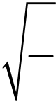
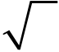
Total No. of Questions : 11] PE-5951 | SEAT No. :
Total No. of Questions : 11] PE-5951 | [Total No. of Pages : 5
[6582]-315
S.E. (Production/Production Sandwich Engineering) PCC-201-PSS : MATHMATICS - III
(2024 Pattern) (Semester - III)
Time : 2½ Hours] [Max. Marks : 70 Instructions to the candidates:
1) All questions are compulsory.
2) Figures to the right indicate full marks.
Q1)Write the correct option for the following multiple choice questions.
 | The solution of differential equation |  |  |  |  |  |  |  |  |  |  | 2  dy |  |  | + |  | 2 | dy |  | + |  | y | = | 0 |  | [2]
i)  ii) |  |  |  |  |  |  |  |  |  |  |  | dx | 2 |  |  |  |  | dx |  |  |  |  |  | 0 | is | [2]
i)  ii) | a) | c1e2x + c2ex |  |  |  | b) |  |  | c1ex + c2e–x
i)  ii) | c) | (c1x + c2)e–x |  |  |  | d) |  |  | (c1x + c2)ex
i)  ii) | Standard deviation of three numbers 9, 10, 11 is _______ |  |  |  |  |  |  |  |  |  |  |  |  |  |  |  |  |  |  |  |  |  |  |  |  | [2]
i)  ii) | a) | 2 |  |  |  | b) |  |  |  |  | 2
 | a) | 3 |  |  |  |  |  |  |  |  | 3
 | c) |  | 1 | d) |  |  |  |  |  | 2
iii)  iv) |  |  | 3
iii)  iv) | The divergence of vector field |  |  |  |  |  | F | = |  | 2  xyi |  |  |  | + |  | 2  yj |  |  | + |  | 2  xzk |  |  | at point (1, 2, 1)
iii)  iv) | is ________ |  |  |  |  | [2]
iii)  iv) | a) | 5 |  |  |  | b) |  |  | 8
iii)  iv) | c) | 10 |  |  |  | d) |  |  | 12
iii)  iv) | A throw is made with two dice. The probability of getting a source of 10
iii)  iv) | points is ______ |  |  |  |  | [2]
iii)  iv) | a) |  | 1 |  | b) |  |  |  |  |  | 1
 |  |  | 12 |  |  |  |  |  |  |  | 6
 | c) |  | 1 | d) |  |  |  |  |  |  | 2
 |  |  | 5 |  |  |  |  |  |  |  | 3
P.T.O.
https://t.me/SPPU_TE_BE_COMP

v) | Coefficient of kurtosis β2 is given by _______ |  |  |  |  |  |  |  |  |  |  |  |  |  |  |  |  |  |  |  |  | [1]
v) | a) |  | μ4 |  |  | b) |  |  |  |  |  |  |  |  |  |  |  |  |  |  | μ4
 |  |  | μ3 |  |  |  |  |  |  |  |  |  |  |  |  |  |  |  |  |  | μ2 2
 | c) |  | μ3 |  |  | d) |  |  |  |  |  |  |  |  |  |  |  |  |  |  | μ4
vi) |  |  | μ2 2 |  |  |  |  |  |  |  |  |  |  |  |  |  |  |  |  |  | μ2 3
vi) | If r is position vector of a point on the curve C where t is a scalar
vi) | variable then df dt represents |  |  |  |  |  |  |  |  |  |  |  |  |  |  |  |  |  |  |  |  | [1]
Q2)a)  b) |  |  |  |  |  |  |  |  |  |  |  |  |  |  |  |  |  |  |  |  |  | [1]
Q2)a)  b) | a) | Tangent Vector |  |  |  |  |  |  |  |  |  |  |  | b) |  |  |  |  |  | Normal Vector
Q2)a)  b) | c) | Radius Vector |  |  |  |  |  |  |  |  |  |  |  | d) |  |  |  |  |  | Orthogonal Vector
Q2)a)  b) | Solve (D2 + 1) y = sin 2x sin x. |  |  |  |  |  |  |  |  |  |  |  |  |  |  |  |  |  |  |  |  | [4]
Q2)a)  b) | Solve |  |  | 2  dy  dx + y = cosecx (by variation of parameters). |  |  |  |  |  |  |  |  |  |  |  |  |  |  |  |  |  | [4]
Q2)a)  b) | Solve |  |  | x | 2 |  | 2  dy |  | − | 3 | x | dy | + | 3 | y | = | x | 2 | sin (log x). |  |  | [4]
c) |  |  |  | x |  |  | dx | 2 |  |  |  | dx |  |  | y |  |  |  |  |  |  | [4]
OR
 | Solve |  | 2  dy |  |  |  | − |  | 7 |  | dy |  | − | 6 |  | y |  |  | = |  | e | 2 | x | (1 |  | + |  | )
Q3)a) |  |  | dx |  |  | 2 |  |  |  |  | dx |  |  |  |  |  |  |  |  |  |  |  |  |  |  |  |  |  | . |  |  |  |  |  |  | [4]
 |  | Solve | x |  | 2 | 2  dy |  |  | − |  | 4 | x | dy |  | + |  |  | 6 |  | y | = |  |  | 4 | .
b) |  | Solve |  |  | 2 | dx |  | 2 |  |  |  | x | dx |  |  |  |  |  |  | y |  |  |  |  | . | + |  | = |  | 4sinlog ([ | x | + | 2) | ] |  | [4]
c) | Solve |  | ( | x |  | + | 2) |  | 2 | 2  dy |  |  | + | 3( |  |  | x |  | + |  | 2) |  | dx
c) |  |  |  |  |  | + |  |  | dx |  |  | 2 |  |  |  |  |  |  |  |  |  |  | dy |  |  |  |  |  |  |  |  |  |  |  | . | [4]
[6582]-315 |  |  |  |  |  |  |  |  |  |  |  |  |  |  |  |  |  |  |  |  |  |  | 2
https://t.me/SPPU_TE_BE_COMP

Q4)a) | Find the Fourier sine transform of the following function. | [4]
f(x) = e–x, x > 0
b) | Find Fourier Cosine Transform of f(x) = x2, 0 < x < π | [4]
c) | Find {te–2t sin 2t} | [4]
OR
 |  | −⎧L ⎨ ⎩ |  |  | s |  |  | s | s |  | 1) |  | ⎫  ⎬⎭. |  | [4]
Q5)a) | Find |  |  | ( |  |  | − | 2)( | s | − |  |  |  |  | [4]
Q5)a) | Find | L | ⎧1 | − |  | cos 3t |  |  |  | ⎫  ⎬⎭. |  |  |  |  | [4]
b)  c)  Q6)a)  b) | Find |  | ⎨  ⎩ |  |  | t |  |  |  |  |  |  |  |  | [4]
b)  c)  Q6)a)  b) | Solve the integral |  |  |  |  |  |  |  |  | ∞∫ |  | fx [] |  | cosλxdλ = 1 – λ, 0 < λ < 1 | [4]
b)  c)  Q6)a)  b) | The first four moments about the working mean 30.2 of a distribution are 0.255,6.222,30.211 and 400.25. Calculate the first four moments about
b)  c)  Q6)a)  b) | the mean. Also evaluate β1, β2. |  |  |  |  |  |  |  |  |  |  |  |  |  | [4]
b)  c)  Q6)a)  b) | Following are the values of import of raw material and export of finished
b)  c)  Q6)a)  b) | product in suitable units : |  |  |  |  |  |  |  |  |  |  |  |  |  | [4]

Export | 10 | 11 | 14 | 14 | 20 | 22 | 16 | 12 | 15 | 13
Import | 12 | 14 | 15 | 16 | 21 | 26 | 21 | 15 | 16 | 14

c) | Fit a straight line of the form y = mx + c to the following data by using
c) | method of least squares. | [4]

x | 0 | 1 | 2 | 3 | 4 | 5 | 6 | 7
y | –5 | –3 | –1 | 1 | 3 | 5 | 7 | 9
OR
Q7)a)  b) | If the two lines of regression are 9x + y – λ = 0 and 4x + y = μ and the means of x and y are 2 and –3 respectively, find the values of λ, μ and
Q7)a)  b) | the coefficient of correlation between x and y. | [4]
Q7)a)  b) | Calculate the coefficient of correlation for the following weight (in kg)
Q7)a)  b) | of husband x and wife y. | [4]

x | 65 | 66 | 67 | 67 | 68 | 69 | 70 | 72
y | 55 | 58 | 72 | 55 | 66 | 71 | 70 | 50

c) | Obtain Regression Line for the following table : | [4]

x | 6 | 2 | 10 | 4 | 8
y | 9 | 11 | 5 | 8 | 7

[6582]-315 | 3
https://t.me/SPPU_TE_BE_COMP

Q8)a) A, B play a game of alternate tossing coin one who gets head first wins the game. Find the probability that of B winning the game if A has a start.
[4]
b) 20% of bolts produced by a machine are defective. Determine the probability that out of 4 bolts chosen at random [4]
i) 1 is defective
ii) Zero is defective
iii) at most 2 bolts are defective
c) The lifetime of an article has a normal distribution with mean 400 hours and standard deviation 50 hours. Find the expected number of articles out of 2000 whose lifetime lies between 335 hours to 465 hours. (Given z = 1.3, A = 0.4032). [4]
OR
Q9)a) The Average number of misprint per page of a book is 1.5.Assuming the distribution of number of misprint to be Poisson, find [4]
i) Particular book is free from misprint
ii) Number of pages containing more than one misprint if the book contains 900 pages
b) If the random variable X takes the values X = 1, 2, 3 with corresponding probabilities 1/6, 2/3, 1/6. Find E(x) and E(x2). [4]
c) The proportions of blood type O,A, B and AB in the general population of a country are known to be in the ratio 49 : 38: 9: 4 respectively. A research team observed the frequencies of the blood type as 88, 80, 22 and 10 respectively in a community of that country. Test the hypothesis at 5% level of significance. [4]
(Given χtab 2 = 7.815).
[6582]-315 4
https://t.me/SPPU_TE_BE_COMP

Q10)a) | Find the directional derivative of φ = xy2 + yz3 at (1, –1, 1) along the
Q10)a) | vector |  |  | 2 | j | + |  | k | . |  |  |  |  |  |  |  |  |  |  | [4]
b) | vector | i | + | 2 | j | + | 2 | k
b) | A curve is given by x = t2 + 1, y = 4t – 3, z = 2t2 – 6t. Find the angle
b) | beween tangents at t = 1 and t = 2. |  |  |  |  |  |  |  |  |  |  |  |  |  |  |  |  |  |  |  |  |  |  |  |  |  |  | [4]
b) | Show that |  |  | F |  | = | (6 |  | xy |  |  |  | ) |  |  |  |  |  |  |  |  |  | (3 |  |  | − | yk |  | is irrotational.
c) |  |  |  |  |  |  |  |  |  | + | z | 3 |  |  | i | + | (3 | x | 2 | − | zj | + | (3 | xz | 2 | − |  |  | is irrotational.
c) | Find scalar φ such that F |  |  |  |  |  |  |  |  |  |  |  |  | =∇. |  |  |  |  |  | [4]
OR
Q11)a) | Find line integral |  |  |  |  |  |  |  |  |  |  | ∫cF d r |  |  |  |  |  | for |  |  | F | = |  |  | 2  xi |  |  | + |  | xyj |  | , | given curve is C is the curve
Q11)a) | y2 = x joining (0, 0) and (1, 1). |  |  |  |  |  |  |  |  |  |  |  |  |  |  |  |  |  |  |  |  |  |  |  |  |  |  |  |  | [4]
Q11)a) | A vector field is given by |  |  |  |  |  |  |  |  |  |  |  |  |  |  |  |  |  |  |  |  |  | F |  |  | = | sin |  |  | yi |  |  |  |  | (1 |  | cos), |  | evaluate
b) |  |  |  |  |  |  |  |  |  |  |  |  |  |  |  |  |  |  |  |  |  |  |  |  |  |  |  |  |  |  |  |  | + | x | (1 | +
b) |  |  |  |  | where, C is the ellipse x2/a2 + y2/ b2 = 1, z = 0. |  |  |  |  |  |  |  |  |  |  |  |  |  |  |  |  |  |  |  |  |  |  |  |  |  |  |  |  |  |  |  |  |  |  | [4]
c) | ∫cF d r
c) | If | F | = | (2 |  | xy | + | 3 | z | 2 | ) |  | i | + | ( | x | 2 | + | 4 | yzj |  |  |  | + |  | (2 |  | y | 2 | + | xzk ), |  |  |  | evaluate |  |  | ∫cF d r |  |  | where
C is the curve x = t, y = t2, z = t3 joining the points (0, 0, 0) and (1, 1, 1). [4]
♦♦♦
[6582]-315 5
https://t.me/SPPU_TE_BE_COMP

Total No. of Questions : 8] PE5961

[6582]-316

S.E. (Production Engineering S/W)
VEC-232-PEE, PSS : UNIVERSAL HUMAN VALUES
(2024 Pattern) (Semester-III)
Time : 2 Hours] [Max. Marks : 35
Instructions to the candidates:
1) All questions are compulsory i.e. solve Q.1 or Q.2, Q.3 or Q.4, Q.5 or Q.6, Q.7
or Q.8.
2) Neat diagrams must be drawn wherever necessary.
3) Figures to the right indicate full marks.
4) Assume suitable data if necessary and mention it clearly.
Q1)a) Explain the meaning of “Right Understanding.” [3]
b) Examine the root causes of confusion and contradictions in today’s
lifestyle. [5]
OR
Q2)a) What contradictions are observed in modern society? [3]
b) Write a detailed note on basic human aspirations and how they can be
achieved holistically. [5]
Q3)a) What is meant by “Harmony in the self ”? [3]
b) Examine lifestyle disorders in modern society and relate them to
misunderstanding of human needs. [5]
OR
Q4)a) | Give any two examples of imbalanced living. | [3]
b) | Describe the value-based approach to health and well-being. | [5]
b) | Describe the value-based approach to health and well-being. | P.T.O. P.T.O.
https://t.me/SPPU_TE_BE_COMP

Q5)a) | What is fearlessness in society? | [3]
b) | Distinguish between affection and care. | [5]
OR
Q6)a) Explain harmony in society through justice, fearlessness, and
coexistence. [3]
b) Write a detailed note on universal human order and its relevance to present
society. [5]
Q7)a) Define professional ethics. [4]
b) Write a detailed note on value-based lifestyle and its role in sustainable
development. [7]
OR
Q8)a) What is meant by a value-based lifestyle? [4]
b) Examine how human intervention disrupts natural harmony and propose
corrective measures. [7]
  
[6582]-316 2
https://t.me/SPPU_TE_BE_COMP

Total No. of Questions : 10] PE-5798 | SEAT No. :
Total No. of Questions : 10] PE-5798 | [Total No. of Pages : 2
[6582]-317
S.E. (Robotics & Artificial Intelligence)
PCC-201-RAI : BASICS OF ROBOTICS & AI
(2024 Pattern) (Semester - III)
Time : 2½ Hours] [Max. Marks : 70
Instructions to the candidates :
1) Solve Q.1, or Q.2, Q.3 or Q.4, Q.5 or Q.6, Q.7 or Q.8 and Q.9 or Q.10.
2) Neat diagrams must be drawn wherever necessary.
3) Figures to the right side indicate full marks.
4) Assume Suitable data if necessary.
Q1)a) Describe spherical (polar) coordinate robot. Identify its limitations
compared to other configurations. [7]
b) Analyze the working principle & suitability of a cylindrical coordinate
robot for a modern automated assembly cell. [7]
OR
Q2)a) Analyze the advantages and limitations of robotic inspection systems
compared to manual inspection in quality control. [7]
b) Compare and contrast Cartesian and SCARA robots in terms of their
structure and applications. [7]
Q3)a) A temperature sensor in a chemical plant must operate in a high-humidity
environment. Discuss the sensor selection criteria with reasoning. [7]
b) Identify the waypoints in robot programming, and explain its use in Robot’s
movement. [7]
OR
Q4)a) An automated weather monitoring station for a remote alpine research
site needs to measure wind speed. Based on selection criteria, recommend
a suitable sensor type and justify your choice considering cost, durability,
and environmental factors. [7]
b) Describe the operational principle of a controller in a control system.
Discuss with example. [7]
P.T.O.
https://t.me/SPPU_TE_BE_COMP

Q5)a) Paraphrase the key reasons of not using hydraulic drives for a clean- room environment, such as in semiconductor manufacturing robotics.[7] b) Differentiate between a mechanical gripper and a vacuum cup gripper in terms of fundamental operation. [7] OR
Q6)a) An automotive factory uses a large robotic arm to spot-weld car bodies.
The robotic arm requires significant force and repeatable precision. Justify the most likely drive type used in this application by comparing it to one less suitable alternative. [7]
b) A robotic arm uses a pneumatic gripper but an electric servo for its joint movements. Analyze the rationale behind this hybrid design. [7]
Q7)a) Elaborate on the primary goals of Artificial Intelligence. [7]
b) Compare & contrast the role of Psychology and the role of Neuroscience in forming the foundation of Artificial Intelligence. [7]
OR
Q8)a) Discuss the potential of a Hybrid Approach to resolve the constraints that characterize standalone Symbolic and Connectionist methods. [7]
b) Analyze the ethical concern of “Bias and discrimination in decision-making” by tracing it back to one of the fundamental technical problems. [7]
Q9)a) Discuss “Heuristic” in the context of search algorithms. Differentiate it from a blind search. [7]
b) Interpret the main purpose of ontology in knowledge representation.[7]
OR
Q10)a) Differentiate between the Forward and Backward reasoning approaches. [7]
b) Describe the fundamental concept behind a Stochastic search algorithm with a simple example. [7]
♦♦♦
[6582]-317 2
https://t.me/SPPU_TE_BE_COMP

Total No. of Questions : 10] PE-5799 | SEAT No. :
Total No. of Questions : 10] PE-5799 | [Total No. of Pages : 3
[6582]-318
S.E. (Robotics & Artificial Intelligence)
PCC-202-RAI : MATERIALS AND MANUFACTURING
(2024 Pattern) (Semester - III)
Time : 2½ Hours] [Max. Marks : 70
Instructions to the candidates :
1) Answer Q.1, or Q.2, Q.3 or Q.4, Q.5 or Q.6, Q.7 or Q.8 and Q.9 or Q.10.
2) Neat diagrams must be drawn wherever necessary.
3) Figures to the right side indicate full marks.
4) Assume Suitable data if necessary.
Q1)a) Explain the different types of engineering materials with examples. Compare their mechanical properties such as stiffness, strength, and ductility using graph, tables, and bar charts. [7]
b) Compare the atomic arrangements in FCC and HCP crystal structures. Explain why both structures have the same atomic packing factor (APF) of 0.74, despite their geometric differences. [7]
OR
Q2)a) Explain the characteristics of dislocations. Discuss the nature of strain fields around dislocations and how they lead to dislocation-dislocation interactions. [7]
b) Explain the process of plastic deformation in metals by dislocation motion. Compare the slip mechanisms in FCC and BCC crystals. [7]
Q3)a) Discuss the industrial significance of creep, fatigue, and impact tests with suitable examples of components where each test is particularly important.
[7]
b) Elaborate the step-by-step procedure for a Tensile Test with a neat labeled diagram of a standard specimen. Explain the following terms as obtained
from the test : |  | ii) | Percent Elongation, | [7]
i) | Tensile Strength, | ii) | Percent Elongation, | [7]
iii) | Engineering Stress, | iv) | Engineering Strain. | [7]
P.T.O.
https://t.me/SPPU_TE_BE_COMP

OR
Q4)a) Explain the creep phenomenon with a typical creep curve. Describe the
three stages of creep and the microstructural mechanisms responsible
for each stage. [7]
b) With a neat schematic diagram, explain the Pulse-Echo technique in
Ultrasonic Testing. Differentiate between A-scan, B-scan, and C-scan
displays. [7]
Q5)a) Elaborate on the different types of ‘Pattern Allowances’ used in casting
process. Discuss ‘Shrinkage Allowance’ and ‘Machining Allowance’ in
detail with the various factors influencing that influence the magnitude of
each. [7]
b) Illustrate the step-by-step cycle of the Hot-Chamber die casting process.
Use a labeled diagram to show the key component. [7]
OR
Q6)a) Categorize the following products based on the most suitable extrusion
process (Hot/Cold/Impact) : [7]
i) Aluminum I-beam
ii) Toothpaste tube
iii) Aluminum can
iv) Automotive chassis rail
v) Copper Electrical Busbar
vi) Aluminum Window Frame
vii) Lead-Acid Battery Terminal
Justify your categorization.
b) Analyze the relationship between direct and indirect extrusion by comparing
their process parameters. Write in tabular format. [7]
Q7)a) Discriminate between the embossing and coining processes. [7]
b) A Washer with a 12.7 mm internal hole and 25.4 mm outside diameter is
to be made from a MS strip of 1.5 mm thickness. Considering elastic
recovery of the material, find : [7]
i) Clearance
ii) Blanking die opening size
iii) Blanking punch size
iv) Piercing punch size
v) Piercing die opening size.
Assume clearance to be 5% of the stock thickness.
[6582]-318 2
https://t.me/SPPU_TE_BE_COMP

OR
Q8)a) Compare Resistance Spot Welding and Projection Welding with following parameters : [7]
i) Explain the fundamental difference in how the weld location is determined in each process.
ii) Typical applications of each process.
iii) Relative complexity of tooling and setup.
b) Elaborate any five welding defects along with remedies. [7]
Q9)a) Describe the process of robotic machine loading and unloading in a CNC machining center. Elaborate the key benefits of automating this specific task? [7]
b) Categorize the types of data generated by robots in manufacturing (e.g., from assembly, logistics, inspection) and explain how this data can be used for overall production planning and management. [7]
OR
Q10)a) Describe the role of sensors in a robotic system used for material transfer. Provide two examples of sensors and their purposes. [7]
b) Analyze how a robotic system using Non-Destructive Testing (NDT) techniques, such as ultrasonic testing, can be used to inspect critical aerospace components for internal flaws. [7]
♦♦♦
[6582]-318 3
https://t.me/SPPU_TE_BE_COMP

Total No. of Questions : 10] PE-5800 | SEAT No. :
Total No. of Questions : 10] PE-5800 | [Total No. of Pages : 2
[6582]-319
S.E. (Robotics and Artificial Intelligence Engineering)
PCC-203-RAI : ANALOG AND DIGITAL ELECTRONICS
(2024 Pattern) (Semester - III)
Time : 2½ Hours] [Max. Marks : 70
Instructions to the candidates :
1) Solve Q.1 or Q.2, Q.3 or Q.4, Q.5 or Q.6, Q.7 or Q.8 and Q.9 or Q.10.
2) Neat diagrams must be drawn wherever necessary.
3) Figures to the right side indicate full marks.
4) Assume Suitable data if necessary.
Q1)a) Differentiate between a Depletion-type and an Enhancement-type MOSFET
[7]
b) Explain how a 555 timer can be configured as a simple astable multivibrator
[7]
OR
Q2)a) Describe the operation of a voltage comparator. How does its operation
differ from a standard amplifier circuit? [7]
b) Describe the role of the capacitor in the feedback path of a relaxation
oscillator circuit. [7]
Q3)a) Analyze the difference between positive and negative logic systems using
a sample gate example. [7]
b) Explain the significance of "don't-care condition" in K-map simplification
with an example. [7]
OR
Q4)a) Explain the prime implicant chart in Quine - McClusky method. [7]
b) Apply Quine-McClusky method to simplifiy a 4-variable Boolean function
[7]
Q5)a) Define a multiplexer. Implement an 8-to-I multiplexer using basic logic
gates and draw its truth table. [7]
b) Describe an even parity generator circuit for a 3-bit data input (A, B, C)
using XOR/XNOR gates. Show the truth table and the logic diagram.[7]
P.T.O.
https://t.me/SPPU_TE_BE_COMP

OR
Q6)a) What is the significance of edge-triggering? Differentiate between a latch
and a flip-flop. [7]
b) Explain the output waveform (Q) for a negative edge-triggered JK flip-
flop given the waveforms of J, K, and CLK. Assume Q starts at 0. [7]
Q7)a) Explain the following timing parameters for a flip-flop with the help of a
timing diagram : [7]
i) Setup Time (ts)
ii) Hold Time (th)
iii) Clock-to output Propagation Delay (tp).
b) Explain 3-bit ring counter using a SISO shift register. [7]
OR
Q8)a) Define a shift register. Draw the block diagram of a 4-bit Serial-In- Serial-
Out (SISO) shift register and show the output waveform as the data 1101
is shifted in, one bit per clock pulse (assume LSB first). [7]
b) Compare the major advantages and disadvantages of synchronous
counters over asynchronous counters in terms of speed, design
complexity, and reliability. [7]
Q9)a) What is a decade counter? Design a synchronous decade counter using
JK flip-flops that counts from 0 to 9 (BCD 0000 to 1001) and then recycles.
[7]
b) Define and differentiate between resolution and accuracy in a Digital- to-
Analog Converter (DAC). [7]
OR
Q10)a) Describe the working of the simultaneous (Flash) ADC. Write advantage
and disadvantage of this type of converter. [7]
b) Compare the successive approximation, and dual-slope ADC. [7]
♦♦♦
[6582]-319 2
https://t.me/SPPU_TE_BE_COMP

Total No. of Questions : 6] PE-5952 | SEAT No. :
Total No. of Questions : 6] PE-5952 | [Total No. of Pages : 4
[6582]-320
S.E. (Robotics and Artificial Intelligence Engineering)
MATHEMATICS FOR INTELLIGENT SYSTEMS
(2024 Pattern) (Semester - III) (MDM-221-RAI)
Time : 2½ Hours] [Max. Marks : 70
Instructions to the candidates:
1) Q.1 is compulsory, in Q2, Q3, Q4, Q5, Q6 follow instruction there.
2) Use of electronic pocket calculator is allowed.
3) Figures to the right indicate full marks.
4) Assume suitable data if necessary.
Q1)Write the correct option for the following multiple choice questions.
a)  b)  c)  d) | Given bxy = 0.85, byx = 0.89 and σx = 6 then values of r(x, y) & σy are [2]
a)  b)  c)  d) | i) | 0.87, 6.14 |  |  |  |  |  |  | ii) |  |  |  | –0.87, 0.61
a)  b)  c)  d) | iii) | 0.75, 6.14 |  |  |  |  |  |  | iv) |  |  |  | 0.89, 4.64
a)  b)  c)  d) | If ϕ = x2 + y2 + z2 then ∇ϕ is |  |  |  |  |  |  |  |  |  |  |  |  | [2]
a)  b)  c)  d) | i) | 2xi + 2yj + 2zk |  |  |  |  |  |  | ii) |  |  |  | 2xi – 2yj + 2zk
a)  b)  c)  d) | iii) | 6 |  |  |  |  |  |  | iv) |  |  |  | xi + yj + zki
a)  b)  c)  d) | The root of equation x3 – 4x – 9 = 0 using bisection method lies
a)  b)  c)  d) | between |  |  |  |  |  |  |  | [2]
a)  b)  c)  d) | i) | 0 & 1 |  |  |  |  |  |  | ii) |  |  |  | 1 & 2
a)  b)  c)  d) | iii) | 2 & 3 |  |  |  |  |  |  | iv) |  |  |  | 3 & 4
a)  b)  c)  d) | For f(x) = x2, h = 2, second forward difference Δ2f (x) is given by[2]
a)  b)  c)  d) | i) | 6 |  |  |  |  |  |  | ii) |  |  |  | 12
a)  b)  c)  d) | iii) | 4 |  |  |  |  |  |  | iv) |  |  |  | 8
a)  b)  c)  d) | The equation |  | ¶ | 2 | u | + | ¶ | 2 | u | = | 0 | is called as |  |  | [2]
e) |  |  | ¶ | x | 2 | + | ¶y |  | 2
e) | i) | Heat equation |  |  |  |  |  |  | ii) |  |  |  | Laplace equation
e) | iii) | Poisson equation |  |  |  |  |  |  | iv) |  |  |  | Wave equation
P.T.O.
https://t.me/SPPU_TE_BE_COMP

Q2)Attempt any three :
a) The first four moments of a distribution about the values 5 are 2, 20, 40 and 50. From the given information obtain the first four central moment, mean, standard deviation and coefficient of skewness and
b) | kurtosis. | [4]
b) | From a group of 5 students, marks obtained by each in two papers
b) | x and y are given below : | [4]

x | 23 | 28 | 42 | 17 | 26
y | 25 | 22 | 38 | 21 | 27
Calculate Karl Pearson's coefficient of correlation.
c) Three groups of workers contain 3 men & 1 women, 2 men & 2 women and 1 men & 3 women respectively. One worker is selected at random from each group what the probability that the group selected contains of 1 men & 2 women? [4]
d) The probability that a student who is freshman will graduate is 0.4. Determine the probability that out of 5 students (i) None will be graduate (ii) at least one will be graduate [4]
e) Number of road accidents follows a Poission's distribution with mean 5, find the probability that in a certain month number of accidents on the highway will be (i) less than 3 (ii) between 3 & 5 (iii) more than 3 [4]
Q3)Attempt any three :
a) | Find angle between the tangent to curve | [4]
x = t, y = t2, z = t3 at t = 1 & t = –1
b) |  | Find directional derivatives of ϕ = xy + yz2 at the point (1, –1, 1)
towards point (2, 1, 2) |  |  |  |  |  |  |  |  | [4]
c) | Show that F = (xy2+xz2)i + (yx2 + yz2)j + (zx2 + zy2)k is irrotational. Find
scalar ϕ such that F = ∇ϕ |  |  |  |  |  |  |  |  | [4]
d) |  | Evaluate |   òCFdr⋅ along a straight line joining the points (0, 0, 0) and  F    = 3 xi 2 + (2 xz-yj ) + zk [4]
 |  | (2, 1, 3)
e) | Evaluate |  | òò | S | (´ | F | )⋅ | dS | where | F | = | 2  yi | + | zj | + | xyk |  | & s is surface of
paraboloid z = 4 – x2 – y2, (z > 0) |  |  |  |  |  |  |  |  |  |  |  |  |  |  |  |  | [4]
[6582]-320 |  |  |  |  |  |  |  |  | 2
https://t.me/SPPU_TE_BE_COMP

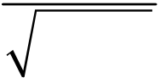
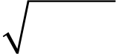
Q4)Attempt any three :
a) | Solve by Gauss elimination method, the system of equations : | [4]
2x1 – 2x2 + 3x3 = 2
x1 + 2x2 – x3 = 3
3x1 – x2 + 2x3 = 1
b) Obtain the real root of the equation 2x3 – 2x – 5 = 0 by applying
Newton-Raphson method at the end of the fourth iteration. [4]
c) Find method of false position to find the fourth root of 32 correct to
three decimal, places. [4]
d) Find a root of equation x3 – 4x – 9 = 0 using bisection method at the
end of fourth iteration. [4]
e) Solve by Gauss Seidal method, the system of equations : [4]
20x1 + x2 – 2x3 = 17
3x1 + 20x2 – x3 = –18
2x1 – 3x2 + 20x3 = 25
Q5)Attempt any three :
a) From the tabulated values of x and y given below, prepare forward
difference table. Find the polynomial passing through the points and
estimate the value of y, when x = 1.5 | [4]

x | 0 | 2 | 4 | 6 | 8
y | 5 | 29 | 125 | 341 | 725

b) |  | By Trapezoidal Rule, find the value of |  |  |  |  |  |  |  |  |  |  |  |  | ò0 | 2 | 2 | 1 | x | 2 | dx | by taking
 |  |  |  |  |  |  |  |  |  |  |  |  |  |  |  |  |  | +
h = 0.5 |  |  |  |  |  |  | [4]
c) | Evaluate |  |  | ò |  | 6 | dx |  |  |  |  | th  by using Simpson's 3æö÷ç÷çèø rule dividing the interval
c) |  |  |  |  |  | 01 + |  |  | x
into 6 parts. |  |  |  |  |  |  | [4]
d) |  | Use Runge-kutta method of fourth order to obtain the numerical solution
of dy dx= |  |  |  |  | x |  | + | y |  | , y(0) = 1 & find y(0.2) taking h = 0.2 |  |  |  |  |  |  |  |  |  |  |  |  | [4]
e) | Given |  | dy  dx=+ |  |  |  |  |  |  |  | xyy , |  | (0) | = Determine y(0.1) by using modified 1
Euler's method, take h = 0.1. |  |  |  |  |  |  |  |  |  |  |  |  |  |  |  |  | [4]
[6582]-320 |  |  |  |  |  |  | 3
https://t.me/SPPU_TE_BE_COMP

Q6)Attempt any two :
a) | Solve the equation | 2  dy  dx=+ | y | with boundary conditions
y(0) = y(1) = 0 by dividing interval (0.1) into 4 subintervals using finite difference method. [6]
b) Solve the Poisson’s equation uxx + uyy = –81xy, 0 < x < 1, 0 < y < l given that u(0,y) = 0, u(x, 0) = 0, u(1, y) = 100, u(x, 1) = 100, h = 1 3 [6]
 |  | ¶ | u | = | ¶ | 2 | u | π
c) | Solve the equation | ¶t |  |  | ¶x |  | 2 | , subject to the conditions u(x, 0) = sinx,
0 < x < 1, u(0, t) = u(1, t) = 0 carry out computation for two level,
 |  | h | = | 1 | , | k | = | 1 | [6]
d) | taking |  |  | 3 |  |  |  | 36
d) | Evaluate the pivotal values of the equation utt = 16uxx, taking h = 1 upto t = 1.25, the boundary conditions are u(0, t) = u(5, t) = 0 and
d) | ut(x, 0) = 0 and u(x, 0) = x2(5 - x) |  |  |  |  |  |  |  |  | [6]

[6582]-320 4
https://t.me/SPPU_TE_BE_COMP

Total No. of Questions : 8] | [6582]-321 | SEAT No. :
PE-5801 | [6582]-321 | [Total No. of Pages : 2
S.E. (Robotics & Artificial Intelligence)
VEC - 233 - RAI : Sustainable Development
(2024 Pattern) (Semester - III)
Time : 2 Hours] [Max. Marks : 35
Instructions to the candidates:
1) Solve Q.1 or Q.2, Q3. or Q.4, Q.5 or Q.6, Q.7 or Q.8.
2) Neat diagrams must be drawn wherever necessary.
3) Figures to the right indicate full marks.
Q1) | 4) | Assume Suitable data if necessary.
Q1) | 5) | SDG refers to Sustainable Development Goal.
Q1) | a) | A proposed new factory promises jobs (economic pillar) but risks
polluting a local river (environmental pillar). Apply the concept of the
pillars of sustainability to identify the key trade-off the community must
consider. [4]
b) Analyze the integration of sustainable practices within a local business.[4]
OR
Q2) | a) | Assess how a government policy in India applies one of the sustainability
Q2) | b) | theories. | [4]
Q2) | b) | Using the Social Capital Theory, propose two ways a community could
strengthen its “bonding” social capital to improve local environmental
Q3) | a) | stewardship. | [4]
Q3) | a) | Describe the shift in the carbon cycle caused by substituting geothermal
Q3) | b) | plant ( a non-conventional source) for coal-fired power plant. | [5]
Q3) | b) | Compare and contrast the concepts of carbon emission and carbon
Q3) | b) | sequestration. | [4]
OR
P.T.O.
https://t.me/SPPU_TE_BE_COMP

Q4) | a) | A city has high air pollution from vehicles. Apply the principles of
sustainable transport to propose one policy and one infrastructure change
Q5) | b) | the city could implement. | [5]
Q5) | b) | Elaborate on integrating the passive solar design principles into a green
Q5) | a) | building in a hot climate to reduce energy consumption. | [4]
Q5) | a) | You are advising a small business. Discuss the application of principles
of SDG 8 (Decent Work and Economic Growth) in the business hiring
and employment practices. Explain with examples. [5]
b) Explain the premise that achieving “No Poverty” (SDG 1) is a fundamental
prerequisite for achieving “Zero Hunger” (SDG 2). [4]
OR
Q6) | a) | Using the concept of “clean water and sanitation” (SDG 6), develop a
set of three basic hygiene rules for a community public health compaign
Q7) | b) | aimed at preventing disease. | [5]
Q7) | b) | Explain the “Decent Work” in SDG 8. List the key characteristics of
Q7) | a) | Decent Work. | [4]
Q7) | a) | Summarize the cocnept of a circular economy and explain its role of
supporting the aims of SDG 12: Responsible Consumption and
Production. [5]
b) Discuss the fundamental relationship between climate action (SDG 13)
and the SDGs for life below water (SDG 14) and life on land (SDG 15).[4]
OR
Q8) | a) | Your local community has a problem with plastic waste. Using the
framework of SDG12, design a simple two-part campaign to promote
responsible consumption and better waste management among residents.
[5]
b) The SDG 11 to make cities and human settlements “inclusive, safe, resilient,
and sustainable”. Justify the statement. [4]
♣♣♣
[6582]-321 2
https://t.me/SPPU_TE_BE_COMP

Total No. of Questions : 10] PE5755

[6582]-322

S.E. (Robotics & Automation Engineering)
PCC-201-ROA : ROBOT OPERATING SYSTEM
(2024 Pattern) (Semester - III)
Time : 2½ Hours] [Max. Marks : 70
Instructions to the candidates:
1) All questions are compulsory i.e. Solve Q.1 or Q.2, Q.3 or Q.4, Q.5 or Q.6,
Q.7 or Q.8, Q.9 or Q.10.
2) | Neat diagrams must be drawn wherever necessary. | [7]
3) | Figures to the right indicate full marks. | [7]
4) | Assume suitable data, if necessary and mention it clearly. | [7]
Q1)a) | Explain ROS equation in detail. | [7]
b) | Explain ROS Frame work. | [7]
OR
Q2)a) Explain meta operating system related to ROS. [7]
b) Explain Nodes and Topic in ROS. [7]
Q3)a) Explain Flex pendent features along with advantages and limitations. [7]
b) Explain online programming related to robotics. [7]
OR
Q4)a) Explain lead through programming in robotics. [7]
b) Explain offline programming related to robotics. [7]
Q5)a) Write program by using VAL language for Pick and Place operation. [7]
b) Explain VAL Hand Control Commands briefly. [7]
OR
Q6)a) Explain syntax of VAL for Move, Depart, Moves and Speed command
used in robotics. [7]
b) Write syntax of VAL II for speed, Wait, Depart used in robotics. [7]
P.T.O.
https://t.me/SPPU_TE_BE_COMP

Q7)a) Explain move master command languages used in robotics. [7]
b) Explain linear and circular movement command used in Rapid language.[7]
OR
Q8)a) | Explain AML along with its features. | [7]
b) | Explain Basic structure of AML Program. | [7]
Q9)a) | Explain Applications of Soft Robotics. | [7]
b) | Define Robot Process Automation with its key Features. | [7]
OR
Q10)a) | What is computer vision? And explain how it works. | [7]
b) | Explain applications virtual reality in robotics. | [7]
  
[6582]-322 2
https://t.me/SPPU_TE_BE_COMP

Total No. of Questions : 10] PE-5942 | SEAT No. :
Total No. of Questions : 10] PE-5942 | [Total No. of Pages : 2
[6582]-323
S.E. (Robotics & Automation Engineering)
PCC-202-ROA : INDUSTRIAL ELECTRONICS AND
ELECTRICAL MACHINES
(2024 Pattern) (Semester - III)
Time : 2½ Hours] [Max. Marks : 70
Instructions to the candidates:
1) | Answer Q.1 or Q.2, Q.3 or Q.4, Q.5 or Q.6, Q.7 or Q.8. Q.9 or Q.10. | [7]
2) | Neat diagrams must be drawn wherever necessary. | [7]
3) | Figures to the right side indicate full marks. | [7]
4) | Assume suitable data if necessary. | [7]
Q1)a) | Draw and explain V-I characteristics of diode. | [7]
b) | Explain full-wave rectifier with center-tapped transformer. | [7]
OR
Q2)a) Explain MOSFET working principle with advantage. [7]
b) List of applications of SCR in industrial control. [7]
Q3)a) Explain Arduino UNO hardware architecture with block diagram. [7]
b) Draw the interfacing diagram of LCD with Arduino board. Also, write
the basic algorithm used for this interfacing. [7]
OR
Q4)a) | Explain interfacing of LM35 temperature sensor with Arduino. | [7]
b) | Explain embedded system architecture with suitable example. | [7]
Q5)a) | Explain types of DC motors. | [7]
b) | Explain construction of DC generator. | [7]
OR
P.T.O.
https://t.me/SPPU_TE_BE_COMP

Q6)a) Explain back EMF and its role in DC motor operation. [7]
b) Explain working of 4-point starter and compare it with 3-point starter.[7]
Q7)a) Explain construction of three-phase induction motor. [7]
b) Explain types of single-phase induction motors with applications. [7]
OR
Q8)a) | Explain DOL starter with neat diagram. | [7]
b) | Define synchronous speed and slip. | [7]
Q9)a) | Explain construction and working of stepper motor. | [7]
b) | Write applications of BLDC motor. | [7]
OR
Q10)a) | Explain working principle of servo motor. | [7]
b) | Write applications of universal motor. | [7]

[6582]-323 2
https://t.me/SPPU_TE_BE_COMP

Total No. of Questions : 10] | [6582]-324 | SEAT No. :
PE5756 | [6582]-324 | SEAT No. :
PE5756 | [6582]-324 | [Total No. of Pages : 2
S.E. (Robotics & Automation)
PCC-203-ROA : HYDRAULICS & PNEUMATICS
(2024 Pattern) (Semester - III)
Time : 2½ Hours] [Max. Marks : 70
Instructions to the candidates:
1) Solve Q.1 or Q.2, Q.3 or Q.4, Q.5 or Q.6, Q.7 or Q.8, Q.9 or Q.10.
2) Neat diagrams must be drawn wherever necessary.
3) Figures to the right indicate full marks.
4) Assume suitable data if necessary and mention it clearly.
Q1)a) Compare hydraulic systems with pneumatic systems. [7]
b) Enumerate and briefly discuss the properties and factors considered the
selection of hydraulic fluids. [7]
OR
Q2)a) Explain with neat diagram, explain basic components required in a
hydraulic system and mention their functions. [7]
b) Explain various types of additives used with hydraulic fluids. [7]
Q3)a) With neat sketch, explain operation of Poppet check valve and state its
advantages & disadvantages. [7]
b) Explain 4/2 DCV with neat sketch along with working. [7]
OR
Q4)a) With neat sketch, explain construction and working of pilot operated
pressure valve. [7]
b) With neat diagram, explain construction, working and application of
3 ×3 DCV. [7]
Q5)a) With neat sketch, explain construction and working of External Gear
Pump. [7]
b) With neat sketch, explain construction and working of Lobe Pump.[7]
OR
P.T.O.
https://t.me/SPPU_TE_BE_COMP

Q6)a) With neat sketch, explain construction and working of Internal Gear Pump.
[7]
b) With neat sketch, explain construction and working of Screw Pump.[7]
Q7)a) With neat circuit diagram explain the control of double acting hydraulic
cylinder. [7]
b) Differentiate between meter in circuit and meter out circuit. [7]
OR
Q8)a) With neat circuit diagram explain the control of single acting hydraulic
cylinder. [7]
b) Explain speed control of a hydraulic motor circuit. [7]
Q9)a) Discuss safety considerations in Hydraulic circuits. [7]
b) Explain in details - Fault analysis and rectification in a hydraulic press.[7]
OR
Q10)a) Discuss safety considerations in Pneumatic circuits. [7]
b) Explain in detail - Fault analysis and rectification in a pneumatic pick-
and-place unit. [7]

[6582]-324 2
https://t.me/SPPU_TE_BE_COMP

Total No. of Questions : 8] PE-5802 | SEAT No. :
Total No. of Questions : 8] PE-5802 | [Total No. of Pages : 3
[6582]-325
S. E. (Robotics and Automation Engineering)
MDM-222-ROA : STATISTICS AND PROBABILITY (2024 Pattern) (Semester - III)
Time : 2½ Hours] [Max. Marks : 70 Instructions to the candidates :
1) | Solve Q1 or Q2, Q3 or Q4, Q5 or Q6, Q7 or Q8. | [7]
2) | Use of non-programmable calculator is allowed. | [7]
Q1)a) | Determine Mean, Median and Mode of Following data. | [7]

Time Interval (sec) (x) | Frequency (f)
40-44 | 2
45-49 | 6
50-54 | 10
55-59 | 4

b) | Calculate the first four moments of the following distribution about the
b) | mean. | [7]

x | 0 | 1 | 2 | 3 | 4 | 5 | 6 | 7 | 8
f | 1 | 8 | 28 | 56 | 70 | 56 | 28 | 8 | 1

c) | Write a short note on histogram. | [4]
OR
Q2)a) | Calculate Mean, Median and Mode of Following data. | [7]

Class interval (x) | Frequency (f)
4-5 | 6
5-6 | 12
6-7 | 18
7-8 | 9
8-9 | 5

b)  c) | Determine the First four moments for the set of Numbers 2, 4, 6, 8.[7]
b)  c) | Write a short note on skewness and Kurtosis. | [4]
P.T.O.
https://t.me/SPPU_TE_BE_COMP

Q3)a) | A data of Payload (kg) and arm deflection (mm) of robot given below
Q3)a) | calculate COV (x, y) and correlation coefficient (r). | [7]

Payload (Kg) (x) | Arm Deflection (mm) (y)
2 | 1.5
4 | 2.2
6 | 3.0
8 | 3.8

b)  c) | Obtain regression equation of Y on X and estimate Y when X=55 from
b)  c) | following data. | [7]
b)  c)
  X | 40 | 50 | 38 | 60 | 65 | 50 | 35
  Y | 38 | 60 | 55 | 70 | 60 | 48 | 30
b)  c) | Explain different types of Correlation. | [3]
OR
Q4)a) | A data of Conveyor speed (m/min) and Throughput (units/min) is given
Q4)a) | in table below calculate COV (x, y) and correlation coefficient (r). | [7]

Conveyor Speed (m/min) (x) | Throughput (units/min) (y)
10 | 40
12 | 49
14 | 55
16 | 64
18 | 72
20 | 79

b) | Obtain regression equation of X on Y and Y on X using method of least
b) | square for following data. | [7]

X | 1 | 2 | 3 | 4 | 5
Y | 2 | 5 | 3 | 8 | 7

c)  Q5)a) | Write a short note on simple linear regression. | [3]
c)  Q5)a) | There are three identical boxes, labeled I, II, and III, each containing two
coins. Box I holds two gold coins, Box II holds two silver coins, and Box III contains one gold and one silver coin. A person randomly selects a box and draws a coin, which turns out to be gold. using Baye’s theorem What is the probability that the other coin in the selected box is also gold.[7]
b) In a 5 independent trials each with success probability P = 0.7, what is the probability of exactly 4 successes. use Binomial distribution. [7]
c) Give the classical and Frequentist definition of Probability. [4]
OR
[6582]-325 2
https://t.me/SPPU_TE_BE_COMP

Q6)a) In a factory that produces bolts, three machines A, B, and C are responsible for manufacturing 25%, 35%, and 40% of the total bolts, respectively.
The defect rates of these machines differ: machine A produces 5% defective bolts, machine B produces 4% defective bolts, and machine C produces 2% defective bolts. A bolt is randomly selected from the overall production, and it is found to be defective, using Bayes theorem What is the probability that this defective bolt was produced by machine B.[7] b) On an average, a robot reports 2 breakdowns per 8-hour shift. What is the probability that exactly 3 breakdown occurs in a shift. use Poisson
c)  Q7)a)  b) | distribution. | [7]
c)  Q7)a)  b) | Define Axiomatic Probability. | [4]
c)  Q7)a)  b) | Explain probability sampling methods. | [7]
c)  Q7)a)  b) | A process that produces metal bracket has true mean hole-drill timeμ = 100 seconds and population standard deviation σ = 15 seconds.
we take a random sample of n = 36 brackets and compute the sample mean x. What is the probability that the sample mean lies between 98 and 103 seconds i.e. P(98<x <103). given that from standard normal table value corresponds to 1 .2 is 0.8849 and value corresponds to 0.8 is 0.7881.
[7]
c) | Explain terminologies used in sampling distribution. | [3]
OR
Q8)a) Explain Non-Probability Sampling methods. [7]
b) State the central limit theorem and discuss its engineering applications.[7]
c) Explain any one type of sampling distribution. [3]
♦♦♦
[6582]-325 3
https://t.me/SPPU_TE_BE_COMP

Total No. of Questions : 8] | [6582]-326 | SEAT No. :
PE5962 | [6582]-326 | SEAT No. :
PE5962 | [6582]-326 | [Total No. of Pages : 2
S.E. (Robotics & Automation)
VEC-232-ROA : UNIVERSAL HUMAN VALUES
(2024 Pattern) (Semester-III)
Time : 2 Hours] [Max. Marks : 35
Instructions to the candidates:
1) Answer Q.1 or Q.2, Q.3 or Q.4, Q.5 or Q.6, Q.7 or Q8.
2) Neat diagrams must be drawn wherever necessary.
3) Figures to the right indicates full marks.
4) Assume suitable data if necessary.
Q1)a) Define Value Education. Why is it essential for students? [3]
b) Explain in detail the need, purpose and importance of Value Education in
present times. [5]
OR
Q2)a) What is self-exploration? State its two key components. [3]
b) Describe the process of self-exploration. How does it help in achieving
right understanding? [5]
Q3)a) Define a human being according to UHV. [3]
b) Explain human being as the coexistence of self and body with suitable
examples. [5]
OR
Q4)a) Distinguish between needs of the self and needs of the body. [3]
b) Discuss how the needs of the body are qualitative and those of the self
are quantitative. [5]
Q5)a) What is the meaning of family in UHV? [3]
b) Discuss how trust forms the foundation of all human relationships?[5]
OR
P.T.O.
https://t.me/SPPU_TE_BE_COMP

Q6)a) Define trust and respect. [3]
b) Explain the values in human relationships: trust, respect, affection and
care. [5]
Q7)a) List the four orders in nature. [4]
b) Describe in detail the four orders in nature and their harmony. [7]
OR
Q8)a) Define interconnectedness in nature. [4]
b) Explain the concept of existence as coexistence with suitable illustrations.
[7]
eeee
[6582]-326 2
https://t.me/SPPU_TE_BE_COMP

Total No. of Questions : 4] PE-5964

[6582]-327
S. E.

OE-201-FA: Financial Accounting
(2024 Pattern) (Semester - III) (Open Elective - I)
Time : 2 Hours] [Max. Marks : 35
Instructions to the candidates :
1) All questions are compulsory.
2) Use of a simple calculator is allowed.
3) Figures to the right indicate full marks.
Q1)Fill in the Blanks : [5]
i) _______ is an intangible asset.
a) Machinery b) Goodwill
c) Books d) Furniture
ii) _____________ is an amount set aside from profit for probable future
expenses.
a) Reserve b) Provision
c) Liability d) Equity
iii) ____________ is a financial obligation from past events, dependent on
an uncertain future event.
a) Current Liability
b) Provisions
c) Contingent Liability
d) Long Term Liability
iv) _______________ means cancellation of shares issued due to non-
payment of allotment or call money.
 | a) | Surrender of shares |  |  | b) | Buy-back of shares
 | c) | Cancellation of shares |  |  | d) | Forfeiture of shares.
 | ________ |  | = | Current Assets | d) | Forfeiture of shares.
v) |  |  |  | Current Liabilities | b) | Profitability Ratio
v) | a) | Current Ratio |  |  | b) | Profitability Ratio
v) | c) | Efficiency Ratio |  |  | d) | Net Profit Ratio
P.T.O.
https://t.me/SPPU_TE_BE_COMP

Q2)a) | Explain in detail how companies ‘Account for Property, Plant and Equipment’ as per Accounting Standard 10. [10]
OR
From the following particulars prepare stores ledger account under LIFO
Method.
Date Particulars
2025
April
1 Opening balance 500 quintals @ E 25
3 Issued 70 quintals
5 Issued 100 quintals
7 Issued 80 quintals
10 Received from vendor 200 quintals @ E 24
15 Received from vendor 240 quintals @ E 26
18 Issued 280 quintals
25 Issued 140 quintals
28 Received from vendor 100 quintals @ E 25
30 Returned to vendor 50 quintals.
Q3)a) Explain in detail meaning and concept of Issue of shares and Buyback of
shares. [10]
OR
Explain in detail various limitations of Financial Statement Analysis.
Q4)Write short notes (Any 2) : [10]
a) Impairment of Assets
b) Concept of Provisions
c) Cash flow statement
d) Historical Cost Concept
  
[6582]-327 2
https://t.me/SPPU_TE_BE_COMP

Total No. of Questions : 4] PE-5965

[6582]-328
S.E.

OE-202-DF: DIGITAL FINANCE
(2024 Pattern) (Semester - III) (Open Elective - I) (NEP)
Time : 2 Hours] [Max. Marks : 35
Instructions to the candidates :
1) All questions are Compulsory.
2) Figures to the right side indicate full Marks.
Q1)Fill in the Blanks : [5]
i) The shift from traditional financial systems to digital systems is known as
_______.
a) Manual Processing b) Offline Banking
c) Cash Management d) Digital Transformation
ii) Technological transformations in financial services include _________
a) Mobile banking and online payments
b) Only branch banking
c) Cheque clearance manually
d) Cash counting machines
iii) NEFT stands for _________
a) National Express Fund System
b) National Electronic Funds Transfer
c) New Electronic Fund Technology
d) Net Exchange Fund Transfer
P.T.O.
https://t.me/SPPU_TE_BE_COMP

iv) __________ are self-executing contracts with terms written in code.
a) Smart contracts b) Cheques
c) Bank drafts d) Demand notes
v) High-frequency trading is a type of_________
a) Algorithmic trading b) Manual cash trading
c) Cheque processing d) Branch banking
Q2)Explain the evolution of digital finance from traditional financial systems.
OR
Describe the digital payment systems like RTGS, NEFT, IMPS, and UPI.
[10]
Q3)What are digital assets? Explain emerging forms of digital assets.
OR
What is predictive analytics? Discuss its role and importance in stock markets
[10]
Q4)Write short notes (Any 2) [10]
a) Future trends in digital finance
b) FinTech applications in NBFCs
c) Blockchain technology
d) Future of Artificial Intelligence in Finance
  
[6582]-328 2
https://t.me/SPPU_TE_BE_COMP

Total No. of Questions : 2] | [6582]-329 | SEAT No. :
PE12111 | [6582]-329 | SEAT No. :
PE12111 | [6582]-329 | [Total No. of Pages : 1
S.E.
OE-203-DM : DIGITAL MARKETING
(2024 Pattern) (Semester - III) (Open Elective - I)
Time : 2 Hours] [Max. Marks : 35 Instructions to the candidates:
1) All questions are compulsory.
2) Figures to the right indicate full marks.
3) Neat diagrams must be drawn wherever necessary.
Q1)Answer any five of the following : [5×2=10] a) Define Digital Marketing and state its significance.
b) Differentiate between Traditional Marketing and Digital Marketing. c) What is PPC (Pay-Per-Click) advertising?
d) List any four types of display ad formats.
e) Explain the concept of Facebook insight.
f) What is the importance of hashtags in social media marketing? g) Define SEO (Search Engine Optimization).
h) Explain the term ‘Googlebot’ (Google Crawler).
Q2)Solve any five of the following : [5×5=25] a) Explain the fundamentals of Digital Marketing and its significance.
Distinguish between Traditional Marketing and Digital Marketing with suitable examples.
b) Describe the evolution of Digital Marketing in India. Discuss the Key Drivers and Digital Marketing Landscape.
c) Explain the terminology used in Digital Marketing : PPC, Social Media Marketing, Email Marketing and Mobile Marketing.
d) Discuss Display Advertising with reference to buying models, different types of ad tools and various ad formats.
e) Explain the fundamentals and necessity of Social Media Marketing.
Describe Facebook Marketing with reference to Facebook for Business, different ad formats and Facebook audience types.
f) What is Facebook Advertising? Explain the process of setting up a Facebook Advertising Account and designing Facebook Advertising campaigns.
g) Explain Search Engine Optimization (SEO). Describe how search engines work and discuss different types of SEO techniques.
h) Discuss SEO phases and SEO tactics. Explain the importance of Keyword Planner tools and Google Search Engine in SEO.

P.T.O.
https://t.me/SPPU_TE_BE_COMP

Total No. of Questions : 2] PE-12107 | SEAT No. :
Total No. of Questions : 2] PE-12107 | [Total No. of Pages : 1
[6582]-330
S.E.
OE-204-DB : DIGITAL BUSINESS
(2024 Pattern) (Semester - III) (OPen Elective- I)
Time : 2 Hours] [Max. Marks : 35
Instructions to the candidates:
1) All questions are compulsory.
2) Figures to the right side indicate full marks.
Q1)Attempt any FIVE : [5 × 2 = 10]
a) Define Digital Business.
b) What is meant by Digital Transformation?
c) State any two benefits of Digital Business.
d) What is Mobile Commerce (M-Commerce)?
e) Define social commerce.
f) What is Internet of Things (IoT)?
g) Define Digital Marketplace.
h) What is Omnichannel Retailing?
Q2)Attempt any FIVE : [5 × 5 = 25]
a) Explain the impact of digital technologies on traditional business models.
b) Discuss AI-driven marketplaces and blockchain - based systems in digital
business, with suitable case study.
c) Explain the role of mobile marketing in customer engagement.
d) Describe IoT applications in retail or healthcare.
e) Explain the digital business ecosystem with reference to platform
economy.
f) Discuss digital payments and related security issues.
g) Explain AI-driven personalization in electronic retailing.
h) Write a note on FinTech applications in digital business.

https://t.me/SPPU_TE_BE_COMP

Total No. of Questions : 2] PE-12108 | SEAT No. :
Total No. of Questions : 2] PE-12108 | [Total No. of Pages : 1
[6582]-331
Second Year Engineering
OE-205-DBT : DIGITAL BUSINESS AND TECHNOLOGY
(2024 Pattern) (Semester - III) (Open Elective - I)
Time : 2 Hours] [Max. Marks : 35
Instructions to the candidates:
1) All questions are compulsory.
2) Figures to the right indicate full marks.
Q1)Attempt any FIVE : [5 × 2 = 10]
a) Define digital transformation.
b) What is subscription - based model?
c) State two advantages of e-commerce.
d) Define cyber threat.
e) What is AI?
f) Define IoT.
g) What is marketplace model?
h) Define automation.
Q2)Attempt any FIVE : [5 × 5 = 25]
a) Explain how digitization has changed business activities.
b) Explain digital business models with examples.
c) Explain business process automation.
d) Explain cybersecurity threats and controls.
e) Explain digital transformation of local stores.
f) Explain AI, IoT and blockchain in business.
g) Explain digital marketing strategies.
h) Case study - OTT platform.
An OTT platform offers low cost monthly subscriptions, multi device
access and personalized content suggestions using AI.
i) Identify the digital business model.
ii) Explain how AI - based recommendations help this business.
iii) State any two challenges related to competition and content cost.

https://t.me/SPPU_TE_BE_COMP

Total No. of Questions : 5] PE5966

[6582]-332
S.Y. (Engineering)

OE-206-PFM : PERSONAL FINANCIAL MANAGEMENT (2024 Pattern) (Semester - III) (Open Elective - I)
Time : 2 Hours] [Max. Marks : 35 Instructions to the candidates :
1) | Question no. 1 and Q.5 are compulsory
2) | Answer any two questions from Q.2 to Q.4.
3) | Figures to the right indicate full marks.
Q1)Fill in the Blanks with most appropriate answer :(choose any five). |  |  |  |  |  | [5]
a) | Emergency fund should ideally cover expenses for ______ time period.
i) |  | 1 month | ii) |  | 2 months
iii) |  | 3-6 months | iv) |  | 1 year
b) | ______ account is mainly used for personal savings.
i) |  | Current account |  | ii) | Savings account
iii) |  | Demat account | iv) |  | Trading account
c) | Debit card uses money from : ______
i) |  | Credit limit | ii) |  | Loan
iii) |  | Bank balance | iv) |  | Reward points
d) | PPF investment period is generally _______.
i) |  | 5 years | ii) |  | 10 years
iii) |  | 15 years | iv) |  | 20 years
e) | Compounding means _______.
i) |  | Simple interest | ii) |  | Interest on interest
iii) |  | No interest | iv) |  | Tax benefit
f) | EPF is related to _______.
i) |  | Insurance | ii) |  | Tax
iii) |  | Retirement | iv) |  | Loan
g) | Phishing is related to ______.
i) |  | Investment | ii) |  | Digital fraud
iii) |  | Banking interest | iv) |  | Insurance
P.T.O.
https://t.me/SPPU_TE_BE_COMP

Q2)Case Study - Neha recently started working and opened a savings bank account.
She uses UPI and debit cards for transactions. One day she received a call
asking for OTP to update bank details. She shared it an later noticed money
deducted from her account. [10]
Questions :
a) Identify the type of fraud involved.
b) Why should OTP not be shared?
c) Mention two digital payment methods used by Neha.
d) Suggest two safety measures to avoid such frauds.
Q3)a) Explain financial goals and their types.
b) Explain digital payment systems used in banking.
[10]
Q4)a) Explain Fixed Deposit and Recurring Deposit.
b) Explain PAN and its role in income tax.
[10]
Q5)Write Short Notes on. (Any two) [10]
a) Income tax
b) Debit Card and Credit Card
c) SIP
d) Emergency Fund

[6582]-332 2
https://t.me/SPPU_TE_BE_COMP

Total No. of Questions : 5]
PE5966 | [6582]-332
S.Y. (Engineering)
OE-206-PFM : PERSONAL FINANCIAL MANAGEMENT (2024 Pattern) (Semester - III) (Open Elective - I)
(‘amR>r ê$nm§Va)
doi : 2 Vmg] |  |  |  |  |  |  | [EHy$U JwU : 35
gyMZm …- | 1) |  | àíZ H«§$. 1 Am{U 5 A{Zdm¶© AmhoV. |  |  |  | [EHy$U JwU : 35
2) |  |  | àíZ H«§$. 2 Vo 4 ‘Yrb H$moUË¶mhr XmoZ àíZm§Mr CÎmao Úm. |  |  |  | [EHy$U JwU : 35
3) |  |  | COdrH$S>rb A§H$ àíZm§Mo nyU© JwU Xe©{dVmV. |  |  |  | [EHy$U JwU : 35
à.à.à.à.à.1) [aH$må¶m OmJm ¶mo½¶ CÎmamZo ^am. (H$moUË¶mhr nmM) |  |  |  |  |  |  | [5]
A) | AmnmVH$mbrZ {ZYr gm‘mÝ¶V… {H$Vr H$mbmdYrgmR>r Agmdm? |  |  |  |  |  | [5]
i) |  |  | 1 ‘{hZm |  | ii) | 2 ‘{hZo | [5]
iii) |  |  |  | 3-6 ‘{hZo | iv) | 1 df© | [5]
~) | ............ ImVo ‘w»¶V… d¡¶{º$H$ ~MVrgmR>r dmnabo OmVo. |  |  |  |  |  | [5]
i) |  |  | Mmby ImVo |  | ii) | ~MV ImVo | [5]
iii) |  |  |  | {S>‘°Q> ImVo | iv) | Q´>oqS>J ImVo | [5]
H$) |  | S>o{~Q> H$mS>© ............... n¡em§Mm dmna H$aVo. |  |  |  |  | [5]
i) |  |  | H«o${S>Q> {b{‘Q> |  | ii) | H$O© | [5]
iii) |  |  |  | ~±H$ {e„H$ | iv) | [adm°S>© nm°B§Q²>g | [5]
S>) | PPF Jw§VdUwH$sMm H$mbmdYr gm‘mÝ¶V… ............. |  |  |  |  |  | [5]
i) |  |  | 5 df} |  | ii) | 10 df} | [5]
iii) |  |  |  | 15 df} | iv) | 20 df} | [5]
B) | MH«$dmT> åhUOo ............. |  |  |  |  |  | [5]
i) |  |  | gmYo ì¶mO |  | ii) | ì¶mOmda ì¶mO | [5]
iii) |  |  |  | ì¶mO Zmhr | iv) | H$a bm^ | [5]
’$) | EPF ho .............. er g§~§{YV Amho. |  |  |  |  |  | [5]
i) |  |  | {d‘m |  | ii) | H$a | [5]
iii) |  |  |  | {Zd¥Îmr | iv) | H$O© | [5]
¶) | Phishing ho ............. er g§~§{YV Amho. |  |  |  |  |  | [5]
i) |  |  | Jw§VdUyH$ |  | ii) | {S>{OQ>b ’$gdUyH$ | [5]
iii) |  |  |  | ~±H$ ì¶mO | iv) | {d‘m | [5]
[6582]-332 |  |  | 3 |  |  |  | [5]
https://t.me/SPPU_TE_BE_COMP

à.à.à.à.à.2) Ho$g ñQ>S>r - ZohmZo ZwH$VoM H$m‘ gwê$ Ho$bo Amho Am{U ~MV ~±H$ ImVo CKS>bo Amho. Vr ì¶dhmam§gmR>r
UPI Am{U S>o{~Q> H$mS>© dmnaVo. EH$m {Xder {Vbm ~±H$ Vnerb AnS>oQ> H$aÊ¶mgmR>r OTP {dMmaUmam
H$m°b Ambm. {VZo OTP eoAa Ho$bm Am{U Z§Va {VÀ¶m ImË¶mVyZ n¡go dOm Pmbo. [10]
àíZ …
A) H$moUË¶m àH$maMr ’$gdUyH$ Pmbr ho AmoiIm?
~) OTP H$m eoAa H$ê$ Z¶o?
H$) ZohmZo dmnaboë¶m XmoZ {S>{OQ>b no‘|Q> nÕVr Z‘yX H$am.
S>) Aem ’$gdUwH$snmgyZ ~Mmd H$aÊ¶mgmR>r XmoZ gwajm Cnm¶ gyMdm.
à.à.à.à.à.3) A) {dÎmr¶ C{Ôï>o Am{U Ë¶m§Mo àH$ma ñnï> H$am.
~) ~±qH$J‘Ü¶o dmnaë¶m OmUmè¶m {S>{OQ>b no‘|Q> àUmbr ñnï> H$am.
[10]
à.à.à.à.à.4) A) Fixed Deposit Am{U Recurring Deposit ñnï> H$am.
~) PAN Am{U Ë¶mMo Am¶H$amVbo ‘hÎd ñnï> H$am.
[10]
à.à.à.à.à.5) g§{já {Q>nm {bhm. (H$moUË¶mhr XmoZ) [10]
A) Am¶H$a
~) S>o{~Q> H$mS>© d H«o${S>Q> H$mS>©
H$) SIP
S>) AmnmVH$mbrZ {ZYr

[6582]-332 4
https://t.me/SPPU_TE_BE_COMP

Total No. of Questions : 8] PE5967

[6582]-333
S.E.

OE-207-WT : WINE TECHNOLOGY
(2024 Pattern) (Semester-III)
Time : 2 Hours] [Max. Marks : 35
Instructions to the candidates:
1) Attempt Q 1 or Q2, Q3 or Q4, Q5 or Q6, Q7 or Q8.
2) Figures to the right indicate full marks.
3) Neat diagrams must be drawn wherever necessary.
4) Assume suitable additional data, if necessary.
Q1)a) Outline the historical evolution of winemaking form ancient to modern
times. [4]
b) Explain the importance of grapes in determining wine quality. [4]
OR
Q2)a) Differentiate between red, white, rosé, sparkling, and fortified wines. [4]
b) List major wine-producing countries and mention one characteristic of
each. [4]
Q3)a) List types of fermenters used in winemaking with one advantage each.
[4]
b) | Describe quality control measures during wine production. | [5]
OR
Q4)a) | Describe grape harvesting methods used in winemaking. | [4]
b) | Explain the role of aging in wine flavor development. | [5]
b) | Explain the role of aging in wine flavor development. | P.T.O. P.T.O.
https://t.me/SPPU_TE_BE_COMP

Q5)a) Define sensory evaluation and explain the role of human sensory organs
in wine perception. [4]
b) Differentiate between discrimination, descriptive, and hedonic tests.[5]
OR
Q6)a) | Describe the sensory attributes of wine appearance. | [4]
b) | Explain cork taint and oxidation as wine defects. | [5]
Q7)a) | Explain the role of wine in hospitality and tourism. | [4]
b) | Evaluate the impact of branding and labeling on wine sales. | [5]
OR
Q8)a) | Explain the role of technology and innovation in wine marketing. | [4]
b) | Assess the economic importance of the wine industry globally. | [5]
  
[6582]-333 2
https://t.me/SPPU_TE_BE_COMP

Total No. of Questions : 8] PE5968

[6582]-334
S.E.

OE-208-DT : DAIRY TECHNOLOGY
(2024 Pattern) (Semester - III) (Open Elective - I)
Time : 2 Hours] [Max. Marks : 35 Instructions to the candidates:
1) Attempt Q1 or Q2, Q3 or Q4, Q5 or Q6, Q7 or Q8.
2) Figures to the right indicate full marks.
3) Neat diagrams must be drawn wherever necessary.
4) Assume suitable additional data, if necessary. 5) Use of non-programmable calculator is allowed.
Q1)a) State four characteristics considered when selecting elite dairy animals.[4]
b) Explain the role of livestock in agriculture and dairy industry. [4]
OR
Q2)Explain how proper animal health management improves milk quality. Discuss the effects of poor health practices on the safety, composition, and market value of milk. [8]
Q3)a) Define dairy plant hygiene and list four practices used to maintain cleanliness in a dairy plant. [4]
b) What are the different types of milks? Describe the process of production of double toned milk. [5]
OR
Q4)a) You are given a sample of raw milk from a local farm. Describe four tests you would perform to assess its quality and explain what each test indicates
b) | about the milk. | [4]
b) | Describe the types of proteins present in milk and discuss their importance
b) | for human nutrition. | [5]
P.T.O.
https://t.me/SPPU_TE_BE_COMP

Q5)a) What is meant by spoilage of milk? Enlist the beneficial microorganisms
for milk and milk products. [4]
b) Give the importance of packaging in dairy industry. [5]
OR
Q6)a) A company wants to extend the shelf life of its cheese. Apply your
understanding of packaging to recommend the most suitable packaging
material and storage conditions. [4]
b) Interpret the role of HACCP in ensuring milk and dairy product safety.[5]
Q7)a) List the main ingredients used in ice-cream production. [4]
b) Compare the production processes of paneer and cheese, highlighting
differences in technology and shelf life. [5]
OR
Q8)Explain the role of milk proteins, fats, vitamins, and minerals in human nutrition.
Discuss how regular consumption of milk and dairy products benefits bone
and overall health. [9]
  
[6582]-334 2
https://t.me/SPPU_TE_BE_COMP

Total No. of Questions : 2] | [6582]-335 | SEAT No. :
PE12112 | [6582]-335 | SEAT No. :
PE12112 | [6582]-335 | [Total No. of Pages : 1
S.E.
OE-209-SCM : SUPPLY CHAIN MANAGEMENT
(2024 Pattern) (Semester - III) (Open Elective)
Time : 2 Hours] [Max. Marks : 35
Instructions to the candidates:
1) Answer all questions are compulsory.
2) Figures to the right indicate full marks.
Q1)Answer any 5 out of 8 : [5×2=10]
a) Define Supply Chain Management.
b) What is meant by a supply chain structure?
c) State the difference between Push and Pull supply chain strategies.
d) List any two types of flows in a supply chain.
e) What is meant by the shift from operations to services in supply chain
management?
f) What is inventory management in supply chain management?
g) Mention any two building blocks of supply chain management.
h) Define customer value in the context of supply chain management.
Q2)Answer any 5 out of 8 : [5×5=25]
a) Explain the structure of a supply chain and its role in smooth flow of goods.
b) Differentiate between Push and Pull strategies in supply Chain management
with suitable examples.
c) Explain the importance of information flow in supply chain management.
d) Explain how globalization has impacted supply chain management practices.
e) Analyse the role of partnership and collaboration in modern supply chains.
f) Explain inventory management as a key building block of supply chain
management.
g) Explain how operational performance affects customer satisfaction in
supply chains.
h) Evaluate the relationship between customer expectations and supply chain
performance.

P.T.O.
https://t.me/SPPU_TE_BE_COMP

Total No. of Questions : 2] PE-12109 | SEAT No. :
Total No. of Questions : 2] PE-12109 | [Total No. of Page : 1
[6582]-336
S.Y. (Engineering)
OE-210-DMF : DIGITAL MANUFACTURING
(2019 Pattern) (Semester - III) (Open Elective - I)
Time : 2 Hours] [Max. Marks : 35
Instructions to the candidates :
1) All questions are compulsory.
2) Figures to the right indicate full marks.
3) Draw neat and labelled deagrams wherever necessary.
Q1)Solve any FIVE : [5 × 2 = 10]
a) Define digital manufacturing.
b) State any two benefits of digital twin implementation.
c) Identify any two operational technologies used in digital factories.
d) State the meaning of engineering knowledge management.
e) List any two objectives of smart production resources allocation.
f) Define business models in the context of digital manufacturing.
g) Identify any two applications of knowledge graphs.
h) State the meaning of modern security in digital manufacturing.
Q2)Solve any Five : [5 × 5 = 25]
a) Explain digital design workflows used in modern digital factories.
b) Analyze the implementation steps of digital twin technology in industry.
c) Describe the construction and use of industrial knowledge graphs.
d) Explain the impact of additive manufacturing on supply chain strategies.
e) Explain production planning and scheduling in a smart factory environment.
f) Illustrate engineering knowledge development with an industrial case study.
g) Discuss challenges faced by digital factories in operational integration.
h) Outline security systems required for digital manufacturing ecosystems.
♦♦♦
https://t.me/SPPU_TE_BE_COMP

Total No. of Questions : 5] PE-12110 | SEAT No. :
Total No. of Questions : 5] PE-12110 | [Total No. of Pages : 2
[6582]-337
S.Y. (Engineering)
OE-211-MLL : MAHARASHTRA LAND LAWS
(Open Elective - I)
(2019 Pattern) (Semester - III)
Time : 2 Hours] [Max. Marks : 35
Instructions to the candidates :
1) Question No. 1 is compulsory and it covers five marks.
2) Solve any three questions from questions 2 to 5.
3) Figures to the right indicate full marks.
Q1)Solve any one of the questions : [1 × 5 = 5]
a) Write a detailed note on the historical background of the land revenue
system in India and the state of Maharashtra.
b) Discuss in detail the powers of mamlatdar under the Mamlatdars
Act, 1906.
Q2)Answer the following :
a) Discuss the provisions related to the 'Powers and functions of Revenue
Officers' under the Maharashtra Land Revenue Code, 1966. [6]
b) Write a note on 'Grant of lands' under the Maharashtra Land Revenue
Code, 1966. [4]
Q3)Answer the following :
a) What is mean by "tillers day" and discuss the provisions related to
termination of tenancy by operation of law under the Maharashtra Tenancy
and Agricultural Lands Act, 1948. [6]
b) Discuss the 'duties and powers of the Mamlatdar' under the Maharashtra
Tenancy and Agricultural Lands Act, 1948. [4]
P.T.O.
https://t.me/SPPU_TE_BE_COMP

Q4)Answer the following :
a) Describe the provisions for 'the distribution of surplus land' under the Maharashtra Agricultural Lands (Ceiling on Holdings) Act, 1961. [6]
b) Write a note on Land held by the family unit under The Maharashtra Agricultural Lands (Ceiling on Holdings) Act, 1961. [4]
Q5)Answer the following :
a) Write a note on the historical background, object and application of the Maharashtra Prevention of Fragmentation and Consolidation of Holdings Act, 1947. [6]
b) Discuss the provisions related to 'the procedure for consolidation and reservation of land for public purposes' under the Maharashtra Prevention of Fragmentation and the Consolidation of Holdings Act, 1947. [4]
♦♦♦
[6582]-337 2
https://t.me/SPPU_TE_BE_COMP

